Supplementary Figure S1

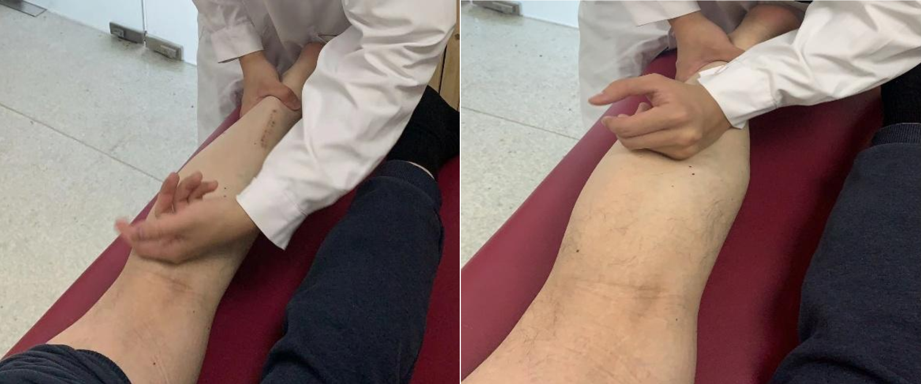 Supplementary Figure S1. Physician-administered massage therapy for a patient with knee OA. The physician performs rolling manipulation over the surrounding muscles while the patient lies in a relaxed prone position.

Supplementary material 2

Knee Osteoarthritis: A Comprehensive Health Education Manual

Summary of content

- Basic Knowledge of Knee Osteoarthritis

- Daily Life and Joint Protection

- Nutrition

- Symptom Monitorin

- Mental Health and Social Support

- Appendix: Self-Monitoring Forms and Resources

- Basic Knowledge of Knee Osteoarthritis

Knee osteoarthritis (Knee OA) is a common chronic joint disease characterized by the degeneration of cartilage and changes in the joint structures, mainly affecting the knee joint. Aging, excessive body weight, or previous knee injuries can increase the risk of developing OA

Main Causes and Risk Factors:
- Age: The most important factor; the ability of cartilage to repair decreases with age. (年龄
- Body Weight: Overweight or obesity significantly increases the load on the knee joint, accelerating cartilage wear. For every 0.5 kg (1 pound) increase in body weight, the knee experiences an additional 1.5–2 kg (3–4 pounds) of pressure.
- Gender: Women over 55 have a higher prevalence than men.
- Joint Overuse and Injury: Repetitive stress (e.g., prolonged kneeling, squatting, lifting heavy objects), sports injuries, or joint instability can increase risk.
- Genetic Factors: Gene mutations or abnormal knee bone structure may increase susceptibility.

Common Symptom:
- Pain: Worsens during activities (e.g., climbing stairs, squatting, prolonged walking) and may improve with rest; in late stages, pain may become persistent.
- Stiffness: Joint feels tight in the morning or after prolonged sitting; usually improves with activity (morning stiffness).
- Swelling: Fluid accumulation within the joint can cause knee enlargement.
- Activity Limitation: Reduced range of motion, difficulty walking, possible knee “giving way” or joint locking.
- Crepitus: Grinding or cracking sensation in the joint during movement.

- Daily Life and Joint Protection

Good daily habits are the foundation for reducing joint stress and slowing disease progression

- Reduce Load: Avoid lifting heavy objects (recommend no more than 5 kg per lift), prolonged standing, or long walks. When climbing stairs, take one step at a time and use the handrail whenever possible.
- Adopt Correct Posture: Use handrails when standing up; avoid sitting on low stools or sofas; choose chairs of appropriate height (knees at about 90° when sitting, feet flat on the floor). Keep your back straight while standing and walking, and avoid inward collapse of the knees.
- Use Assistive Devices: Use a cane, walking stick, or walker if needed. Hold the cane in the stronger hand, and move the cane forward before the affected leg while walking
- Keep Warm: The knees are sensitive to cold. Wear knee protection during cold weather and avoid direct exposure to air conditioning or fans. Dry and warm the knees promptly if they get wet.
- Rest Appropriately: During periods of acute pain or swelling, rest as needed, but avoid prolonged inactivity to prevent muscle atrophy and joint stiffness.
- Nutrition
Balanced Diet
- Calcium for Strong Bones: Consume more dairy products (milk, yogurt), soy products, dark green vegetables (bok choy, spinach), and seafood. Anti-inflammatory and Joint-Nourishing Nutrients:
  - Omega-3 Fatty Acids: Found in deep-sea fish (salmon, cod), help reduce inflammation.
  - Antioxidants: Found in dark-colored vegetables (broccoli, spinach) and berries (cherries, blueberries), help reduce oxidative damage.
  - Joint Nutrients: Consume foods rich in chondroitin and glucosamine (e.g., pork tendons, chicken cartilage) in moderation. Ensure adequate vitamin D (sunlight, fortified foods) to promote calcium absorption.
- Dietary Restrictions: Limit high-fat, high-sugar, high-purine foods (animal organs, rich soups), excessively salty or spicy foods, and avoid alcohol.

- Symptom Monitoring

Key Points for Self-Monitoring
- Record changes in pain (intensity, location, triggers), stiffness (duration), swelling, and limitations in daily activities (e.g., climbing stairs, squatting, standing up).
Pain Score Visualization (0–10 Scale)
Score | Description
0 | No pain
1-2 | Very mild pain, barely noticeable
3-4 | Mild pain, noticeable but not limiting
5-6 | Moderate pain, affects some daily activities
7-8 | Severe pain, limits most activities
9 | Very severe pain, almost unbearable
10 | Worst imaginable pain

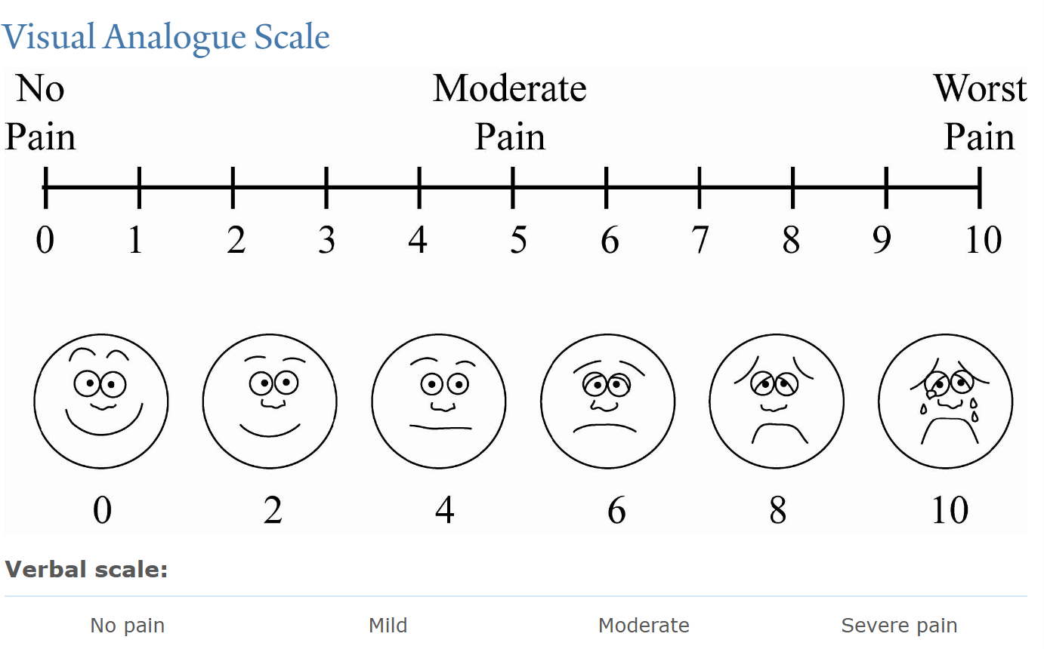

- Mental Health and Social Support
Chronic pain and limited mobility can easily lead to anxiety and depression, making psychological adjustment crucial.
Psychological Adjustment Methods:
- Acceptance and Positive Mindset: Understand the disease, maintain optimism, and avoid excessive anxiety due to pain
- Relaxation Training: Practice deep breathing (inhale 4 seconds – hold 2 seconds – exhale 6 seconds), listen to soothing music, meditate, etc.
- Cultivate Hobbies: Engage in reading, gardening, calligraphy, or other activities to divert attention from pain.
Social Support:
- Family Communication: Share feelings with family members to gain understanding and assistance.
- Peer Support: Join patient support groups to share experiences and encourage each other.
- Seek Professional Help: If emotional distress is severe, consult a psychologist or mental health professional.

- Appendix: Self-Monitoring Forms and Resources
Daily Self-Monitoring Form Example:
- Date: xxxx-xx-xx
- Pain Score (0–10): x
- Joint Stiffness (None/Mild/Moderate/Severe): Mild
- Activity Limitations (e.g., stairs, walking distance): Pain after climbing 3 floors
- Notes (medication, special activities, etc.): Walked 20 minutes today

