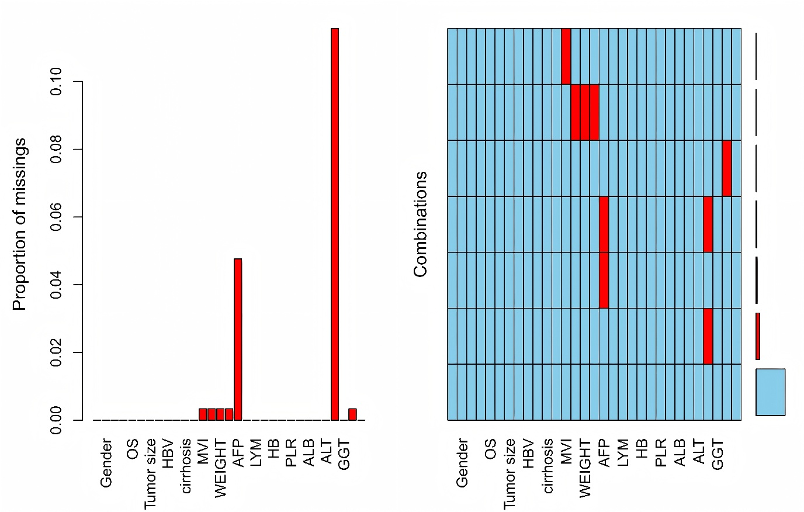
Supplementary Figure S1 Multiple Imputation Results
(Blue: observed data; Red: missing data).

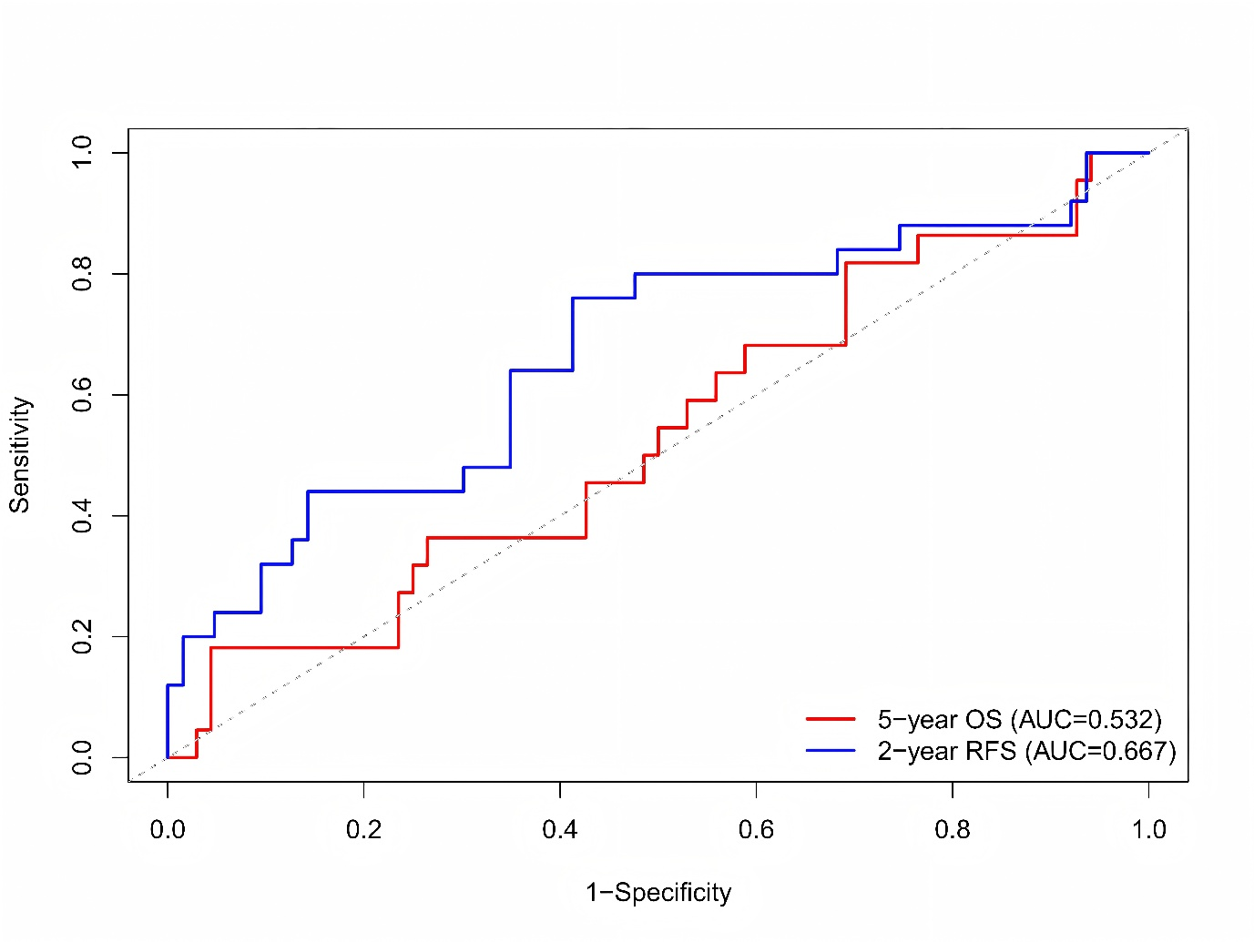
Supplementary Figure S2 ROC curves of the LASSO-Cox model for predicting 5-year overall survival (OS) and 2-year recurrence-free survival (RFS) in the small HCC subgroup (n=90).

Supplementary Table S1. Ten fold cross validated time dependent AUCs for the tuned LASSO-Cox models
Outcome | Time | Mean AUC | 95%CI
OS | 1-year | 0.758 | 0.622-0.895
 | 3-year | 0.718 | 0.611-0.825
 | 5-year | 0.698 | 0.624-0.773
RFS | 1-year | 0.718 | 0.630-0.806
 | 2-year | 0.727 | 0.630-0.784
 | 5-year | 0.794 | 0.673-0.812

Supplementary Table S2. Ten-fold cross-validated time-dependent AUCs for the tuned XGBoost model

Outcome | Time | Mean AUC | 95%CI
OS | 1-year | 0.671 | 0.489-0.854
 | 3-year | 0.714 | 0.603-0.826
 | 5-year | 0.646 | 0.543-0.750
RFS | 1-year | 0.715 | 0.648-0.781
 | 2-year | 0.708 | 0.620-0.795
 | 5-year | 0.751 | 0.653-0.849

