Supplementary Figure 1. Risk of bias assessment for randomized control trials
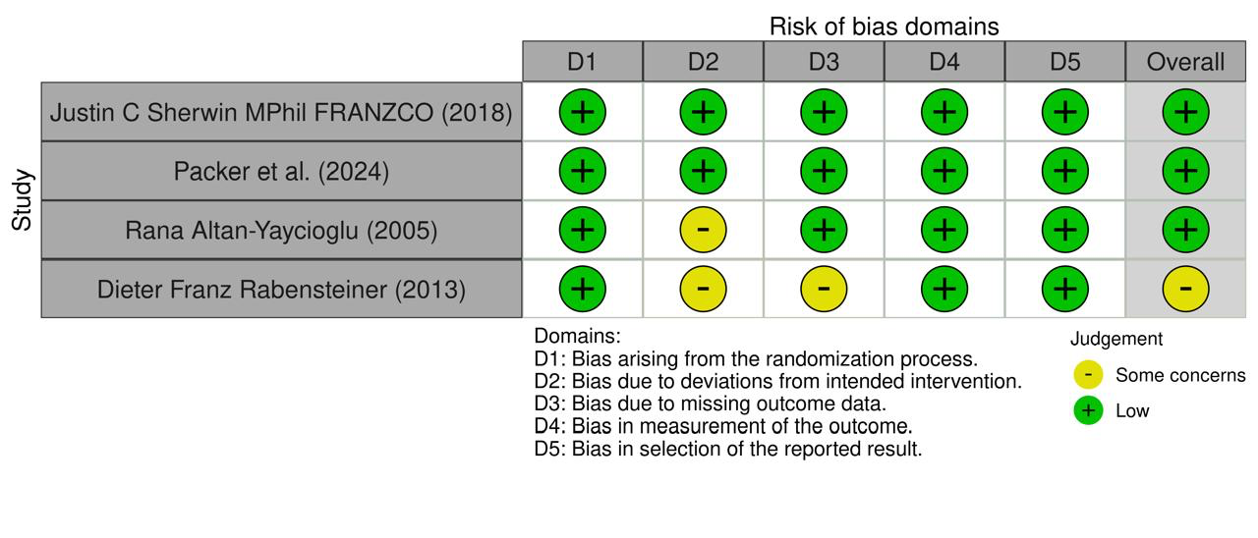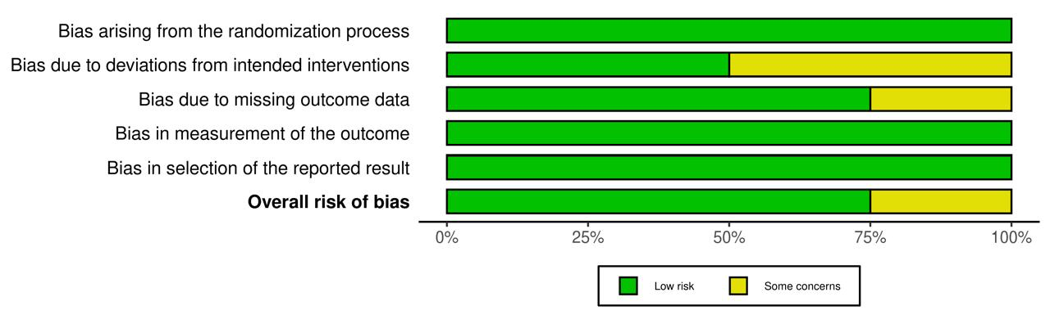

Supplementary figure 2. Risk of bias assessment for non-randomized trials
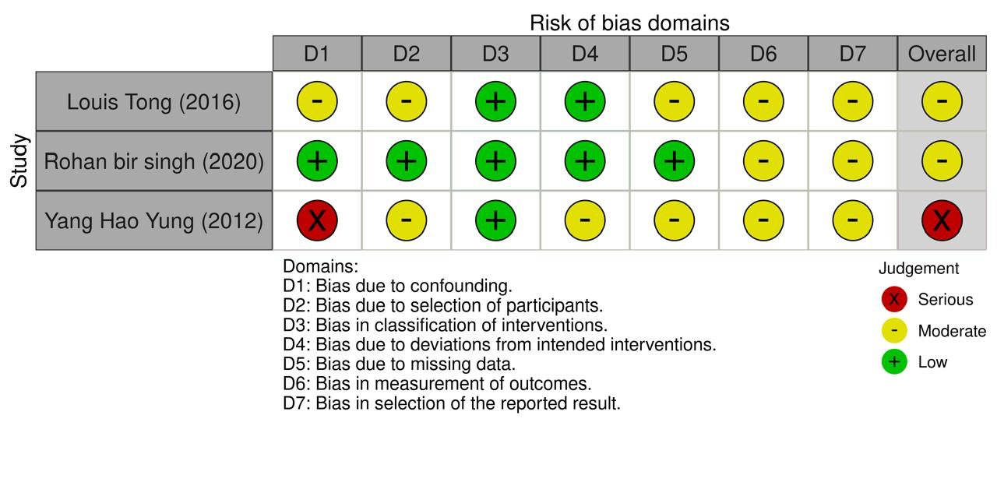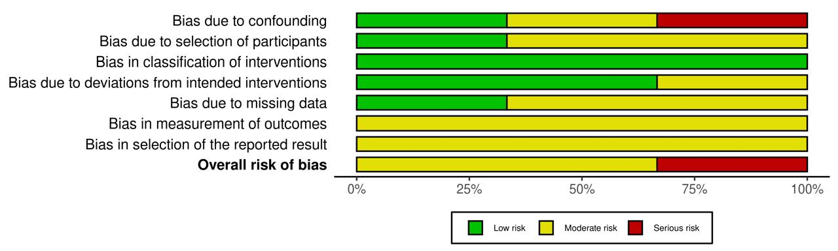

Supplementary Table 1. Critical appraisal for case-series

ID | Holzchuh 2011 | Yaguchi 2012 | Balaram 2001 | Emi Obha 2010 | Yvonne Wang | Ming Cheng | Kazunori
Were there clear criteria for inclusion in the case series? | Yes | Yes | Yes | Yes | Yes | Yes | Yes
Was the condition measured in a standard, reliable way for all the participants included? | Yes | Yes | Yes | Yes | Yes | Yes | Yes
Were valid methods used for identification of the condition for all participants included ? | Yes | Yes | Yes | Yes | Yes | Yes | Yes
Did the case series have consecutive inclusion of participants? | Unclear | Yes | Yes | Yes | Yes | Yes | Unclear
Did the case series have complete inclusion of participants? | Unclear | Yes | Yes | Yes | Yes | Yes | Unclear
Was there clear reporting of demographics of the participants? | Yes | Yes | Yes | Yes | Yes | Yes | Yes
Was there clear reporting of clinical information of the participants? | Yes | Yes | Yes | Yes | Yes | Yes | Yes
Were the outcomes or the follow up results of cases clearly reported? | Yes | Yes | Yes | Yes | Yes | Yes | Yes
Was there clear reporting of the presenting site(s)/ clinic(s) demographic information? | Yes | Yes | Yes | Yes | Yes | Yes | Yes
Was statistical analysis appropriate? | Yes | Yes | Yes | Yes | Yes | Yes | Yes
Overall appraisal | Include | Include | Include | Include | Include | Include | Include

