Clinical Research Protocol
Project Name: Effects of Music Intervention on Pain, Mood, Sleep, and Heart Rate Variability in Patients with Chronic Pain: A Randomized Controlled Trial
Principal Investigator: Bo Wang.
Clinical research department: Department of Pain Management, Huadong Hospital, Fudan University, Shanghai, China.
Applicant: Bo Wang
Ethical review number: ChiCTR-INR-2500095297.
Protocol version number: such as 01, September 24, 2024

Content

Clinical study protocol 1
Contents 2
1. Names and contact information of researchers and clinical research related personnel 4
2. Outline of the research plan（Essential Elements of the Protocol） 5
1、Research programme questions： 5
2、Research background： 5
3、Purpose of research： 7
4、Experimental design： 7
4.1 Types of research design： 7
4.2 Subject selection 8
5、Experimental arrangements for each group 16
6、Observation indicators and efficacy criteria： 18
6.1 HRV metric 18
6.2 Level of pain 18
6.3 Anxiety level 19
6.4 Depression level 20
6.5 Sleep quality 20
7、Common adverse events/reactions and management 21
8、Statistical analysis ： 21
9、Ethics of experimentation： 22
10、The method by which subjects were recruited and the process by which they obtained informed consent： 23
11、Research expected progress and completion dates： 23
12、Follow-up and medical measures after the end of the study： 24
13、The responsibilities of each party and other relevant provisions： 24
14、References 25

I. Names and contact information of researchers and clinical research related personnel
Applicant: Bo Wang

Lead researcher:
Bo Wang 18817350336
Research team members:
Fan Yu
Yantao Ma
Huiying Zhao
II. Outline of the research plan (Essential Elements of the Protocol)
- Title of research plan:
Effects of Music Intervention on Pain, Mood, Sleep, and Heart Rate Variability in Patients with Chronic Pain: A Randomized Controlled Trial
2.Research Background
Chronic pain(CP) is typically defined as pain that persists or recurs for more than three months, leading to significant emotional disturbances and functional impairment in affected individuals^{[1]}. Approximately 20% of adults in Europe experience CP^{[2]}, and it is estimated that there are over 300 million individuals living with CP in China^{[3]}. In addition to its substantial physical and emotional impact, CP imposes a significant economic burden on society. Current estimates indicate that annual expenditures related to CP exceed 200 billion euros in Europe and 150 billion dollars in the United States^{[4]}.
Patients with CP are frequently affected by progressive autonomic symptoms. Anxiety, depression, and sleep disorders are among the most common complications observed in individuals with CP^{[5]}. Non-steroidal anti-inflammatory drugs (NSAIDs) and opioids have traditionally been the primary pharmacological treatments for CP^{[2, 6-8]}. However, excessive use of NSAIDs is associated with an increased risk of adverse effects, including hypertension, arrhythmias, gastrointestinal disorders, and other related conditions^{[9]}. In addition, due to concerns regarding the adverse effects and potential for addiction associated with opioids, a variety of novel non-pharmacological therapies are increasingly being explored as alternative treatment options^{[10]}. Among these approaches, music intervention is regarded as one of the safest and most widely utilized non-pharmacological therapies for pain management, with a high level of patient acceptance^{[11, 12]}. The melody and rhythm of music can influence the regulation of the autonomic nervous system (ANS) and pain perception by modulating activity in the limbic system and hypothalamus, ultimately leading to a reduction in catecholamine secretion^{[13]}. In addition, musical stimuli are primarily processed by the amygdala and hippocampus, which are situated adjacent to the hypothalamic-pituitary axis at the core of the limbic system^{[14]}. Music therapy (MT) has also been shown to exert beneficial effects on anxiety, depression, pain, fatigue, physiological responses, and overall quality of life^{[15, 16]}. For example, music with frequencies in the 8–13 Hz range can stimulate alpha brain wave activity, thereby promoting psychological relaxation. Additionally, low-frequency music (16–150 Hz) has been shown to help alleviate pain and reduce stress^{[17]}.
Abnormal autonomic nervous function is frequently observed during the progression of CP. Simultaneously, assessing the efficacy of interventions for CP by monitoring changes in objective physiological indicators has become an increasingly prominent focus in pain research^{[18-20]}. Studies have demonstrated that both the sympathetic and parasympathetic nervous systems play integral roles in the regulation of pain^{[21]}. Heart rate variability (HRV) analysis has been widely adopted as a standard method for assessing ANS function. In particular, the low-frequency (LF; 0.04–0.15 Hz) and high-frequency (HF; 0.15–0.4 Hz) spectral components of HRV serve as independent indicators for evaluating sympathetic and vagal (parasympathetic) activity, respectively^{[22, 23]}. In addition, studies have demonstrated that HRV is associated with depressive symptoms and insomnia^{[24, 25]}. Therefore, the aim of this study is to investigate the effectiveness of music intervention in patients with CP by evaluating changes in pain severity, sleep quality, mood, and HRV.
3.Research Objectives
- To study the effect of music therapy on CP;
- to study the effect of music therapy on anxiety, depression and sleep disorders caused by CP;
(3) to study the effect of music therapy on HRV related indicators.
4. Experimental design: (Type of research design, method of trial grouping and level of blinding)
4.1 Type of research design: This study was a single-center, randomized, single-blind, prospective clinical intervention trial.
4.2 Subject selection
The number of cases required for the expected purpose of the experiment was calculated according to statistical principles: Given the lack of prior studies in this area, the sample size for this study was estimated based on data from a preliminary pilot experiment. This randomized controlled trial utilized a parallel-group design, with the visual analogue scale (VAS) as the primary outcome measure—a continuous variable. Sample size calculations were performed using G*Power 3.1.9.7 software. The significance level was set at α = 0.05 (two-sided), and statistical power was set at 90% (1-β = 0.90). Based on these parameters, the minimum required sample size was calculated to be 34 participants per group (N₁ = N₂= 34). Allowing for an anticipated dropout rate of 20%, at least 43 participants were required in each group.
Participants were screened according to the following criteria:
4.2.1 Inclusion Criteria
1. Meeting the diagnostic criteria for CP^{[26]}: Experiencing persistent or recurrent pain for more than 3 months. 2. Aged between 18 and 70 years. 3. Pain has a significant impact on quality of life, sleep quality, or mood. 4. Abstinence from caffeine, alcohol, and medications that may affect HRV parameters for at least 24 hours prior to assessment, and not currently receiving any treatment. 5. Provision of written informed consent.
Exclusion Criteria
- Presence of severe cardiovascular or cerebrovascular diseases, arrhythmias, hematological disorders, malignancies, or significant organ dysfunction. 2. Menstruation or pregnancy. 3. History of skin allergies or other serious dermatological conditions. 4. Presence of other neurological disorders. 5. Major psychiatric illness, cognitive impairment, or any condition that precludes cooperation with study procedures. 6. Refusal to provide written informed consent.
Any of the above four criteria will be excluded from this study
To ensure greater statistical validity of the experimental results, this study selected patients from the Pain Clinic at East China Hospital between January 2024 and June 2025. Based on inclusion and exclusion criteria, patients with chronic pain voluntarily participated in the experiment. A total of 86 CP patients were recruited and randomly divided into two groups (Group A: music therapy + health education, 43 patients; Group B: health education only, 43 patients). Both groups underwent HRV testing using the ZSY-1 HRV detector (manufactured by Shenyang Weijin Gene Technology Co., Ltd.). To avoid diurnal variations in HRV, measurements were conducted between 08:00:00 and 12:00:00. The room was kept quiet, with a constant temperature of approximately 25°C and consistent light intensity. Participants were instructed to sit comfortably in a special chair and avoid speaking or moving unless absolutely necessary. Audio prompts guided exhalation and inhalation, with the breathing rate adjusted to 12 breaths per minute. The HRV recording duration was 5 minutes. The signal analysis program performed a Fourier transform to display time-domain and frequency-domain results, recording high-frequency (HF), low-frequency (LF), total power (TP), and low-frequency/high-frequency (LF/HF) components.
4.2.3 Additional exclusion criteria
1. Patients who received alternative treatment regimens or who withdrew during the treatment or follow-up period. 2. Occurrence of serious adverse events necessitating a change in treatment.
4.2.4 Collect basic information from the recruited subjects (Groups A and B) and have them complete the Visual Analogue Scale (VAS), the Brief McGill Pain Questionnaire, the Generalized Anxiety Disorder 7-item Scale (GAD-7), the Patient Health Questionnaire-9 (PHQ-9), and the Pittsburgh Sleep Quality Index (PSQI).

Visual Analogue Scale, VAS
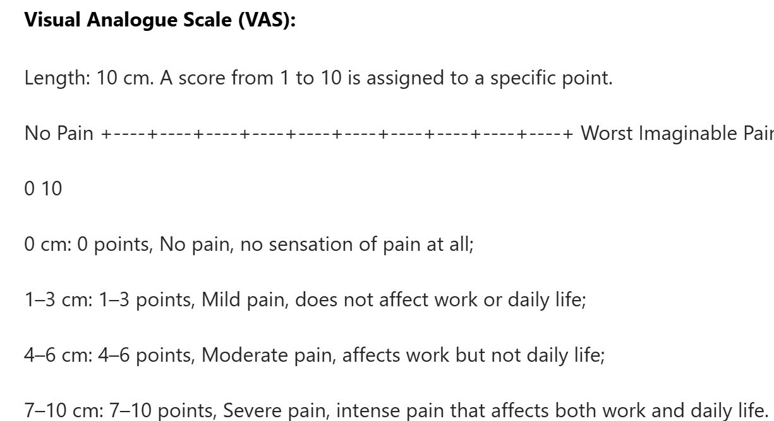

Short-form of McGill Pain Questionnaire, SF-MPQ

Generalized Anxiexy Disorde-7, GAD-7
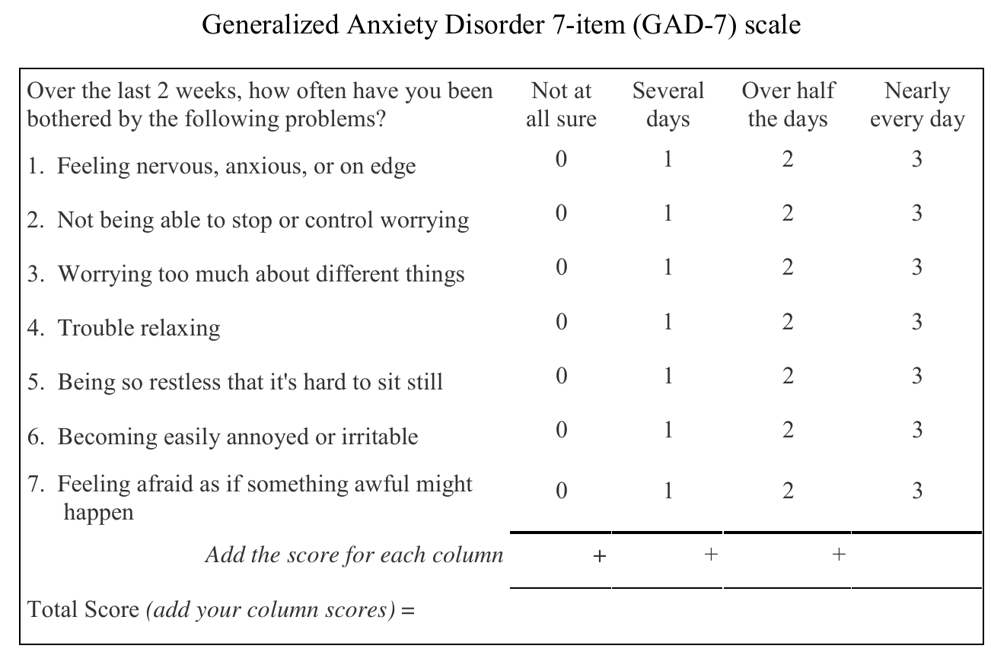

Patient Health Questionnaire-9 Items, PHQ-9

Pittsburgh sleep quality index, PSQI

Collect basic information from the recruited subjects (Groups A and B) and have them complete the VAS, SF-MPQ, GAD-7, PHQ-9, and PSQI.

4.2.5 Experimental Procedures (Groups A and B)

a. HRV testing was conducted on patients in the experimental group and control group to preliminarily observe the expression of sympathetic nervous system (LF), parasympathetic nervous system (HF), VLF (Very Low Frequency, VLF), and SDNN (Standard Deviation of NN Intervals, SDNN) indicators in the two groups;

b. Control group: Provide patients with health education (functional exercises guided by clinical doctors);

c. Experimental group: In addition to the control group interventions, provide music therapy (which can be conducted at home), divided into immediate intervention and long-term intervention.

4.2.6 Intervention Methods

Immediate intervention: After HRV testing, provide experimental group patients with corresponding music therapy based on the test results. After quietly listening for 10 minutes, conduct the same questionnaire assessment as the control group patients.

Long-term intervention: Patients are advised to use their mobile phones to listen to the music in the video with headphones after lunch, before dinner, and before bedtime. Patients should sit or lie down quietly, close their eyes, relax their entire body, and control the volume of the song to a comfortable level (between 60-85 dB); they should avoid text messages, phone calls, and other distractions as much as possible to maintain a quiet environment and ensure patient comfort. It is particularly important to note that during music listening, patients should follow the audio prompts to breathe rhythmically (breath in—inhale; breath out—exhale), with continuous playback throughout. Each intervention lasts 10 minutes, three times daily. If the patient feels well, they may repeat once, seven days a week, for two weeks.

Supervision plan: Patients are required to record their perception of pain intensity, as well as the number of times and duration of music listening each day, immediately after completing the music session. They should bring the music therapy record book to follow-up appointments. A weekly phone call should be made to inquire about the patient's treatment progress, emphasizing the importance of adhering to the prescribed schedule for music listening. Family members may be encouraged to assist in supervision to prevent treatment ineffectiveness.

Experimental Group Arrangements

Group A, Group B

Groups A and B underwent a two-week dry run test. After two weeks of treatment, patients underwent HRV testing and questionnaire assessments to evaluate changes in LF, HF, LF/HF, VLF, SDNN, anxiety and depression levels, and sleep quality. This was done to assess the efficacy of music therapy for chronic pain.

6. Observation indicators and efficacy criteria:

6.1 a. HRV frequency domain analysis indicators: low-frequency power (LF), high-frequency power (HF), LF/HF ratio, and very low-frequency power (VLF).

b. HRV time domain analysis indicators: standard deviation of all normal sinus RR intervals (SDNN).
c. LF, HF, LF/HF, VLF, and SDNN indicators: measured using an HRV machine.
6.2 Pain Level: (1) Pain levels were measured using the Visual Analogue Scale (VAS), where 0 indicates no pain, 10 indicates severe pain, and the intermediate values represent varying degrees of pain. Patients were asked to mark their pain level on a horizontal line based on their own perception. Scores of 2–4 indicate mild pain, 5–7 indicate moderate pain, and 8–9 indicate severe pain; (2) The Simplified McGill Pain Questionnaire (SF-MPQ) is a simplified version of the McGill Pain Questionnaire, providing measurements of the subject's perception of pain, emotional response, and evaluation dimensions. The SF-MPQ includes the Pain Rating Index (PRI), Visual Analogue Scale (VAS), and Present Pain Intensity (PPI). The PRI further includes the Sensory Pain Rating Index (S-PRI) and the Affective Pain Rating Index (A-PRI). Items 1–11 assess the S-PRI, while items 12–15 assess the A-PRI. Each description level is categorized as 0 = no pain, 1 = mild, 2 = moderate, and 3 = severe. The total score is 45 points, with higher scores indicating more severe pain. VAS measurement: 0 indicates no pain, ≤3 indicates mild pain, 4–6 indicates moderate pain, and ≥7 indicates severe pain. PPI is categorized into no pain, slight pain, discomfort, distress, severe pain, and intolerable pain, with each level represented by scores from 0 to 5.
6.3 Anxiety Level: The GAD-7 (Generalized Anxiety Disorder-7, GAD-7) self-assessment scale is used to evaluate patients' anxiety levels. The GAD-7 questionnaire consists of seven questions designed to assess the frequency of anxiety symptoms: “Never” corresponds to 0 points, indicating that symptoms rarely occur; “a few days” corresponds to 1 point, indicating that symptoms occasionally occur; “more than a week” corresponds to 2 points, indicating that symptoms occur in most cases; “almost every day” corresponds to 3 points, indicating that symptoms are frequent and persistent. A total score of 0–4 indicates almost no anxiety, 5–9 indicates mild anxiety, 10–14 indicates moderate anxiety, and 15–21 indicates severe anxiety. The higher the score, the more severe the anxiety symptoms.
6.4 Depression Level: The PHQ-9 (Patient Health Questionnaire-9, PHQ-9) depression symptom screening scale is used to assess the severity of depression in patients. This assessment questionnaire consists of nine items, each representing a specific aspect of depressive symptoms. The questionnaire uses a four-point scoring system to evaluate the frequency of depressive symptoms: 0 points indicate almost no or very few occurrences (less than 1 day); 1 indicates occasional occurrence (1 to 2 days); 2 indicates most of the time (3 to 4 days); and 3 indicates the most frequent occurrence, i.e., almost always or constantly (5 to 7 days). A total score of 0–4 indicates almost no depression, 5–9 indicates mild depression, 10–14 indicates moderate depression, 15–19 indicates moderate-to-severe depression, and 20–27 indicates severe depression. The higher the score, the more severe the depressive symptoms.
6.5 Sleep Quality: The Pittsburgh Sleep Quality Index (PSQI) was used to evaluate patients' sleep quality before and after intervention. The PSQI includes 7 factors, each scored from 0 to 3 points, with higher scores indicating poorer sleep quality.
6.6 Interpretation of HRV Parameters
(1) TP: Reflects the overall state of autonomic nervous system function;
(2) LF: Reflects the combined regulatory effect of the sympathetic and parasympathetic nervous systems on the sinoatrial node, with sympathetic nervous system activity predominating;
(3) HF: Reflects parasympathetic nervous system regulatory power;
(4) LF/HF: The ratio of low-frequency to high-frequency components, reflecting the balance between sympathetic and parasympathetic nervous system activity. An increased LF/HF ratio indicates enhanced sympathetic nervous system excitability;
(5) VLF: Generally believed to be associated with temperature regulation of peripheral vascular tone, renin and angiotensin levels, changes in blood volume, cardiac pump status, and low-frequency fluctuations in tidal volume;
(6) SDNN: Reflects overall HRV.
7. Common adverse events/reactions and management
Adverse reactions to music therapy: ① Increased pain; ② Elevated anxiety and depression levels; ③ Deterioration in sleep quality. If any of the above symptoms occur, treatment should be discontinued immediately. During treatment, it is important to ensure that the frequency range of the music being listened to is accurate to minimize the occurrence of such events.
- Statistical Analysis:
Data were analyzed using SPSS 26.0 statistical software. Quantitative data are expressed as mean ± standard deviation (X ± SD). If normality is satisfied, between-group comparisons use independent samples t-tests, and within-group comparisons use paired samples t-tests; If normality was not met, intergroup comparisons were performed using the Mann-Whitney U test, and intragroup comparisons were performed using the Wilcoxon signed-rank test. A p-value < 0.05 indicated a statistically significant difference.
- Experimental Ethics:
The clinical study will adhere to the relevant provisions of the World Medical Association's Declaration of Helsinki. The clinical study will only be conducted after the trial protocol has been approved by the Ethics Committee prior to the study's commencement. Before enrolling in this study, researchers are responsible for fully and comprehensively informing participants or their representatives about the purpose, procedures, and potential risks of the study, and obtaining written informed consent. Participants should be informed that they have the right to withdraw from the study at any time, and the informed consent form should be retained as part of the clinical research documentation for reference. During the study, the personal privacy and data confidentiality of participants will be protected. All participants in this clinical trial will receive an explanation of the paper-based informed consent form from the researchers in person, obtain consent, and sign the informed consent form. Participants may voluntarily request to withdraw from the study, and the data collected during this process will be confidentially processed and organized into case reports.

10. Methods for recruiting participants and obtaining informed consent:
Patients from the Pain Clinic at Huadong Hospital between January 2025 and June 2025 were selected. Based on the inclusion and exclusion criteria, patients with chronic pain voluntarily participated in the experiment and signed the informed consent form.

11. Study expected schedule and completion date:
A. Declaration (file with the Research Office and ethical review):

Expected completion date: 2024-10

- Subject recruitment (publishing subject recruitment advertisement, screening qualified subjects and signing informed consent form):

Expected completion date: 2024-12-30

C.Conduct experiments (music therapy, data collection):

Expected completion date: 2025-04-30

D. Statistical analysis (data entry, data testing, drawing, etc.)

Expected completion date: 2025-05-28

Write the paper (first draft and final draft)

Expected completion date: 2025-06-20
- Follow-up and medical measures after the end of the study:
- Provide long-term follow-up to patients and provide guidance on treatment.
- Follow up according to the condition, and give suggestions and help if further treatment is needed.
- Responsibilities and Relevant Regulations:
As subjects, you are obligated to provide truthful information regarding your medical history and current health status; inform the study physician of any discomfort experienced during this research; and disclose whether you have participated in or are currently involved in any other clinical trials. As investigators, you are responsible for ensuring participant safety. Should any injuries related to this study occur, the project team will compensate according to relevant national laws and regulations.

References
[1] SCHOLZ J, FINNERUP N B, ATTAL N, et al. The IASP classification of chronic pain for ICD-11: chronic neuropathic pain [J]. Pain, 2019, 160(1): 53-9.
[2] TREEDE R D, RIEF W, BARKE A, et al. A classification of chronic pain for ICD-11 [J]. Pain, 2015, 156(6): 1003-7.
[3] Fan B. Chinese pain medicine development report.[M]. Beijing: Tsinghua University publishing house, 2020.
[4] FAN B. Chinese pain medicine development report [M]. Beijing: Tsinghua University publishing house, 2020.
[5] LI L W, CHEW A M K, GUNASEKERAN D V. Digital health for patients with chronic pain during the COVID-19 pandemic [J]. British journal of anaesthesia, 2020, 125(5): 657-60.
[6] YONGJUN Z, TINGJIE Z, XIAOQIU Y, et al. A survey of chronic pain in China [J]. The Libyan journal of medicine, 2020, 15(1): 1730550.
[7] TRACY L M, IOANNOU L, BAKER K S, et al. Meta-analytic evidence for decreased heart rate variability in chronic pain implicating parasympathetic nervous system dysregulation [J]. Pain, 2016, 157(1): 7-29.
[8] HAASE J, BROWN E. Integrating the monoamine, neurotrophin and cytokine hypotheses of depression--a central role for the serotonin transporter? [J]. Pharmacology & therapeutics, 2015, 147: 1-11.
[9] VAN'T VEER A, CARLEZON W A, JR. Role of kappa-opioid receptors in stress and anxiety-related behavior [J]. Psychopharmacology, 2013, 229(3): 435-52.
[10] CHEN T, WANG J, WANG Y Q, et al. Current Understanding of the Neural Circuitry in the Comorbidity of Chronic Pain and Anxiety [J]. Neural plasticity, 2022, 2022: 4217593.
[11] FELGER J C, LOTRICH F E. Inflammatory cytokines in depression: neurobiological mechanisms and therapeutic implications [J]. Neuroscience, 2013, 246: 199-229.
[12] GUREJE O, VON KORFF M, KOLA L, et al. The relation between multiple pains and mental disorders: results from the World Mental Health Surveys [J]. Pain, 2008, 135(1-2): 82-91.
[13] AUVINEN J, ESKOLA P J, OHTONEN H R, et al. Long-term adolescent multi-site musculoskeletal pain is associated with psychological distress and anxiety [J]. Journal of psychosomatic research, 2017, 93: 28-32.
[14] SUN Y, LAKSONO I, SELVANATHAN J, et al. Prevalence of sleep disturbances in patients with chronic non-cancer pain: A systematic review and meta-analysis [J]. Sleep medicine reviews, 2021, 57: 101467.
[15] NADEAU S E, WU J K, LAWHERN R A. Opioids and Chronic Pain: An Analytic Review of the Clinical Evidence [J]. Frontiers in pain research (Lausanne, Switzerland), 2021, 2: 721357.
[16] MORRONE L A, SCUTERI D, ROMBOLà L, et al. Opioids Resistance in Chronic Pain Management [J]. Current neuropharmacology, 2017, 15(3): 444-56.
[17] BREIVIK H, COLLETT B, VENTAFRIDDA V, et al. Survey of chronic pain in Europe: prevalence, impact on daily life, and treatment [J]. European journal of pain (London, England), 2006, 10(4): 287-333.
[18] GROSSER T, RICCIOTTI E, FITZGERALD G A. The Cardiovascular Pharmacology of Nonsteroidal Anti-Inflammatory Drugs [J]. Trends in pharmacological sciences, 2017, 38(8): 733-48.
[19] DEL VECCHIO G, SPAHN V, STEIN C. Novel Opioid Analgesics and Side Effects [J]. ACS chemical neuroscience, 2017, 8(8): 1638-40.
[20] DOWELL D, HAEGERICH T M, CHOU R. CDC Guideline for Prescribing Opioids for Chronic Pain--United States, 2016 [J]. Jama, 2016, 315(15): 1624-45.
[21] HEDAYATI J, BAGHERI-NESAMI M, ELYASI F, et al. The Effect of Music Therapy on the Pain and Anxiety Levels of Patients Experiencing Wound Healing by Suturing in the Emergency Wards [J]. Anesthesiology and pain medicine, 2023, 13(1): e132943.
[22] JIA T, OGAWA Y, MIURA M, et al. Music Attenuated a Decrease in Parasympathetic Nervous System Activity after Exercise [J]. PloS one, 2016, 11(2): e0148648.
[23] LV Y, WU J, XU Y, et al. Musical therapy attenuates neuroma pain by modifying leptin expression [J]. BMC complementary medicine and therapies, 2022, 22(1): 316.
[24] TSE M M Y, YAN E, TANG A S K, et al. A music-with-movement exercise programme for community-dwelling older adults suffering from chronic pain: A pilot randomized controlled trial [J]. Nursing open, 2023, 10(9): 6566-74.
[25] LOW M Y, LACSON C, ZHANG F, et al. Vocal Music Therapy for Chronic Pain: A Mixed Methods Feasibility Study [J]. Journal of alternative and complementary medicine (New York, NY), 2020, 26(2): 113-22.
[26] HOLE J, HIRSCH M, BALL E, et al. Music as an aid for postoperative recovery in adults: a systematic review and meta-analysis [J]. Lancet (London, England), 2015, 386(10004): 1659-71.
[27] ZHANG J, SHI P, DU J, et al. A study based on functional near-infrared spectroscopy: Cortical responses to music interventions in patients with myofascial pain syndrome [J]. Frontiers in human neuroscience, 2023, 17: 1119098.
[28] HAWKER G A, MIAN S, KENDZERSKA T, et al. Measures of adult pain: Visual Analog Scale for Pain (VAS Pain), Numeric Rating Scale for Pain (NRS Pain), McGill Pain Questionnaire (MPQ), Short-Form McGill Pain Questionnaire (SF-MPQ), Chronic Pain Grade Scale (CPGS), Short Form-36 Bodily Pain Scale (SF-36 BPS), and Measure of Intermittent and Constant Osteoarthritis Pain (ICOAP) [J]. Arthritis care & research, 2011, 63 Suppl 11: S240-52.
[29] TANG N K Y, SALKOVSKIS P M, HODGES A, et al. Effects of mood on pain responses and pain tolerance: an experimental study in chronic back pain patients [J]. Pain, 2008, 138(2): 392-401.
[30] PENG K, YüCEL M A, STEELE S C, et al. Morphine Attenuates fNIRS Signal Associated With Painful Stimuli in the Medial Frontopolar Cortex (medial BA 10) [J]. Frontiers in human neuroscience, 2018, 12: 394.
[31] ASHRAF A B, LUCEY S, COHN J F, et al. The Painful Face - Pain Expression Recognition Using Active Appearance Models [J]. Image and vision computing, 2009, 27(12): 1788-96.
[32] HAMMAL Z, COHN J F. Automatic detection of pain intensity [J]. Proceedings of the ACM International Conference on Multimodal Interaction ICMI (Conference), 2012, 2012: 47-52.
[33] SHAFFER F, GINSBERG J P. An Overview of Heart Rate Variability Metrics and Norms [J]. Frontiers in public health, 2017, 5: 258.
[34] D'ANGELO J, RITCHIE S D, ODDSON B, et al. Using Heart Rate Variability Methods for Health-Related Outcomes in Outdoor Contexts: A Scoping Review of Empirical Studies [J]. International journal of environmental research and public health, 2023, 20(2).
[35] CHEN X, YANG R, KUANG D, et al. Heart rate variability in patients with major depression disorder during a clinical autonomic test [J]. Psychiatry research, 2017, 256: 207-11.
[36] LEONE M, PROIETTI CECCHINI A, MEA E, et al. Neuroimaging and pain: a window on the autonomic nervous system [J]. Neurological sciences : official journal of the Italian Neurological Society and of the Italian Society of Clinical Neurophysiology, 2006, 27 Suppl 2: S134-7.
[37] NEUGEBAUER V, MAZZITELLI M, CRAGG B, et al. Amygdala, neuropeptides, and chronic pain-related affective behaviors [J]. Neuropharmacology, 2020, 170: 108052.

