Supporting Information

Supplementary Material 1: Supplementary method
Total RNA was extracted using the Trizol (Invitrogen, CA, USA), RNA purity and integrity was monitored by NanoDrop 2000 spectrophotometer (NanoDrop Technologies, Wilmington, DE, USA) and a Bioanalyzer 2100 system (Agilent Technologies, CA, USA). RNA contamination was assessed by 1.5% agarose gel.
Ribosomal RNA was removed by the RIbo-Zero kit to enrich mRNA. Purified mRNA was fragmented into small pieces with fragment buffer at appropriate temperature. First-strand cDNA was generated using random hexamer-primed reverse transcription. The buffer, dNTPs (dTTP is replaced with dUTP), the DNA polymerase I and RNase H are then added to synthesize second- stranded cDNA. AMPure XP beads were then used to purify double-stranded cDNA, and then USER enzyme was used to degrade the second strand of cDNA containing U. Afterwards, A- Tailing Mix and RNA Index Adapters were added to repair the end of cDNA. The cDNA fragments obtained from previous steps were amplified, and products were purified by Ampure XP Bead. After the library was constructed, Qubit 2.0 was used for quantification. Then Agilent 2100 BioAnalyzer was used to detect the insert size of the library. Nanodrop was used to accurately quantify the effective concentration of the library to ensure the quality of the library.
HISAT2¹ (V2.1.0) was used to align clean reads to the reference genome.
Using featureCounts², Mapping results were used for statistics, and the number of Reads of each transcript of each sample was obtained, and FPKM (Fragments Per Kilobase Per Million bases) value was calculated.
DESeq2³ (V1.22.2)/edgeR⁴（V3.6.8）was used for different expression analysis, and the threshold was FDR (false discovery rate) ＜ 0.05，log2FC（fold change）＞1 or ＜-1.
GO (Gene Ontology) is divided into Molecular Function, biological processes, and cellular component three Ontology. cluterProfiler was used for GO enrichment analysis, and the GO term with Q-value ≤0.05 was selected as the significantly enriched GO entry. KEGG (Kyoto Encyclopedia of Genes and Genomes) is the main public database on Pathway, annotated with KOBAS⁵ (V3.0). Pathways with Q-value ≤0.05 were defined as those significantly enriched pathways. Pathway enrichment analysis was performed using cluterProfiler⁶ .
Protein interaction network analysis (PPI) is constructed by align protein sequences to the species/near species in STRING⁷ database, and using the relationship in this database to construct the network.
The new transcripts were detected by Rockhopper⁸ (V2.03).
Use a picard (V1.96) tool suite to sort the bam file obtained by comparing it with the reference genome and remove duplication. Use SAMtools⁹ (V0.1.19) combined with GATK¹⁰ (V3.7) method to call SNV and INDEL to obtain high-quality SNV and INDEL information.

Table S1 Key RNA-seq quality metrics
Sample Name | Raw Reads (Million) | Clean Reads (Million) | Q20 (%) | Q30 (%) | GC Content (%)
ZnO_NPs_1 | 22.18 | 21.95 | 98.57 | 95.68 | 51.98
ZnO_NPs_2 | 21.75 | 21.60 | 98.75 | 96.05 | 52.32
ZnO_NPs_3 | 20.76 | 20.58 | 98.70 | 95.96 | 52.17
Control_1 | 25.27 | 25.08 | 98.76 | 96.12 | 51.49
Control_2 | 21.85 | 21.67 | 98.66 | 95.85 | 51.71
Control_3 | 24.26 | 23.97 | 98.57 | 95.62 | 51.64
Mean ± SD | 22.68 ± 1.77 | 22.48 ± 1.74 | 98.67 ± 0.08 | 95.88 ± 0.19 | 51.89 ± 0.31

Table S2 Primers sequences of qPCR
Name | Primers | Sequences (5’ - 3’)
glgA | Forward | TCACATTACGGCGGTCAGTC
glgA | Reverse | GCGGCACTTTATCGTCAACC
gltB | Forward | TCTGAAAAGCCGCCATCCAT
gltB | Reverse | ACGGCGAATGGGGTATCATC
rpoD | Forward | AGGAAGGCAACATCGGTCTG
rpoD | Reverse | TTGTCTTCCGGCATCAGCAT

Table S3. Physicochemical properties of ZnO NCs in different media
Medium | Hydrodynamic Diameter (nm) | PDI | Zeta Potential (mV)
Deionized Water | 122.4 ± 13.9 | 0.275 ± 0.028 | 32.4 ± 3.2
LB Broth | 177.7 ± 3.1 | 0.206 ± 0.064 | -14.1 ± 0.6

Figure S1 Preliminary inhibition zone of ZnO NCs
A. The inhibition zone of ZnO NCs against S. aureus; B. The diameter of the inhibition zone of ZnO NCs against S. aureus; C. The inhibition zone of ZnO NCs against E. coli; D. The diameter of the inhibition zone of ZnO NCs against E. coli. Data are presented as the mean ± SD (n = 3 independent experiments).

Figure S2 growth curve of E. coli biofilm

Figure S3 Antibacterial and antibiofilm efficacy of Methanol.
A, Relative absorbance at 562 nm of crystal violet staining for inhibited biofilm formation; B, Relative absorbance at 562 nm of crystal violet staining for removed mature biofilms. Comparisons among all groups showed no statistically significant differences (p > 0.05).
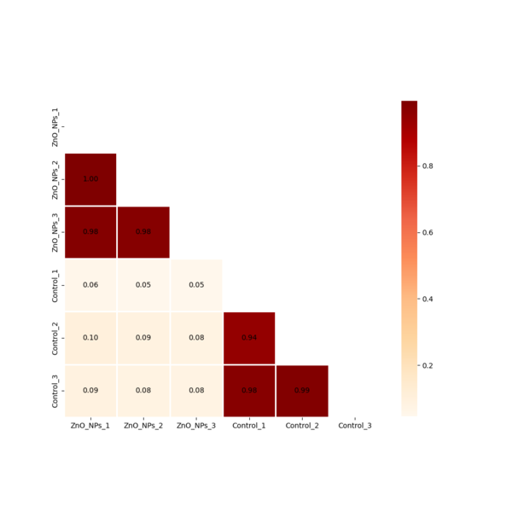
Figure S4 Heat map of inter-sample correlation
Figure S5 Volcano map of differential genes

References
- Kim D, Langmead B, Salzberg SL. HISAT: a fast spliced aligner with low memory requirements. Nat Methods. 2015;12(4):357-360. doi:10.1038/nmeth.3317
- Liao Y, Smyth GK, Shi W. featureCounts: an efficient general purpose program for assigning sequence reads to genomic features. Bioinformatics. 2014;30(7):923-930. doi:10.1093/bioinformatics/btt656
- Love MI, Huber W, Anders S. Moderated estimation of fold change and dispersion for RNA-seq data with DESeq2. Genome Biol. 2014;15(12):550. doi:10.1186/s13059-014-0550-8
- Robinson MD, McCarthy DJ, Smyth GK. edgeR: a Bioconductor package for differential expression analysis of digital gene expression data. Bioinformatics. 2010;26(1):139-140. doi:10.1093/bioinformatics/btp616
- Xie C, Mao X, Huang J, et al. KOBAS 2.0: a web server for annotation and identification of enriched pathways and diseases. Nucleic Acids Res. 2011;39(Web Server issue):W316-W322. doi:10.1093/nar/gkr483
- Yu G, Wang LG, Han Y, He QY. clusterProfiler: an R package for comparing biological themes among gene clusters. OMICS. 2012;16(5):284-287. doi:10.1089/omi.2011.0118
- Snel B, Lehmann G, Bork P, Huynen MA. STRING: a web-server to retrieve and display the repeatedly occurring neighbourhood of a gene. Nucleic Acids Res. 2000;28(18):3442-3444. doi:10.1093/nar/28.18.3442
- McClure R, Balasubramanian D, Sun Y, et al. Computational analysis of bacterial RNA-Seq data. Nucleic Acids Res. 2013;41(14):e140. doi:10.1093/nar/gkt444
- Li H, Handsaker B, Wysoker A, et al. The Sequence Alignment/Map format and SAMtools. Bioinformatics. 2009;25(16):2078-2079. doi:10.1093/bioinformatics/btp352
- McKenna A, Hanna M, Banks E, et al. The Genome Analysis Toolkit: a MapReduce framework for analyzing next-generation DNA sequencing data. Genome Res. 2010;20(9):1297-1303. doi:10.1101/gr.107524.110

