Supplemental Table S1 Primer sequence
Primer name | Sequence (5-3)
mouse GAPDH F | TGCCCCCATGTTTGTGATG
mouse GAPDH R | TGTGGTCATGAGCCCTTCC
mouse NAAA F | GCAGCATCTGTGACTCGCTCAA
mouse NAAA R | CCAAAAGGATAGTCCAGGTTCCG
mouse PPARGC1A F | GAATCAAGCCACTACAGACACCG
mouse PPARGC1A R | CATCCCTCTTGAGCCTTTCGTG
mouse GIPC2 F | CTCTGAAGCCAAGGCAAAGGCA
mouse GIPC2 R | GTCTCGTCAAGAGCGACAGCAA
Supplemental Table S2 Results of MR randomization analysis for different exposure factors
Gene | method | nsnp | b | p | p_bonferroni | p_bh | Q | Q_pval
PPARGC1A | Inverse variance weighted | 4 | -0.001 | 0.016 | 1 | 0.96 | 0.49 | 0.92
PADI2 | Inverse variance weighted | 7 | 0.001 | 0.042 | 1 | 0.99 | 2.82 | 0.83
TEX11 | Inverse variance weighted | 3 | -0.001 | 0.033 | 1 | 0.99 | 1.58 | 0.45
TST | Inverse variance weighted | 8 | 0.001 | 0.009 | 1 | 0.96 | 4.71 | 0.70
SEC14L1 | Inverse variance weighted | 3 | -0.001 | 0.033 | 1 | 0.99 | 1.58 | 0.45
GIPC2 | Inverse variance weighted | 4 | -0.001 | 0.016 | 1 | 0.96 | 0.49 | 0.92
NAAA | Inverse variance weighted | 6 | 0 | 0.039 | 1 | 0.99 | 2.09 | 0.84
SLC16A9 | Inverse variance weighted | 7 | 0.001 | 0.042 | 1 | 0.99 | 2.82 | 0.83
SERPINA6 | Inverse variance weighted | 4 | -0.001 | 0.016 | 1 | 0.96 | 0.49 | 0.92
SERPINA6 | Inverse variance weighted | 4 | -0.001 | 0.016 | 1 | 0.96 | 0.49 | 0.92

Supplemental Table S3 Calculation of Cochran's Q statistic based on MRE-IVW and MR Egger regression methods
id.exposure | id.outcome | method | Q | Q_pval
eqtl-a-ENSG00000109819 | GCST90038684 | MR Egger | 0.491 | 0.782
eqtl-a-ENSG00000109819 | GCST90038684 | Inverse variance weighted | 0.493 | 0.92
eqtl-a-ENSG00000117115 | GCST90038684 | MR Egger | 1.173 | 0.947
eqtl-a-ENSG00000117115 | GCST90038684 | Inverse variance weighted | 2.822 | 0.831
eqtl-a-ENSG00000120498 | GCST90038684 | MR Egger | 0 | 0.998
eqtl-a-ENSG00000120498 | GCST90038684 | Inverse variance weighted | 1.584 | 0.453
eqtl-a-ENSG00000128311 | GCST90038684 | MR Egger | 4.322 | 0.633
eqtl-a-ENSG00000128311 | GCST90038684 | Inverse variance weighted | 4.711 | 0.695
eqtl-a-ENSG00000129657 | GCST90038684 | MR Egger | 0 | 0.998
eqtl-a-ENSG00000129657 | GCST90038684 | Inverse variance weighted | 1.584 | 0.453
eqtl-a-ENSG00000137960 | GCST90038684 | MR Egger | 0.491 | 0.782
eqtl-a-ENSG00000137960 | GCST90038684 | Inverse variance weighted | 0.493 | 0.92
eqtl-a-ENSG00000138744 | GCST90038684 | MR Egger | 2.024 | 0.731
eqtl-a-ENSG00000138744 | GCST90038684 | Inverse variance weighted | 2.087 | 0.837
eqtl-a-ENSG00000165449 | GCST90038684 | MR Egger | 1.173 | 0.947
eqtl-a-ENSG00000165449 | GCST90038684 | Inverse variance weighted | 2.822 | 0.831
eqtl-a-ENSG00000170099 | GCST90038684 | MR Egger | 0.491 | 0.782
eqtl-a-ENSG00000170099 | GCST90038684 | Inverse variance weighted | 0.493 | 0.92
eqtl-a-ENSG00000277405 | GCST90038684 | MR Egger | 0.491 | 0.782
eqtl-a-ENSG00000277405 | GCST90038684 | Inverse variance weighted | 0.493 | 0.92

Supplemental Table S4 Multi efficacy analysis - Ulcerative colitis
id.exposure | id.outcome | egger_intercept | se | PRESSO_P | RSSobs
eqtl-a-ENSG00000109819 | GCST90038684 | 0 | 0.0003 | 0.946 | 0.703
eqtl-a-ENSG00000117115 | GCST90038684 | 0.0002 | 0.0001 | 0.861 | 3.529
eqtl-a-ENSG00000120498 | GCST90038684 | -0.0002 | 0.0002 | 0.64 | 4.261
eqtl-a-ENSG00000128311 | GCST90038684 | 0.0001 | 0.0001 | 0.597 | 7.735
eqtl-a-ENSG00000129657 | GCST90038684 | -0.0002 | 0.0002 | 0.642 | 4.261
eqtl-a-ENSG00000137960 | GCST90038684 | 0 | 0.0003 | 0.942 | 0.703
eqtl-a-ENSG00000138744 | GCST90038684 | 0 | 0.0002 | 0.838 | 3.086
eqtl-a-ENSG00000165449 | GCST90038684 | 0.0002 | 0.0001 | 0.859 | 3.529
eqtl-a-ENSG00000170099 | GCST90038684 | 0 | 0.0003 | 0.947 | 0.703
eqtl-a-ENSG00000277405 | GCST90038684 | 0 | 0.0003 | 0.952 | 0.703

Supplemental Table S5 Directional analysis
id.exposure | snp_r2.exposure | snp_r2.outcome | correct_causal_direction | steiger_pval
eqtl-a-ENSG00000109819 | 0.046514965 | 0.0000131 | TRUE | 1.67E-301
eqtl-a-ENSG00000117115 | 0.065319331 | 0.0000141 | TRUE | 0
eqtl-a-ENSG00000120498 | 0.015879572 | 0.0000126 | TRUE | 3.82E-97
eqtl-a-ENSG00000128311 | 0.047845569 | 0.0000239 | TRUE | 3.61E-287
eqtl-a-ENSG00000129657 | 0.015879572 | 0.0000126 | TRUE | 3.82E-97
eqtl-a-ENSG00000137960 | 0.046514965 | 0.0000131 | TRUE | 1.67E-301
eqtl-a-ENSG00000138744 | 0.124056771 | 0.0000125 | TRUE | 0
eqtl-a-ENSG00000165449 | 0.065319331 | 0.0000141 | TRUE | 0
eqtl-a-ENSG00000170099 | 0.046514965 | 0.0000131 | TRUE | 1.67E-301
eqtl-a-ENSG00000277405 | 0.046514965 | 0.0000131 | TRUE | 1.67E-301

Supplemental Table S6 The co-localization analysis results
PP.H0.abf | PP.H1.abf | PP.H2.abf | PP.H3.abf | PP.H4.abf | gene_symbol | n_snps
0 | 0.991699931100092 | 0 | 0.00803171316870844 | 0.000268355731226628 | PPARGC1A | 990
0 | 0.996735392975198 | 0 | 0.00313270934211504 | 0.00013189768297445 | PADI2 | 1646
1.02659967348706e-141 | 0.999193871714716 | 6.82197112681531e-145 | 0.000663843094794616 | 0.000142285190500986 | TST | 689
2.57510809373688e-73 | 0.999648560201703 | 4.31261508881451e-77 | 0.000167230100976579 | 0.000184209697325995 | SEC14L1 | 361
0.461901585395819 | 0.537924067113357 | 3.26699897655616e-06 | 3.63725766377632e-06 | 0.000167443234182909 | GIPC2 | 22
0 | 0.99717482848404 | 0 | 0.00146872105714711 | 0.00135645045891578 | NAAA | 3439
4.23689695061763e-13 | 0.999904335006275 | 2.67226498343064e-18 | 6.21707634445605e-06 | 8.94479169571504e-05 | SLC16A9 | 64
0.137660393798175 | 0.862257218889621 | 5.42017076455843e-07 | 3.31647917465887e-06 | 7.85288159523869e-05 | SERPINA6 | 40

Supplemental Table S7 The binding energy between key genes and three active compounds
Targets | PDB ID | DrugName | Docking score（kcal/mol）
PPARGC1A | 6W9L | Resveratrol | -8.1
 |  | Rosiglitazone | -8.5
 |  | Rotenone | -7.9
GIPC2 | 3GGE | Benzo(a)pyrene | -8.3
 |  | bisphenol A | -6.8
 |  | Tetrachlorodibenzodioxin | -6.4

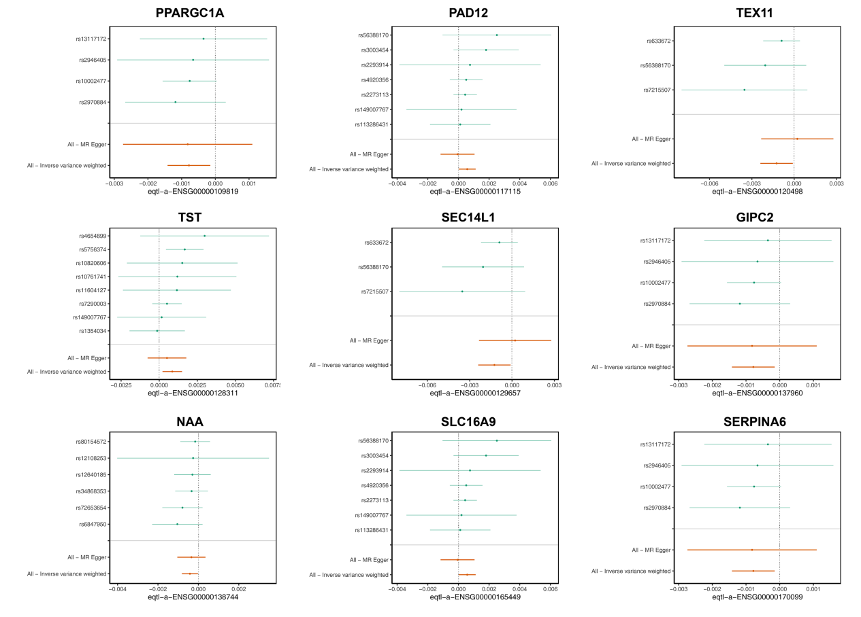
Supplemental Fig. S1 Forest plot of Mendelian randomization analysis for 9 gene (PPARGC1A, PAD12, TEX11, TST, SEC14L1, GIPC2, NAA, SLC16A9, and SERPINA6) present the MR estimate for each SNP.

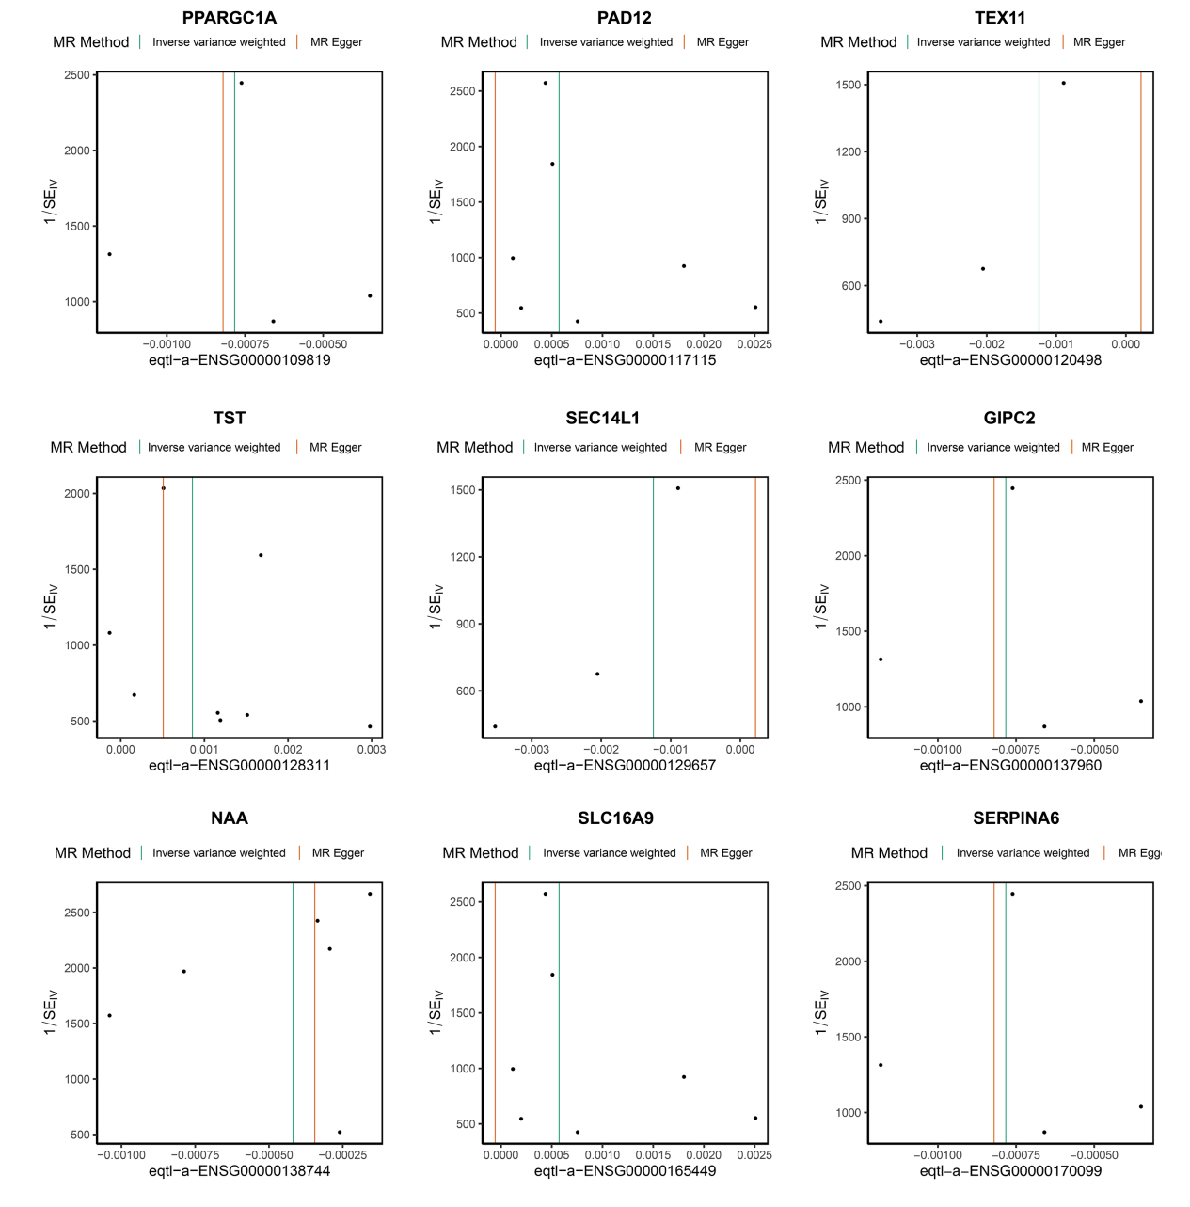
Supplemental Fig. S2 The Funnel plot employed to evaluate the presence of potential heterogeneity in the observed association.

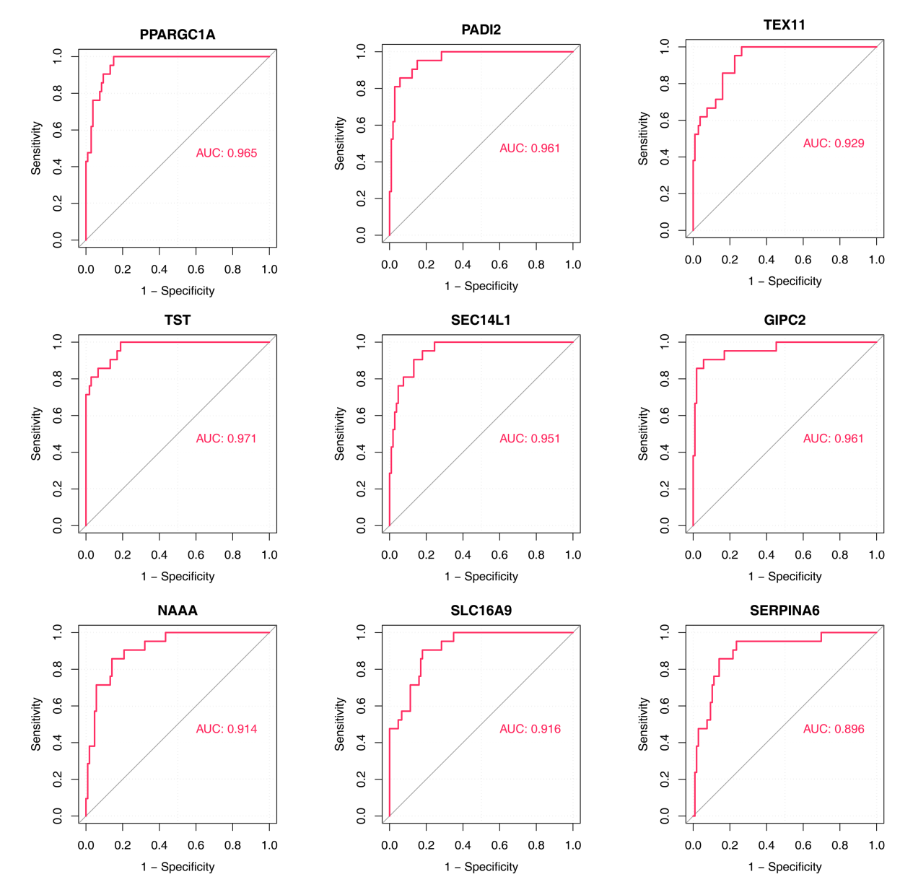
Supplemental Fig. S3 The ROC curve drawn for explore the diagnostic value of the candidate key genes(PPARGC1A, PAD12, TEX11, TST, SEC14L1, GIPC2, NAA, SLC16A9, and SERPINA6). ROC, receiver operating characteristic curve. AUC, area under the receiver operating characteristic curve.

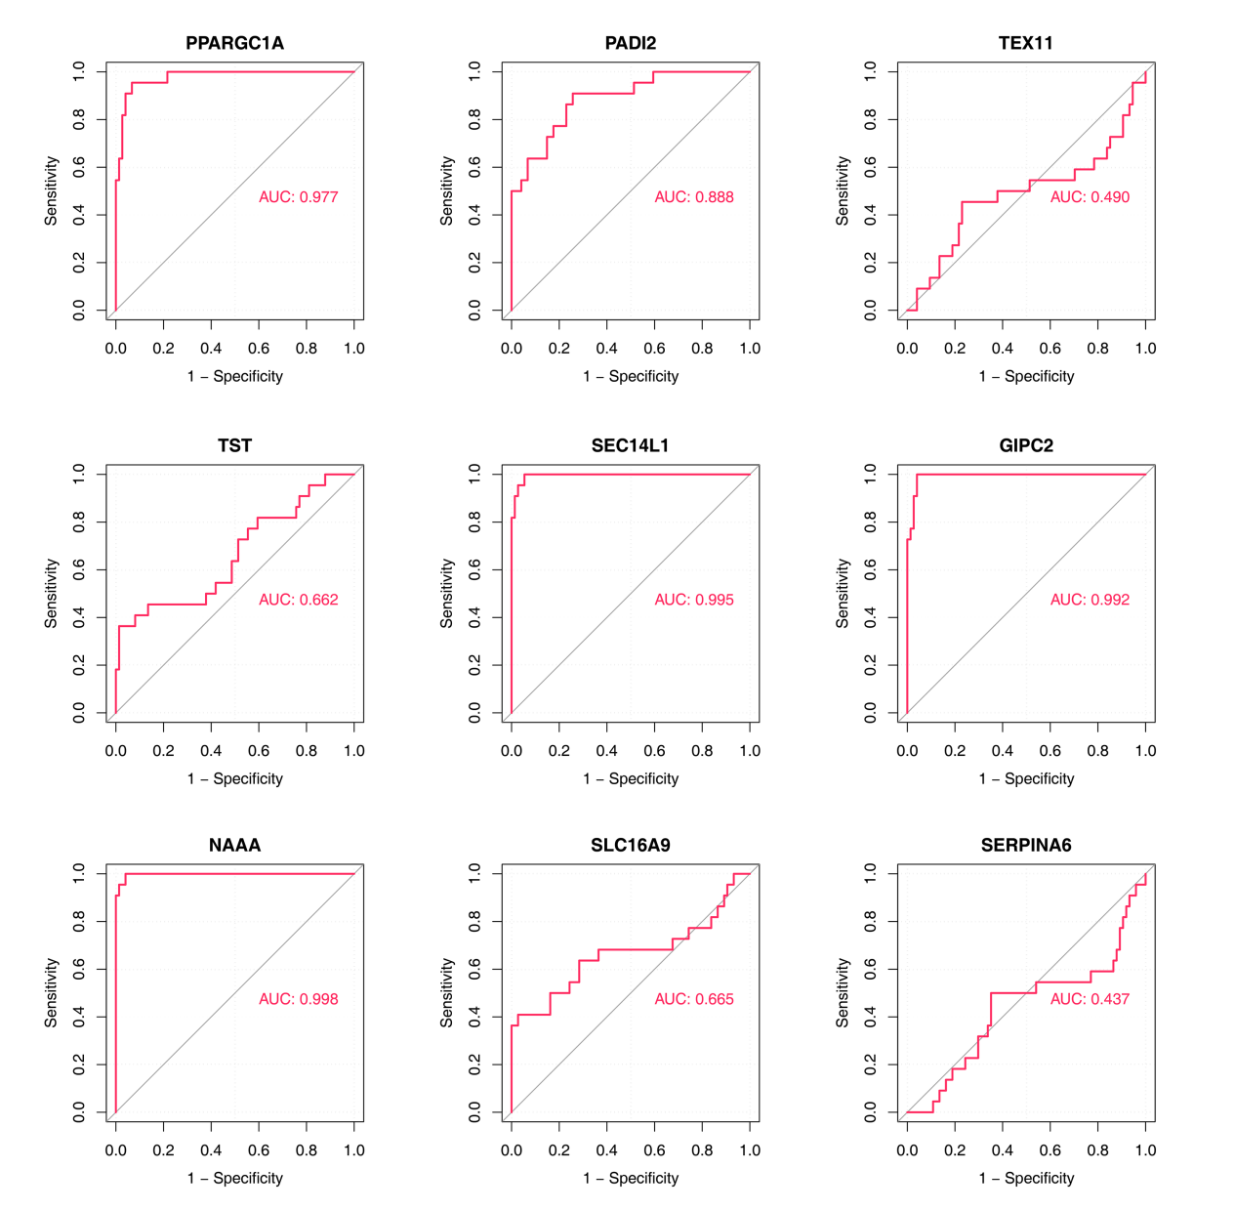
Supplemental Fig. S4 The ROC curve drawn for explore the diagnostic value of the candidate key genes(PPARGC1A, PAD12, TEX11, TST, SEC14L1, GIPC2, NAA, SLC16A9, and SERPINA6). ROC, receiver operating characteristic curve. AUC, area under the receiver operating characteristic curve.

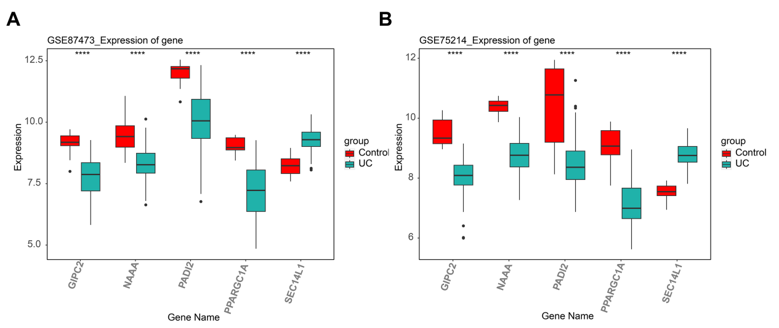
Supplemental Fig. S5 Expression of biomarkers in the validation set shows significant differences gene between the UC group and the control group.

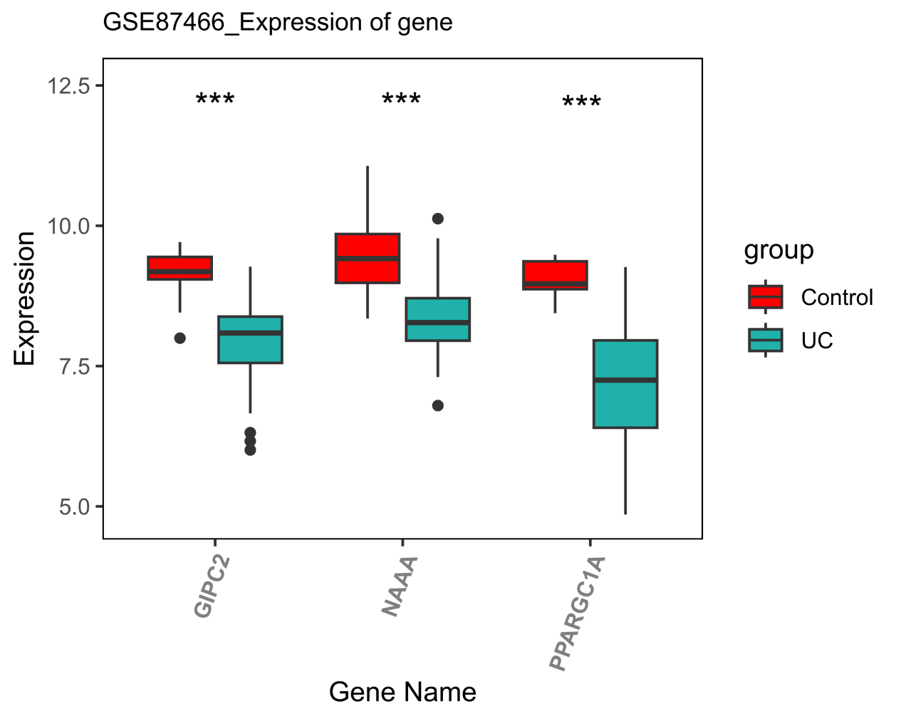
Supplemental Fig. S6 Expression of biomarkers in the GSE87466 set shows significant differences gene between the UC group and the control group.

