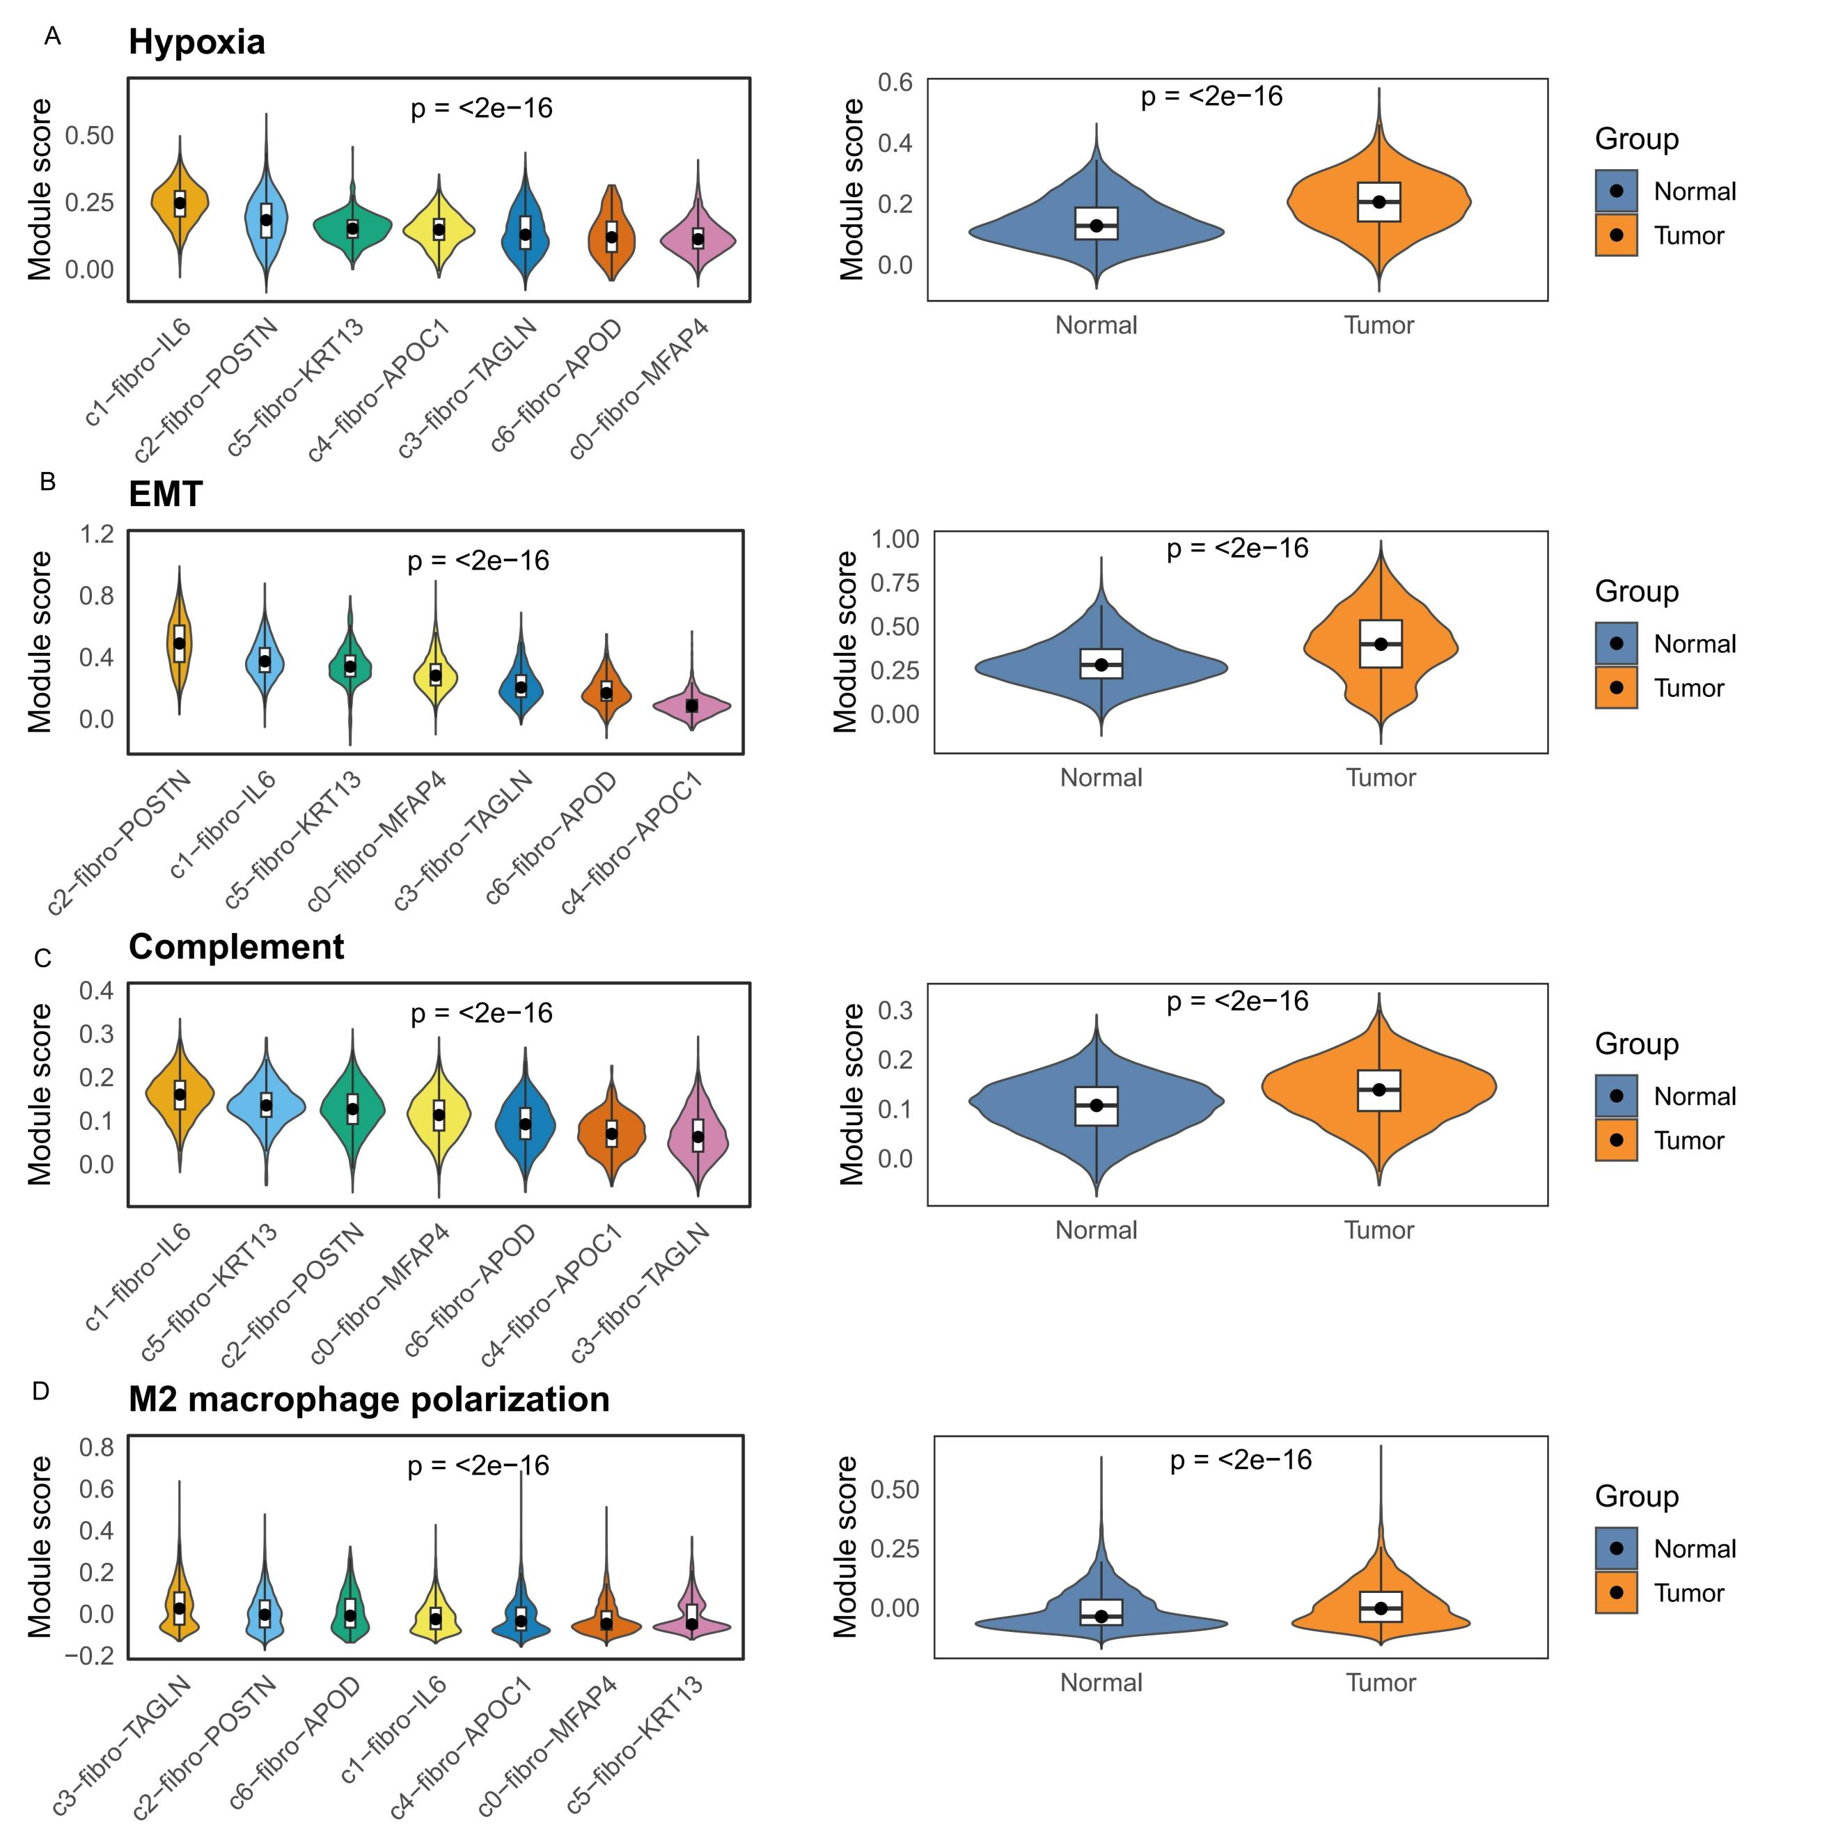
Supplementary Figure 1 Functional module activation of fibroblast subtypes in LSCC.
(A-D) Violin plots showing ssGSEA module scores associated with Hypoxia, EMT, Complement activation, and M2 macrophage polarization across fibroblast subtypes. POSTN⁺ CAFs (c2-fibro-POSTN) exhibit significantly higher activation of EMT.
Abbreviations: LSCC, laryngeal squamous cell carcinoma；CAF, cancer-associated fibroblast; EMT, Epithelial–Mesenchymal Transition.
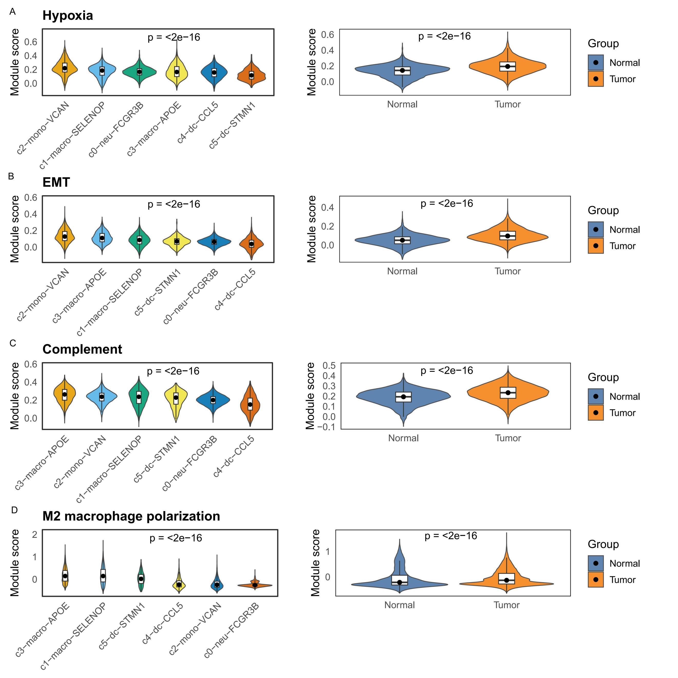
Supplementary Figure 2 Functional module activation of macrophage subclusters in LSCC.
(A-D) Violin plots showing ssGSEA module scores for Hypoxia, EMT, Complement activation, and M2 macrophage polarization across macrophage subclusters. APOE⁺TAMs (c3-macro-APOE) exhibit significantly higher activation of M2 macrophage polarization.
Abbreviations: LSCC, laryngeal squamous cell carcinoma; TAM, tumor associated macrophage; EMT, Epithelial–Mesenchymal Transition.
Supplementary Figure 3 Clinical and functional significance of POSTN⁺ CAFs and APOE⁺ TAMs in the TCGA-HNSC cohort
(A) Quantification of POSTN⁺ CAF abundance in TCGA-HNSC cohort shows significantly higher levels in tumors than normal tissues (Wilcoxon test).
(B) Kaplan–Meier curves reveal poorer overall survival in HNSC patients with high POSTN⁺ CAF infiltration (log-rank test).
(C) TCGA-HNSC cohort confirms higher abundance of APOE⁺TAMs in tumors than normal tissues (Wilcoxon test).
(D) Kaplan–Meier curves show that high APOE⁺TAMs levels are associated with poorer overall survival (log-rank test) in HNSC.
(E) Kaplan-Meier survival analysis shows worst outcomes in POSTN⁺CAFs high/APOE⁺TAMs high group in HNSC.
(F) GO analysis reveals enrichment in extracellular matrix organization and collagen regulation in POSTN⁺CAFs^{high}/APOE⁺TAMs^{high} group.
Supplementary Figure 4 Pathway enrichment and immune microenvironment features of the POSTN⁺CAFs ^{high}/APOE⁺TAMs ^{high} group
- GSEA indicates activation of EMT, antigen presentation, neuroactive ligand–receptor signaling, and TGF-β pathways in the POSTN⁺CAFs^{high}/APOE⁺TAMs^{high} group.
(B) High POSTN⁺CAFs/APOE⁺TAMs enrichment shows increased stromal, immune, ESTEMATE and TIDE scores but reduced tumor purity and IPS z-score.
Supplementary Figure 5 TME immune cell infiltration across LSCC clinical subgroups quantified by five deconvolution algorithms.
Supplementary Table 1 Fibroblast genesets.
gene | cluster
CXCL2 | c1-fibro-IL6
IL6 | c1-fibro-IL6
SOD2 | c1-fibro-IL6
PTGS2 | c1-fibro-IL6
IER3 | c1-fibro-IL6
CXCL1 | c1-fibro-IL6
GPRC5A | c1-fibro-IL6
PTX3 | c1-fibro-IL6
NFKBIA | c1-fibro-IL6
TNFAIP6 | c1-fibro-IL6
SEMA4A | c1-fibro-IL6
DNAJB1 | c1-fibro-IL6
FOSB | c1-fibro-IL6
SERPINE2 | c1-fibro-IL6
IRF1 | c1-fibro-IL6
SPSB1 | c1-fibro-IL6
GFPT2 | c1-fibro-IL6
INTS6 | c1-fibro-IL6
KLF4 | c1-fibro-IL6
UAP1 | c1-fibro-IL6
UGDH | c1-fibro-IL6
RND3 | c1-fibro-IL6
ICAM1 | c1-fibro-IL6
MEDAG | c1-fibro-IL6
NFKB1 | c1-fibro-IL6
NFKBIZ | c1-fibro-IL6
NAMPT | c1-fibro-IL6
HSPH1 | c1-fibro-IL6
PLA2G2A | c1-fibro-IL6
CXCL8 | c1-fibro-IL6
POSTN | c2-fibro-POSTN
MMP1 | c2-fibro-POSTN
COL1A1 | c2-fibro-POSTN
TNC | c2-fibro-POSTN
CTHRC1 | c2-fibro-POSTN
COL3A1 | c2-fibro-POSTN
MMP11 | c2-fibro-POSTN
KIF26B | c2-fibro-POSTN
COL1A2 | c2-fibro-POSTN
IGFBP3 | c2-fibro-POSTN
COL6A3 | c2-fibro-POSTN
LSAMP | c2-fibro-POSTN
COL5A2 | c2-fibro-POSTN
COL8A1 | c2-fibro-POSTN
DELEC1 | c2-fibro-POSTN
HMCN1 | c2-fibro-POSTN
WNT5A | c2-fibro-POSTN
TWIST2 | c2-fibro-POSTN
SERPINE1 | c2-fibro-POSTN
SPARC | c2-fibro-POSTN
CDH11 | c2-fibro-POSTN
COL12A1 | c2-fibro-POSTN
PAPPA | c2-fibro-POSTN
GREM1 | c2-fibro-POSTN
COL5A1 | c2-fibro-POSTN
ASPN | c2-fibro-POSTN
COL11A1 | c2-fibro-POSTN
ADAMTS2 | c2-fibro-POSTN
COL6A1 | c2-fibro-POSTN
PTGDS | c2-fibro-POSTN
RGS5.1 | c3-fibro-TAGLN
TAGLN | c3-fibro-TAGLN
MYH11 | c3-fibro-TAGLN
MYL9 | c3-fibro-TAGLN
INPP4B | c3-fibro-TAGLN
MCAM | c3-fibro-TAGLN
TPM2 | c3-fibro-TAGLN
NDUFA4L2 | c3-fibro-TAGLN
NOTCH3 | c3-fibro-TAGLN
TINAGL1 | c3-fibro-TAGLN
PPP1R14A | c3-fibro-TAGLN
EPS8 | c3-fibro-TAGLN
NCKAP5 | c3-fibro-TAGLN
IGFBP7 | c3-fibro-TAGLN
SORBS2 | c3-fibro-TAGLN
MEF2C | c3-fibro-TAGLN
FABP4 | c3-fibro-TAGLN
RERGL | c3-fibro-TAGLN
STEAP4 | c3-fibro-TAGLN
HTR1F | c3-fibro-TAGLN
A2M | c3-fibro-TAGLN
MYLK | c3-fibro-TAGLN
PDE3A | c3-fibro-TAGLN
RGS6 | c3-fibro-TAGLN
SYNPO2 | c3-fibro-TAGLN
NR2F2 | c3-fibro-TAGLN
RGS16 | c3-fibro-TAGLN
C11orf96 | c3-fibro-TAGLN
COL4A2 | c3-fibro-TAGLN
RCAN2 | c3-fibro-TAGLN
GNB2L1 | c5-fibro-KRT13
KRT13 | c5-fibro-KRT13
H3F3B | c5-fibro-KRT13
H3F3A | c5-fibro-KRT13
ATP5E | c5-fibro-KRT13
SELM | c5-fibro-KRT13
S100A9 | c5-fibro-KRT13
S100A8 | c5-fibro-KRT13
CYR61 | c5-fibro-KRT13
TCEB2 | c5-fibro-KRT13
SEPT7 | c5-fibro-KRT13
ATP5L | c5-fibro-KRT13
SEPW1 | c5-fibro-KRT13
PTRF | c5-fibro-KRT13
NUPR1 | c5-fibro-KRT13
SPRR3 | c5-fibro-KRT13
ATP5I | c5-fibro-KRT13
SEPP1 | c5-fibro-KRT13
PRKCDBP | c5-fibro-KRT13
ATP5J | c5-fibro-KRT13
S100A2 | c5-fibro-KRT13
GLTSCR2 | c5-fibro-KRT13
ATP5G2 | c5-fibro-KRT13
LHFP | c5-fibro-KRT13
ATP5D | c5-fibro-KRT13
CTGF | c5-fibro-KRT13
C14orf2 | c5-fibro-KRT13
SHFM1 | c5-fibro-KRT13
KRT4 | c5-fibro-KRT13
USMG5 | c5-fibro-KRT13
NRXN1 | c6-fibro-APOD
CDH19 | c6-fibro-APOD
SCN7A | c6-fibro-APOD
CLDN1 | c6-fibro-APOD
ITGA6 | c6-fibro-APOD
NGFR | c6-fibro-APOD
MATN2 | c6-fibro-APOD
TENM2 | c6-fibro-APOD
ARHGEF28 | c6-fibro-APOD
MCTP1 | c6-fibro-APOD
ANGPTL7 | c6-fibro-APOD
SLC22A3 | c6-fibro-APOD
NRP2 | c6-fibro-APOD
PTGDS | c6-fibro-APOD
MTSS1 | c6-fibro-APOD
SORBS1 | c6-fibro-APOD
DOCK5 | c6-fibro-APOD
MEOX2 | c6-fibro-APOD
ARHGAP42 | c6-fibro-APOD
STARD13 | c6-fibro-APOD
APOD | c6-fibro-APOD
KIAA1217 | c6-fibro-APOD
EBF2 | c6-fibro-APOD
PLP1 | c6-fibro-APOD
ANK3 | c6-fibro-APOD
NRXN3 | c6-fibro-APOD
BNC2 | c6-fibro-APOD
NCAM2 | c6-fibro-APOD
ITGB8 | c6-fibro-APOD
ADGRB3 | c6-fibro-APOD
PDZRN4 | c0-fibro-MFAP4
CFD | c0-fibro-MFAP4
IGFBP6 | c0-fibro-MFAP4
SLPI | c0-fibro-MFAP4
GSN | c0-fibro-MFAP4
MGST1 | c0-fibro-MFAP4
MFAP5 | c0-fibro-MFAP4
MFAP4 | c0-fibro-MFAP4
SFRP2 | c0-fibro-MFAP4
PCOLCE2 | c0-fibro-MFAP4
S100A10 | c0-fibro-MFAP4
MYOC | c0-fibro-MFAP4
TNXB | c0-fibro-MFAP4
CST3 | c0-fibro-MFAP4
OGN | c0-fibro-MFAP4
DCN | c0-fibro-MFAP4
NOX4 | c0-fibro-MFAP4
LTBP4 | c0-fibro-MFAP4
PLAC9 | c0-fibro-MFAP4
FBLN1 | c0-fibro-MFAP4
OMD | c0-fibro-MFAP4
LEPR | c0-fibro-MFAP4
NOVA1 | c0-fibro-MFAP4
CLU | c0-fibro-MFAP4
PTGIS | c0-fibro-MFAP4
MGP | c0-fibro-MFAP4
RAMP2 | c0-fibro-MFAP4
PDGFRL | c0-fibro-MFAP4
CCDC80 | c0-fibro-MFAP4
S100A6 | c0-fibro-MFAP4
CADM2 | c4-fibro-APOC1
DLK1 | c4-fibro-APOC1
APOC1 | c4-fibro-APOC1
MEG8 | c4-fibro-APOC1
KLHL41 | c4-fibro-APOC1
MEG3 | c4-fibro-APOC1
TUBB2B | c4-fibro-APOC1
RUNX1 | c4-fibro-APOC1
ELL2 | c4-fibro-APOC1
NEB | c4-fibro-APOC1
MAT2A | c4-fibro-APOC1
PCDH7 | c4-fibro-APOC1
EZR | c4-fibro-APOC1
MYF5 | c4-fibro-APOC1
MYO18B | c4-fibro-APOC1
KCNQ5 | c4-fibro-APOC1
APOE | c4-fibro-APOC1
PAX7 | c4-fibro-APOC1
UGCG | c4-fibro-APOC1
TRDN | c4-fibro-APOC1
NPTX2 | c4-fibro-APOC1
YBX3 | c4-fibro-APOC1
NAV2 | c4-fibro-APOC1
PVT1 | c4-fibro-APOC1
NNMT | c4-fibro-APOC1
MT1A | c4-fibro-APOC1
HIVEP3 | c4-fibro-APOC1
SOD2 | c4-fibro-APOC1
MT1X | c4-fibro-APOC1
SAMD4A | c4-fibro-APOC1
Supplementary Table 2 Macrophage genesets.
gene | cluster
APOE | c3-macro-APOE
APOC1 | c3-macro-APOE
CTSD | c3-macro-APOE
IFI27 | c3-macro-APOE
ATP5E | c3-macro-APOE
C1QB | c3-macro-APOE
C1QA | c3-macro-APOE
GNB2L1 | c3-macro-APOE
H3F3A | c3-macro-APOE
CD81 | c3-macro-APOE
CD68 | c3-macro-APOE
GPNMB | c3-macro-APOE
CTSB | c3-macro-APOE
CAPG | c3-macro-APOE
LGALS1 | c3-macro-APOE
PRDX1 | c3-macro-APOE
HLA-DRB1 | c3-macro-APOE
PLD3 | c3-macro-APOE
GRN | c3-macro-APOE
ATP5L | c3-macro-APOE
TMEM176B | c3-macro-APOE
FABP5 | c3-macro-APOE
C1QC | c3-macro-APOE
FTL | c3-macro-APOE
GPX1 | c3-macro-APOE
MT1G | c3-macro-APOE
SPP1 | c3-macro-APOE
MT1X | c3-macro-APOE
MMP12 | c3-macro-APOE
CCL18 | c3-macro-APOE
SELENOP | c1-macro-SELENOP
F13A1 | c1-macro-SELENOP
SLC16A10 | c1-macro-SELENOP
LMNA | c1-macro-SELENOP
FMNL2 | c1-macro-SELENOP
MRC1 | c1-macro-SELENOP
RBPJ | c1-macro-SELENOP
LYVE1 | c1-macro-SELENOP
GPR183 | c1-macro-SELENOP
RNASE1 | c1-macro-SELENOP
FMN1 | c1-macro-SELENOP
FRMD4A | c1-macro-SELENOP
PDE4D | c1-macro-SELENOP
SPRED1 | c1-macro-SELENOP
LRMDA | c1-macro-SELENOP
SEMA4A | c1-macro-SELENOP
HLA-DQB1 | c1-macro-SELENOP
HLA-DPB1 | c1-macro-SELENOP
SLC9A9 | c1-macro-SELENOP
NRP1 | c1-macro-SELENOP
HLA-DQA1 | c1-macro-SELENOP
C1QC | c1-macro-SELENOP
ZNF331 | c1-macro-SELENOP
HLA-DRA | c1-macro-SELENOP
HMOX1 | c1-macro-SELENOP
COLEC12 | c1-macro-SELENOP
PDGFC | c1-macro-SELENOP
ANKH | c1-macro-SELENOP
CST3 | c1-macro-SELENOP
HLA-DPA1 | c1-macro-SELENOP
CXCL5 | c2-mono-VCAN
VCAN | c2-mono-VCAN
CCL20 | c2-mono-VCAN
SERPINB2 | c2-mono-VCAN
EREG | c2-mono-VCAN
TIMP1 | c2-mono-VCAN
INHBA | c2-mono-VCAN
PID1 | c2-mono-VCAN
FLT1 | c2-mono-VCAN
SNX9 | c2-mono-VCAN
ITGB8 | c2-mono-VCAN
CD300E | c2-mono-VCAN
PLCB1 | c2-mono-VCAN
CRADD | c2-mono-VCAN
PALM2AKAP2 | c2-mono-VCAN
KYNU | c2-mono-VCAN
JARID2 | c2-mono-VCAN
WARS1 | c2-mono-VCAN
FCN1 | c2-mono-VCAN
PLIN2 | c2-mono-VCAN
SMAD3 | c2-mono-VCAN
SLC39A8 | c2-mono-VCAN
MAP2K1 | c2-mono-VCAN
TNIP3 | c2-mono-VCAN
CD44 | c2-mono-VCAN
NOCT | c2-mono-VCAN
TCF7L2 | c2-mono-VCAN
NRIP1 | c2-mono-VCAN
THBS1 | c2-mono-VCAN
CXCL3 | c2-mono-VCAN
CCL5 | c4-dc-CCL5
FYN | c4-dc-CCL5
GNLY | c4-dc-CCL5
CNOT6L | c4-dc-CCL5
IL32 | c4-dc-CCL5
SKAP1 | c4-dc-CCL5
GZMB | c4-dc-CCL5
CD3D | c4-dc-CCL5
BICDL1 | c4-dc-CCL5
PPP1R16B | c4-dc-CCL5
RORA | c4-dc-CCL5
NKG7 | c4-dc-CCL5
GZMA | c4-dc-CCL5
CD2 | c4-dc-CCL5
TRBC2 | c4-dc-CCL5
CXCL13 | c4-dc-CCL5
ETS1 | c4-dc-CCL5
TOX | c4-dc-CCL5
CD247 | c4-dc-CCL5
KLF12 | c4-dc-CCL5
TRAC | c4-dc-CCL5
PTPN22 | c4-dc-CCL5
CD3G | c4-dc-CCL5
CAMK4 | c4-dc-CCL5
CD96 | c4-dc-CCL5
BCL11B | c4-dc-CCL5
THEMIS | c4-dc-CCL5
CBLB | c4-dc-CCL5
RNF19A | c4-dc-CCL5
PDE3B | c4-dc-CCL5
IFITM2 | c0-neu-FCGR3B
FCGR3B | c0-neu-FCGR3B
HCAR3 | c0-neu-FCGR3B
AQP9 | c0-neu-FCGR3B
PROK2 | c0-neu-FCGR3B
G0S2 | c0-neu-FCGR3B
LIMK2 | c0-neu-FCGR3B
S100A8 | c0-neu-FCGR3B
CSF3R | c0-neu-FCGR3B
KCNJ15 | c0-neu-FCGR3B
CPD | c0-neu-FCGR3B
HCAR2 | c0-neu-FCGR3B
OSM | c0-neu-FCGR3B
TECPR2 | c0-neu-FCGR3B
NEDD9 | c0-neu-FCGR3B
CMTM2 | c0-neu-FCGR3B
NAMPT | c0-neu-FCGR3B
PLEK | c0-neu-FCGR3B
IVNS1ABP | c0-neu-FCGR3B
PDE4B | c0-neu-FCGR3B
CXCR2 | c0-neu-FCGR3B
LUCAT1 | c0-neu-FCGR3B
CXCL8 | c0-neu-FCGR3B
IL1R2 | c0-neu-FCGR3B
ADGRG3 | c0-neu-FCGR3B
BCL6 | c0-neu-FCGR3B
RUBCNL | c0-neu-FCGR3B
PI3 | c0-neu-FCGR3B
IFIT2 | c0-neu-FCGR3B
KATNBL1 | c0-neu-FCGR3B
STMN1 | c5-dc-STMN1
HIST1H4C | c5-dc-STMN1
TOP2A | c5-dc-STMN1
MKI67 | c5-dc-STMN1
CENPF | c5-dc-STMN1
TYMS | c5-dc-STMN1
PTTG1 | c5-dc-STMN1
CDK1 | c5-dc-STMN1
H2AFZ | c5-dc-STMN1
H2AFV | c5-dc-STMN1
ATP5J2 | c5-dc-STMN1
ATP5G3 | c5-dc-STMN1
TUBA1B | c5-dc-STMN1
TUBB | c5-dc-STMN1
HMGB2 | c5-dc-STMN1
ATP5L | c5-dc-STMN1
HMGN2 | c5-dc-STMN1
GNB2L1 | c5-dc-STMN1
HMGB1 | c5-dc-STMN1
NUCKS1 | c5-dc-STMN1
DUT | c5-dc-STMN1
PTMA | c5-dc-STMN1
ATP5E | c5-dc-STMN1
C1QB | c5-dc-STMN1
IFI27 | c5-dc-STMN1
APOC1 | c5-dc-STMN1
CTSD | c5-dc-STMN1
APOE | c5-dc-STMN1
SPP1 | c5-dc-STMN1
H4C3 | c5-dc-STMN1
Supplementary Table 3 Docking score table showing the top 9 docking poses with docking score, confidence score, and ligand RMSD (Root Mean Square Deviation).
Rank | Docking  Score | Confidence  Score | Ligand  rmsd (Å)
1 | -252.68 | 0.8863 | 83.94
2 | -251.49 | 0.8839 | 71.48
3 | -250.73 | 0.8823 | 70.26
4 | -242.32 | 0.8637 | 65.99
5 | -238.87 | 0.8554 | 80.03
6 | -237.38 | 0.8516 | 61.86
7 | -235.91 | 0.8479 | 88.02
8 | -233.94 | 0.8427 | 73.3
9 | -233.11 | 0.8405 | 65.17

