Supplementary Material

Xiaolong Wang¹ Kexin Yao¹ Yue Niu¹ Zheyi Dong¹ Shuang Liang ¹

¹Department of Nephrology, First Medical Center of Chinese PLA General Hospital, Chinese PLA Institute of Nephrology, State Key Laboratory of Kidney Diseases, National Clinical Research Center for Kidney Diseases, Beijing Key Laboratory of Kidney Diseases, Beijing, China.

Table S1. Characteristics and risk factors for relapse in patients who achieved remission
Variables | Total (N=200) | Relapse (N=94) | Non-relapse (N=106) | P
Demographics
Age (years) | 51.0 (37.0, 60.0) | 52.5 (43.0, 61.0) | 49.5 (37.6, 59.3) | 0.128
Gender (male), n (%) | 127 (63.5%) | 64 (68.1%) | 63 (59.4%) | 0.205
BMI (kg/m²) | 26.4 (24.1, 28.9) | 26.4 (24.2, 29.0) | 26.4 (24.0, 28.7) | 0.926
GRS | 0 (-1.27, 0) | 0 (-0.3, 0) | -0.32 (-2.0, 0) | <0.001
Laboratory Examination
Hemoglobin (g/L) | 132.2±18.1 | 133.0±18.4 | 131.4±17.9 | 0.543
WBC (10⁹/L) | 6.9 (5.5, 8.5) | 7.2 (5.7, 8.7) | 6.7 (5.5, 8.2) | 0.238
Platelet (10⁹/L) | 258.2±66.9 | 254.7±75.0 | 263.1±61.7 | 0.384
Neutrophils (%) | 0.56±0.10 | 0.59±0.11 | 0.56±0.10 | 0.068
Lymphocytes (%) | 0.34±0.10 | 0.31±0.10 | 0.32±0.10 | 0.229
CRP (mg/dL) | 0.1 (0.09, 0.1) | 0.1 (0.06, 0.1) | 0.1 (0.09, 0.10) | 0.681
IL-6 (pg/mL) | 2.0 (2.0, 3.8) | 2.0 (2.0, 3.3) | 2.0 (2.0, 4.4) | 0.412
Total protein (g/L) | 47.2 (42.5, 53.0) | 47.6 (43.0, 53.2) | 47.0 (42.2, 52.3) | 0.413
Serum albumin (g/L) | 24.7 (21.5, 28.4) | 25.5 (22.5, 28.7) | 24.4 (20.8, 28.1) | 0.208
Cholesterol (mmol/L) | 6.6 (5.3, 8.5) | 6.3 (5.0, 8.6) | 6.9 (5.7, 8.1) | 0.273
Triglycerides (mmol/L) | 2.1 (1.5, 3.1) | 2.0 (1.5, 3.4) | 2.1 (1.6, 3.0) | 0.819
HDL cholesterol (mmol/L) | 1.2 (1.0, 1.5) | 1.2 (0.9, 1.6) | 1.1 (1.0, 1.5) | 0.515
LDL cholesterol (mmol/L) | 4.4 (3.3, 5.9) | 3.8 (3.1, 5.6) | 4.7 (3.5, 6.2) | 0.039
Glucose (mmol/L) | 4.8 (4.4, 5.4) | 5.0 (4.5, 5.6) | 4.7 (4.4, 5.2) | 0.051
Urea nitrogen (mmol/L) | 5.0 (3.9, 6.4) | 5.2 (3.8, 6.5) | 4.9 (4.0, 6.3) | 0.853
Uric acid (μmol/L) | 360.1±99.2 | 370.4±104.0 | 352.0±94.3 | 0.294
Serum creatinine (μmol/L) | 75.2 (62.9, 90.1) | 75.1 (62.6, 87.1) | 75.4 (63.0, 90.3) | 0.688
eGFR (mL/min/1.73m²) | 96.6 (76.0, 108.1) | 94.5 (75.8, 107.0) | 98.3 (70.6, 110.3) | 0.384
Complement C3 (mg/dL) | 115.0 (101.0, 131.0) | 114.0 (94.5, 124.8) | 116.0 (102.0, 133.0) | 0.275
Complement C4 (mg/dL) | 29.7 (24.5, 36.9) | 28.1 (22.8, 37.9) | 31.0 (25.1, 36.9) | 0.153
Anti-PLA2R antibody (RU/mL) | 38.2 (8.1, 110.0) | 38.2 (13.7, 93.5) | 38.0 (6.2, 133.0) | 0.884
24h proteinuria (g/24h) | 5.6 (4.0, 7.5) | 5.6 (4.0, 7.6) | 5.3 (4.1, 7.6) | 0.814
Urinary potassium (mmol/24h) | 40.7±18.9 | 42.7±24.8 | 39.0±12.0 | 0.499
Urinary calcium (mmol/24h) | 1.6 (0.7, 2.8) | 1.3 (0.7, 2.7) | 1.7 (0.7, 2.8) | 0.842
Urinary sodium (mmol/24h) | 170.3±90.0 | 160.2±82.9 | 178.4±95.3 | 0.327
TyG index | 9.0 (8.7, 9.5) | 9.1 (8.7, 9.5) | 9.0 (8.7, 9.4) | 0.282
TyG-BMI | 236.4 (212.7, 267.9) | 236.7 (212.9, 269.9) | 236.1 (212.5, 263.2) | 0.937
SII | 457.4 (335.9, 649.2) | 455.4 (340.1, 662.3) | 460.3 (322.0, 611.4) | 0.746
Comorbidities
Hypertension, n (%) | 95 (47.5%) | 49 (52.1%) | 43 (43.4%) | 0.217
Diabetes, n (%) | 25 (12.5%) | 15 (16.0%) | 10 (9.4%) | 0.164
Hyperlipidemia, n (%) | 36 (18.0%) | 13 (13.8%) | 23 (21.7%) | 0.148
Coronary heart disease, n (%) | 9 (4.5%) | 5 (5.3%) | 4 (4.8%) | 0.599
Renal Pathology
Pathological stage, n (%) |  |  |  | 0.393
Stage I | 65 (32.5%) | 34 (36.2%) | 31 (29.2%)
Stage II | 105 (52.5%) | 46 (48.9%) | 59 (55.7%)
Stage III | 9 (3.8%) | 3 (3.2%) | 6 (5.7%)
Stage IV | 2 (1.0%) | 2 (2.1%) | 0 (0.0%)
Glomerulosclerosis (%) | 0 (0, 7) | 0 (0, 9.5) | 3 (0, 5.8) | 0.193
Renal arteriosclerosis, n (%) | 68 (34.0%) | 30 (31.9%) | 38 (35.8%) | 0.873
Tubulointerstitial injury, n (%) | 10 (5.5%) | 6 (3.8%) | 4 (6.4%) | 0.696
IgG1 deposition, n (%) |  |  |  | 0.680
+ | 161 (80.5%) | 77 (79.2%) | 84 (81.9%)
++ | 15 (7.5%) | 5 (5.3%) | 10 (9.4%)
IgG4 deposition, n (%) |  |  |  | 0.148
+ | 119 (59.5%) | 63 (67.0%) | 56 (52.8%)
++ | 58 (29.0%) | 20 (21.3%) | 38 (25.8%)
Treatment
ARB/ACEI, n (%) | 154 (77.0%) | 75 (79.8%) | 79 (74.5%) | 0.378
Tacrolimus, n (%) | 150 (75.0%) | 71 (75.5%) | 79 (74.5%) | 0.870
Glucocorticoids, n (%) | 60 (30.0%) | 28 (29.8%) | 32 (30.2%) | 0.951
Cyclosporine A, n (%) | 17 (8.5%) | 11 (11.7%) | 6 (5.7%) | 0.126
Cyclophosphamide, n (%) | 9 (4.5%) | 6 (6.4%) | 3 (2.8%) | 0.226
Rituximab, n (%) | 20 (10.0%) | 5 (5.3%) | 15 (14.2%) | 0.038
Clinical Risks Stratification |  |  |  | 0.536
Moderate risk | 89 (44.5%) | 44 (46.8%) | 45 (42.5%)
High risk | 111 (55.5%) | 50 (53.2%) | 61 (57.5%)
Clinical Outcomes
Remission status |  |  |  | 0.025
Partial remission, n (%) | 96 (48.0%) | 53 (56.4%) | 43 (40.6%)
Complete remission, n (%) | 104 (52.0%) | 41 (43.6%) | 63 (59.4%)
Immunological remission, n (%) | 150 (75.0%) | 61 (64.9%) | 89 (84.0%) | 0.002
Time to remission (months) | 4.3 (2.0, 8.8) | 4.0 (2.0, 8.0) | 5.0 (3.0, 9.3) | 0.296
Follow-up time (months) | 30.0 (22.3, 39.8) | 36.0 (24.8, 64.3) | 24.0 (17.8, 31.3) | <0.001
Kidney progression, n (%) | 16 (8.0%) | 14 (14.9%) | 2 (1.9%) | <0.001
Notes: TyG=Ln [TG ( mg/dL)× FBG ( mg/dL) / 2], TyG-BMI=TyG × BMI (kg/m²), SII=PLT (109/L)× NEU (109/L)/ LYM (109/L);
Abbreviations: ACEI, angiotensin-converting enzyme inhibitor; ARB, angiotensin II receptor blocker; BMI, body mass index; CRP, C-reactive protein; eGFR, estimated glomerular filtration rate; GRS, genetic risk score; HDL, high-density lipoprotein; IgG, immunoglobulin G; IL-6, interleukin-6; IQR, interquartile range; LDL, low-density lipoprotein; PLA2R, phospholipase A2 receptor; SII, systemic immune-inflammation index; TyG, triglyceride-glucose; WBC, white blood cell.

Table S2. Treatment-related adverse events during follow-up
Adverse Events | Total (N=234) | Remission (N=200) | Non-remission (N=34) | P
Any adverse event, n (%) | 45 (19.2%) | 35 (17.5%) | 10 (29.4%) | 0.567
Upper respiratory tract infection, n (%) | 9 (3.8%) | 7 (3.5%) | 2 (5.9%)
Pulmonary infection, n (%) | 31 (13.2%) | 24 (12.0%) | 7 (20.6%)
Urinary tract infection, n (%) | 0 (0.0%) | 0 (0.0%) | 0 (0.0%)
Hyperglycemia, n (%) | 3 (1.3%) | 2 (1.0%) | 1 (2.9%)
Others, n (%) | 2 (0.9%) | 2 (1.0%) | 0 (0.0%)

Table S3. Cox Regression Analysis of Risk Factors for Remission
Variable | Univariable Analysis |  |  | Multivariable Analysis
Variable | HR | 95% CI | P value | HR | 95% CI | P value
Age (years) | 0.989 | 0.979–0.999 | 0.036 | 0.984 | 0.971–0.998 | 0.027
GRS | 0.973 | 0.831–1.139 | 0.732 | – | – | –
Total protein (g/L) | 1.027 | 1.009–1.046 | 0.004 | – | – | –
Albumin (g/L) | 1.053 | 1.022–1.086 | <0.001 | – | – | –
Cholesterol (mmol/L) | 0.933 | 0.871–1.000 | 0.049 | – | – | –
Triglyceridesl (mmol/L) | 0.899 | 0.828–0.977 | 0.012 | – | – | –
HDL cholesterol (mmol/L) | 1.298 | 1.020–1.653 | 0.034 | – | – | –
eGFR (ml/min/1.73m²) | 1.006 | 1.000–1.012 | 0.049 | – | – | –
24-hour proteinuria (g/24h) | 0.938 | 0.887–0.991 | 0.023 | 0.908 | 0.843–0.978 | 0.011
Urinary sodium (mmol/24h) | 0.998 | 0.996–1.000 | 0.046 | – | – | –
Anti-PLA2R antibody (RU/ml) | 0.998 | 0.997–0.999 | <0.001 | 0.998 | 0.997–1.000 | 0.010
TyG index | 0.639 | 0.504–0.811 | <0.001 | – | – | –
TyG-BMI index | 0.997 | 0.995–1.000 | 0.041 | – | – | –
Diabetes | 0.481 | 0.315–0.733 | <0.001 | – | – | –
Abbreviations: GRS, genetic risk score; HR, hazard ratio; CI, confidence interval; HDL, high-density lipoprotein; eGFR, estimated glomerular filtration rate; TyG, triglyceride-glucose index; TyG-BMI, triglyceride-glucose-body mass index.

Table S4. Cox regression analysis of risk factors for relapse
Variable | Univariable analysis |  |  | Multivariable analysis
Variable | HR | 95% CI | P value | HR | 95% CI | P value
GRS | 1.800 | 1.277–2.535 | <0.001 | 1.639 | 1.173–2.291 | 0.004
Albumin (g/L) | 1.042 | 0.996–1.090 | 0.074 | – | – | –
Uric acid (μmol/L) | 1.002 | 1.000–1.004 | 0.039 | 1.002 | 1.000–1.005 | 0.030
Glomerulosclerosis (%) | 1.016 | 0.999–1.033 | 0.060 | – | – | –
Cyclosporine A | 2.126 | 1.116–4.051 | 0.022 | 2.408 | 1.228–4.728 | 0.011
Time to remission (months) | 0.971 | 0.942–1.000 | 0.049 | 0.940 | 0.909–0.972 | <0.001
Immunological remission | 0.665 | 0.431–1.027 | 0.066 | – | – | –
Remission status (PR vs CR ) | 2.005 | 1.327–3.029 | <0.001 | 3.322 | 3.014–5.161 | <0.001
Abbreviations: GRS, genetic risk score; HR, hazard ratio; CI, confidence interval; CR, complete remission; PR, partial remission.

Table S5. Improvement in relapse risk prediction by adding GRS to the base model
Items | AUC (95%CI) | P for AUC | NRI (95% CI) | P for NRI | IDI (95% CI) | P for IDI | AIC | BIC | LRT
1 year |  | <0.001 |  | 0.003 |  | 0.004 |  |  | 0.077
Base model | 0.811 (0.719-0.902) |  | reference |  | reference |  | 226.59 | 234.53
Base model + GRS | 0.825 (0.726-0.924) |  | 0.398 (0.131-0.664) |  | 0.033 (0.005-0.135) |  | 225.45 | 234.54
2 year |  | <0.001 |  | <0.001 |  | 0.002 |  |  | <0.001
Base model | 0.741 (0.653-0.830) |  | reference |  | reference |  | 577.84 | 592.50
Base model + GRS | 0.778 (0.698-0.859) |  | 0.467 (0.248-0.685) |  | 0.076 (0.017-0.161) |  | 563.51 | 580.27
4 year |  | <0.001 |  | <0.001 |  | <0.001 |  |  | <0.001
Base model | 0.842 (0.724-0.961) |  | reference |  | reference |  | 789.46 | 806.96
Base model + GRS | 0.869 (0.759-0.979) |  | 0.422 (0.199-0.646) |  | 0.066 (-0.005-0.141) |  | 776.60 | 796.60
5 year |  | <0.001 |  | <0.001 |  | <0.001 |  |  | <0.001
Base model | 0.755 (0.591-0.919) |  | reference |  | reference |  | 793.82 | 811.40
Base model + GRS | 0.850 (0.691-0.999) |  | 0.412 (0.190-0.635) |  | 0.063 (-0.012-0.136) |  | 780.21 | 800.30
Notes: Base model: time-dependent ROC model based on a multivariable Cox regression analysis including the variables: Remission status, Immunological remission, Glomerulosclerosis, UA, CsA use, ALB, and time to remission. P for AUC: Time-dependent AUC bootstrap test for difference between models.
Abbreviations: AUC, area under the curve; CI, confidence interval; NRI, net reclassification improvement; IDI, integrated discrimination improvement; AIC, Akaike information criterion; BIC, Bayesian information criterion; LRT, likelihood ratio test; GRS, genetic risk score; UA, uric acid; CsA, cyclosporine A; ALB, albumin.

Figure S1.Comparison of maintenance therapy duration between patients with and without adverse reactions.
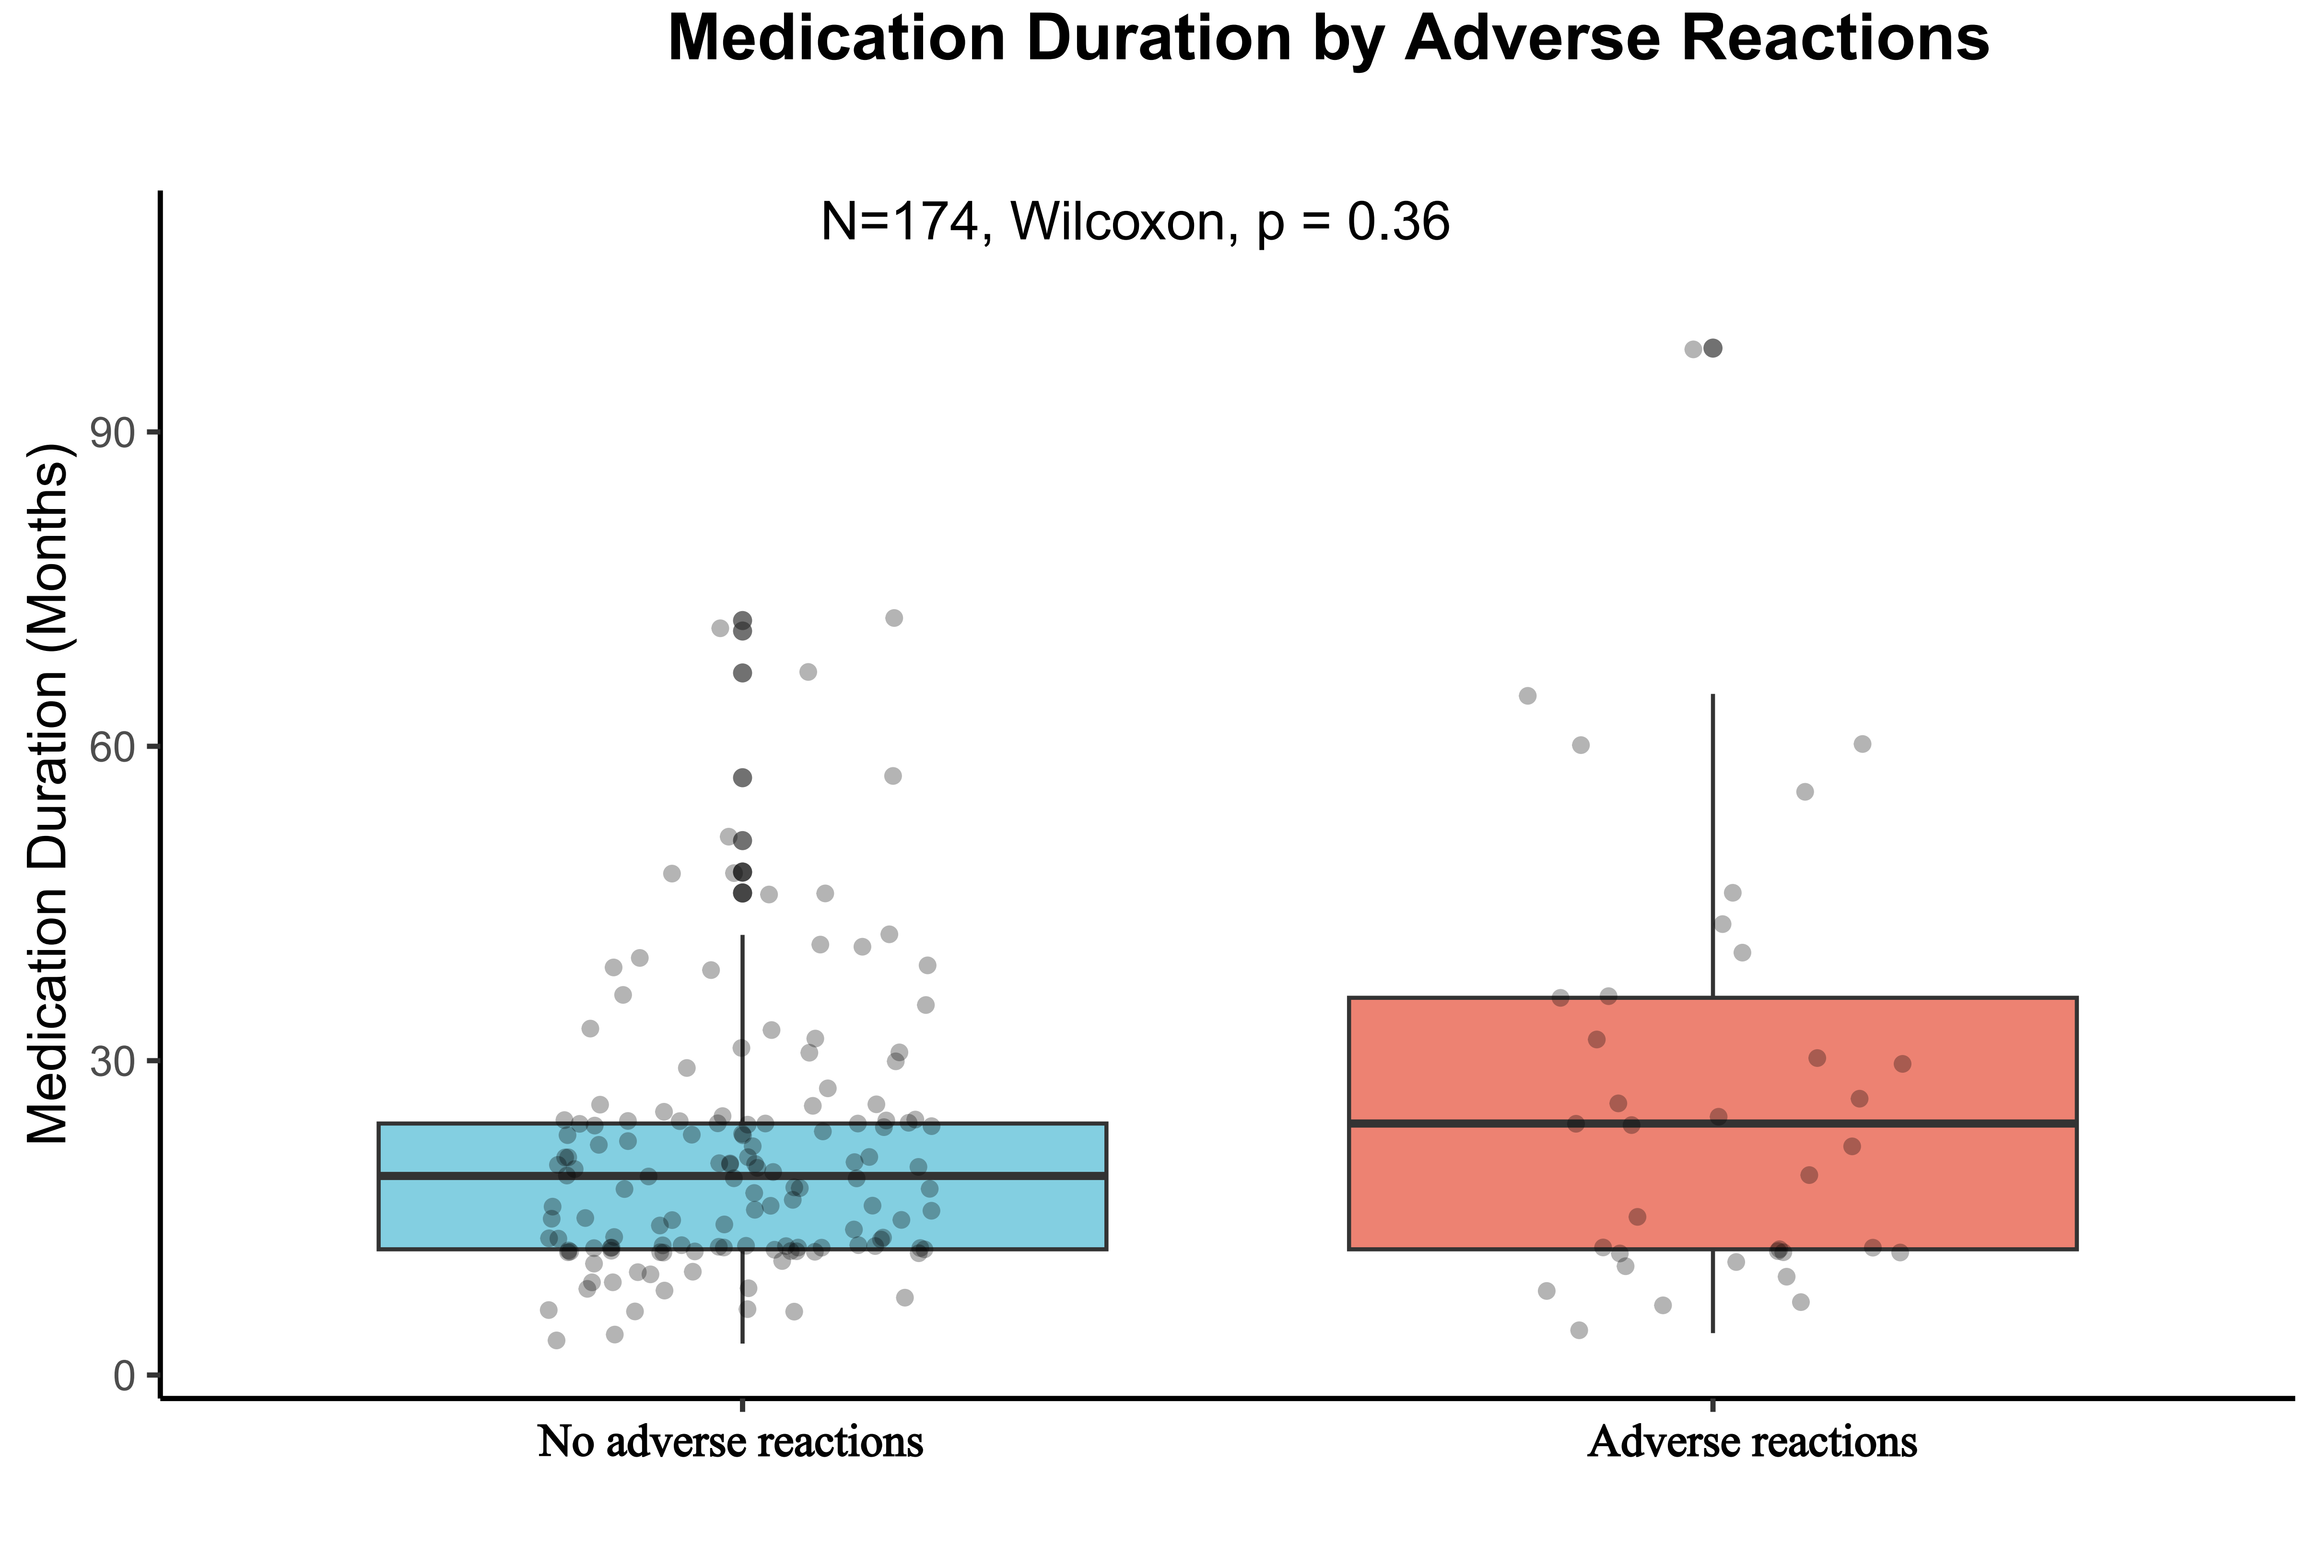

Figure S2. Impact of high-risk vs. low-risk GRS groups on renal outcomes
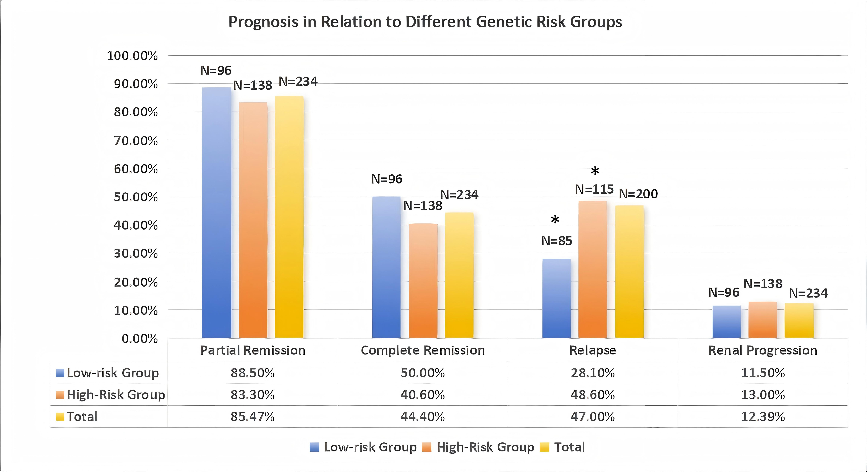
Abbreviations: GRS: genetic risk score

Figure S3. Box plots of C-index distributions from 10-fold cross-validation comparing the base model (left, red) versus the combined model (base model + GRS; right, blue)
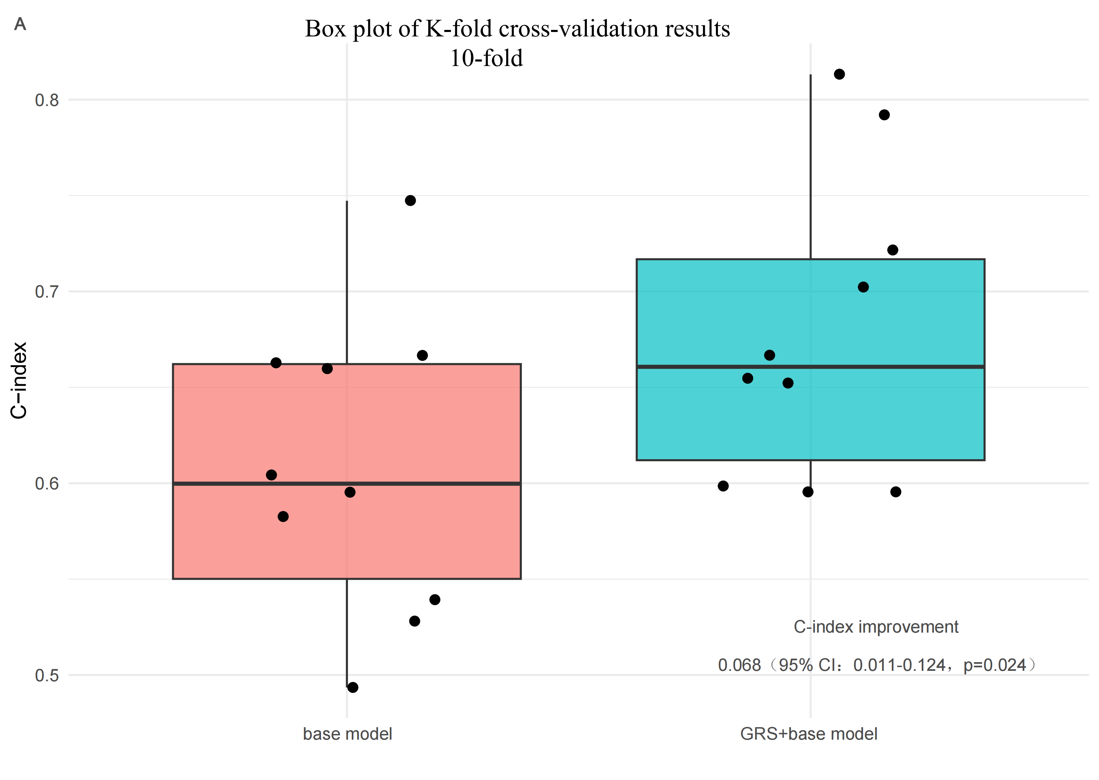

Figure S4. Scatter plot demonstrating consistent performance improvement of the combined model (integrating GRS) over the base model

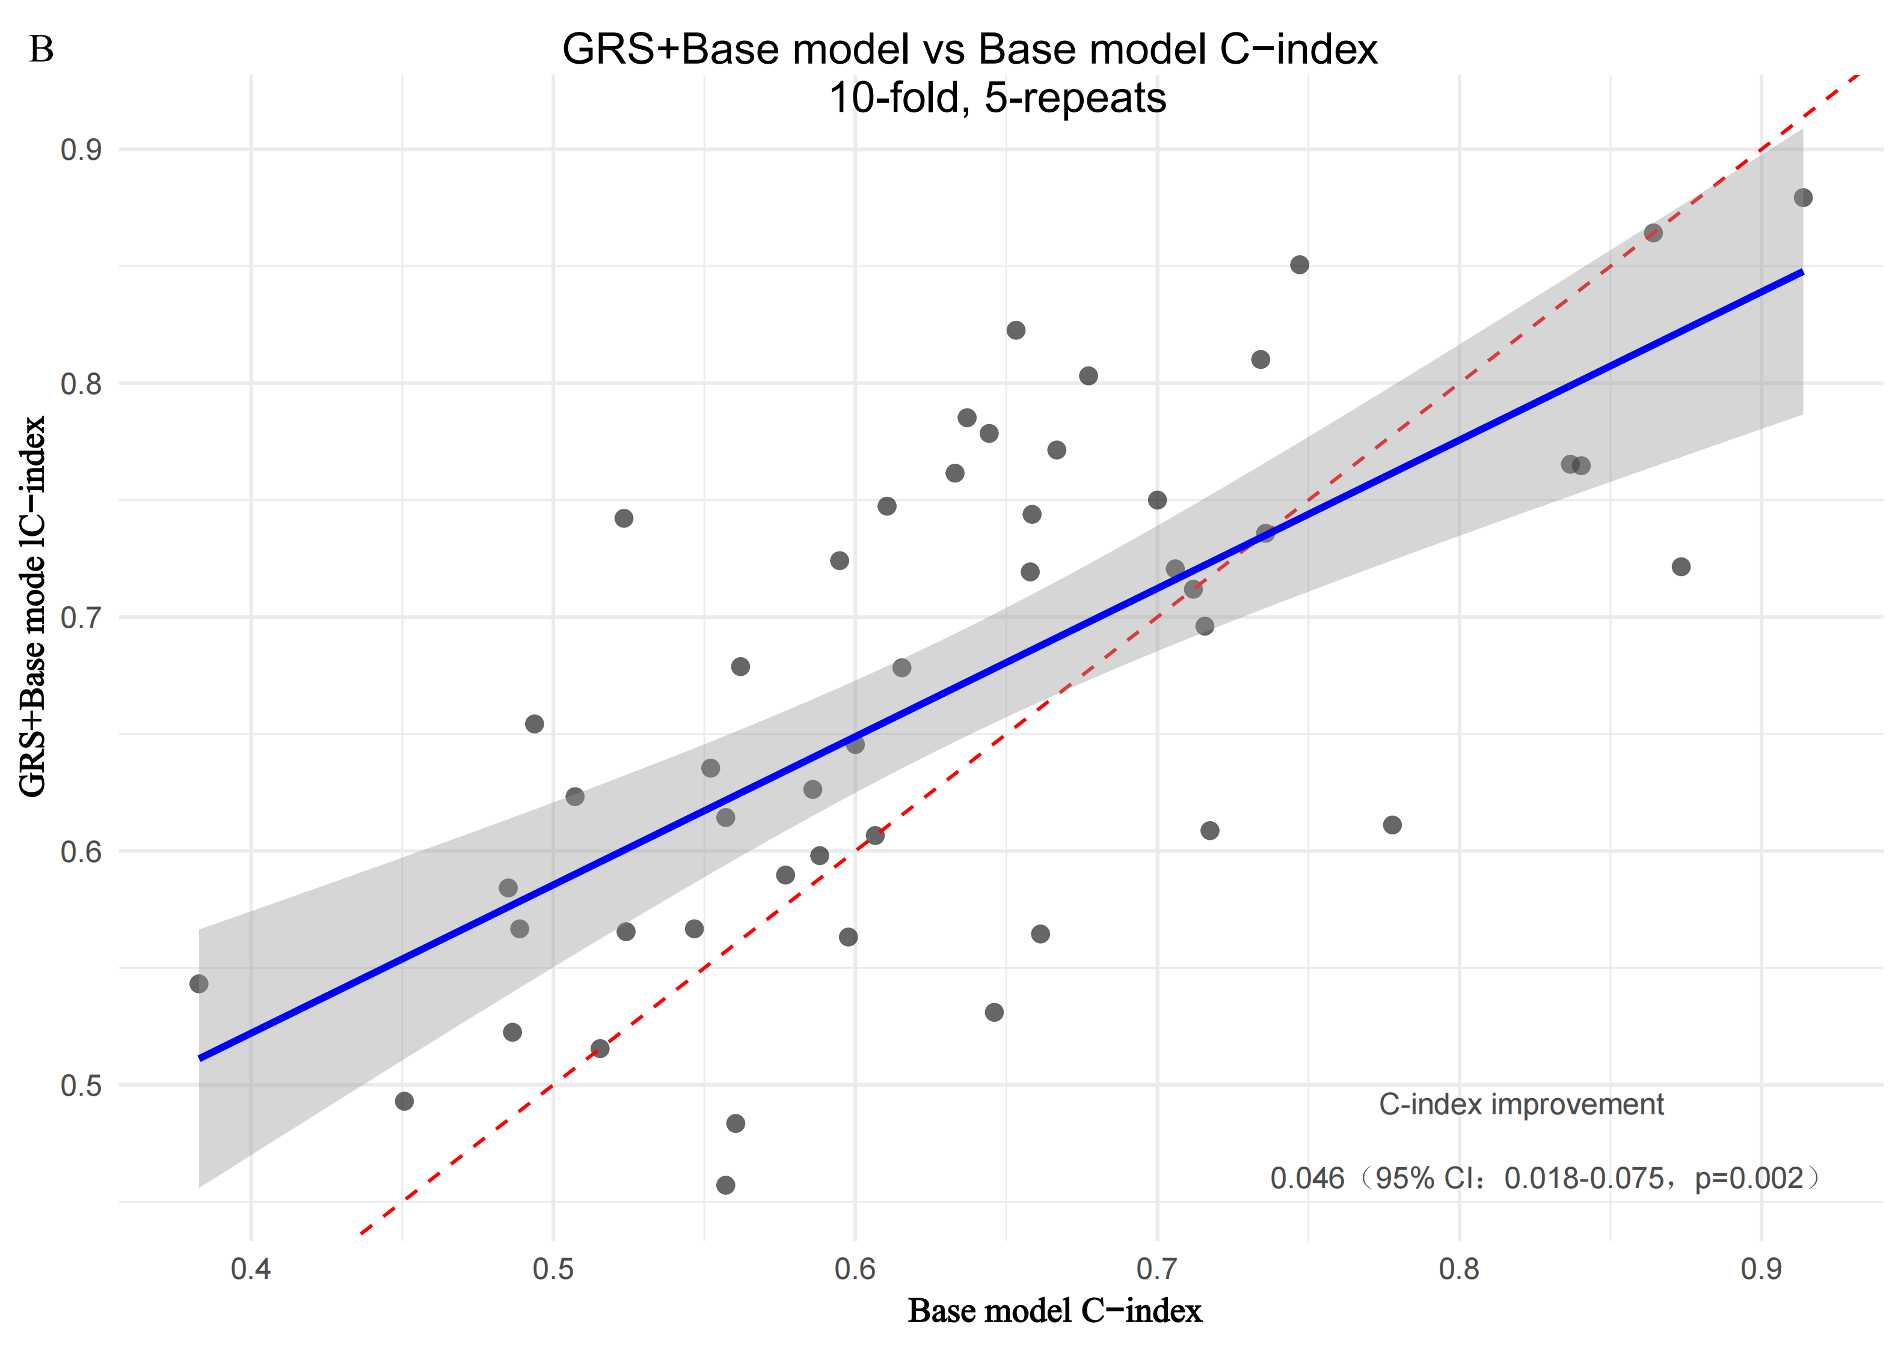
Each black dot represents an independent cross-validation run (n=50 from 5×10-fold CV). The red line is the reference line (y=x), and the blue solid line is the linear regression trend line for all data points, representing the average overall trend of the performance relationship between the two models.

Figure S5. Distribution of C-index improvement values across different follow-up time points (1, 2, 3, and 5 years) based on 10-repeated 10-fold cross-validation.

The Y-axis represents the difference in C-index between the joint model (incorporating GRS) and the base model, serving as the key metric for evaluating the contribution of GRS to predictive performance enhancement. The red horizontal dashed line (y=0) indicates the "no improvement" reference line, representing identical performance between the two models. Each colored dot in the plot represents an independent validation result. The black diamond markers denote the mean C-index improvement values across all validation results for each year, with the upper and lower black error bars indicating the standard error (SE), reflecting the precision of the mean estimate.

Figure S6. Time-dependent ROC curve based on the Cox proportional hazards regression model at (A) the first year; (B) the second year; (C) the fourth year; (D) the fifth year
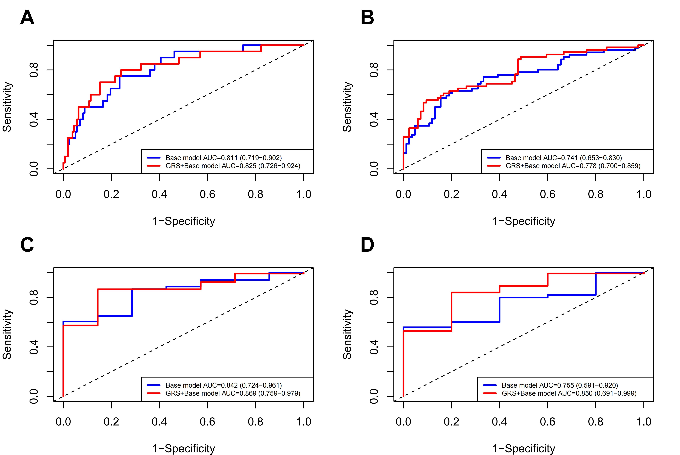
Notes: Base model: time-dependent ROC model based on a multivariable Cox regression analysis including the variables: Remission status, Immunological remission, Glomerulosclerosis, UA, CsA use, ALB, and time to remission. P for AUC: Time-dependent AUC bootstrap test for difference between models.
Abbreviations: AUC, area under the curve; GRS, genetic risk score; UA, uric acid; CsA, cyclosporine A; ALB, albumin.

