Supplementary Figure 1
Schematic illustration of morphometric similarity network (MSN) construction.
(A) Structural MRI data were processed with CAT12 to reconstruct cortical surfaces. Four morphometric features were extracted for each subject: cortical thickness (CT), fractal dimension (FD), gyrification index (GI), and sulcal depth (SD).
(B) All features were mapped to the Desikan–Killiany atlas (68 cortical regions), resulting in a subject-specific feature matrix of 68 × 4.
(C) For each subject, features were normalized within-subject (z-scored across regions) to reduce inter-feature scaling differences.
(D) Morphometric similarity between each pair of cortical regions was computed as the Pearson correlation between their four-dimensional feature vectors, yielding a 68 × 68 subject-level MSN adjacency matrix.

Supplementary Table 1
Cluster-wise report of gray-matter differences (with peak MNI and dominant
Label | Cluster Size | T | Coordinates
Label | Cluster Size | T | x | y | z
Left Fusiform | 9359 | 6.11 | -6 | -4.5 | -9
Right Fusiform | 1185 | 4.74 | 42 | -69 | -19.5
Right Rectus | 881 | 4.32 | 10.5 | 28.5 | -19.5
Left Calcarine | 4641 | 5.09 | 0 | -78 | -6
Left Angular | 898 | 5.19 | -40.5 | -69 | 52.5
anatomical labels)
Reported are cluster size (voxels), peak t statistic, and peak MNI coordinates (mm), with representative anatomical labels (AAL), from the discovery-cohort analysis. Group comparisons were performed with age, sex and TIV included as covariates. All clusters survived cluster-level FWE correction at p < 0.05 (voxel-wise threshold p < 0.001, minimum extent ≥ 50 voxels).

Supplementary Figure 2
Voxel-based morphometry results in the discovery cohort (stratified VBM analyses)
Axial slice overlays of brain regions showing significant gray matter (GM) volume differences in the discovery cohort, based on voxel-wise two-sample t-tests in SPM12. All models included age, sex, and TIV as covariates. Statistical maps were thresholded at p < 0.05, cluster-level family-wise error (FWE) correction (whole-brain). Panels show subtype-stratified contrasts: (A) TLE vs HC, (B) non-TLE vs HC, (C) left TLE vs HC, and (D) right TLE vs HC. Significant clusters were predominantly observed in temporo-limbic/ventral temporal territories, with additional subgroup-specific involvement in extra-temporal regions. The color bar represents T values (higher values indicate stronger between-group effects).

Supplementary Table 2
Significant clusters of gray matter volume reduction in the discovery cohort (stratified VBM analyses)
Contrast | Cluster ID | Cluster size | Peak T | Coordinates |  |  | Label
 |  |  |  | x | y | z | Label
non-TLE vs HC | 1 | 20010 | 5.53 | -37.5 | -61.5 | -48 | Left Cerebelum lobule VIIb
TLE vs HC | 1 | 2435 | 4.22 | -37.5 | -60 | -51 | Left Cerebelum lobule VIII
 | 2 | 1597 | 4.28 | -9 | -52.5 | -45 | Left Cerebelum lobule IX
 | 3 | 1994 | 4.83 | 19.5 | 10.5 | -33 | Right Fusiform
 | 4 | 13034 | 6.27 | -9 | -4.5 | -7.5 | Left Thalamus
 | 5 | 1749 | 4.36 | 3 | 45 | -27 | Left Rectus
 | 6 | 4216 | 4.88 | 1.5 | -87 | -16.5 | Righ Cerebelum lobule VIII
 | 7 | 2648 | 4.20 | -1.5 | -34.5 | 45 | Left mid cingulate gyrus
Left TLE vs HC | 1 | 14562 | 7.44 | -24 | -31.5 | -1.5 | Left Thalamus
 | 2 | 1497 | 4.10 | -58.5 | -15 | -27 | Left inferior temporal gyrus
 | 3 | 1560 | 5.13 | -40.5 | -67.5 | 54 | Left inferior parietal lobule
Right TLE vs HC | 1 | 1610 | 4.17 | -33 | -69 | -48 | Left Cerebelum lobule VIII
 | 2 | 2484 | 4.92 | 21 | 10.5 | -33 | Right Fusiform
 | 3 | 7661 | 6.69 | 25.5 | -28.5 | -4.5 | Left Thalamus
Reported are cluster size (voxels), peak t statistic, and peak MNI coordinates, with representative anatomical labels (AAL). Results are from voxel-wise two-sample t-tests in the discovery cohort, with age, sex, and TIV included as covariates in all models. All clusters survive cluster-level FWE correction at p < 0.05 (voxel-wise threshold p < 0.001, minimum extent ≥ 50 voxels).

Supplementary Figure 3
Voxel-based morphometry results in the validation cohort.
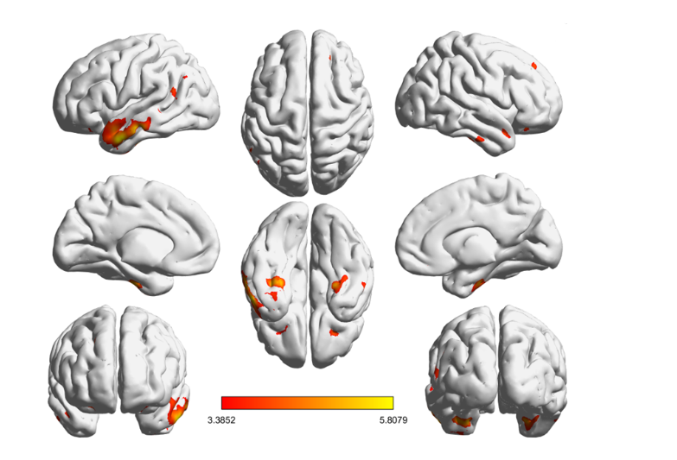
Surface rendering of brain regions showing significant gray matter volume differences in the validation dataset, thresholded at p < 0.05, cluster-level family-wise error (FWE) correction. All models included age, sex, and TIV as covariates. Significant clusters were mainly located in the bilateral temporal lobes (including middle/inferior temporal gyri, fusiform gyrus, parahippocampal gyrus, and temporal poles), as well as the left angular gyrus and right frontal regions. The color bar represents T values (range: 3.39–5.81).

Supplementary Table 3
Significant clusters of gray matter volume reduction in the validation cohort
Label | Cluster Size | T | Coordinates |  |  | Overlap Exploration
Label | Cluster Size | T | x | y | z | Overlap Exploration
Left Middle Temporal Gyrus | 5953 | 5.81 | -55.5 | 1.5 | -30 | Y
Right Parahippocampal | 715 | 5.71 | 27 | -18 | -36 | Y
Right Inferior Temporal Gyrus | 208 | 4.26 | 55.5 | -13.5 | -31.5 | Y
Right Temporal Pole | 449 | 4.68 | 46.5 | 10.5 | -24 | Y
Left Inferior Frontal Gyrus, orbital part | 328 | 3.99 | -21 | 24 | -21 | N
Right Superior Frontal Gyrus, orbital part | 423 | 4.71 | 21 | 31.5 | -16.5 | N
The table lists significant clusters identified in the validation dataset using voxel-based morphometry, thresholded at p < 0.05 with cluster-level family-wise error (FWE) correction. Group comparisons were performed with age, sex, and TIV included as covariates. For each cluster, the peak MNI coordinates (x, y, z), cluster size, maximum T value, and principal anatomical label are reported. The final column indicates whether the identified region overlaps with significant findings from the discovery cohort (“Y” = overlap; “N” = no overlap).

Supplementary Figure 4
Voxel-based morphometry results in the validation cohort (stratified VBM analyses)
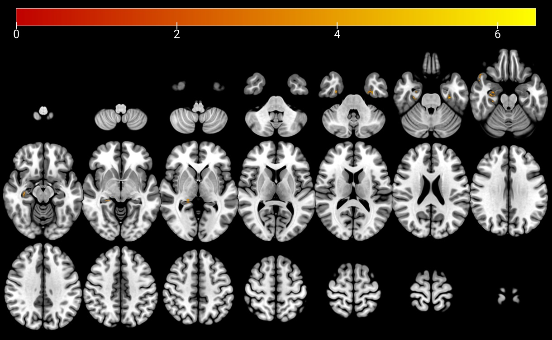
Axial slice overlays of brain regions showing significant GM volume differences in the validation cohort for the TLE vs HC comparison, based on voxel-wise two-sample t-tests in SPM12. All models included age, sex, and TIV as covariates. Statistical maps were thresholded at p < 0.05, cluster-level family-wise error (FWE) correction (whole-brain). The color bar represents T values (higher values indicate stronger between-group effects).

Supplementary Table 4
Significant clusters of gray matter volume reduction in the validation cohort (stratified VBM analyses)
Contrast | Cluster ID | Cluster size | Peak T | Coordinates |  |  | Label
 |  |  |  | x | y | z | Label
TLE vs HC | 1 | 146 | 6.90 | -31.5 | -10.5 | -31.5 | Left Fusiform
 | 2 | 91 | 5.05 | 31.5 | -7.5 | -37.5 | Right ParaHippocampal
 | 3 | 152 | 4.94 | 27 | -15 | -25.5 | Right Hippocampus
 | 4 | 52 | 6.00 | 49.5 | 18 | -25.5 | Right Superior Temporal Pole
 | 5 | 72 | 4.71 | 18 | -33 | -1.5 | Right Hippocampus
Reported are cluster size (voxels), peak t statistic, and peak MNI coordinates, with representative anatomical labels (AAL). Results are from voxel-wise two-sample t-tests in the validation cohort. Age, sex and TIV included as covariates in all models. All clusters survive cluster-level FWE correction at p < 0.05 (voxel-wise threshold p < 0.001, minimum extent ≥ 50 voxels).

Supplementary Figure 5
Group comparison of regional MSN metrics in the validation cohort.
(A–C) Distributions for the left isthmus cingulate, right medial orbitofrontal, and right pars triangularis in the validation cohort. Group comparisons were conducted using HC3-robust linear models with age and sex included as covariates, with two-sided testing and FDR correction (two-sided). The effect directions were consistent with the exploration cohort, showing lower regional meanMS in DRE relative to HC; however, none of the three parcels reached statistical significance (q > 0.05). These findings highlight directional concordance across datasets, albeit without statistical replication in independent cohort.

Supplementary Figure 6
TLE vs HC comparison of regional MSN metrics in the discovery cohort
Notes: Distributions for the left isthmus cingulate, right medial orbitofrontal, and right pars triangularis in the discovery cohort. Group differences were tested using HC3-robust linear models with age and sex included as covariates, with two-sided inference and FDR correction across regions. All three parcels showed lower regional meanMS in DRE than in HC (q < 0.05), consistent with focal MSN weakening in limbic/orbitofrontal and frontal territories. Significance symbols: * q < 0.05, ** q < 0.01, *** q < 0.001; ns, not significant.

Supplementary Figure 7A
Spatial correlations between gray-matter atrophy and neurotransmitter maps in the validation cohort.
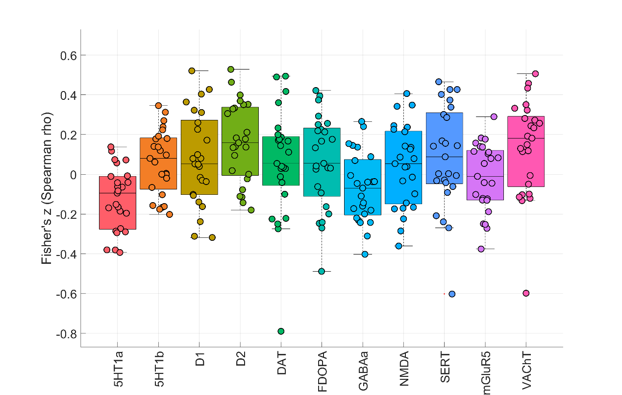
Boxplots depict Fisher’s z-transformed Spearman correlation coefficients between the DRE vs HC regional gray-matter atrophy pattern and reference PET/SPECT neurotransmitter maps in the validation dataset. Asterisks (*) denote associations surviving BH–FDR correction (q < 0.05). No neurotransmitter association survived BH–FDR correction in the validation dataset.
Supplementary Figure 7B
Spatial correlations between gray-matter atrophy and cell-type/mitochondrial maps in the validation cohort.
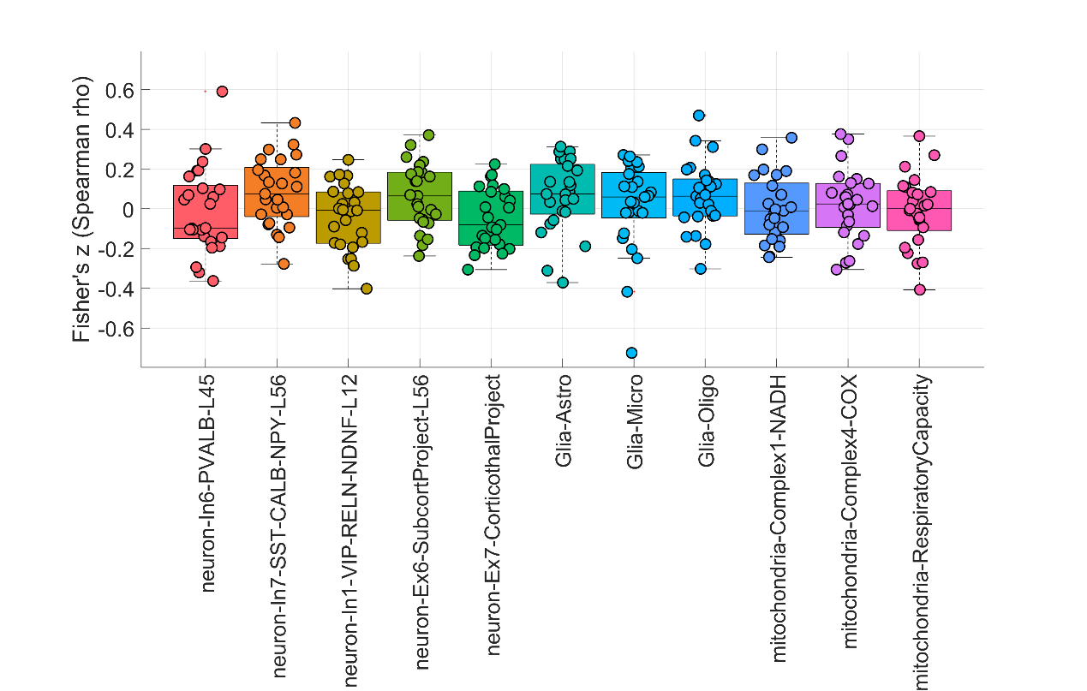

Boxplots depict Fisher’s z-transformed Spearman correlation coefficients between the DRE vs HC regional gray-matter atrophy pattern and reference cell-type transcriptional and mitochondrial maps in the validation dataset. Asterisks (*) denote associations surviving BH–FDR correction (q < 0.05). No cell-type or mitochondrial association survived BH–FDR correction in the validation dataset.

Supplementary Figure 8
Spatial correlations between gray-matter atrophy and neurotransmitter maps in the discovery cohort (TLE vs HC)

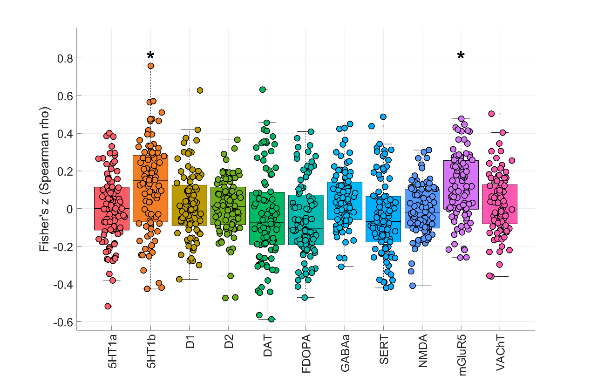
Boxplots depict Fisher’s z-transformed Spearman correlation coefficients between the TLE vs HC regional gray-matter atrophy pattern and reference PET/SPECT neurotransmitter maps in the discovery dataset. Asterisks denote associations surviving BH–FDR correction (q < 0.05). The atrophy pattern showed FDR-significant positive correlations with 5-HT1b and mGluR5, whereas correlations with the remaining neurotransmitter systems did not survive FDR correction.

Supplementary Figure 9
Spatial correlations between gray-matter atrophy and neurotransmitter maps in the discovery cohort (left TLE vs HC)
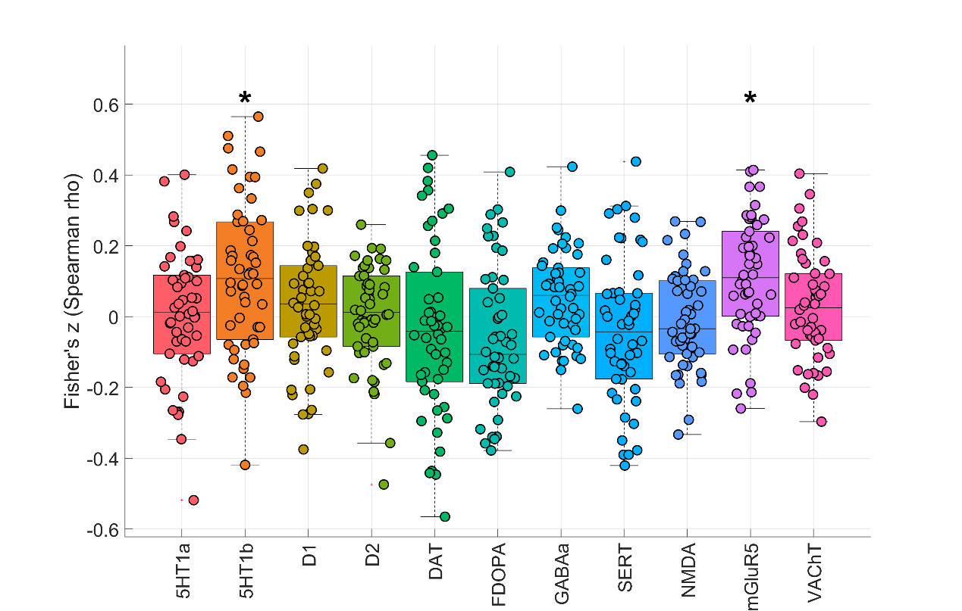
Boxplots depict Fisher’s z-transformed Spearman correlation coefficients between the left TLE vs HC regional gray-matter atrophy pattern and reference PET/SPECT neurotransmitter maps in the discovery dataset. Asterisks denote associations surviving BH–FDR correction (q < 0.05). The atrophy pattern showed FDR-significant positive correlations with 5-HT1b and mGluR5, whereas correlations with the remaining neurotransmitter systems did not survive FDR correction.

Supplementary Figure 10
Spatial correlations between gray-matter atrophy and neurotransmitter maps in the discovery cohort (right TLE vs HC)
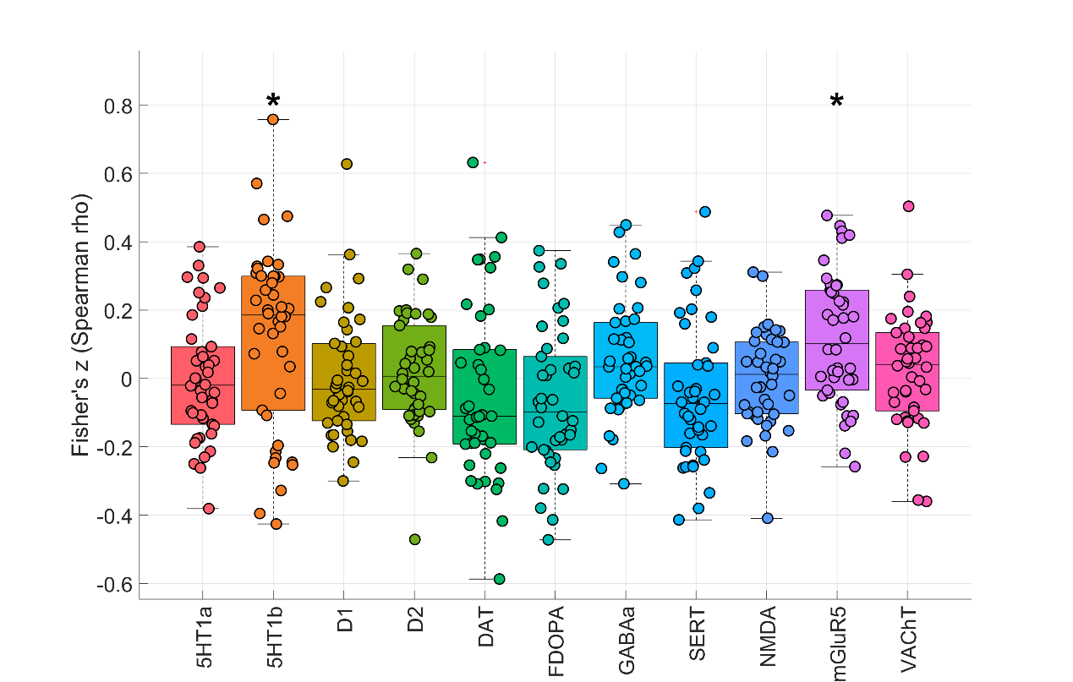
Boxplots depict Fisher’s z-transformed Spearman correlation coefficients between the left TLE vs HC regional gray-matter atrophy pattern and reference PET/SPECT neurotransmitter maps in the discovery dataset. Asterisks denote associations surviving BH–FDR correction (q < 0.05). The atrophy pattern showed FDR-significant positive correlations with 5-HT1b and mGluR5, whereas correlations with the remaining neurotransmitter systems did not survive FDR correction.

Supplementary Figure 11
Spatial correlations between gray-matter atrophy and neurotransmitter maps in the discovery cohort (non TLE vs HC)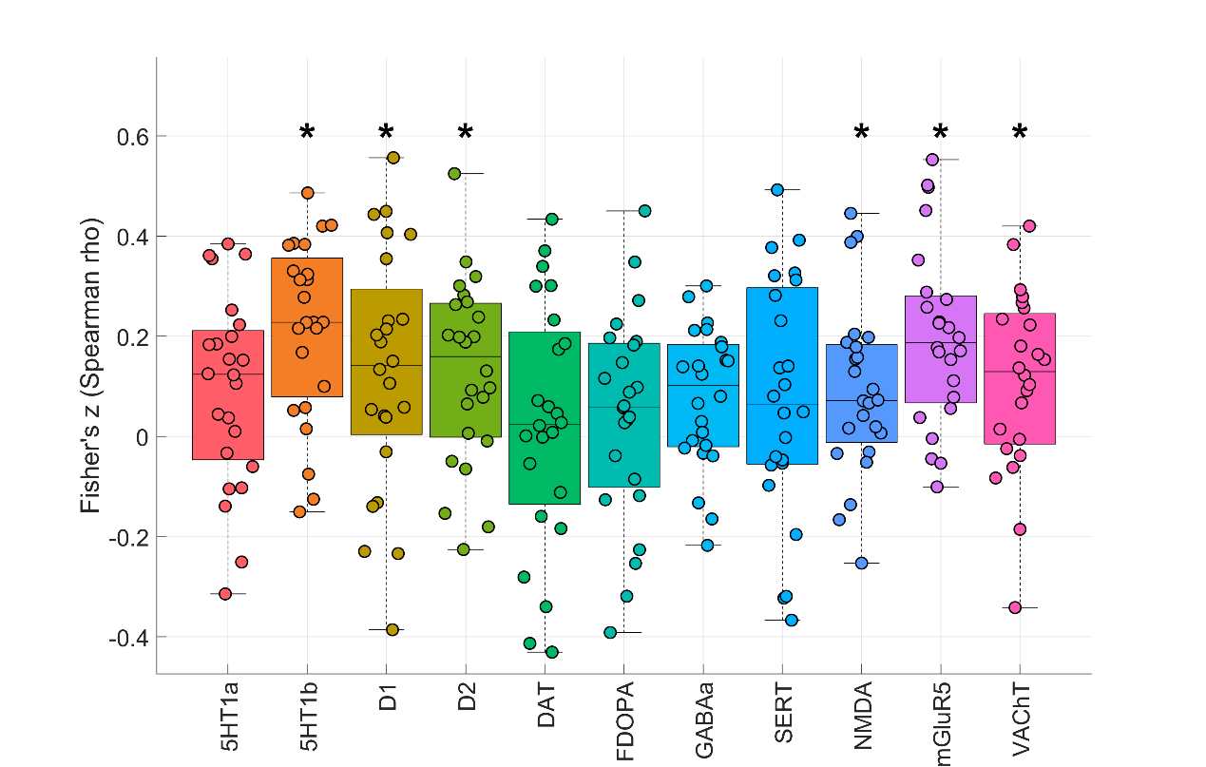
Boxplots depict Fisher’s z-transformed Spearman correlation coefficients between the non-TLE vs HC regional gray-matter atrophy pattern and reference PET/SPECT neurotransmitter maps in the discovery dataset. Asterisks denote associations surviving BH–FDR correction (q < 0.05). The atrophy pattern showed FDR-significant positive correlations with 5-HT1b, D1, D2, NMDA, mGluR5, and VAChT, whereas correlations with the remaining neurotransmitter systems did not survive FDR correction.

Supplementary Figure 12
Spatial correlations between gray-matter atrophy and cell-type/mitochondrial maps in the discovery cohort (non TLE vs HC)
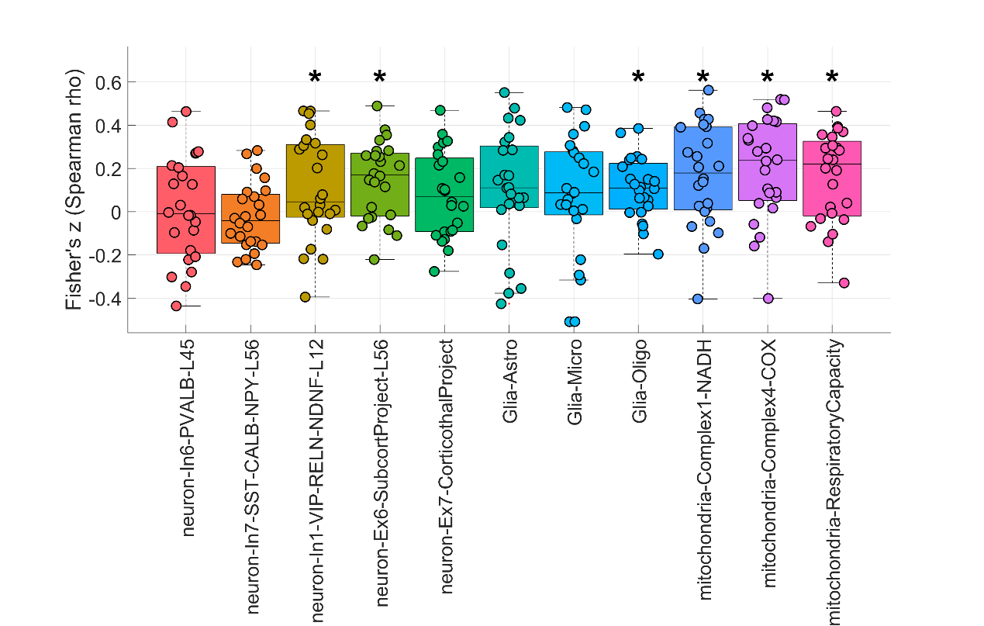
Boxplots depict Fisher’s z-transformed Spearman correlation coefficients between the non-TLE vs HC regional gray-matter atrophy pattern and reference maps of neuronal subtypes, glial classes, and mitochondrial systems in the discovery dataset. Asterisks denote associations surviving BH–FDR correction (q < 0.05). The atrophy pattern showed FDR-significant positive correlations with neuron-In1-VIP-RELN-NDNF-L12, neuron-Ex6-SubcortProject-L56, and Glia-Oligo, as well as with mitochondrial Complex I (NADH dehydrogenase), Complex IV (cytochrome c oxidase), and respiratory capacity, whereas correlations with the remaining neuronal and glial-class maps did not survive FDR correction.

Supplementary Table 5
Neurotransmitter receptor/transporter distribution map
 |  | 5HT1a | 5HT1b | D1 | D2 | DAT | FDOPA | GABAα | SERT | NMDA | mGluR5 | VAChT
DRE vs HC | Fisher z | 0.104 | 0.510 | 0.179 | 0.177 | -0.070 | -0.159 | 0.211 | -0.034 | 0.079 | 0.506 | 0.199
 | FDR-p | 0.82 | 0.03 | 0.82 | 0.82 | 0.82 | 0.82 | 0.82 | 0.89 | 0.82 | 0.04 | 0.82
Spatial correspondence between group-wise GM atrophy and neurotransmitter in the discovery cohort (DRE vs HC) using Moran spectral randomization (BrainSpace)
Entries show the Fisher z-transformed Spearman correlations between the group-wise GM atrophy map (DRE vs HC) and each reference template (neurotransmitter receptor/transporter). P-values are FDR-adjusted.

