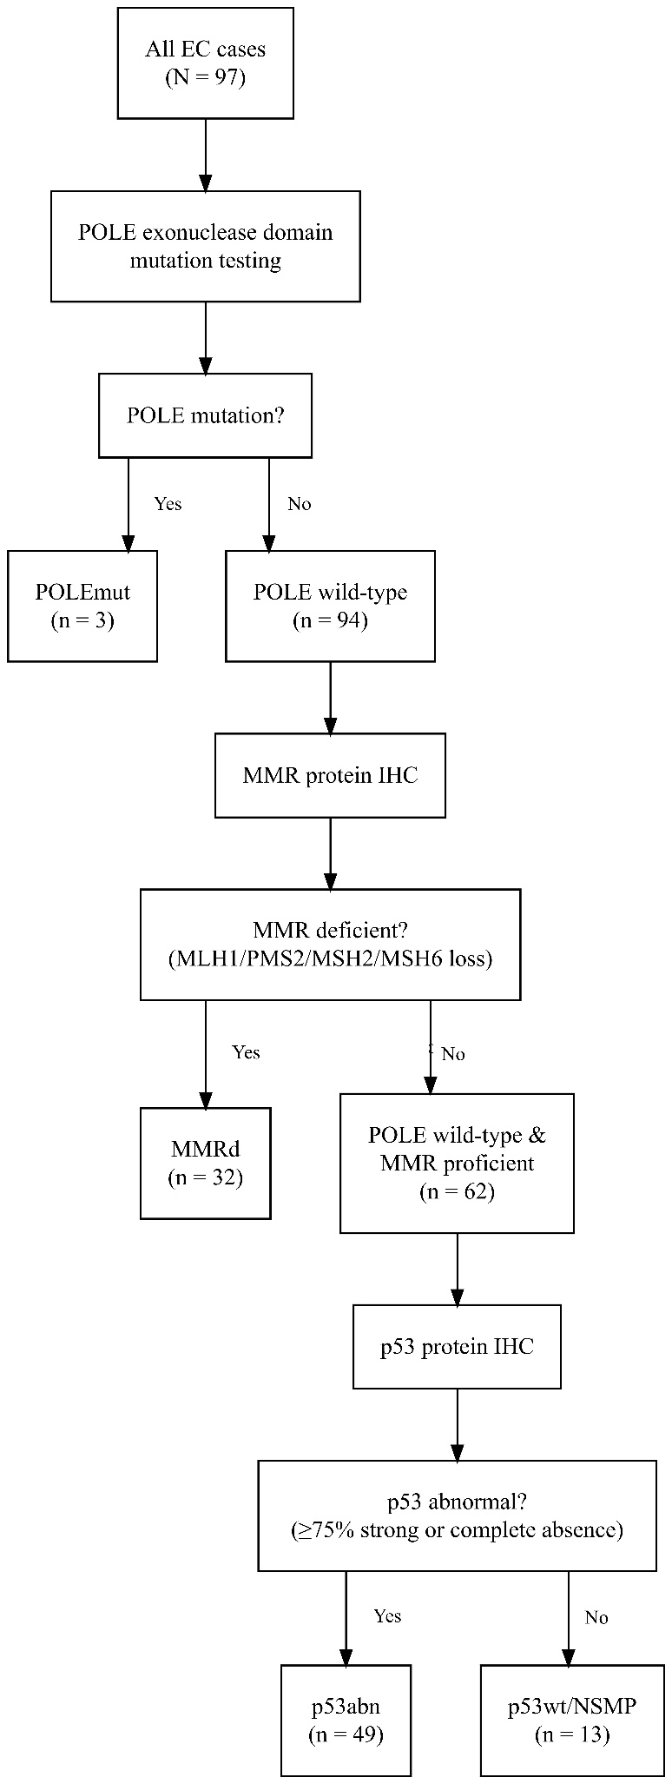
Figure S1. ProMisE molecular classification algorithm.
Table S1. Summary of POLE exonuclease domain mutations identified in the study cohort
Case No. | Exon | Nucleotide Change | Amino Acid Change | Pathogenicity Prediction | Method of Verification
1 | Exon 9 | c.857C>T | p.P286R | Pathogenic (ClinVar) | Sanger sequencing
2 | Exon 13 | c.1376G>A | p.V456M | Likely pathogenic (in-silico analysis) | Sanger sequencing
3 | Exon 14 | c.1592A>G | p.D530G | Pathogenic (ClinVar) | Sanger sequencing
Note: Detailed information of POLE mutations detected in three patients with endometrial carcinoma. The table lists the exon location, nucleotide and amino acid changes, predicted pathogenicity, and verification method for each variant. Pathogenicity was determined based on the ClinVar database or in-silico prediction, and all mutations were confirmed by Sanger sequencing.

