Supplementary Figure 1

Dry powder inhaler

Supplementary Figure 2
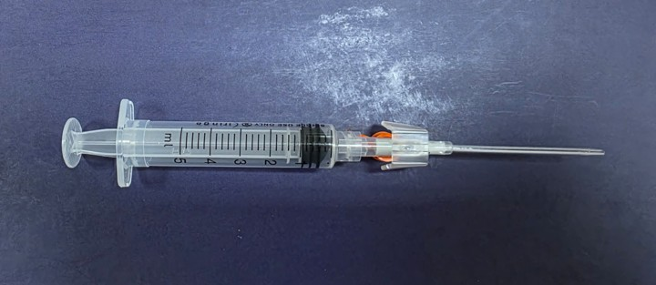
Inhalation device
Adapted from Ito T, Okuda T, Takashima Y, Okamoto H. Naked pDNA inhalation powder composed of hyaluronic acid exhibits high gene expression in the lungs. Mol Pharm 2018;16:489-497. https://doi.org/10.1021/acs.molpharmaceut.8b00502.

Supplementary Figure 3
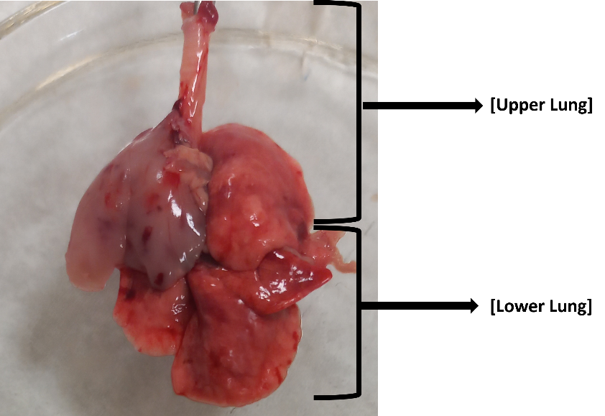
Rat lung tissue

Supplementary Equation 1
Polynomial correlation of SX: powder mass vs FPF_{<4.5µm,} y = 0.0047x² - 0.4761x + 36.75, R² = 0.6686; powder mass vs RF_{<4.5µm}, y = 0.005x² - 0.566x + 71.718, R² = 0.9812; powder mass vs FPF_{<3.6µm}, y = 0.0019x² - 0.2234x + 28.518, R² = 0.9002; powder mass vs RF_{<3.6µm}, y = 0.0067x² - 0.7538x + 62.762, R² = 0.9997; powder mass vs 0.5 µm < FPF ˂ 3.6 µm, y = 0.002x² - 0.213x + 24.603, R² = 0.8205; powder mass vs 0.5 µm < RF ˂ 3.6 µm, y = 0.0065x² - 0.6867x + 54.078, R² = 0.991; polynomial correlation of FP: powder mass vs FPF_{<4.5µm,} y = 0.0018x² - 0.1331x + 27.74, R² = 0.2867; powder mass vs RF_{<4.5µm}, y = 0.0066x² - 0.605x + 67.23, R² = 0.9526; powder mass vs FPF_{<3.6µm}, y = 0.0022x² - 0.1577x + 18.222, R² = 0.7766; powder mass vs RF_{<3.6µm}, y = 0.006x² - 0.5289x + 45.18, R² = 0.9615; powder mass vs 0.5 µm < FPF ˂ 3.6 µm, y = 0.0018x² - 0.1209x + 16.555, R² = 0.831; powder mass vs 0.5 µm < RF ˂ 3.6 µm, y = 0.0055x² - 0.458x + 40.322, R² = 0.9551

Supplementary Equation 2
Polynomial correlation of SX: magnesium stearate content vs FPF_{<4.5µm}, y = -0.3739x² + 4.428x + 23.717, R² = 1; magnesium stearate content vs RF_{<4.5µm}, y = -0.8605x² + 11.774x + 35.483, R² = 1; magnesium stearate content vs FPF_{<3.6µm}, y = -0.38x² + 4.506x + 16.41, R² = 1; magnesium stearate content vs RF_{<3.6µm}, y = -0.8504x² + 11.306x + 23.48, R² = 1; magnesium stearate content vs 0.5 µm < FPF ˂ 3.6 µm, y = -0.3704x² + 4.438x + 12.3, R² = 1; magnesium stearate content vs 0.5 µm < RF ˂ 3.6 µm, y = -0.8072x² + 10.662x + 17.21, R² = 1; polynomial correlation of FP: magnesium stearate content vs FPF_{<4.5µm}, y = -0.6709x² + 8.292x + 9.3133, R² = 1; magnesium stearate content vs RF_{<4.5µm}, y = -0.6229x² + 7.968x + 42.363, R² = 1; magnesium stearate content vs FPF_{<3.6µm}, y = -0.436x² + 5.226x + 8.2, R² = 1; magnesium stearate content vs RF_{<3.6µm}, y = -0.4008x² + 4.798x + 32.19, R² = 1; magnesium stearate content vs 0.5 µm < FPF ˂ 3.6 µm, y = -0.452x² + 5.602x + 5.68, R² = 1; magnesium stearate content vs 0.5 µm < RF ˂ 3.6 µm, y = -0.4667x² + 6.024x + 25.657, R² = 1

