Supplementary Information

Sequential release of mRNA complex and T cells by a double-layered implantable scaffold for combination therapy of head and neck squamous cell carcinoma

Supplementary section 1:
Materials and Methods
In vitro mRNA transcription
Murine Bim mRNA (mBim) was synthesized using a T7 polymerase-based in vitro transcription method (Gene ID: 12125). This methodology is consistent with previously reported protocols.¹ The PVAX1-mBim plasmid was amplified by polymerase chain reaction (PCR) to generate linear mBim-encoding DNA fragments. Primer sequences were as follows:
Forward: 5ʹ-TAATACGACTCACTATAGGGAGAATGGCCAAGCAACCTTCT-3ʹ
Reverse: 5ʹ-ATGCCTTCTCCATACCAGACG-3ʹ
Subsequently, the amplicon was transcribed using the T7 High-Yield RNA Synthesis Kit for Co-transcription (10673ES60, Yeasen Biotechnology, Shanghai, China) following the manufacturer's protocols. The resulting mRNA was purified using the MEGAclear Transcription Clean-Up Kit (Thermo Fisher Scientific, USA). The purified mRNA concentration was quantified and stored at -80°C until use.
Critical micelle concentration (CMC) measurement of DMP
To detect the CMC of DMP cationic micelles, we used pyrene (Mr = 202.3) as the fluorescent dye. 10.1 mg pyrene (T200798, TargetMol Chemicals Inc., USA) was first dissolve in 10 mL ethanol, shaking well for dissolution to get the stock solution (5mM). And then a 100 μM of working solution was obtained by diluting the stock solution with ethanol. Then the pyrene working solution was added to different concentration of DMP nanoparticles (1, 0.5, 0.2, 0.1, 0.05, 0.02, 0.01, 0.005, 0.002, 0.001, 0 mg/mL) with a final pyrene concentration of 0.6 μM. Then the mixtures were incubated at 20 ◦C for 12 h. And then the mixtures were added to black 96-well microplate and detected by full-wavelength microplate reader (Infinite E Plex, TECAN, Switzerland). The emission spectra (350-450 nm) of the solutions were recorded at an excitation wavelength of 335 nm. Fluence intensity ratio (I₁/I₃) of the first peak (I₁ at 373 nm) and the third peak (I₃ at 384 nm) was calculated for analysis using OriginPro 2024.
Hemolysis test
We collected the blood of C3H/HeN mice, and wash it with normal saline. After that, the RBCs were diluted to 2%. Then the DMP nanoparticle or PEI25K was added to 1mL of the diluted RBC suspension at the final concentration of 50, 75, 150, 300 or 400 μg/mL, respectively. After incubated at 37℃ for 1h, the specimens were then centrifuged under 10000×g for 5 min. All specimens were photographed and the supernatant was collected. A 100 μL amount of supernatant from the sample tube was transferred to a 96-well plate. The absorbance value of hemoglobin at 562 nm was measured. An 1mL amount of diluted RBC suspension incubated with normal saline and Triton X-100 was used as the negative or positive control in this assay. The percent of hemolysis was calculated as follows: Hemolysis (%) = [(sample absorbance-negative control)/(positive control-negative control)] × 100%.
mRNA gel retarding assay
An mRNA gel-retardation assay was used to evaluate the binding capacity of DMP nanoparticles to mBim mRNA. mBim mRNA (0.5 μg) was incubated with DMP nanoparticles at various weight ratios for 15 min. Subsequently, a 1% (w/v) agarose gel was prepared and stained with GoldView II Nuclear Staining Dye (Solarbio, Beijing, China). The complexes were loaded onto the gel using RNA loading buffer. Electrophoresis was performed at a constant voltage of 120 V for 15 min. The results were visualized using a ChemiDoc XRS imaging system (Bio-Rad, Hercules, CA, USA).
RNase protection assay
The protective efficacy of DMP nanoparticles was assessed using an RNase protection assay. Initially, free mBim mRNA or DMP-mRNA complexes (0.5 μg each) were incubated with RNase A (Solarbio, China) at a final concentration of 25 μg/mL. The mixtures were maintained at 37 °C for various durations (0, 0.25, 1, 2, and 4 h). Subsequently, sodium dodecyl sulfate (SDS, 2.7 mg/mL) was added to all DMP-mRNA samples and incubated at 80 °C for 10 min. The resulting solutions were subjected to electrophoresis on a 1% (w/v) agarose gel and stained with GoldView II Nuclear Staining Dye at 120 V for 15 min. The results were visualized using ChemiDocTM Imaging System (Bio-Rad, Hercules, CA, USA).
Cytotoxicity assay
The cytotoxicity of DMP nanoparticles was assessed using the MTT assay in 293T cells. Cells were seeded in 96-well plates at a density of 1.5 × 10⁴ cells/well and incubated for 48 h at 37 °C. Subsequently, DMP nanoparticles and PEI25K were added to the wells at various concentrations. Each treatment group contained six replicate wells, followed by an additional 24-hour incubation. Thereafter, 20 μL of MTT solution (5 mg/mL; Sigma-Aldrich, USA) was added to each well to terminate the reaction. After 4 h of incubation at 37 °C in the dark, the supernatant was aspirated and replaced with 150 μL dimethyl sulfoxide (DMSO) solution. Following a 10-minute incubation at 25 °C, the absorbance at 562 nm was measured using a SpectraMax absorbance reader (Molecular Devices, USA).
In vitro anti-proliferation assay
To evaluate the antiproliferative effects of the DMP-mBim complex, SCC-VII cells were seeded in 96-well plates at a density of 5,000 cells/well. Following the established transfection protocol, the cells were treated with DMP or DMP-mBim complex (0.5 μg/well). Transfection was initiated 24 h after seeding. After an additional 24-hour incubation, the anti-proliferative activity was quantified using the MTT assay as mentioned before.
Clonogenic assay
A clonogenic assay was performed to evaluate the antiproliferative effects of the complex. SCC-VII cells were seeded in 6-well plates at a density of 1,000 cells/well. Transfection with DMP and DMP-mBim mRNA (2 μg per well) was performed 24 and 96 h post-seeding. The culture was terminated 9 days after transfection, and the colonies were visible on the plates. The supernatant was aspirated, and the wells were gently washed three times with PBS. Cells were fixed by incubation with 4% paraformaldehyde for 15 min, followed by staining with 1 mL of 0.5% (w/v) crystal violet solution for 20 min. The plates were then washed with PBS. Images of the plates were acquired, and colonies were quantified.
Quantitative real-time PCR
To assess mBim transcription levels post-transfection, SCC-VII cells were seeded in 24-well plates (4 × 10⁴ cells/well) and transfected with either DMP or DMP-mBim mRNA (1 μg per well). Total RNA was extracted 24 h post-transfection using the FastPure Cell/Tissue Total RNA Isolation Kit (Vazyme, Nanjing, China). Subsequently, cDNA was synthesized from the RNA template using the SuperScript II Reverse Transcriptase kit (Invitrogen, USA), following the manufacturer’s protocol. Quantitative PCR was performed using SYBR qPCR Master Mix (Vazyme, China) on an ABI 7500 system (Applied Biosystems, USA) under the following cycling conditions: 50°C for 2 min; 95°C for 10 min; and 40 cycles of 95°C for 15 s and 60°C for 1 min. mBim expression was normalized to that of β-actin. Primer sequences were as follows:
mBim: Forward 5ʹ-TTTGACACAGACAGGAGCCC-3ʹ, Reverse 5ʹ-CAGCTCCTGTGCAATCCGTA-3ʹ;
β-actin: Forward 5ʹ-CCCAGGCATTGCTGACAGG-3ʹ, Reverse 5ʹ-TGGAAGGTGGACAGTGAGGC-3ʹ.
All primers were synthesized and purified using HPLC (TSINGKE Biological Technology, Chengdu, China).
In vitro apoptosis assay
Given the pro-apoptotic function of mBim, we examined the cell death mechanisms after transfection. SCC-VII cells were seeded in 24-well plates (2.3 × 10⁴ cells/well). Following the aforementioned transfection protocol, the cells were treated with DMP or DMP-mBim complexes (2 μg mRNA/well) on two occasions: 24 and 48 h post-seeding. Twenty-four hours after the second transfection, the cells were harvested and dual-stained with Annexin V-FITC and propidium iodide (KeyGEN BioTECH, China). Apoptotic cells were quantified by flow cytometry.
Live/dead staining
Cell viability was assessed using live/dead staining after transfection. SCC-VII cells were seeded in 24-well plates at a density of 2.3 × 10⁴ cells/well. Following the aforementioned transfection protocol, the cells were transfected with DMP or DMP-mBim complexes (2 μg mRNA/well) 24 h after seeding. After an additional 24-hour incubation, dual staining was performed using the Calcein AM/PI Double Stain Kit (Yeasen Biotechnology) according to the manufacturer’s instructions. Fluorescence microscopy images were acquired (Olympus, Tokyo, Japan) and analyzed using ImageJ software to quantify fluorescence intensity.
Double-layered scaffold in vitro and in vivo degradation ability
First, the in vitro degradability of the double-layered scaffolds was assessed. The inner scaffold layer was stained with a red non-diffusible hydrogel dye, whereas the outer layer remained unstained. The scaffold was prepared according to the aforementioned procedure and placed in a 24-well plate containing 1 mL of PBS with varying concentrations of collagenase IV (0, 10, 50, 100, 150, 200, 400, and 500 μg). The plate was incubated at 37 °C for 2 h, and the scaffolds were photographed to document their degradation.
The degradation process was also evaluated in vivo. The inner PR and outer GM hydrogels were stained with red and blue non-diffusible hydrogel dyes (EFL), respectively, before crosslinking under 405 nm blue light illumination. Stained hydrogels were subcutaneously implanted into C3H/HeN mice. The volume of the double-layered scaffolds was measured daily using the following formula: Volume = 0.5 × length × width². On Days 4, 7, 12, and 15, one mouse was euthanized, and the in vivo hydrogels were retrieved for observation and imaging purposes.
Quantification of mRNA released from scaffolds
Next, the in vitro release of mRNA from the outer layer of the GM hydrogel was quantified over a 7-day period. A 100 μL volume of 5% GM hydrogel containing the DMP-mBim complex (10 μg mRNA) was prepared prior to crosslinking and placed in 24-well plates with 1 mL of PBS containing 1 μL collagenase IV (0.1 mg/mL). The plates were incubated at 37 °C, and the supernatant was collected every 24 h, followed by the addition of fresh PBS containing collagenase IV. All supernatant samples were stored at −80 °C. By Day 7, the scaffold was fully degraded. Subsequently, the mRNA content in the supernatant was analyzed using a Synergy™ HTX Multi-Mode microplate reader, following the low-range protocol of the Quant-iT™ RiboGreen® RNA Assay Kit (Thermo Fisher Scientific, USA)
Transfection ability of released gene complexes in vitro
Following confirmation of mRNA release from the outer scaffold, the transfection efficiency of the DMP-mRNA complex was assessed following short- and long-term degradation. For short-term degradation, 100 μL of 5% GM hydrogel containing the DMP-EGFP complex (1 μg mRNA) was crosslinked in a 24-well plate, and 500 μL of RPMI 1640 medium containing 10 μL of collagenase IV (1 mg/mL) was added. SCC-VII cells were simultaneously seeded in a separate 24-well plate (3 × 10⁴ cells/well) and incubated at 37 °C. After 24 h, the scaffold was completely degraded, and the cell culture medium was replaced with scaffold degradation products to initiate the transfection. After 8 h of incubation, 500 μL of RPMI 1640 medium supplemented with 10% FBS was added to each well. After 24 h of transfection, the transfection efficiency of the released DMP-EGFP complex was measured using a NovoCyte Flow Cytometer (ACEA Biosciences) and imaged using a fluorescence microscope (Imager Z2, Zeiss, Germany).
For long-term degradation, 100 μL of 5% GM hydrogel containing the DMP-EGFP complex (10 μg mRNA) was prepared and placed in a 24-well plate with 1 mL of RPMI 1640 medium containing 1 μL of collagenase IV (0.1 mg/mL). The supernatant was collected every 24 h, and fresh medium containing collagenase IV was added. By Day 7, the scaffolds had completely degraded. The collected supernatants were then used to treat SCC-VII cells seeded at 4 × 10⁴ cells/well. After 24 h of incubation, the transfection efficiency was quantified using a NovoCyte Flow Cytometer, and the cells were imaged using a fluorescence microscope.
Biological function of released gene complexes in vitro
The transcription levels of mBim and the antiproliferative effects of the released gene complex were evaluated in SCC-VII cells in vitro using the short-term degradation method described above. For quantitative real-time PCR, SCC-VII cells were seeded in 24-well plates (2.5 × 10⁴ cells/well). GM hydrogel (100 μL) containing the DMP-mBim complex (1 μg) or DMP alone was crosslinked in a 24-well plate and incubated in 500 μL of RPMI 1640 medium containing 10 μL of collagenase IV (1 mg/mL) overnight. After 24 h of degradation, the cells were transfected with degradation products, and FBS-supplemented medium was added 8 h later. RNA was extracted 24 h post-transfection using a FastPure Cell/Tissue Total RNA Isolation Kit (Vazyme, China), and cDNA was synthesized using a SuperScript II Reverse Transcriptase kit (Invitrogen, USA), according to the manufacturer’s instructions. Quantitative PCR was performed using qPCR Master Mix (Vazyme, China), as previously described.
The growth-inhibitory effect of the released DMP-mBim complex on SCC-VII cells was assessed using the MTT assay. Cells were seeded in 96-well plates (5 × 10 cells per well). GM hydrogels containing DMP-mBim (0.5 μg) or DMP alone were crosslinked in a 24-well plate and degraded following the same protocol. The resulting degradation products were used to treat the cells after 24 h of incubation, and FBS-supplemented medium was added 8 h later. After 24 h of transfection, an MTT assay was performed, as previously described, to evaluate cell proliferation.
Cell viability was assessed using the live/dead staining method. The GM hydrogel (100 μL) containing the DMP-mBim complex (3 μg) or DMP alone was crosslinked in a 24-well plate and incubated in 500 μL of RPMI 1640 medium containing 10 μL of collagenase IV (1 mg/mL) overnight. SCC-VII cells were seeded in 24-well plates (3 × 10 cells/well). After 24 h, the scaffold was fully degraded, and the supernatant was used to treat the cells. After 24 h of incubation, the cells were stained with a Calcein AM/PI Double Stain Kit (Yeasen Biotechnology, Shanghai, China). Fluorescence images were captured, and quantitative analysis was performed using the ImageJ software.
Controlled release of T cells from the inner layer scaffold
We assessed the release kinetics of T cells from the inner PR hydrogel layer of the double-layer scaffold system. T cells (3 × 10⁶ cells per scaffold) were encapsulated in 50 μL PR hydrogel supplemented with anti-mouse CD3, CD28, and Interleukin-2 (IL-2). The construct was surrounded by a 100 μL outer layer of empty GM hydrogel. The assembled scaffolds were immersed in 1 mL of RPMI 1640 medium, containing 10% FBS and 1 μg/mL collagenase IV. The supernatant was collected from each well at 24-hour intervals, and the released cells were quantified using an automated cell counter (Countstar). Following each collection, the wells were replenished with fresh RPMI 1640 medium supplemented with 10% FBS and 1 μg/mL collagenase IV. The measurements were continued until complete scaffold degradation.
T-cell proliferation ability in the inner layer scaffold (CFSE)
The proliferative ability of the extracted T cells was evaluated both in the plate and the inner scaffold layer. Following extraction and washing, T cells were seeded onto anti-mouse CD3/CD28-precoated 6-well plates at 6 × 10⁶ cells/well in 2 mL of RPMI 1640 medium. Interleukin-2 (IL-2; BioLegend, San Diego, CA, USA) was used to promote the proliferation of cells. Cells were cultured at 37°C under 5% CO₂ for 72 h, then harvested and stained with CFSE Cell Proliferation Kit (C34554, Invitrogen, USA), with this timepoint designated Day 0. Stained cells were divided into four experimental groups, and in the medium group, cells were seeded in 24-well plates (8 × 10⁵ cells per well) to evaluate their proliferation ability in plates with new interleukin-2. In the other three groups, cells were cultured in 50 μL PR hydrogel with different outer layers (GM hydrogel, GM hydrogel containing DMP, and GM hydrogel containing DMP-mBim (4 μg) complex). The four groups were named as: Medium, Gel/PR-T cell, Gel-DMP/PR-T cell and Gel-DMP-mBim/PR-T cell. Complete double-layered constructs were incubated in 24-well plates containing 1 mL RPMI 1640 medium. On Day 5, the scaffolds were enzymatically digested with collagenase IV to harvest the cells. All samples were analyzed by flow cytometry.
Assessing the T cell phenotype in the double-layered scaffold
Besides proliferation capacity, the T-cell phenotype was assessed in vitro and compared to conventional medium culture with double-layered systems. Following extraction, T cells (6 × 10⁶ cells/well) were seeded onto anti-mouse CD3/CD28-precoated 6-well plates in an interleukin-2-supplemented medium. After 72-hour culture at 37 °C/5% CO₂, the cells were harvested and allocated to three experimental groups. In the medium control group, cells were seeded in 24-well plates (8 × 10⁵ cells/well) to evaluate their proliferative ability in medium containing fresh interleukin-2. In the other two groups, cells were cultured in 50 μL PR hydrogel with different outer layers (GM hydrogel and GM hydrogel containing DMP-mBim (4 μg) complex). The three groups were named as: Medium, Gel/PR-T cell and Gel-DMP-mBim/PR-T cell. This time point was designated as Day 0. Double-layered scaffolds were incubated in 24-well plates containing 1 mL of RPMI 1640 medium. On Day 5, the scaffolds were enzymatically digested with collagenase IV for cell retrieval. The cells were washed with PBS and stained with the following fluorescently labeled antibodies: CD3 (FITC), CD4 (PE), CD8 (APC), CD44 (PE), CD62L (APC), CD3 (FITC), and CD25 (APC). Cell samples were analyzed using flow cytometry.
Bone marrow derived dendritic cell isolation
The bone marrow-derived dendritic cells (BMDC) were isolated from six-week-old C3H/HeN mice for the co-cultivation assay. Briefly, the mice were euthanized and its femur and tibia were dissected. After removing the muscle from the surface of the bone, both ends of the bone was cut and the syringe filled with 1 mL 1640 RPMI medium (10%FBS) was inserted into the bone. Then the bone marrow was flushed out into a petri dish with 10 mL 1640 RPMI (10%FBS). Cells were harvested, passed through a sterile 70 μm Nylon cell strainer, and centrifuged at 1500 rpm for 5 min. The cell pellet was resuspended with RBC lysis buffer followed by washing with 1640 RPMI. The cell suspension was then cultured in 1640 RPMI medium containing 20 ng/mL granulocyte-macrophage colony-stimulating factor (GM-CSF) at 37℃, 5% CO₂ humidified incubator. The day of cell harvest was counted as the Day 0. On Day 2 and Day 4, 4 mL additional 1640 RPMI complete medium containing 20 ng/mL GM-CSF was added into the dish. On the Day 6, the non-adherent and loosely adherent cells were harvested for subsequent experiments.
Immunohistochemistry analysis
In the subcutaneous tumor model, histological analysis was performed to evaluate the expression of specific proteins in tumor tissues after treatment. The tumors were fixed in 4% paraformaldehyde, dehydrated, cleared, and embedded in paraffin blocks. Paraffin-embedded tissues were sectioned to a thickness of 3–4 μm for staining purposes. Apoptosis in tumor tissues was detected using the terminal deoxynucleotididyl transferase dUTP nick-end labeling (TUNEL) kit (Promega, USA). For other sections, following antigen retrieval, tissue sections were incubated with the following primary antibodies: Bim (1:250, CST), CD31 (1:50, Abcam), CD4 (1:1000, Abcam), CD8 (1:500, Abcam), IFN-γ (1:200, Abcam), and TNF-α (1:500, Abcam). The sections were then treated with horseradish peroxidase (HRP)-conjugated secondary antibodies. Whole tissue sections were scanned using the SLIDEVIEW VS200 system (Olympus, Tokyo, Japan) for imaging and analysis.
Statistical power analysis and sample size calculation in animal experiments
The sample size was determined based on an a priori statistical power analysis using G*Power 3.1.9.7 software. Assuming a typically meaningful reduction in tumor volume of half of the volume in NS group, a two-tailed t test with α = 0.05 and 90% power indicated that 7 mice per group would be sufficient to detect this effect. And we chose this sample size in the in vivo experiments.

References
1. Gao Y, Men K, Pan C, et al. Functionalized DMP-039 hybrid nanoparticle as a novel mRNA vector for efficient cancer suicide gene therapy. Int J Nanomedicine. 2021;16:5211-5232. doi:10.2147/ijn.s319092

Table S1. The antibody used in the analysis of the study.

Name | Fluorochrome | Clone name | Lot number | Company
CD3 | FITC | 17A2 | 100204 | BioLegend
CD4 | PE | GK1.5 | 100408 | BioLegend
CD8 | APC | 53-6.7 | 100712 | BioLegend
CD44 | PE | IM7 | 103024 | BioLegend
CD62L | APC | MEL-14 | 104412 | BioLegend
CD25 | APC | PC61 | 102012 | BioLegend
CD69 | PE | H1.2F3 | 104508 | BioLegend
CD11c | FITC | N418 | 117306 | BioLegend
CD80 | APC | 16-10A1 | 104714 | BioLegend
CD86 | PE | GL-1 | 105008 | BioLegend
CD45 | PerCP/Cy5.5 | 30-F11 | 103132 | BioLegend
Calreticulin | APC |  | CL647-27298 | peprotech
Bim |  |  | C34C5 | CST
CD31 |  |  | ab182981 | abcam
CD3 |  |  | ab16669 | abcam
CD4 |  |  | ab183685 | abcam
CD8 |  |  | ab217344 | abcam
CD11c |  |  | ab219799 | abcam
IFN-γ |  |  | ab216642 | abcam
TNF-α |  |  | ab6671 | abcam
CD80 |  |  | ab215166 | abcam

Figure S1. The transfection efficiency of DMP-EGFP in SCC-VII cells in different weight ratio in ordinary transfection process and after released from scaffolds (scale bar: 100 μm).

Figure S2. Image of the whole intact double-layered scaffold of different batches.

Figure S3. Representative flow cytometry histograms of the characteristics of T cell cultivation in medium or different scaffolds (CD4, CD8 and CD25 markers on T cells and T-cell subsets (Tcm, CD44⁺ CD62L⁺; Tem, CD44⁺ CD62L⁻).
Figure S4. The Representative flow cytometry images in the immune response process of the DMP-mBim in outer layer scaffold. A. The representative flow cytometry images of CRT⁺ cells in tumor after implantation of Gel-DMP-mBim in mice. B. The representative flow cytometry images of CRT⁺ cells in scaffolds after implantation of Gel-DMP-mBim in mice. C. The representative flow cytometry images of CD80+ DCs in scaffolds.

Figure S5. The representative flow cytometry images exhibiting mature DCs and T cells in scaffolds in different groups.

Figure S6. The DCs maturation and T cell activation in co-culture environments. A. Representative flow cytometry histograms and quantification of mature DCs in each group (****P<0.0001, ***P<0.001). B. The proliferation of T cells in different co-culture environments groups and representative flow cytometry chart (****P<0.0001). C. Secretion level of antitumor cytokines in each group (***P<0.001, *P<0.05).

Figure S7. The representative flow cytometry images of T cells and DCs in the tumors after treatment with different double-layered scaffolds.

Figure S8. The flow cytometry gating strategy illustration for T cells and DCs in tumor. The arrows indicated the sequence of steps in flow cytometry analysis. The red arrows indicated the first step of analysis and sorting and the green arrows and blue arrows represented the second and third steps.

Figure S9. The representative flow cytometry images T cells and DCs in tumor after treatment with double-layered scaffolds in subcutaneous tumor models.

Figure S10. The immunohistochemical evaluation of tumor tissue in each group with CD4 and TNF-α antibodies (scale bar: 100μm).

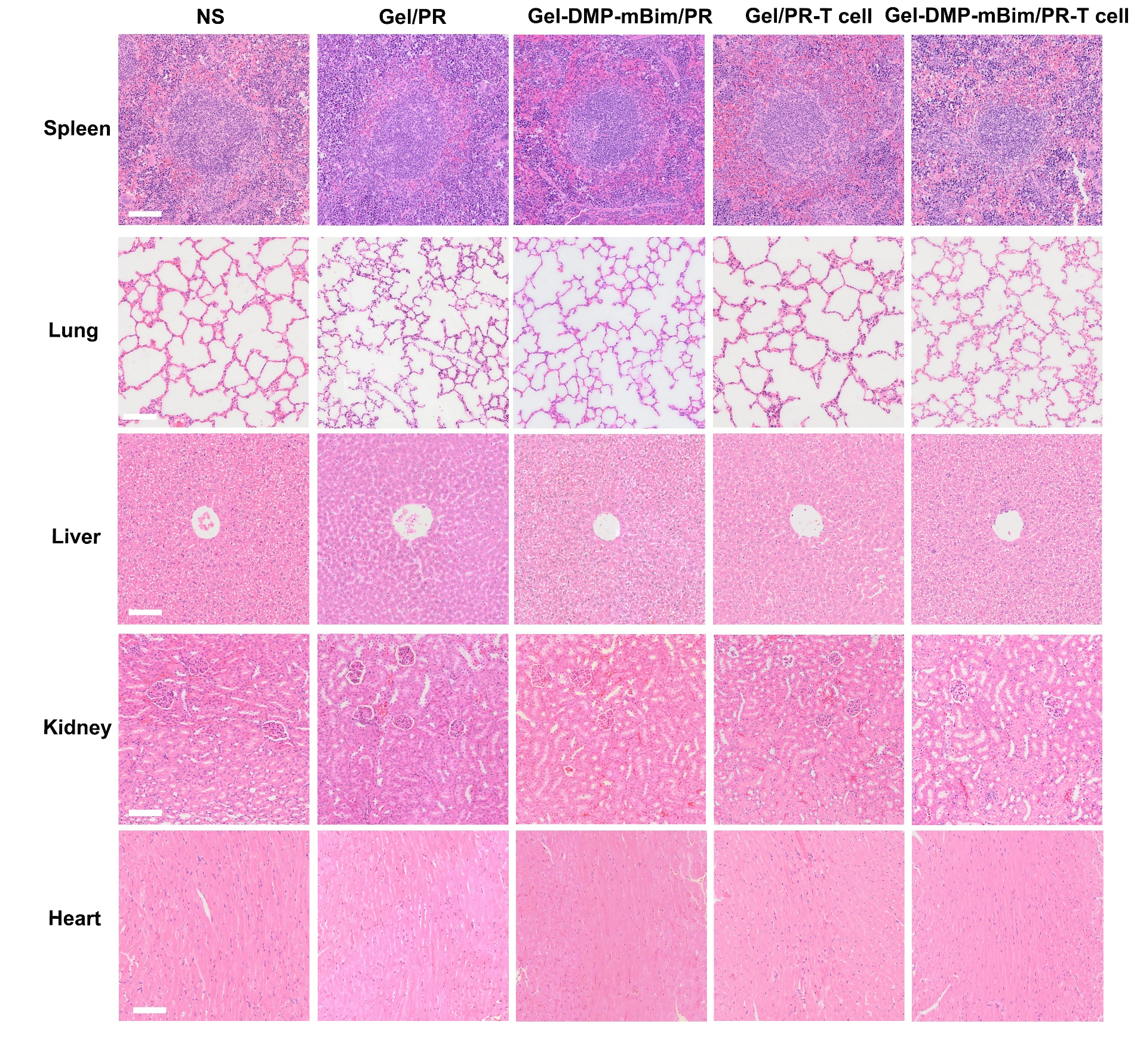
Figure S11. The H&E staining of main organs in each group of the SCC-VII mouse subcutaneous tumor models (scale bar: 100μm).

Figure S12. The H&E staining analysis of the tumor and mandible surface of mice in each group (scale bar: 5 mm for the entire image; scale bar: 200 μm for partial image).

Figure S13. The representative flow cytometry images T cells and DCs in tumor after treatment with double-layered scaffolds in mandible invasion models.

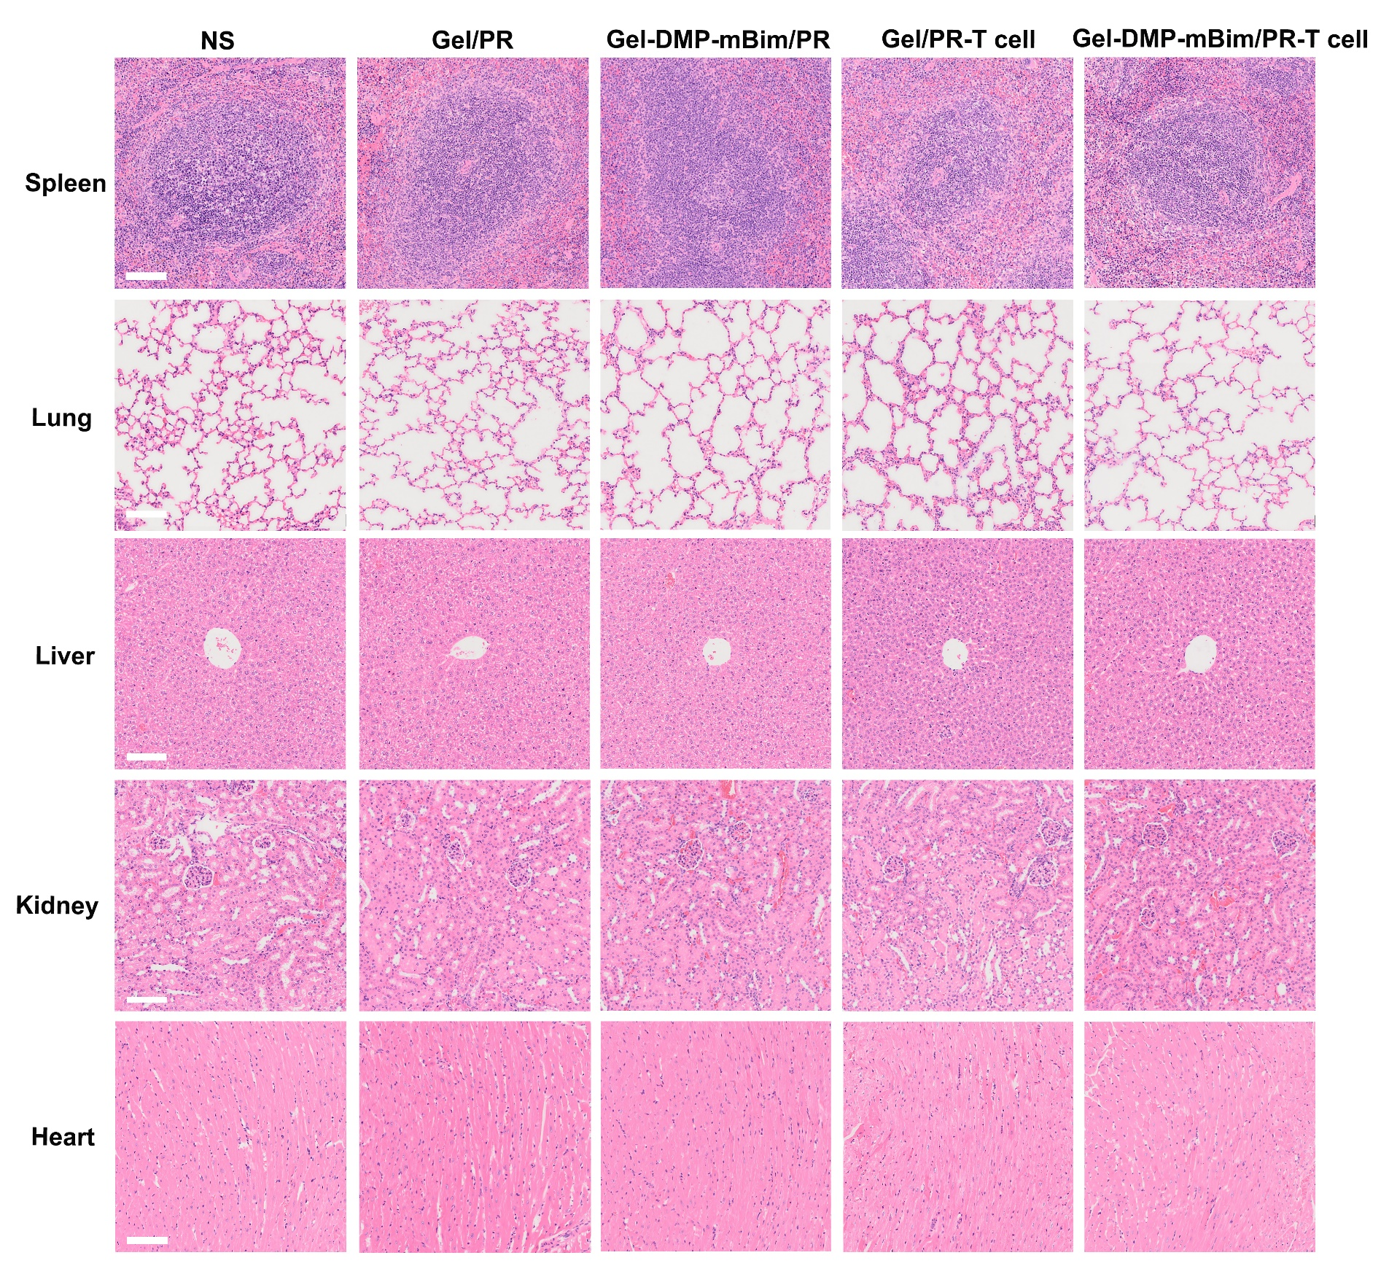
Figure S14. The H&E staining of main organs in each group of the SCC-VII mouse mandible invasion models (scale bar: 100μm).

