Table S1. Stepwise inclusion and exclusion of cases and controls corresponding to Figure 1.
Stage | Eligibility and workflow node | No. remaining | No. excluded at this stage | Primary reason(s) for exclusion
1 | Hospitalised adults with diabetes identified from EHR over the study period | 20,684 | – | –
2 | After excluding clearly non-eligible encounters per protocol (e.g., benign thyroid nodules, cysts, non-malignant personal history/benign findings) | 4,376 | 16,308 | Non-eligible benign conditions and non-target indications
3 | “Clinically suspected malignancy” diabetes admissions entering the diagnostic pathway | 4,376 | 0 | –
4 | Histopathology-confirmed malignancy among suspected cases | 512 | 3,864 | No histopathological confirmation / negative or benign pathology
5 | Eligible malignant cases meeting the study case definition (incident, asymptomatic detection during index admission) | 160 | 352 | Not incident within index admission and/or symptomatic presentation and/or did not meet case definition
6 | After excluding missing key predictors required for modelling | 140 | 20 | Missing key clinical/metabolic and/or tumour-marker variables
7 | Control pool: hospitalised adults with diabetes without malignancy during index admission | 20,524 | – | No malignancy during index admission
8 | Controls selected by matching on age and diabetes duration (SMD < 0.1 for matching factors) | 141 | 20,383 | Not selected by matching algorithm / ineligible for matching constraints
9 | Final matched analytic cohort | 281 | – | 140 cases + 141 controls
Table S1. Patient counts at each stage of cohort assembly and exclusion. This table summarises the sequential inclusion and exclusion of hospitalised adults with diabetes, reporting the number of patients remaining and excluded at each stage of cohort construction, from the initial EHR-identified population to the final matched analytic cohort of cases and controls.
Table S2. Post-matching balance assessed using standardised mean differences
Variable | Cases (n=140) | Controls (n=141) | SMD
Age (years) | 67.63 ± 8.53 | 67.26 ± 8.81 | 0.043
Diabetes duration (years) | 10.61 ± 8.95 | 11.06 ± 9.52 | -0.049
Sex, male | 99 (70.71) | 101 (71.63) | -0.020
Table S2. Standardised mean differences for covariate balance after frequency matching.
Values are mean ± SD for continuous variables and n (%) for categorical variables. Standardised mean differences (SMDs) are reported for each covariate; absolute SMD values <0.1 were considered indicative of adequate between-group balance.

Table S3. Multicollinearity assessment for predictors in Model A and Model B
Predictor | Model A Tolerance | Model A VIF | Model B Tolerance | Model B VIF
Age | 0.946 | 1.057 | 0.840 | 1.191
BMI | 0.924 | 1.083 | 0.848 | 1.179
HbA1c | 0.789 | 1.267 | 0.779 | 1.283
MAGE | 0.452 | 2.213 | 0.829 | 1.207
Mean glucose | 0.577 | 1.732 | 0.757 | 1.322
2-h C-peptide | 0.975 | 1.026 | 0.965 | 1.037
Albumin | 0.963 | 1.038 | — | —
ApoA-I | 0.795 | 1.257 | 0.804 | 1.244
Sex | 0.822 | 1.217 | 0.799 | 1.252
SGLT2 inhibitor use | 0.873 | 1.145 | 0.931 | 1.074
CEA | — | — | 0.848 | 1.179
CA19-9 | — | — | 0.782 | 1.279
CA125 | — | — | 0.927 | 1.079
CYFRA21-1 | — | — | 0.942 | 1.061
Table S3. Multicollinearity assessment for predictors included in the multivariable models (Model A and Model B). Values are tolerance statistics and variance inflation factors (VIF) calculated for each predictor within the corresponding model specification. All VIF values were below 3, indicating no evidence of problematic multicollinearity.
Table S4. Distribution of primary tumour origin among included malignancy cases
Primary tumour type | n (%)
Pancreatic malignancy | 28 (20.0)
Lung cancer | 27 (19.3)
Colorectal cancer | 18 (12.9)
Gastric cancer | 16 (11.4)
Prostate cancer | 14 (10.0)
Renal cancer | 13 (9.3)
Liver cancer | 6 (4.3)
Thyroid cancer | 6 (4.3)
Breast cancer | 6 (4.3)
Bladder cancer | 2 (1.4)
Nasopharyngeal carcinoma | 1 (0.7)
Ovarian cancer | 1 (0.7)
Oesophageal cancer | 1 (0.7)
Lymphoma | 1 (0.7)
Table S4. Primary tumour types among included malignancy cases. Values are counts and percentages (n, %), calculated using the total number of malignancy cases included in the analysis.

Table S5. Logistic regression coefficients for malignancy in participants with type 2 diabetes (Model A)
Variable | B | SE | OR (95% CI) | P value
Age (per 1 year) | -0.02 | 0.02 | 0.98 (0.94–1.02) | 0.291
Male sex (ref: female) | -0.43 | 0.41 | 0.65 (0.29–1.46) | 0.299
BMI (per 1 kg/m²) | 0.03 | 0.05 | 1.03 (0.92–1.14) | 0.629
SGLT2 inhibitor use (yes; ref: no) | -0.55 | 0.43 | 0.57 (0.25–1.34) | 0.201
HbA1c (per 1%) | -0.20 | 0.10 | 0.82 (0.67–1.01) | 0.064
MAGE (per 1 mmol/L) | 0.29 | 0.13 | 1.34 (1.04–1.73) | 0.023
Mean glucose (per 1 mmol/L) | 0.25 | 0.14 | 1.28 (0.99–1.68) | 0.064
2-h C-peptide (per 1 nmol/L) | -0.64 | 0.21 | 0.53 (0.35–0.80) | 0.002
Albumin (per 1 g/L) | -0.06 | 0.05 | 0.94 (0.85–1.04) | 0.237
ApoA-I (per 1 g/L) | -1.48 | 0.68 | 0.23 (0.06–0.86) | 0.029
Intercept | 2.26 | 3.10 | — | 0.466
Table S5. Base specification (Model A) includes only clinical–metabolic covariates for malignancy. Values are regression coefficients (B), standard errors (SE), odds ratios (OR) with 95% confidence intervals (CI), and Wald P values from a multivariable logistic model. The intercept is reported to enable full model reconstruction (logit(p)=β₀+Σβx).

Table S6. Logistic regression coefficients for malignancy in participants with type 2 diabetes (Model B)
Variable | B | SE | OR (95% CI) | P value
Age (per 1 year) | -0.03 | 0.03 | 0.97 (0.91–1.03) | 0.340
Male sex (ref: female) | -0.70 | 0.61 | 0.50 (0.15–1.63) | 0.249
BMI (per 1 kg/m²) | 0.05 | 0.08 | 1.05 (0.89–1.23) | 0.560
SGLT2 inhibitor use (yes; ref: no) | -0.66 | 0.55 | 0.52 (0.17–1.52) | 0.231
HbA1c (per 1%) | -0.39 | 0.17 | 0.68 (0.48–0.95) | 0.024
MAGE (per 1 mmol/L) | -0.16 | 0.27 | 0.85 (0.51–1.43) | 0.542
Mean glucose (per 1 mmol/L) | 0.21 | 0.25 | 1.23 (0.75–2.02) | 0.416
2-h C-peptide (per 1 nmol/L) | -0.70 | 0.28 | 0.49 (0.28–0.86) | 0.012
ApoA-I (per 1 g/L) | -2.71 | 1.06 | 0.07 (0.01–0.53) | 0.010
CEA (per 1 ng/mL) | 0.24 | 0.14 | 1.28 (0.96–1.69) | 0.089
CA19-9 (per 1 U/mL) | 0.01 | 0.02 | 1.01 (0.97–1.06) | 0.494
CA125 (per 1 U/mL) | 0.02 | 0.03 | 1.02 (0.97–1.08) | 0.455
CYFRA21-1 (per 1 ng/mL) | 0.34 | 0.16 | 1.41 (1.03–1.93) | 0.034
Intercept | 3.09 | 5.29 | — | 0.560
Table S6. Coefficients and effect estimates from the extended multivariable model (Model B), which adds tumour markers to clinical–metabolic predictors to evaluate independent associations with malignancy. Reported are B, SE, OR (95% CI), and Wald P; the intercept is provided to enable full model reconstruction (logit(p) = β₀ + Σβx).

Table S7. Sensitivity analysis: logistic regression coefficients for malignancy in the tumour-marker-complete subset
Variable | B | SE | OR (95% CI) | P value
Age (per 1 year) | -0.01 | 0.02 | 0.99 (0.94–1.03) | 0.606
Male sex (ref: female) | -0.51 | 0.44 | 0.60 (0.25–1.41) | 0.241
BMI (per 1 kg/m²) | -0.01 | 0.06 | 0.99 (0.88–1.13) | 0.909
SGLT2 inhibitor use (yes; ref: no) | 0.78 | 0.44 | 2.17 (0.92–5.13) | 0.077
HbA1c (per 1%) | -0.07 | 0.11 | 0.93 (0.75–1.15) | 0.504
MAGE (per 1 mmol/L) | -0.21 | 0.19 | 0.81 (0.56–1.17) | 0.264
Mean glucose (per 1 mmol/L) | 0.24 | 0.16 | 1.27 (0.92–1.76) | 0.137
2-h C-peptide (per 1 nmol/L) | -0.38 | 0.23 | 0.68 (0.44–1.06) | 0.091
Albumin (per 1 g/L) | -0.05 | 0.06 | 0.95 (0.85–1.07) | 0.391
ApoA-I (per 1 g/L) | -3.09 | 0.77 | 0.05 (0.01–0.21) | <0.001
Table S7. Sensitivity analysis refitting the clinical–metabolic candidate predictor set within the tumour-marker-complete subset (n=156). Values are regression coefficients (B), standard errors (SE), odds ratios (OR) with 95% confidence intervals (CI), and Wald P values from a multivariable logistic model. The intercept is reported to enable full model reconstruction (logit(p)=β₀+Σβx).

Figure S1. ROC curves for sensitivity analyses additionally adjusting Model B for ESR and eGFR
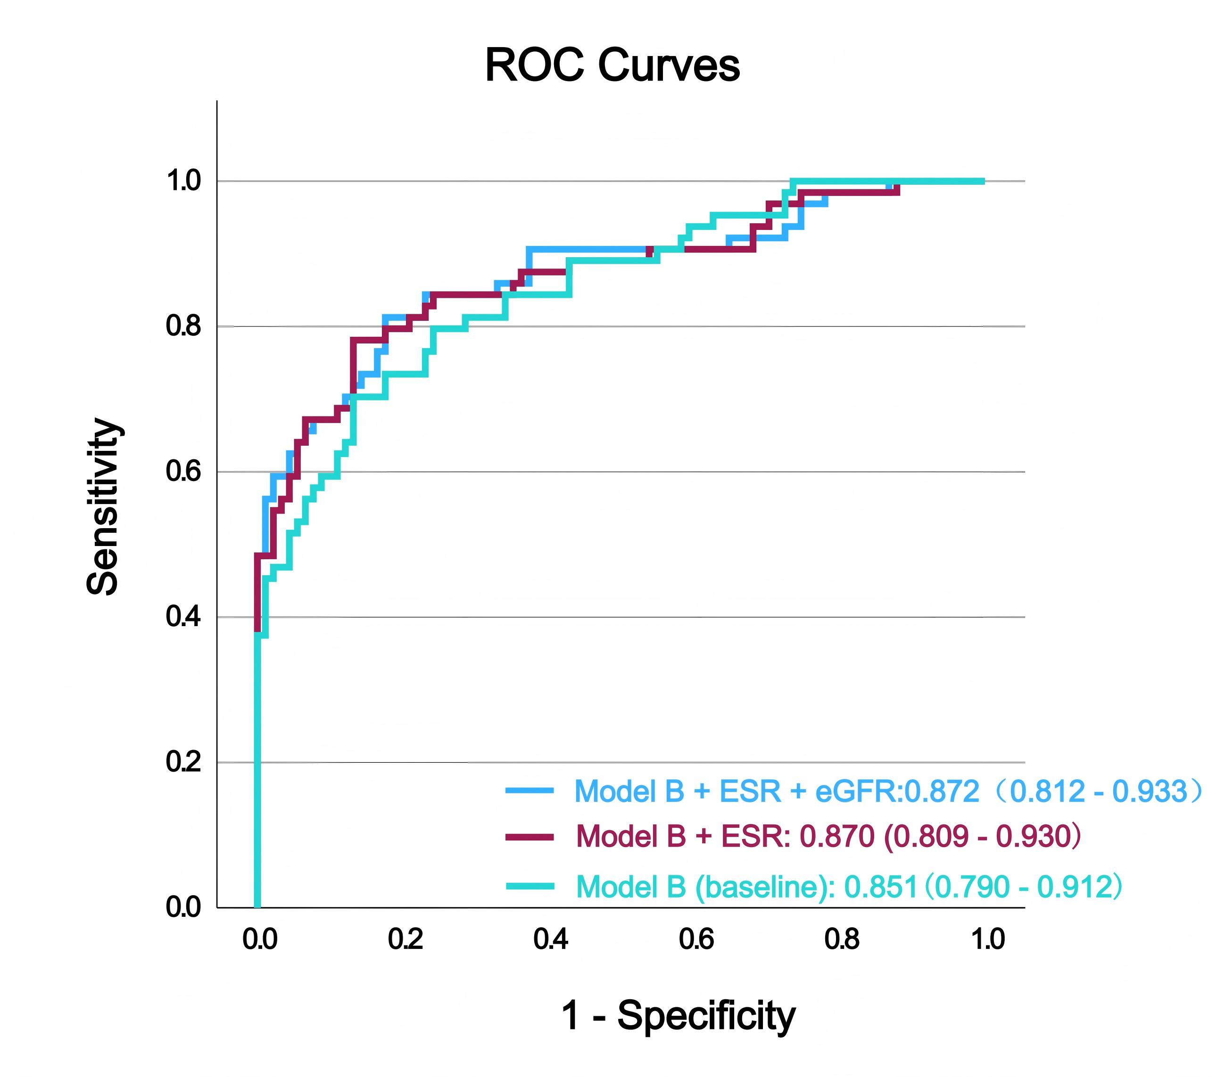
Sensitivity analysis of Model B discrimination after additional adjustment for inflammatory and renal function markers. ROC curves for the baseline tumour marker–extended model (Model B) and sensitivity specifications additionally adjusted for ESR alone or for both ESR and eGFR. AUCs were 0.851 (95% CI, 0.790 - 0.912) for Model B, 0.870 (95% CI, 0.809 - 0.930) after additional adjustment for ESR, and 0.872 (95% CI, 0.812 - 0.933) after additional adjustment for ESR and eGFR.

