Table S1. Demographics and Clinical Characteristics of the SMCGES Serological Assessment Cohort.
 |  | SMCGES Serological Assessment Sub-Cohort
 |  | Total | House Dust Mite (HDM) positives¹
Total (n, %) |  | 736 | 476
Age (Year, Mean ± 1SD) |  | 21.72 ± 5.89 | 21.19 ± 4.15
Gender: Male (n, %) |  | 309 (42.0) | 235 (49.4)
Female (n, %) |  | 411 (55.8) | 232 (48.7)
Ethnic (Chinese n, %) |  | 448 (60.9) | 316 (66.4)
Smoking Status: Non-smoker (n, %) |  | 689 (93.6) | 454 (95.4)
Ex-smoker (n, %) |  | 25 (3.4) | 14 (2.9)
Current Smoker (n, %) |  | 10 (1.4) | 4 (0.8)
Allergic Sensitization (SPT positive) |  | - | -
Blomia Tropicalis, Blo t + (n, %) |  | 396 (53.8) | -
Dermatophagoides pteronyssinus, Der p + (n, %) |  | 401 (54.5) | -
House Dust Mites (Blo t or Der p) + (n, %) |  | 476 (64.7) | -
Asthma |  | 91 (12.4) | 71 (14.9)
Wheezing (past 12 months) |  | 11 (1.5) | 8 (1.7)
Wheezing with exercise (past 12 months) |  | 15 (2) | 12 (2.5)
Nocturnal cough (past 12 months) |  | 19 (2.6) | 12 (2.5)
Daytime asthma attack (past 12 months) |  | 9 (1.2) | 8 (1.7)
Nighttime asthma attack (past 12 months) |  | 8 (1.1) | 6 (1.3)
School absenteeism due to asthma (past 12 months) |  | 1 (0.1) | 0 (0)
General practitioner/specialist visits due to asthma (past 12 months) |  | 6 (0.8) | 5 (1.1)
Emergency department admission due to asthma (past 12 months) |  | 1 (0.1) | 1 (0.2)
Hospitalization due to asthma (past 12 months) |  | 1 (0.1) | 1 (0.2)
Any exacerbation event (past 12 months)² |  | 6 (0.8) | 5 (1.1)
Allergic Rhinitis |  | 311 (42.3) | 243 (51.1)
Atopic Dermatitis |  | 162 (22) | 113 (23.7)
HDM: house dust mite; SD: standard deviation; SMCGES: Singapore/Malaysia Cross-sequential Genetics and Epidemiological Study; SPT: skin prick test.
¹HDM positive individuals were defined as having a positive SPT reaction to either Blomia tropicalis or Dermatophagoides pteronyssinus.
²Asthma-related exacerbation refers to at least one of the following events due to asthma in the past 12 months: school absenteeism, general practitioner/specialist visits, emergency department admission, or hospitalization.

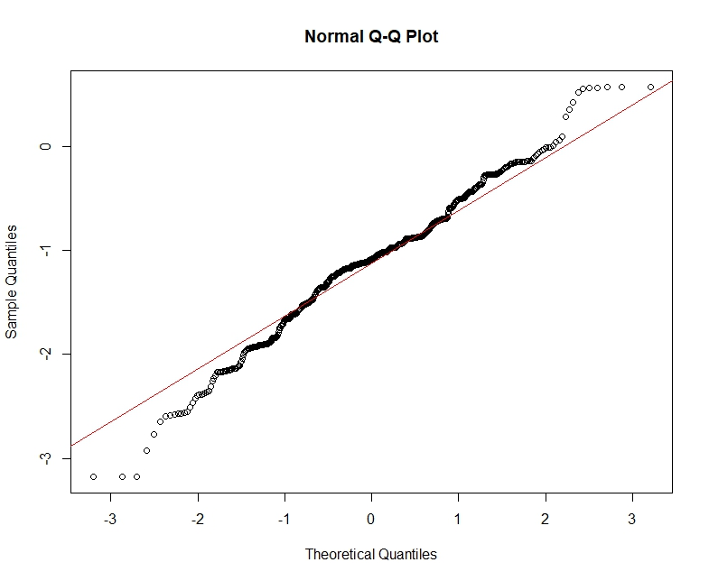
Figure S1. Normal Q-Q plot of log10-transformed Can f 1-specific IgE levels. The figure displays the sample quantiles of log10-transformed Can f 1-specific IgE concentrations (y-axis) plotted against the theoretical quantiles of a normal distribution (x-axis) in the SMCGES serological cohort (n = 736). The close alignment of the data points with the diagonal reference line indicates that the log-transformation successfully achieved a distribution suitable for parametric analysis.

Figure S2. Prevalence and Pairwise correlation plot of SSIgE Reactivities to Common Allergens. (A) The percentages of population demonstrating specific IgE reactivity to common aeroallergens were classified based on ImmunoCAP-defined classes: non-detectable (SSIgE < 0.35 IU/mL); Class 1 (SSIgE 0.35–0.69 IU/mL), Class 2 (SSIgE 0.7–3.49 IU/mL), or Class 3 and above (SSIgE > 3.5 IU/mL). (B) Upper panel: pairwise correlation plots of SSIgE titers (IU/ml) against HDM and animal dander. Lower panel: Spearman correlation coefficients (R) were shown. The strength of correlation was defined as: very strong (R = 0.80 – 1.00), strong (R = 0.60 – 0.79), and moderate (R = 0.40 – 0.59). For both (A) and (B), serological assessment was performed on a previously collected, unbiased, and consecutive serum biobank comprising 1,069 legacy serum samples from allergic patients at local hospitals in Singapore.

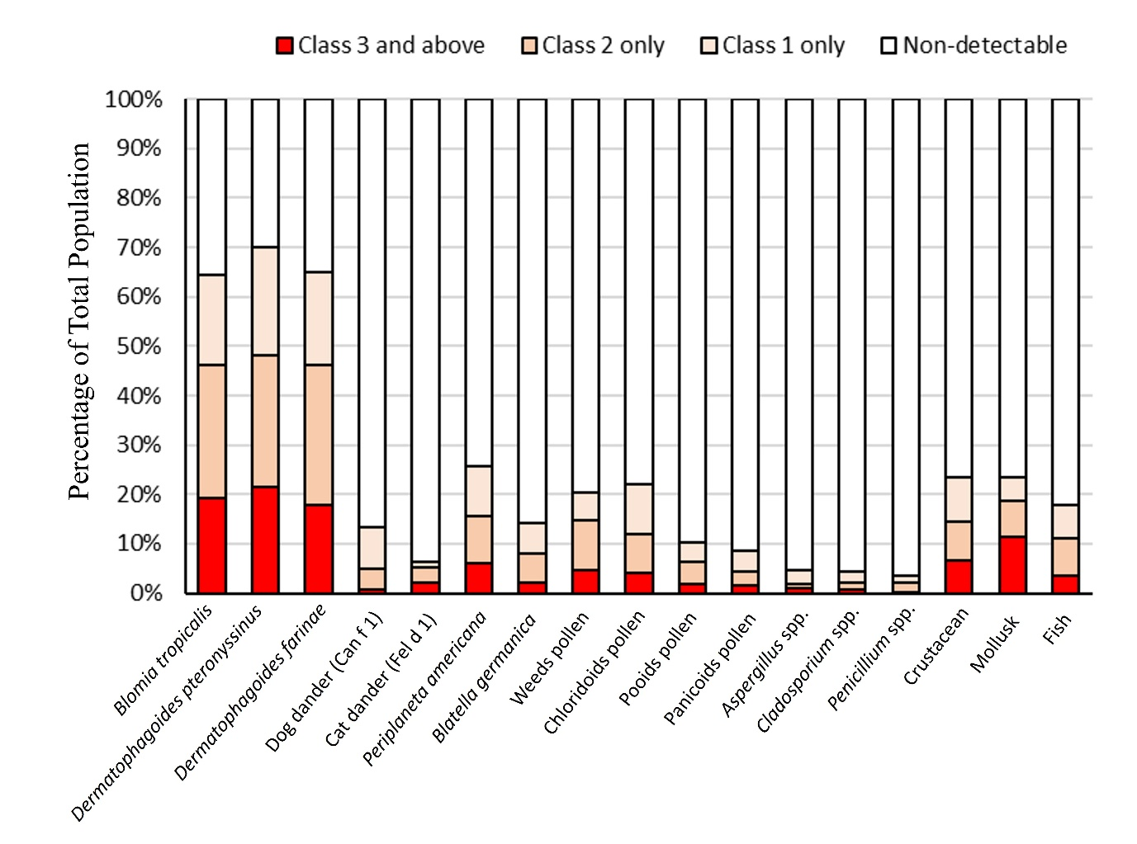
Figure S3. Percentages of SSIgE Sensitization to Common Allergens in the SMCGES Sub-cohort. Serological assessment was performed on 736 individuals. Specific IgE responses were classified based on ImmunoCAP-defined classes: non-detectable (SSIgE < 0.35 IU/mL); Class 1 (SSIgE 0.35–0.69 IU/mL), Class 2 (SSIgE 0.7–3.49 IU/mL), or Class 3 and above (SSIgE > 3.5 IU/mL).

Figure S4. Association between Dog Dander (Can f 1) SSIgE Levels and Allergic Diseases. Associations of Can f 1 SSIgE levels with (A) asthma, (B) allergic rhinitis (AR), and (C) atopic dermatitis (AD) were assessed on 736 individuals from the SMCGES sub-cohort. Independent-sample t tests were performed to assess the significance of associations. ns: not significant (p>0.05).

Figure S5. Association between Dog Dander (Can f 1) SSIgE Levels and Allergic Diseases among HDM-sensitized Individuals. Associations of Can f 1 SSIgE levels with (A) asthma, (B) allergic rhinitis (AR), and (C) atopic dermatitis (AD) were assessed on 476 HDM-sensitized individuals from the SMCGES sub-cohort. Independent-sample t tests were performed to assess the significance of associations. ns: not significant (p>0.05).

