Supplemental Materials 1
Search Strategy
The search aimed to capture all parametric PopPK studies and used the following terms: “Daptomycin,” “Deptomycin,” “Daptomycin, 9-L beta-Aspartic Acid,” “Daptomycin, 9 L beta Aspartic Acid,” “LY-146032,” “LY146032,” “LY 146032,” “Cubicin” combined with “population pharmacokinetic”, “nonlinear mixed-effects model”, “NONMEM”, “Pmetrics”, “WINNONMIX”, “ADAPT”, “P-PHARM”, “nlmixr”, “NLME”, “MONOLIX”, “WinBUGS.” To ensure comprehensiveness, reference lists of included articles were also screened.
The literature search and study selection were independently performed by two investigators (Xi Xie and Cheng Qian) using EndNote (Version X20; Thomson Scientific, Box Hill, Victoria, Australia). Discrepancies were resolved by consultation with a third senior reviewer (Xin Liu). Inclusion criteria were: (1) human studies involving healthy volunteers or patients; (2) daptomycin as the study drug; (3) PopPK or PK/PD analysis conducted; (4) publications in English. Exclusion criteria were: (1) non-article publications, or studies focusing solely on methodology, algorithms, or software; (2) insufficient reporting of critical PK parameters, or studies only applying external models for simulations.
Figure S1. Simulated daptomycin unbound concentration–time profiles at steady state for for different renal function populations after intravenous infusion of daptomycin in retrieved studies.
Notes: A) Normal renal function; B) Mild renal impairment; C) Moderate renal impairment; D) Severe renal impairment (renal categories defined according to each original model). The shaded sections represent the 5th-95th percentiles of the simulated concentration–time profiles.
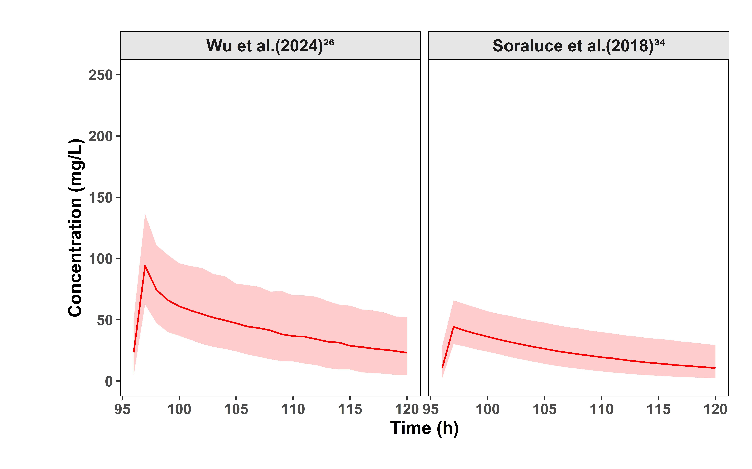
Figure S2. Simulated daptomycin total concentration–time profiles at steady state for patients undergoing continuous renal replacement therapy (CRRT).
Notes: The shaded sections represent the 5th-95th percentiles of the simulated concentration-time profiles.
Figure S3. Probability of achieving the target where AUC_{24h}/MIC ≥ 666 for daptomycin in the included studies. The gray dashed line denotes a 90% target compliance rate, and the blue dashed line corresponds to the clinical breakpoint with MIC = 1.
Notes: A)-K) represent different population pharmacokinetic models from different studies used in the simulations. The blue dashed line represents MIC = 1, the grey dashed line represents the 90% threshold
Figure S4. The comparison of the AUC_{24h} of each model prediction in different renal function populations after intravenous infusion of 6mg/kg in retrieved studies.
Notes: A) Normal renal function; B) Mild renal impairment; C) Moderate renal impairment; D) Severe renal impairment (renal categories defined according to each original model). The red dashed line represents AUC_{24h}/MIC = 666.
Figure S5. The comparison of the AUC_{24h} of each model prediction in different renal function populations after intravenous infusion of 8mg/kg in retrieved studies.
Notes: A) Normal renal function; B) Mild renal impairment; C) Moderate renal impairment; D) Severe renal impairment (renal categories defined according to each original model). The red dashed line represents AUC_{24h}/MIC = 666.
Figure S6. The comparison of the AUC_{24h} of each model prediction in different renal function populations after intravenous infusion of 10mg/kg in retrieved studies.
Notes: A) Normal renal function; B) Mild renal impairment; C) Moderate renal impairment; D) Severe renal impairment (renal categories defined according to each original model). The red dashed line represents AUC_{24h}/MIC = 666.
Figure S7. The comparison of the AUC_{24h} of each model prediction in different renal function populations after intravenous infusion of 12mg/kg in retrieved studies.
Notes: A) Normal renal function; B) Mild renal impairment; C) Moderate renal impairment; D) Severe renal impairment (renal categories defined according to each original model). The red dashed line represents AUC_{24h}/MIC = 666.

Supplementary Materials 2

User Guide for the Model-informed Daptomycin Dosing Tool

1. Overview
The Model-informed Daptomycin Dosing Tool is an interactive Shiny application developed to support individualized dosing strategies of daptomycin based on pharmacometric modeling and simulation. This tool integrates:
- Population pharmacokinetic modeling (via mrgsolve)
- Bayesian individual PK parameter estimation (via mapbayr)
- Dose adjustment

2. System Requirements and Launch

Software Requirements:
- R version: ≥ 4.5.1
- Packages required: shiny, mrgsolve, mapbayr, ggplot2, dplyr, purrr, tidyr, tibble

3. Module Details
Purpose: To perform maximum a posteriori (MAP) Bayesian estimation using observed concentration data, enabling individualized dose adjustment.

User Inputs:
- Administration:
Dose (mg/kg): Default value: 6, maximum value: 20, minimum value: 1
Infusion duration (h): Default value: 1, minimum value: 0.1
Dosing interval (h): Default value: 24, maximum value: 72, minimum value: 6
Sample taken after which dose number?: Default value: 5, maximum value: 30, minimum value: 1
- Patient information: Creatinine clearance (mL/min), Serum albumin (g/L), Weight (kg)
- Observations:
Time 1 after last dose (h): Default value: 5
Conc 1 (mg/L)
Time 2 after last dose (h): Default value: 14
Conc 2 (mg/L)
- Targets:
Target AUC (mg*h/L): Default value: 666
Target trough concentration (mg/L): Default value: 24.3

Outputs:
- Figures:
Concentrations: Posterior predicted PK curve fitted to observed data: To evaluate the pharmacokinetic model's predictive accuracy and characterize the drug's in vivo dynamics.
Parameters: Histogram of individual posteriors: To visualize the uncertainty and central tendency of inter - individual differences in PK parameters (CLNR, CLR, V1, V2, Q, N) within a popPK model, thereby providing a basis for personalized dosing strategies.
Results:
AUC Results:
○ Predicted AUC over the last interval [0, 24.0] h: To evaluate drug exposure and dosing regimen efficacy by predicting the AUC value (MIC=1) in the last dosing interval via MAP.
○ Predicted C_{min} within interval: To evaluate the toxicity of the dosing regimen by predicting the Cmin value in the last dosing interval via MAP.
Next Dose Explorer:
○ The recommended next dose regimen: To explore and identify the optimal next dose to support dosing regimen optimization.

4. Pharmacokinetic Assumptions
- All simulations are based on the validated population model for daptomycin (using mrgsolve).
- Concentrations are expressed in mg/L.

