Supplementary Materials

Supplementary Text
- Preparation of colloidal gold nanoparticles
Colloidal gold nanoparticles were synthesized using the citrate reduction method. Briefly, 250 mL of ultrapure water was brought to boiling under stirring, and 2.5 mL of 1% HAuCl₄ was added to obtain a 0.01% gold solution. To prepare particles of 72 nm, 2.8 mL of 1% trisodium citrate was rapidly added. For 40 nm particles, the same procedure was followed with 5.0 mL of 1% trisodium citrate. The solutions were stirred for 15 minutes after the color stabilized (purple-red for 72 nm, bright red for 40 nm), then cooled and stored in amber bottles. The particle size was qualitatively estimated based on color and confirmed by UV-Vis absorbance. All glassware used in the synthesis was thoroughly cleaned with detergent, soaked in sulfuric acid–potassium dichromate solution for 48 h, rinsed with ultrapure water, and oven-dried prior to use.

2. Optimization of gold nanoparticle size and labeling conditions
2.1 Optimization of gold nanoparticle size
To evaluate the optimal particle size for antibody labeling, colloidal gold nanoparticles with average diameters of approximately 72 nm and 40 nm were compared in a series of visual labeling trials using a 96-well microplate, as shown in Table S1. Each well was prepared with a mixture of colloidal gold solution, either anti-KPC or anti-NDM monoclonal antibodies (5 µg), and pbs, with or without pH adjustment using 0.2 M K₂CO₃. After gentle mixing, the plate was incubated at room temperature for 20 minutes without agitation, and the color change and colloidal stability in each well were visually assessed.
Taking anti-NDM monoclonal antibody as an example, the results showed that in the absence of K₂CO₃, the pH of the gold solution was suboptimal, and the addition of antibody led to significant color fading or colloidal aggregation, particularly in the 72 nm group. As shown in Figure S1, the 40 nm particles retained relatively stable color without pH adjustment, although their labeling efficiency was still suboptimal. With pH adjustment using 0.2 M K₂CO₃, the 40 nm colloidal gold solutions exhibited improved color stability, indicating better compatibility for antibody conjugation. As a result, 40 nm gold nanoparticles adjusted to optimal pH with K₂CO₃ were selected for subsequent conjugation experiments, owing to their superior visual intensity and colloidal stability compared to the 72 nm counterpart.
2.2 Optimization of pH for gold nanoparticle conjugation
To determine the optimal pH for antibody labeling, 2 mL of colloidal gold solution was distributed across six wells of a 96-well microplate. The pH of each well was adjusted to 6.5, 7.0, 7.5, 8.0, 8.5, or 9.0 using 0.2 M K₂CO₃. Each adjusted solution was then tested with either anti-NDM or anti-KPC monoclonal antibodies by adding 5 µg of antibody per well, followed by gentle mixing and incubation at room temperature for 20 minutes. The color and colloidal stability of the solutions were visually evaluated. As shown in Figure S2 and Figure S3, both antibodies exhibited optimal compatibility at pH 8.0, where the gold solutions remained stable without aggregation or visible color change.
2.3 Optimization of antibody concentration for gold nanoparticle labeling
To determine the optimal antibody concentration for conjugation, 4 mL of colloidal gold solution (pre-adjusted to optimal pH) was distributed across four wells of a 96-well microplate. Anti-KPC and anti-NDM monoclonal antibodies were added to achieve final concentrations of 15, 20, 25, and 30 µg/mL, respectively. After gentle mixing, the solutions were incubated at room temperature for 20 minutes without agitation. The color intensity and colloidal stability of the solutions were visually assessed. As shown in Figure S4 and Figure S5, both anti-KPC and anti-NDM antibodies exhibited optimal labeling performance at a final concentration of 25 µg/mL, where the solutions remained stable and showed the most intense red coloration without aggregation.

3. Optimization of coating concentrations for test and control lines
3.1 Optimization of test line coating for anti-KPC monoclonal antibody
To determine the optimal coating concentration for the test line 1 (T1), anti-KPC monoclonal antibodies were diluted in PBS to final concentrations of 1.5, 1.2, 1.0, and 0.8 mg/mL and dispensed onto the nitrocellulose (NC) membrane. After drying and assembly of the lateral flow immunoassay (LFIA) strips, the performance of each coating concentration was evaluated using KPC recombinant antigens at concentrations of 100 ng/mL, 10 ng/mL, and 1 ng/mL. As shown in Table S2, a concentration of 1.2 mg/mL offered an optimal balance between signal intensity, band clarity, and antibody consumption.
3.2 Optimization of test line coating for anti-NDM monoclonal antibody
The same procedure was performed for the anti-NDM monoclonal antibody, using PBS to prepare coating concentrations of 1.5, 1.2, 1.0, and 0.8 mg/mL. The antibodies were dispensed onto NC membranes as the test line 2 (T2) and dried before LFIA assembly. NDM recombinant antigens at 200 ng/mL, 20 ng/mL, and 2 ng/mL were used to evaluate performance. As shown in Table S3, a coating concentration of 1.2 mg/mL produced optimal signal intensity and clarity, while using a moderate amount of antibody.
3.3 Optimization of control line coating using goat anti-mouse IgG
Goat anti-mouse IgG was used as the control line (C line) and prepared at coating concentrations of 1.5, 1.2, 1.0, and 0.8 mg/mL in PBS. After dispensing onto the NC membrane, drying, and assembly of the LFIA strips, performance was evaluated using KPC/NDM recombinant antigens and PBS as a background control. As shown in Table S4, the optimal concentration for the control line was 1.2 mg/mL, providing a strong, consistent control signal with minimal reagent usage.

4. Supplementary NDM detection in non-Klebsiella Enterobacterales
To supplement the evaluation of NDM detection beyond K. pneumoniae, the duplex LFIA was tested using eight non-Klebsiella NDM-positive Enterobacterales isolates, including four Enterobacter cloacae complex isolates carrying bla_{NDM-1} and four Escherichia coli isolates carrying bla_{NDM-5}, with a blank control included, as shown in Figure S6.

Supplementary Tables

Table S1 Comparison of colloidal gold solutions with two different particle sizes
Well No. | 1 | 2 | 3 | 4 | 5 | 6 | 7 | 8
Gold nanoparticle size (nm) | 72 | 72 | 72 | 72 | 40 | 40 | 40 | 40
0.2M K₂CO₃ (μL) | 0 | 1 | 0 | 0 | 0 | 1 | 0 | 0
Anti-NDM mAb (μg) | 5 | 5 | 0 | 0 | 5 | 5 | 0 | 0
PBS (μL) | 0 | 0 | 10 | 0 | 0 | 0 | 10 | 0

Table S2 Optimization of test line coating for anti-KPC monoclonal antibody
Coating concentration | Recombinant KPC antigen |  |  | PBS
Coating concentration | 100ng/mL | 10ng/mL | 1ng/mL | PBS
1.5mg/mL | ++++ | +++ | + | -
1.2mg/mL | ++++ | +++ | + | -
1.0mg/mL | ++++ | ++ | ± | -
0.8mg/mL | ++++ | ++ | ± | -
Note: Symbols indicate visual test-line signal intensity: ++++ strong, +++ moderate-to-strong, ++ moderate, + weak, ± very faint, and - no visible line.

Table S3 Optimization of test line coating for anti-NDM monoclonal antibody
Coating concentration | Recombinant NDM antigen |  |  | PBS
Coating concentration | 200ng/mL | 20ng/mL | 2ng/mL | PBS
1.5mg/mL | ++++ | +++ | + | -
1.2mg/mL | ++++ | +++ | + | -
1.0mg/mL | ++++ | ++ | ± | -
0.8mg/mL | ++++ | ++ | ± | -
Note: Symbols indicate visual test-line signal intensity: ++++ strong, +++ moderate-to-strong, ++ moderate, + weak, ± very faint, and - no visible line.

Table S4 Optimization of control line coating using goat anti-mouse IgG
Coating concentration | Recombinant KPC antigen  1ng/mL | Recombinant NDM antigen  2ng/mL | PBS
1.5mg/mL | ++++ | ++++ | ++++
1.2mg/mL | ++++ | ++++ | ++++
1.0mg/mL | +++ | +++ | +++
0.8mg/mL | +++ | +++ | +++
Note: Symbols indicate visual test-line signal intensity: ++++ strong, and +++ moderate-to-strong.

Supplementary Figures

Figure S1 Antibody labeling with different gold nanoparticle sizes.
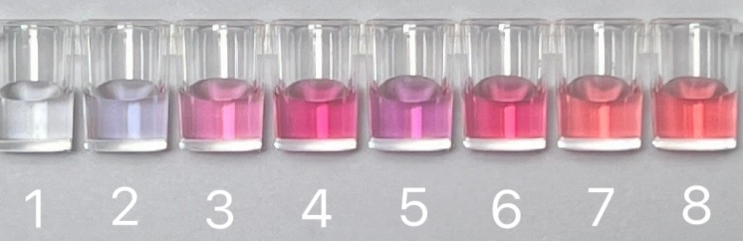
Wells 1-4 used 72-nm colloidal gold and wells 5-8 used 40-nm colloidal gold. K₂CO₃ (0.2 M, 1 µL) was added to wells 2 and 6 for pH adjustment. Anti-NDM mAb (5 µg) was added to wells 1-2 and 5-6; PBS (10 µL) was added to wells 3 and 7; wells 4 and 8 were gold-only controls (see Table S1 for details). Color differences reflect the visual stability of the colloidal gold under different labeling conditions.

Figure S2 Optimization of pH for labeling with anti-KPC monoclonal antibody.
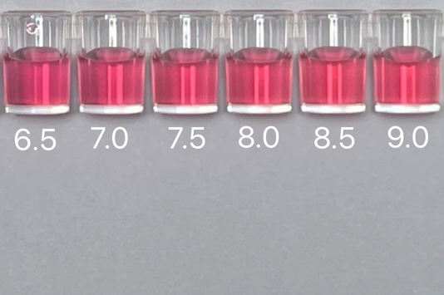
The pH of colloidal gold was adjusted to 6.5-9.0 (using K₂CO₃) prior to antibody addition; the optimal pH was chosen based on visual colloid stability.

Figure S3 Optimization of pH for labeling with anti-NDM monoclonal antibody.
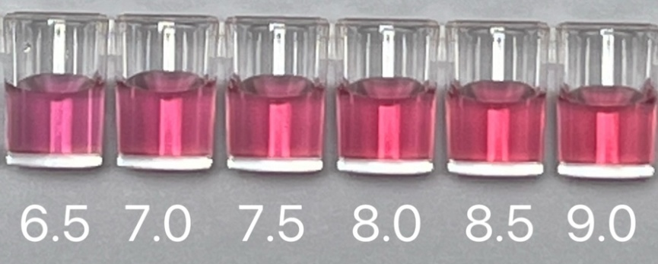
The pH of colloidal gold was adjusted to 6.5-9.0 (using K₂CO₃) prior to antibody addition; the optimal pH was chosen based on visual colloid stability.

Figure S4 Optimal labeling concentration of anti-KPC monoclonal antibody.
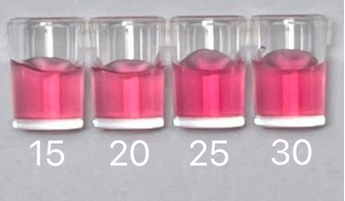
Anti-KPC monoclonal antibody was added to colloidal gold to final concentrations of 15, 20, 25, and 30 µg/mL and incubated at room temperature for 20 min. Conjugation performance was evaluated by visual inspection of color intensity and colloidal stability.

Figure S5 Optimal labeling concentration of anti-NDM monoclonal antibody.
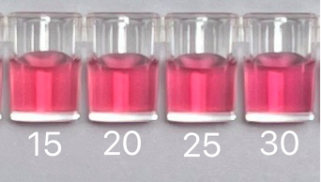
Anti-NDM monoclonal antibody was added to colloidal gold to final concentrations of 15, 20, 25, and 30 µg/mL and incubated at room temperature for 20 min. Conjugation performance was evaluated by visual inspection of color intensity and colloidal stability.

Figure S6. Supplementary evaluation of NDM detection in non-Klebsiella Enterobacterales isolates.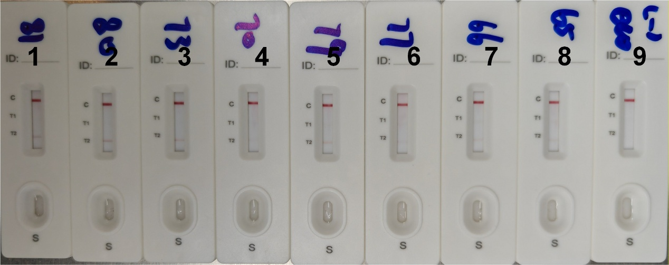 Strips 1-4, Enterobacter cloacae complex isolates carrying bla_{NDM-1}; strips 5-8, Escherichia coli isolates carrying bla_{NDM-5}; strip 9, blank control. A visible control line (C) indicates a valid test, and appearance of the NDM test line (T2) indicates NDM positivity.

