Appendix A: Supplementary Materials
Balanced Allocation to Groups
Propensity score matching was employed to divide the total sample into demographically balanced exploratory (n = 256) and confirmatory (n = 255) subsamples. This approach was preferred over simple random splitting to ensure covariate balance while maintaining statistical independence for cross-validation purposes. Nearest-neighbor matching with a 1:1 ratio and a caliper of 0.25 standard deviations was applied using nine demographic covariates: age, gender, marital status, parental status, education level, occupation, social security status, income level, and place of residence. The matching procedure successfully paired 234 participants in each group, with 43 participants remaining unmatched and randomly assigned to preserve sample sizes.

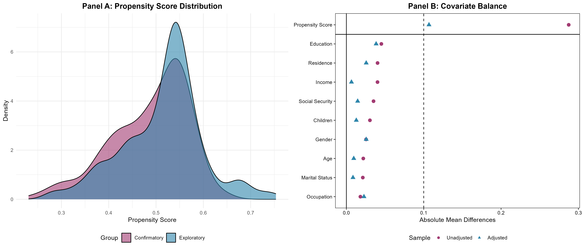
Supplementary Figure 1: Propensity score matching diagnostics for exploratory and confirmatory sample allocation.
The results of the propensity score matching indicated that the mean and standard deviation of the propensity scores were highly similar between the exploratory (Mean = 0.515, SD = 0.085) and confirmatory (Mean = 0.487, SD = 0.081) groups. The region of common support was identified as 100%, indicating complete overlap of propensity score ranges across all participants. The distributions of propensity scores for both groups visually overlapped to a large extent, exhibiting a similar pattern. Although the Kolmogorov–Smirnov test yielded a statistically significant result (D = 0.155, p = .004), this is likely attributable to the large sample size, which increases sensitivity to even minor differences. Nevertheless, the effect size (D = 0.155) was small, and detailed analyses of demographic variables revealed that most between-group differences were not statistically significant (Supplementary Figure 1).
Balance diagnostics demonstrated excellent covariate balance following matching. All nine covariates achieved standardized mean differences (SMD) below the conventional 0.1 threshold, indicating adequate balance: age (SMD = 0.010), gender (SMD = 0.026), marital status (SMD = 0.009), parental status (SMD = 0.013), education (SMD = −0.039), occupation (SMD = 0.023), social security (SMD = −0.015), income (SMD = −0.007), and residence (SMD = 0.026). The largest imbalance was observed for education (SMD = −0.039), which remained well within acceptable limits. Propensity score distributions showed substantial overlap between groups (Supplementary Figure 1, Panel A), and the Love plot confirmed that all covariates achieved balance after matching (Supplementary Figure 1, Panel B).
Supplementary Table 1 presents the comparison of demographic characteristics between the exploratory and confirmatory samples. The total sample consisted of 511 participants, with n = 256 (50.1%) in the exploratory group and n = 255 (49.9%) in the confirmatory group.
Supplementary Table 1: Demographic characteristics and group comparisons between exploratory and confirmatory samples.
Variable | Category | Exploratory  n (%) | Confirmatory  n (%) | χ² /p
Gender | Female | 207 (80.9) | 183 (71.8) | χ² = 5.35  p = 0.021*
Gender | Male | 49 (19.1) | 72 (28.2) | χ² = 5.35  p = 0.021*
Marital status | Single | 206 (80.5) | 213 (83.5) | χ² = 0.62  p = 0.432
Marital status | Married | 50 (19.5) | 42 (16.5) | χ² = 0.62  p = 0.432
Children | No | 211 (82.4) | 213 (83.5) | χ² = 0.05  p = 0.829
Children | Yes | 45 (17.6) | 42 (16.5) | χ² = 0.05  p = 0.829
Education level | High school or lower | 53 (20.7) | 67 (26.3) | χ² = 1.91  p = 0.167
Education level | Higher education | 203 (79.3) | 188 (73.7) | χ² = 1.91  p = 0.167
Occupation | Retired / not working | 18 (7.0) | 22 (8.6) | χ² = 0.88  p = 0.644
Occupation | Student | 172 (67.2) | 162 (63.5) | χ² = 0.88  p = 0.644
Occupation | Employed (public/private) | 66 (25.8) | 71 (27.8) | χ² = 0.88  p = 0.644
Social security | None | 61 (23.8) | 66 (25.9) | χ² = 2.40  p = 0.301
Social security | SSI | 173 (67.6) | 158 (62.0) | χ² = 2.40  p = 0.301
Social security | Private | 22 (8.6) | 31 (12.2) | χ² = 2.40  p = 0.301
Income level | Less than expenses | 67 (26.2) | 81 (31.8) | χ² = 2.38  p = 0.304
Income level | Equal to expenses | 152 (59.4) | 135 (52.9) | χ² = 2.38  p = 0.304
Income level | More than expenses | 37 (14.5) | 39 (15.3) | χ² = 2.38  p = 0.304
Place of residence | Urban | 218 (85.2) | 220 (86.3) | χ² = 0.06  p = 0.814
Place of residence | Rural | 38 (14.8) | 35 (13.7) | χ² = 0.06  p = 0.814
 |  | Mean ± SD  Median (Min.-Max.) | Mean ± SD  Median (Min.-Max.) | z / p
Age (year) |  | 26.34 ± 11.63  21.5 (18-83) | 25.46 ± 9.92  22.0 (18-75) | z = -0.064  p = 0.949
Footnote. χ²: Pearson chi-square; z: Mann Whitney U test; *: p<0.05.

The mean age for the exploratory sample was 26.34 years (SD = 11.63, Median = 21.5, Range: 18–83), while the confirmatory sample had a mean age of 25.46 years (SD = 9.92, Median = 22.0, Range: 18–75). The Mann-Whitney U test indicated no significant age difference between the groups (z = −0.064, p = .949). Although a statistically significant difference was observed for gender distribution (χ² = 5.35, p = .021), with a higher proportion of females in the exploratory group (n = 207; 80.9%) compared to the confirmatory group (n = 183; 71.8%), this result is attributable to the sensitivity of chi-square tests to sample size rather than substantively meaningful imbalance. Critically, the standardized mean difference for gender (SMD = 0.026) remained well below the conventional 0.10 threshold, indicating adequate balance from a matching perspective. Comparisons across marital status, parental status, education level, occupation, social security, income level, and place of residence revealed no statistically significant differences (all p > .05). Furthermore, measurement invariance testing across gender demonstrated configural, metric, and scalar invariance, confirming that this minor distributional difference did not compromise the validity of cross-validation results.
Exploratory Factor Analysis
Exploratory factor analysis (EFA) was conducted on the full sample (n = 511) to validate and complement the two-dimensional structure identified through exploratory graph analysis. Prior to factor extraction, data suitability was assessed through standard indices (Supplementary Table 2).
Supplementary Table 2: Reliability and descriptive statistics from exploratory factor analysis.
Factors |  | Mean | SD | EFA | EV | PoV | α | AVE | CR
Generalist View
1 | MMS1 | 6.06 | 1.38 | 0.870 | 3.32 | 36.93 | 0.81 | 0.63 | 0.87
2 | MMS2 | 5.88 | 1.48 | 0.820
3 | MMS3 | 6.22 | 1.29 | 0.744
4 | MMS4 | 6.16 | 1.33 | 0.731
Overall score of GV |  | 24.32 | 4.38
Individualist View
1 | MMS6 | 3.76 | 1.94 | 0.788 | 1.82 | 20.18 | 0.74 | 0.49 | 0.83
2 | MMS7 | 4.78 | 1.79 | 0.655
3 | MMS8 | 5.25 | 1.65 | 0.702
4 | MMS9 | 5.32 | 1.61 | 0.779
5 | MMS10 | 5.45 | 1.63 | 0.565
Overall score of IV |  | 24.56 | 6.07
Overall score of MMS |  | 48.88 | 8.46 |  |  | 57.10 | 0.78 | 0.55 | 0.92
Footnote. Kaiser-Meyer-Olkin (KMO): .796; Barlett Sphericity Test: χ2:1349.318; df: 36; p<.001; EV: Eigenvalues; PoV: Percent of Explained Variance; AVE: Average Variance Extracted; CR: Composite Reliability.

The Kaiser-Meyer-Olkin (KMO) measure of sampling adequacy yielded a value of .796, which exceeds the commonly recommended threshold of .70 and approaches the .80 criterion for "meritorious" factorability, indicating that the correlation patterns among items were sufficiently strong and compact for factor analysis. Bartlett's test of sphericity produced a highly significant result (χ²_{df:36} = 1349.318, p < .001), rejecting the null hypothesis that the correlation matrix was an identity matrix and confirming that the items shared sufficient common variance to warrant factor extraction. Maximum likelihood estimation was selected as the extraction method due to its superior statistical properties, including the provision of standard errors and goodness-of-fit statistics, as well as its robustness when data approximate multivariate normality. Promax rotation with kappa set to 4 was employed to allow for oblique (correlated) factors, as theoretical considerations suggested that different orientations toward medical care might be interrelated rather than orthogonal. The analysis converged on a two-factor solution based on eigenvalues greater than 1.0, parallel analysis, and theoretical interpretability. These two factors collectively explained 57.10% of the total variance in the nine items, which exceeds the minimum threshold of 50% commonly cited in the literature and indicates that the majority of item variance was captured by the extracted factors. Factor 1, labeled "Generalist View," accounted for 36.93% of the variance with an eigenvalue of 3.32, while Factor 2, termed "Individualist View," explained an additional 20.18% of variance with an eigenvalue of 1.82. The substantial difference in variance explained by the two factors suggests that the Generalist View represents the primary dimension of medical maximizing-minimizing orientation, while the Individualist View captures a secondary but meaningful aspect of individual variation in medical decision-making preferences. Factor loadings demonstrated excellent simple structure with clear item clustering and minimal cross-loadings. All four items loading on Factor 1 (MMS1, MMS2, MMS3, MMS4) exhibited strong factor loadings ranging from .731 to .870, substantially exceeding the conventional threshold of .40 for practical significance and the more stringent criterion of .60 for strong loadings. These items reflect general proactive attitudes toward seeking medical care, with MMS1 ("When it comes to health care, the only responsible thing to do is to actively seek medical care") showing the highest loading (.870), followed by MMS2 (.820), MMS3 (.744), and MMS4 (.731). The five items comprising Factor 2 (MMS6, MMS7, MMS8, MMS9, MMS10) displayed factor loadings between .565 and .788, all surpassing the minimum threshold and most exceeding .60. MMS6 ("If I feel unhealthy, the first thing that I do is to go to the doctor and get a prescription") demonstrated the strongest loading on this factor (.788), followed by MMS9 (.779), MMS8 (.702), MMS7 (.655), and MMS10 (.565). These items represent more individualized perspectives on medical intervention, treatment preferences, and attitudes toward medication. The absence of substantial cross-loadings (all secondary loadings < .30) supports the discriminant validity of the two-factor structure and indicates that each item contributes primarily to one dimension. Internal consistency reliability coefficients were calculated for each factor and the overall scale using multiple indices. Cronbach's alpha for Factor 1 was .81, indicating good internal consistency and suggesting that the four items measuring the Generalist View share substantial common variance. Factor 2 demonstrated acceptable internal consistency with α = .74, slightly lower than Factor 1 but still exceeding the minimum threshold of .70 for research purposes. The overall nine-item scale yielded a Cronbach's alpha of .78, reflecting adequate reliability for the total score. Composite reliability (CR), which accounts for the actual factor loadings rather than assuming equal weights, was excellent for both factors (Factor 1: CR = .87; Factor 2: CR = .83) and the overall scale (CR = .92), all substantially exceeding the recommended minimum of .70. Average Variance Extracted (AVE) was computed to assess convergent validity, with Factor 1 achieving an AVE of .63, well above the threshold of .50, indicating that the factor explains more than half of the variance in its indicators. Factor 2's AVE was .49, marginally below the .50 criterion but considered acceptable given the strong factor loadings (all > .55) and excellent composite reliability. The overall scale AVE was .55, confirming adequate convergent validity at the total scale level. The interfactor correlation between the Generalist View and Individualist View was moderate (r = .45), suggesting that while these dimensions are positively related—individuals with stronger general maximizing orientations tend to also exhibit more individualistic maximizing tendencies—they represent sufficiently distinct constructs to warrant separate measurement and interpretation. This correlation magnitude supports the decision to use oblique rotation and aligns with theoretical expectations that different facets of medical decision-making orientation would be related but not redundant. Descriptive statistics for the factor and scale scores provide normative information for the Turkish sample. The Generalist View factor mean was 24.32 (SD = 4.38, possible range 4-28), indicating that participants on average endorsed these items at a moderately high level. The Individualist View factor mean was 24.56 (SD = 6.07, possible range 5-35), with greater variability reflecting more diverse individual differences in this dimension. The overall MMS total score averaged 48.88 (SD = 8.46, possible range 9-63), suggesting moderate overall maximizing orientation in this sample (Supplementary Table 2).

Bifactor Model Factor Loadings
Supplementary Table 3 presents the standardized factor loadings from the full bifactor model for the nine-item Turkish Medical Maximizer-Minimizer Scale.
Supplementary Table 3. Standardized Factor Loadings for the Full Bifactor Model of the Turkish MMS
Item | General Factor | GV (Specific) | IV (Specific)
MMS1 | 0.42 | 0.75 | —
MMS2 | 0.33 | 0.63 | —
MMS3 | 0.40 | 0.39 | —
MMS4 | 0.53 | 0.50 | —
MMS6 | 0.20 | — | 0.64
MMS7 | 0.44 | — | 0.18
MMS8 | 0.50 | — | 0.37
MMS9 | 0.63 | — | 0.51
MMS10 | 0.55 | — | 0.13
GV = Generalist View; IV = Individualist View. All standardized factor loadings are from the full bifactor model with orthogonal specific factors estimated on the confirmatory sample (n = 255). Items 1–4 load on both the General factor and the GV specific factor; Items 6–10 load on both the General factor and the IV specific factor.
In the bifactor specification, all items load on the general factor representing the overarching maximizing-minimizing orientation, while items additionally load on their respective specific factors: Generalist View (Items 1–4) and Individualist View (Items 6–10). Factor loadings on the general factor ranged from .20 to .63, with seven items exceeding the .40 threshold. The Generalist View specific factor demonstrated uniformly adequate loadings (.39–.75), whereas the Individualist View specific factor showed more variable loadings (.13–.64), with MMS7 and MMS10 exhibiting notably weak specific factor contributions. These loading patterns informed the scoring recommendations presented in the main text, specifically that the Individualist View subscale should be interpreted cautiously and in conjunction with the total score rather than as a standalone indicator (Supplementary Table 3).
Other Confirmatory Factor Analysis Models
To comprehensively evaluate the optimal factorial structure of the Turkish Medical Maximizer-Minimizer Scale, five competing structural models were systematically tested and compared using confirmatory factor analysis on the confirmatory sample (n = 255). While the main manuscript presents the final bifactor (full) model selected based on superior fit indices and theoretical coherence, Supplementary Figure 2 displays the path diagrams of the alternative models examined during the model comparison process.
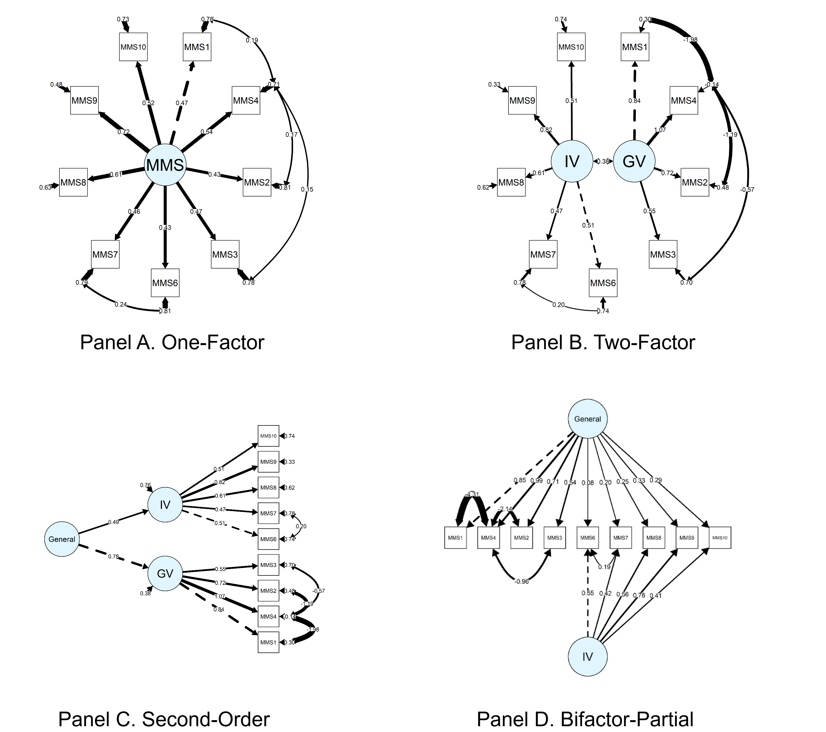
Supplementary Figure 2: Alternative structural models tested in confirmatory factor analysis.
To identify the optimal factorial structure of the Turkish Medical Maximizer-Minimizer Scale, five competing structural models were systematically evaluated using confirmatory factor analysis. The model comparison process began with a unidimensional model assuming all nine items reflect a single latent construct, followed by a two-factor correlated model distinguishing Generalist View and Individualist View as related but distinct dimensions. A second-order hierarchical model was also tested, positing that a higher-order general factor explains the covariance between two first-order specific factors. Additionally, a partial bifactor model was examined, as this structure had been identified in the original American validation study where items MMS1, MMS2, and MMS3 formed a distinct specific factor. For all models, theoretically justified modifications were implemented based on modification indices, including correlated error terms between conceptually overlapping items (MMS1-MMS4 and MMS6-MMS7). The Turkish sample revealed structural differences from the original scale: the Generalist View specific factor expanded to include MMS4 alongside MMS1-3, while MMS5—the only reverse-coded item—failed to load meaningfully on any dimension. This item demonstrated consistently poor psychometric performance across multiple analytic approaches, including low and inconsistent loadings in exploratory factor analysis, the lowest stability coefficient in bootstrap exploratory graph analysis, and non-significant factor loading in confirmatory models. Consequently, MMS5 was excluded from the final measurement instrument. Among all tested specifications, the full bifactor model demonstrated superior fit indices and best represented both the overarching medical maximizing-minimizing orientation and the two culturally relevant specific facets unique to the Turkish context (Supplementary Figure 2).
Bifactor Diagnostics and Scoring Recommendations
Supplementary Table 4 presents bifactor diagnostics for the selected full bifactor model.
Supplementary Table 4: Bifactor Model Diagnostics and Interpretation
Index | General | GV | IV | Threshold | Interpretation
ECV | .461 | .333 | .206 | > .60 | Multidimensional
PUC | .556 | – | – | > .80 | Subscales recommended
ω (omega total) | .738 | .772 | .497 | > .70 | Acceptable
ω_{H} / ω_{HS} | .535 | .548 | .287 | > .50 | GV adequate; IV weak
H | .722 | .713 | .553 | > .70 | General & GV well-defined
FD | .966 | .972 | .883 | > .90 | Excellent
Footnote. ECV = Explained Common Variance; PUC = Percentage of Uncontaminated Correlations; ω = omega total; ω_{H} = omega hierarchical (general factor); ω_{HS} = omega hierarchical subscale (specific factors); H = construct replicability index; FD = factor determinacy. GV = Generalist View; IV = Individualist View. Based on bifactor diagnostics, a multidimensional scoring approach is recommended: use the total score together with the Generalist View subscale score; the Individualist View subscale should be interpreted with caution.
The Explained Common Variance for the general factor (ECV = .461) indicates that less than half of the common variance is attributable to the general maximizing-minimizing factor, with specific factors contributing substantial unique variance. The Percentage of Uncontaminated Correlations (PUC = .556) falls below the .80 threshold. According to established interpretive guidelines, when both ECV and PUC fall below their respective thresholds, reliance on total scores alone may obscure meaningful multidimensionality, supporting the interpretation of subscale scores alongside total scores. Omega hierarchical for the general factor (ω_{H} = .535) indicates that approximately 54% of reliable variance in total scores is attributable to the general factor, while omega hierarchical subscale values suggest that the Generalist View subscale (ω_{HS} = .548) captures adequate unique reliable variance beyond the general factor, whereas the Individualist View subscale (ω_{HS} = .287) demonstrates limited unique reliability. Construct replicability indices (H) indicate that the general factor (H = .722) and Generalist View (H = .713) are well-defined constructs likely to replicate across samples, while the Individualist View (H = .553) shows lower replicability. Factor determinacy scores were excellent for all factors, indicating that factor scores can be estimated with high precision. Based on these diagnostics, a multidimensional scoring approach is recommended: researchers should report both the total score and the Generalist View subscale score; the Individualist View subscale should be interpreted cautiously and in conjunction with the total score rather than as a standalone indicator.

Sensitivity Analysis: Robust Estimation
Given that MMS items employ a 7-point Likert response format, a sensitivity analysis was conducted to evaluate the robustness of the bifactor model to alternative estimation approaches appropriate for ordinal data. The primary analyses used maximum likelihood (ML) estimation, which assumes continuous and normally distributed indicators. To address potential violations of these assumptions, the bifactor model was re-estimated using robust maximum likelihood (MLR), which provides Satorra-Bentler scaled chi-square statistics and robust standard errors that are resilient to non-normality.
Results demonstrated excellent consistency across estimators. Under ML estimation, the bifactor model yielded χ²_{df=14} = 15.556, p = .341, CFI = .997, TLI = .993, RMSEA = .021, and SRMR = .025. Under MLR estimation, the scaled fit indices were χ²_{df=14} = 13.851, p = .461, CFI = 1.000, TLI = 1.001, RMSEA = .000, and SRMR = .025. Standardized factor loadings were identical across both estimation methods (mean absolute difference = .000). The convergence of results across ML and MLR estimators confirms that the bifactor structure is robust to estimation method and that non-normality in item responses did not bias the primary findings.
Normality Assessment
The General Scale demonstrated acceptable skewness (-0.83) but elevated kurtosis (3.92), indicating a leptokurtic distribution with heavier tails than a normal distribution. The Shapiro-Wilk test was statistically significant (W = 0.957, p < .001), rejecting the normality assumption. The Generalist View subscale exhibited substantial negative skewness (-2.24) and excessive kurtosis (9.02), with the Shapiro-Wilk test strongly rejecting normality (W = 0.754, p < .001), indicating a highly peaked distribution with most scores concentrated at higher values. The Individualist View subscale showed relatively mild departures from normality, with skewness of -0.41 and kurtosis of 2.66 (excess kurtosis = -0.34), though the Shapiro-Wilk test remained significant (W = 0.978, p < .001). Item 5 (the excluded reverse-coded item) displayed near-normal skewness (-0.10) but platykurtic characteristics (excess kurtosis = -1.31), with significant Shapiro-Wilk results (W = 0.909, p < .001). The EQ-5D index exhibited severe negative skewness (-3.28) and extreme positive kurtosis (18.27), reflecting a ceiling effect common in health-related quality of life measures, with the Shapiro-Wilk test strongly rejecting normality (W = 0.666, p < .001). The EuroQol Visual Analog Scale showed moderate negative skewness (-0.99) and elevated kurtosis (3.97), with significant Shapiro-Wilk results (W = 0.925, p < .001). Given the violations of normality assumptions across all examined variables, non-parametric statistical methods (Spearman correlations, Mann-Whitney U tests, and Kruskal-Wallis tests) were employed for all subsequent inferential analyses to ensure robust and valid statistical inferences.

Supplementary Figure Legends
Supplementary Figure 1: Propensity score matching diagnostics for exploratory and confirmatory sample allocation. Panel A displays the propensity score density distributions for both groups, demonstrating substantial overlap indicative of successful matching. Panel B presents a Love plot showing standardized mean differences for all nine matching covariates (age, gender, marital status, parental status, education level, occupation, social security status, income level, and place of residence) before (circles) and after (triangles) matching. The vertical dashed line indicates the conventional SMD threshold of 0.10; all post-matching differences fall below this threshold, confirming adequate covariate balance between exploratory and confirmatory subsamples.
Supplementary Figure 2: Alternative structural models tested in confirmatory factor analysis for the nine-item Turkish Medical Maximizer-Minimizer Scale. (A) One-factor model with all items loading on a single MMS factor; (B) Two-factor correlated model with Generalist View and Individualist View as correlated factors; (C) Second-order model with a higher-order General factor explaining the two first-order factors; (D) Partial bifactor model with a General factor loading on all items and one orthogonal specific factor (Individualist View). Solid lines indicate positive loadings; dashed lines indicate negative or non-significant loadings. Standardized factor loadings are displayed on paths. All models estimated using maximum likelihood on the confirmatory sample (n = 255).

Supplementary Table 5: Turkish Version of the Medical Maximizer-Minimizer Scale (MMS-TR)
Sağlık Hizmeti Kullanımında Çoğaltıcı-Azaltıcı Eğilim Ölçeği
Lütfen aşağıdaki sorular için kendi sağlık hizmeti kullanım  eğiliminizi düşünerek “kesinlikle katılmıyorum, katılmıyorum, biraz  katılıyorum, ne katılıyorum ne katılmıyorum, biraz katılıyorum,  katılıyorum, kesinlikle katılıyorum” seçeneklerinden birini  işaretleyin. |  | Kesinlikle  Katılmıyorum (1) | Katılmıyorum (2) | Biraz  Katılmıyorum (3) | Ne Katılıyorum  Ne Katılmıyorum (4) | Biraz  Katılıyorum (5) | Katılıyorum (6) | Kesinlikle  Katılıyorum (7)
1. | Hayatta kalmak açısından bir fark yaratmasa bile bir hastalığı tedavi etmek önemlidir. |  |  |  |  |  |  | 
2. | Yaşam kalitesinde bir fark yaratmasa bile hastalığı tedavi etmek önemlidir. |  |  |  |  |  |  | 
3. | Hastalıkla mücadele etmek için her şey yapılmalıdır. |  |  |  |  |  |  | 
4. | Sağlık söz konusu olduğunda yapılacak en sorumlu davranış aktif olarak tıbbi yardım almaktır. |  |  |  |  |  |  | 
5. | Sağlık sorunum olduğunda, bekleyip bu sorunun kendi kendine  iyileşip iyileşmediğini görmeyi tercih ederim.* |  |  |  |  |  |  | 
6. | Kendimi sağlıklı hissetmediğimde yaptığım ilk iş doktora gidip reçete yazdırmaktır. |  |  |  |  |  |  | 
7. | Sıklıkla aile ve arkadaşlarıma doktorlarıyla görüşmelerini öneririm. |  |  |  |  |  |  | 
8. | Konu sağlık olunca bekleyip görmek asla kabul edilebilir bir seçenek değildir. |  |  |  |  |  |  | 
9. | Bir hastalığım olduğunda doğrudan doktora giderek görüşünü almayı tercih ederim. |  |  |  |  |  |  | 
10. | Konu tıbbi tedavi olduğunda daha fazla sağlık hizmeti almak daha iyidir. |  |  |  |  |  |  | 
Footnote. * Item 5 ("If I have a health issue, my preference is to wait and see if the problem gets better on its own before going to the doctor") was excluded from the final scale based on converging psychometric evidence: low corrected item-total correlation (r = .105), non-significant factor loading (λ = .028, p = .691), and low bootstrap stability coefficient (0.688). The recommended final scale consists of 9 items (Items 1–4 and Items 6–10).

