Supplementary Material for

The Relationship Between Urinary Neonicotinoids Concentrations and Obesity Among Individuals Aged 35 to 74 in Guangxi, China
Submitted by
Liujuan Ou^{1,*}, Junshang Wen^{1,*}, Wanhui Li¹, Xin Qin¹, Xiaolin Wu², Qihua Zhu³, Junwang Gu⁴, Huishen Huang⁵, Xiaohong Liu⁶, Xiaoqiang Qiu⁷, Dongping Huang⁸
¹Department of Nutrition and Food Hygiene, School of Public Health, Guangxi Medical University, Nanning, Guangxi, China; ²Department of Community Health Service, Fengcheng Town, Shanghai, China; ³Beihai Center for Disease Control and Prevention, Beihai, Guangxi, China; ⁴Department of Epidemiology and Health Statistics, School of Public Health, Guangxi Medical University, Nanning, Guangxi, China; ⁵Department of Occupational and Environmental Health, School of Public Health, Guangxi Medical University, Nanning, Guangxi, China; ⁶ Information Center, Guangxi Medical University, Nanning, Guangxi, China; ⁷Department of Sanitary Chemistry, School of Public Health, Guangxi Medical University, Nanning, Guangxi, China.
*These authors contributed equally to this work.
Correspondence: Dongping Huang; Xiaoqiang Qiu, Department of Sanitary Chemistry, School of Public Health, Guangxi Medical University, Nanning, Guangxi, China, Department of Epidemiology and Health Statistics, School of Public Health, Guangxi Medical University, Nanning, Guangxi, China, E-mail dongpinghuang@gxmu.edu.cn; xqqiu9999@163.com.
Text: 1.
Figures: 5.
Tables: 8.

Contents:
Text S1. Determination of neonicotinoids (NEOs) in urine sample.
Fig. S1. Spearman correlation between urinary NEOs concentrations of research subjects. All correlations were statistically significant (p<0.001). Abbreviations: CLO, clothianidin; NACE, N-desmethyl-acetamiprid; IMI, imidacloprid; TMX, thiamethoxam.
Fig. S2. Sex-stratified weights for the positive and negative partial effects of NEOs on OWO and ABO from quantile g-computation (Qgcomp) model. The model was adjusted for age, education, residence, smoking status, drinking status, ALT, AST, DDS, FBG, HDL-C, LDL-C, TC, TG, UA, SBP, DBP. (A) OWO in females. (B) ABO in females. (C) OWO in males. (D) ABO in males.
Fig. S3. A sex-stratified analysis of the associations between urinary NEOs and and both OWO and ABO was performed using the Bayesian kernel machine regression (BKMR) model. The model was adjusted for age, education, residence, smoking status, drinking status, ALT, AST, DDS, FBG, HDL-C, LDL-C, TC, TG, UA, SBP, DBP. (A, E) Quantile effect plots for OWO in females and males, respectively. (B, F) Univariate exposure-response function plots for OWO in females and males, respectively. (C, G) Quantile effect plots for abdominal obesity (ABO) in females and males, respectively. (D, H) Univariate exposure-response function plots for ABO in females and males, respectively.
Fig. S4. Performance of machine learning models based on NEOs in predicting OWO risk (area under the curve (AUC) values). (A) Decision Tree (DT); (B) K-Nearest Neighbors (KNN); (C) Light Gradient Boosting Machine (LightGBM); (D) Multilayer Perceptron (MLP); (E) Random Forest (RF); (F) eXtreme Gradient Boosting (XGBoost).
Fig. S5. Performance of machine learning models based on NEOs in predicting ABO risk (AUC values). (A) Decision Tree (DT); (B) K-Nearest Neighbors (KNN); (C) Light Gradient Boosting Machine (LightGBM); (D) Multilayer Perceptron (MLP); (E) Random Forest (RF); (F) eXtreme Gradient Boosting (XGBoost).
Table S1 Recovery rates and relative standard deviations of the target compounds at three concentration levels.
Table S2 The detection rate and exposure level of NEOs in urine.
Table S3 Sex-stratified associations of urinary NEOs exposure with OWO and ABO using generalized linear models.
Table S4 Contribution weights of NEOs compounds to OWO and ABO assessed using Qgcomp model.
Table S5 Posterior inclusion probabilities (PIPs) determined using BKMR model.
Table S6 Comparison of diagnostic OWO performance of six different machine learning models.
Table S7 Comparison of diagnostic ABO performance of six different machine learning models.
Table S8 Associations of urinary NEOs concentrations with continuous BMI and WC in the sensitivity analysis.

Text S1. Determination of NEOs in urine sample.
Urinary concentrations of ten NEOs were quantified using ultra-performance liquid chromatography-tandem mass spectrometry (UPLC-MS/MS, Waters, USA). The analytes included acetamiprid (ACE), imidacloprid (IMI), nitenpyram (NIT), thiamethoxam (THIA), fipronil (FLU), thiacloprid (TMX), clothianidin (CLO), dinotefuran (DIN), sulfoxaflor (SUL), and N-desmethyl-acetamiprid (NACE).
The analytical methodology was as follows:
(1) Sample preparation: After collecting 1.2 mL of urine sample, add 20 μL of a 300 ng/mL mixed internal standard solution (containing THIA-¹³C₆, TMX-¹³C₄-¹⁵N, NIT-¹³C₃-¹⁵N₂, IMI-¹³C₆, CLO-¹³C₄-¹⁵N, ACE-¹³C₆, NACE-¹³C₂-¹⁵N, DIN-¹³C₅), and vortex mix. After adding 3 mL of ethyl acetate, the mixture was vortexed for 3 min and centrifuged at 5000 rpm for 5 min, and the supernatant was collected. The extraction was repeated a second time with an additional 3 mL of ethyl acetate. The combined supernatants were then evaporated to dryness under a vacuum at 45°C using a centrifugal concentrator (JM Technology Co., Ltd., Beijing, China). The residue was reconstituted in 300 μL reconstitution solution (acetonitrile: water =2:8), mixed thoroughly, equilibrated at room temperature for 30 minutes, filtered through a 0.22 μm membrane filter, and injected for analysis.
(2) Calibration curve preparation: Quantitative analysis employed the internal standard method. Mixed standard solutions were serially diluted, combined with 10 μL mixed internal standard solution (20 ng/mL), and diluted to 1 mL with acetonitrile:water (2:8, v/v) to prepare mixed standard solutions at 10 concentration levels ranging from 0.0-50 ng/mL (0, 0.25, 0.5, 1, 2.5, 5, 10, 25, 50 ng/mL).
(3) Qualitative and quantitative analysis: Determination of NEOs by UPLC-MS/MS. Qualitative analysis was based on precursor ion characteristics and retention times, while quantitative analysis utilized quantifier ion peak areas with internal standard correction.
(4) Method accuracy and precision: Given the widespread presence of NEOs in the environment and the associated high potential for human exposure, we employed artificial urine (Solarbio, Beijing, China) to perform method validation in order to minimize potential matrix interference. A spike-and-recovery experiment was conducted by spiking the artificial urine samples with a mixed standard solution of the target analytes and a mixed internal standard solution. Samples were prepared at three concentration levels (low, medium, and high) corresponding to 1.0 ng/mL, 5.0 ng/mL, and 10.0 ng/mL of the target compounds, with the concentration of all internal standards maintained at 20 ng/mL. For each concentration level, six replicate samples were prepared and analyzed. The average recovery rate and relative standard deviation (RSD) for each compound at each concentration are presented in Table S1.

Table S1 Recovery rates and relative standard deviations of the target compounds at three concentration levels.
NEOs | Labeled concentration (ng/mL)
NEOs | 1 |  |  | 5 |  |  | 10
NEOs | Recovery rate (%) | RSD (%) |  | Recovery rate (%) | RSD (%) |  | Recovery rate (%) | RSD (%)
ACE | 98.10 | 9.03 |  | 104.90 | 10.84 |  | 102.67 | 13.76
CLO | 104.90 | 8.37 |  | 110.60 | 12.35 |  | 91.50 | 10.93
DIN | 101.02 | 9.88 |  | 99.60 | 7.74 |  | 103.15 | 9.57
IMI | 110.00 | 14.30 |  | 106.3 | 9.29 |  | 105.20 | 5.96
NACE | 103.60 | 8.48 |  | 96.93 | 5.07 |  | 99.20 | 5.49
NIT | 92.45 | 5.27 |  | 80.40 | 6.74 |  | 91.75 | 13.95
SUL | 85.50 | 13.78 |  | 95.60 | 8.52 |  | 85.60 | 6.34
TMX | 91.60 | 5.31 |  | 117.00 | 9.14 |  | 104.00 | 11.14
THIA | 112.60 | 5.36 |  | 107.00 | 3.89 |  | 106 | 2.94
FLU | 83.73 | 4.27 |  | 86.07 | 3.78 |  | 105.59 | 7.59
Abbreviations: ACE: acetamiprid, CLO: clothianidin, DIN: dinotefuran, IMI: imidacloprid, NACE: N-desmethyl-acetamiprid, NIT: nitenpyram, SUL: sulfoxaflor, TMX: thiacloprid, THIA: thiamethoxam, FLU: fipronil.

Table S2 The detection rate and exposure level of NEOs in urine.
NEOs | Detection rate  (%) | LOD  (ng/ml) | Unadjustedª (ng/ml) |  |  |  |  |  | Creatinine adjustedª (μg/g creatinine)
NEOs | Detection rate  (%) | LOD  (ng/ml) | P25 | P50 | P75 | P95 |  |  | P25 | P50 | P75 | P95
ACE | 9.16 | 0.05 | <LOD | <LOD | <LOD | 0.209 |  |  | <LOD | <LOD | <LOD | 0.143
CLO | 54.99 | 0.05 | <LOD | 0.433 | 2.076 | 11.772 |  |  | <LOD | 0.257 | 1.332 | 7.339
DIN | 12.30 | 0.05 | <LOD | <LOD | <LOD | 0.544 |  |  | <LOD | <LOD | <LOD | 0.330
IMI | 50.00 | 0.05 | <LOD | <LOD | 0.293 | 1.144 |  |  | <LOD | <LOD | 0.199 | 0.916
NACE | 95.82 | 0.05 | 0.838 | 2.611 | 7.328 | 35.608 |  |  | 0.532 | 1.596 | 4.646 | 20.712
NIT | 7.54 | 0.15 | <LOD | <LOD | <LOD | 0.311 |  |  | <LOD | <LOD | <LOD | 0.160
SUL | 8.58 | 0.10 | <LOD | <LOD | <LOD | 0.709 |  |  | <LOD | <LOD | <LOD | 0.413
TMX | 82.02 | 0.05 | 0.159 | 0.568 | 1.721 | 8.814 |  |  | 0.095 | 0.375 | 1.042 | 4.658
THIA | 0.00 | 0.05 | <LOD | <LOD | <LOD | <LOD |  |  | <LOD | <LOD | <LOD | <LOD
FLU | 0.30 | 0.05 | <LOD | <LOD | <LOD | <LOD |  |  | <LOD | <LOD | <LOD | <LOD
Abbreviations: NEOs, neonicotinoids; LOD, limit of detection.
ªThe exposure concentration of NEOs has not been subjected to Ln conversion treatment.

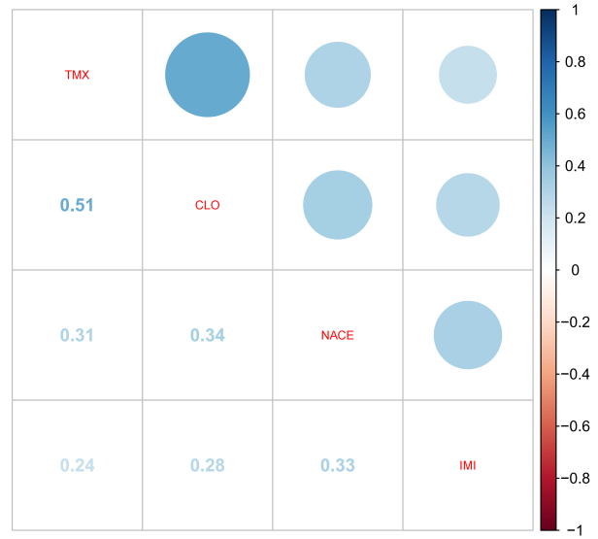

Fig. S1. Spearman correlation between urinary NEOs concentrations of research subjects. All correlations were statistically significant (p<0.001). Abbreviations: CLO, clothianidin; NACE, N-desmethyl-acetamiprid; IMI, imidacloprid; TMX, thiamethoxam.

Table S3 Sex-stratified associations of urinary NEOs exposure with OWO and ABO using generalized linear models.
NEOsª | Outcomes | Model 1  [OR (95% CI)] | Model 2  [OR(95% CI)] | Model 3  [OR (95% CI)]
Female
CLO | OWO | 1.134 (1.039, 1.239)* | 1.136 (1.038, 1.244)* | 1.134 (1.023, 1.258)*
CLO | ABO | 1.080 (0.980, 1.191) | 1.105 (1.000, 1.222) | 1.081 (0.965, 1.210)
NACE | OWO | 1.095 (0.980, 1.225) | 1.100 (0.981, 1.235) | 1.059 (0.927, 1.212)
NACE | ABO | 1.092 (0.965, 1.239) | 1.152 (1.011, 1.316)* | 1.089 (0.938, 1.268)
IMI | OWO | 1.157 (0.996, 1.344) | 1.155 (0.991, 1.346) | 1.193 (1.001, 1.424)*
IMI | ABO | 1.174 (0.995, 1.381) | 1.210 (1.020, 1.432)* | 1.244 (1.031, 1.501)*
TMX | OWO | 1.026 (0.919, 1.146) | 1.017 (0.908, 1.138) | 0.968 (0.851, 1.099)
TMX | ABO | 1.039 (0.919, 1.176) | 1.044 (0.919, 1.186) | 1.013 (0.878, 1.167)
Male
CLO | OWO | 1.043 (0.934, 1.164) | 1.031 (0.919, 1.154) | 0.987 (0.853, 1.139)
CLO | ABO | 1.081 (0.953, 1.224) | 1.087 (0.955, 1.235) | 1.098 (0.936, 1.289)
NACE | OWO | 1.228 (1.073, 1.411)* | 1.230 (1.070, 1.421)* | 1.237 (1.035, 1.486)*
NACE | ABO | 1.286 (1.100, 1.514)* | 1.304 (1.111, 1.542)* | 1.381 (1.119, 1.724)*†
IMI | OWO | 1.063 (0.883, 1.277) | 1.056 (0.869, 1.279) | 1.079 (0.853, 1.361)
IMI | ABO | 0.991 (0.793, 1.220) | 1.008 (0.800, 1.251) | 1.044 (0.799, 1.347)
TMX | OWO | 1.040 (0.906, 1.193) | 1.021 (0.887, 1.175) | 0.988 (0.822, 1.186)
TMX | ABO | 1.132 (0.968, 1.326) | 1.120 (0.956, 1.314) | 1.169 (0.948, 1.442)
Abbreviations: NEOs, neonicotinoids; OWO, overweight and obesity; ABO, abdominal obesity; OR, odds Ratio; CI, confidence interval.
Model 1: unadjusted;
Model 2: adjusted for age, education, residence, smoking status, drinking status, DDS;
Model 3: adjusted for age, education, residence, smoking status, drinking status, AST, ALT, DDS, FBG, HDL-C, LDL-C, TC, TG, UA,SBP, DBP.
ª The exposure concentration of NEOs has been subjected to Ln conversion treatment.
* and bold significant at p < 0.05.
† False discovery rate (FDR)-adjusted p value < 0.05.

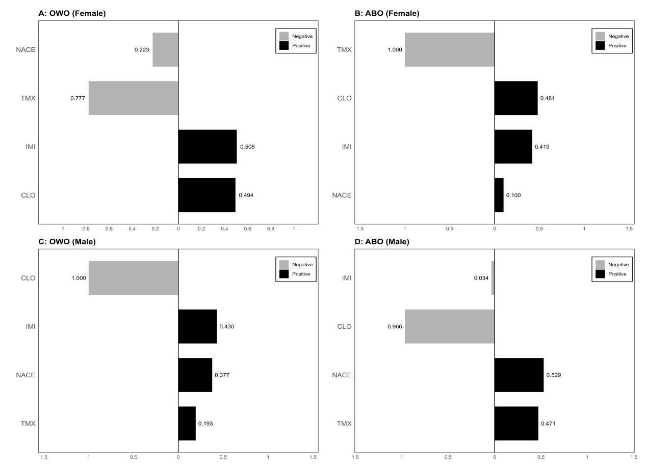

Fig. S2. Sex-stratified weights for the positive and negative partial effects of NEOs on OWO and ABO from quantile g-computation (Qgcomp) model. The model was adjusted for age, education, residence, smoking status, drinking status, ALT, AST, DDS, FBG, HDL-C, LDL-C, TC, TG, UA, SBP, DBP. (A) OWO in females. (B) ABO in females. (C) OWO in males. (D) ABO in males.

Table S4 Contribution weights of NEOs compounds to OWO and ABO assessed using Qgcomp model.
 | Outcomes | OR | 95% CI | p value
Totalª | OWO | 1.568 | (0.989, 2.484) | 0.055
Totalª | ABO | 1.964 | (1.181, 3.266) | 0.009
Female^{b} | OWO | 2.053 | (1.141, 3.695) | 0.016
Female^{b} | ABO | 2.089 | (1.103, 3.954) | 0.024
Male^{b} | OWO | 1.041 | (0.480, 2.255) | 0.919
Male^{b} | ABO | 1.521 | (0.642, 3.605) | 0.341
ªThe model was adjusted for age, sex, education, residence, smoking status, drinking status, ALT, AST, DDS, FBG, HDL-C, LDL-C, TC, TG, UA, SBP, DBP.
^{b}The model was adjusted for age, education, residence, smoking status, drinking status, ALT, AST, DDS, FBG, HDL-C, LDL-C, TC, TG, UA, SBP, DBP.
Bold indicates statistically significant differences (p < 0.05).
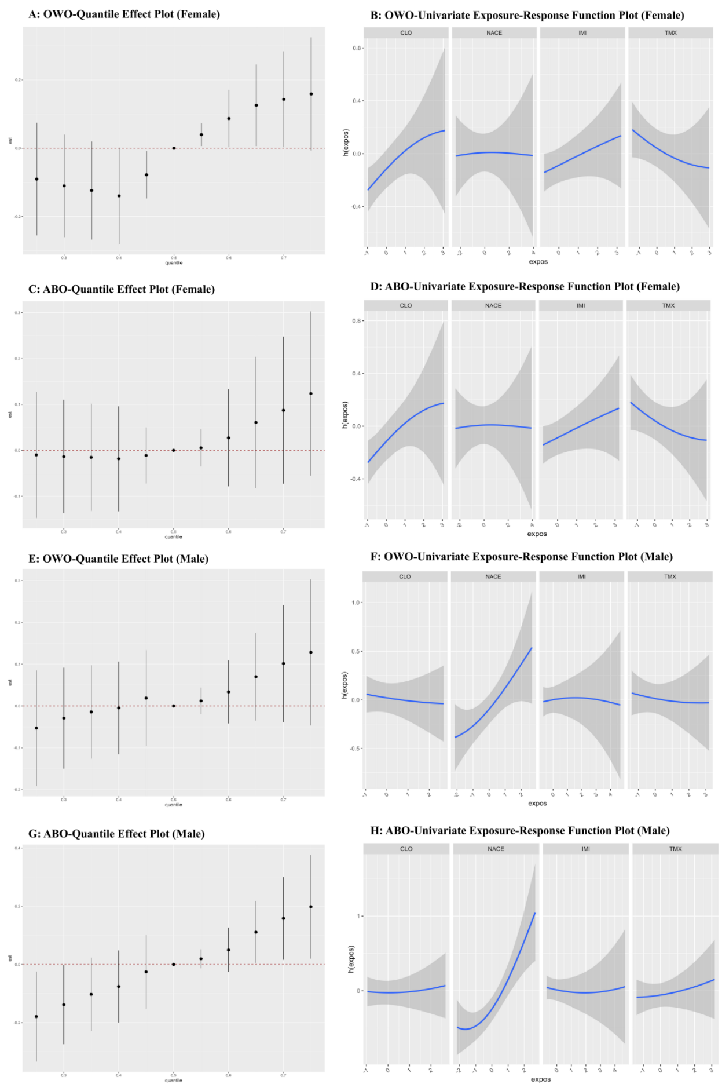

Fig. S3. A sex-stratified analysis of the associations between urinary NEOs and and both OWO and ABO was performed using the Bayesian kernel machine regression (BKMR) model. The model was adjusted for age, education, residence, smoking status, drinking status, ALT, AST, DDS, FBG, HDL-C, LDL-C, TC, TG, UA, SBP, DBP. (A, E) Quantile effect plots for OWO in females and males, respectively. (B, F) Univariate exposure-response function plots for OWO in females and males, respectively. (C, G) Quantile effect plots for abdominal obesity (ABO) in females and males, respectively. (D, H) Univariate exposure-response function plots for ABO in females and males, respectively.

Table S5 Posterior inclusion probabilities (PIPs) determined using BKMR model.
Outcomes | NEOsª | Total^{b} PIPs | Sex^{c}
Outcomes | NEOsª | Total^{b} PIPs | Female PIPs | Male PIPs
OWO | CLO | 0.611 | 0.635 | 0.107
OWO | NACE | 0.583 | 0.201 | 0.680
OWO | IMI | 0.604 | 0.414 | 0.192
OWO | TMX | 0.554 | 0.373 | 0.149
ABO | CLO | 0.265 | 0.205 | 0.127
ABO | NACE | 0.737 | 0.169 | 0.949
ABO | IMI | 0.256 | 0.630 | 0.161
ABO | TMX | 0.195 | 0.135 | 0.154
ª The exposure concentration of NEOs has been subjected to Ln conversion treatment.
^{b}The model was adjusted for age, sex, education, residence, smoking status, drinking status, ALT, AST, DDS, FBG, HDL-C, LDL-C, TC, TG, UA, SBP, DBP.
^{c}The model was adjusted for age, education, residence, smoking status, drinking status, ALT, AST, DDS, FBG, HDL-C, LDL-C, TC, TG, UA, SBP, DBP.

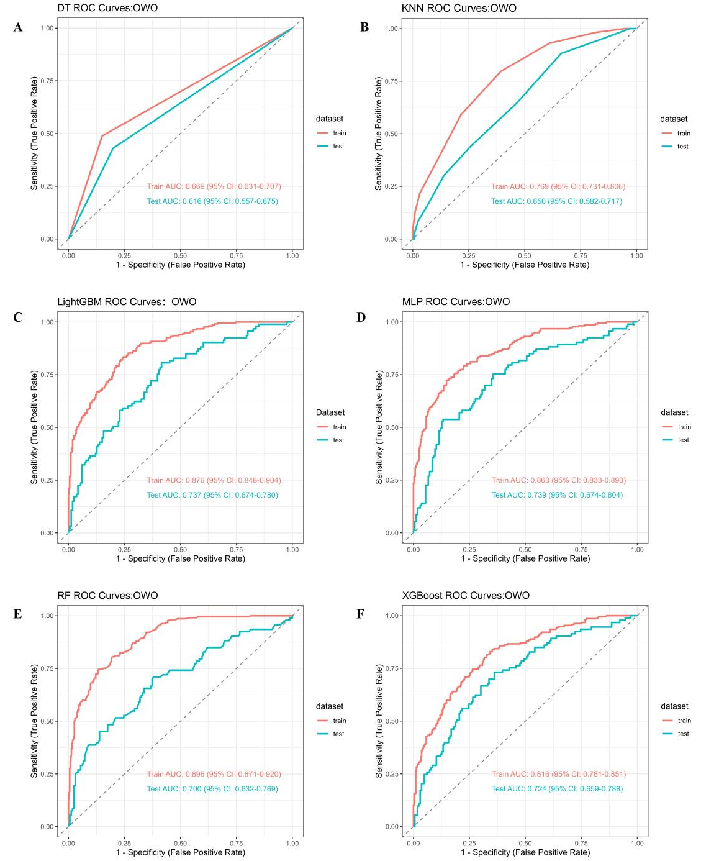

Fig. S4. Performance of machine learning models based on NEOs in predicting OWO risk (area under the curve (AUC) values). (A) Decision Tree (DT); (B) K-Nearest Neighbors (KNN); (C) Light Gradient Boosting Machine (LightGBM); (D) Multilayer Perceptron (MLP); (E) Random Forest (RF); (F) eXtreme Gradient Boosting (XGBoost).

Table S6 Comparison of diagnostic OWO performance of six different machine learning models.
Classfier | AUC | Accurracy | Sensitivity | Specificity
Train set
DT | 0.669 | 0.720 | 0.488 | 0.850
KNN | 0.769 | 0.675 | 0.797 | 0.606
LightGBM | 0.876 | 0.784 | 0.834 | 0.756
MLP | 0.863 | 0.806 | 0.724 | 0.852
RF | 0.896 | 0.823 | 0.747 | 0.865
XGBOOST | 0.795 | 0.757 | 0.669 | 0.785
Test set
DT | 0.616 | 0.668 | 0.430 | 0.801
KNN | 0.650 | 0.575 | 0.645 | 0.536
LightGBM | 0.737 | 0.660 | 0.634 | 0.675
MLP | 0.739 | 0.703 | 0.538 | 0.795
RF | 0.700 | 0.672 | 0.527 | 0.753
XGBOOST | 0.717 | 0.685 | 0.581 | 0.717
Abbreviations: AUC, area under the curve; DT, Decision Tree; KNN, K-Nearest Neighbors; LightGBM, Light Gradient Boosting Machine; MLP, Multilayer Perceptron; RF, Random Forest; XGBoost, eXtreme Gradient Boosting.

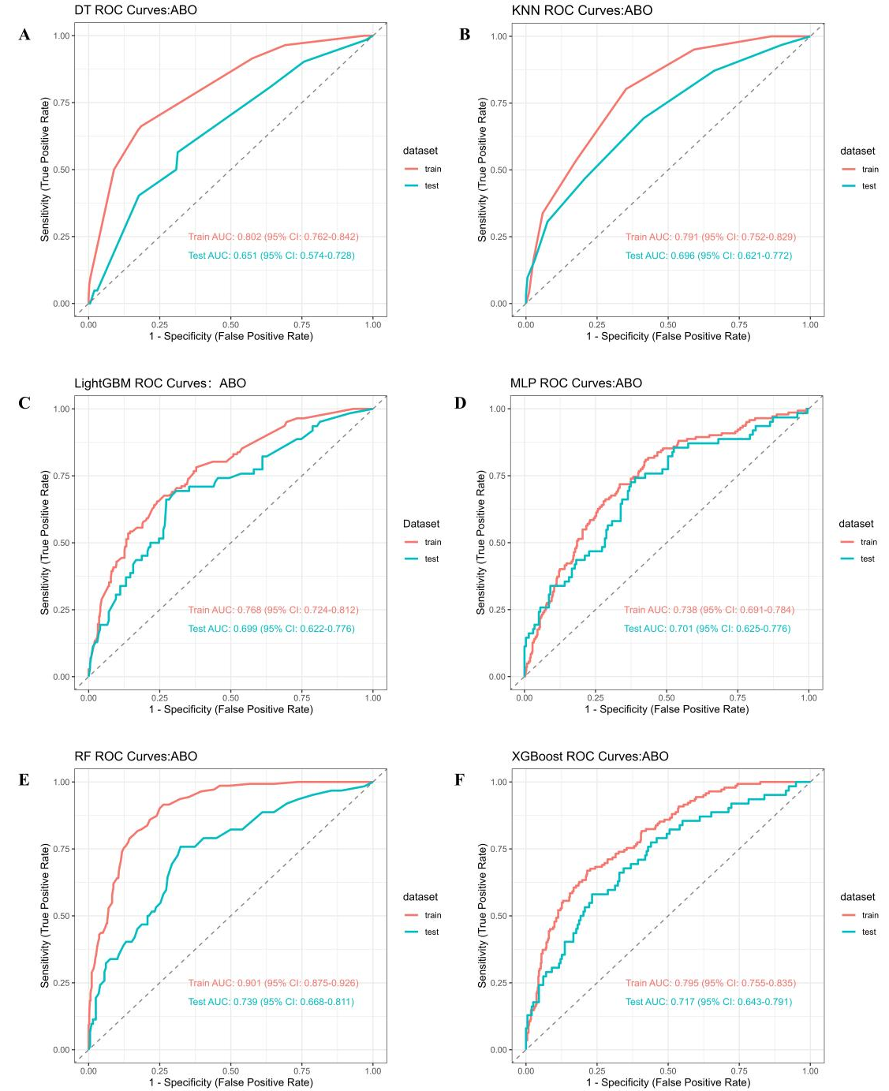

Fig. S5. Performance of machine learning models based on NEOs in predicting ABO risk (AUC values). (A) Decision Tree (DT); (B) K-Nearest Neighbors (KNN); (C) Light Gradient Boosting Machine (LightGBM); (D) Multilayer Perceptron (MLP); (E) Random Forest (RF); (F) eXtreme Gradient Boosting (XGBoost).

Table S7 Comparison of diagnostic ABO performance of six different machine learning models.
Classfier | AUC | Accurracy | Sensitivity | Specificity
Train set
DT | 0.802 | 0.779 | 0.662 | 0.815
KNN | 0.791 | 0.684 | 0.803 | 0.648
LightGBM | 0.768 | 0.734 | 0.655 | 0.759
MLP | 0.738 | 0.630 | 0.810 | 0.574
RF | 0.901 | 0.779 | 0.915 | 0.737
XGBOOST | 0.816 | 0.720 | 0.829 | 0.658
Test set
DT | 0.651 | 0.658 | 0.565 | 0.687
KNN | 0.696 | 0.612 | 0.694 | 0.586
LightGBM | 0.699 | 0.700 | 0.677 | 0.707
MLP | 0.701 | 0.612 | 0.758 | 0.566
RF | 0.739 | 0.642 | 0.790 | 0.596
XGBOOST | 0.724 | 0.664 | 0.731 | 0.627

Table S8 Associations of urinary NEOs concentrations with continuous BMI and WC in the sensitivity analysis.
NEOsª | BMI |  |  | WC
NEOsª | β (95% CI) | p value |  | β (95% CI) | p value
CLO | 0.089 (-0.009, 0.187) | 0.075 |  | 0.164 (-0.107, 0.435) | 0.234
NACE | 0.139 (0.017, 0.260) | 0.025 |  | 0.470 (0.136, 0.804) | 0.006
IMI | 0.082 (-0.085, 0.250) | 0.335 |  | 0.359 (-0.102, 0.819) | 0.127
TMX | 0.008 (-0.114, 0.130) | 0.898 |  | 0.253 (-0.084, 0.589) | 0.140
ª The exposure concentration of NEOs has been subjected to Ln conversion treatment.
Adjusted for age, sex, education, residence,smoking status, drinking status, ALT, AST, DDS, FBG, HDL-C, LDL-C, TC, TG, UA,SBP, DBP.
Bold significant at p < 0.05.

