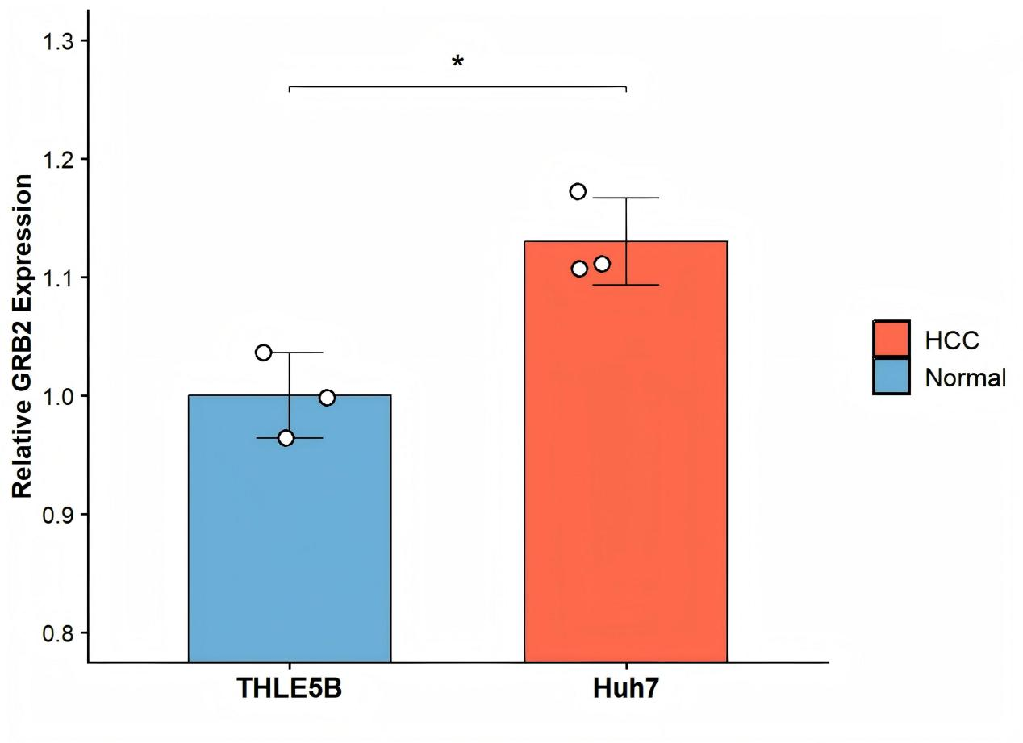
Supplementary Figure 1. GRB2 expression in THLE5B (normal) and Huh7 (HCC) cells from the E-MTAB-7847 dataset (n = 3). unpaired t-test ,*P = 0.012.

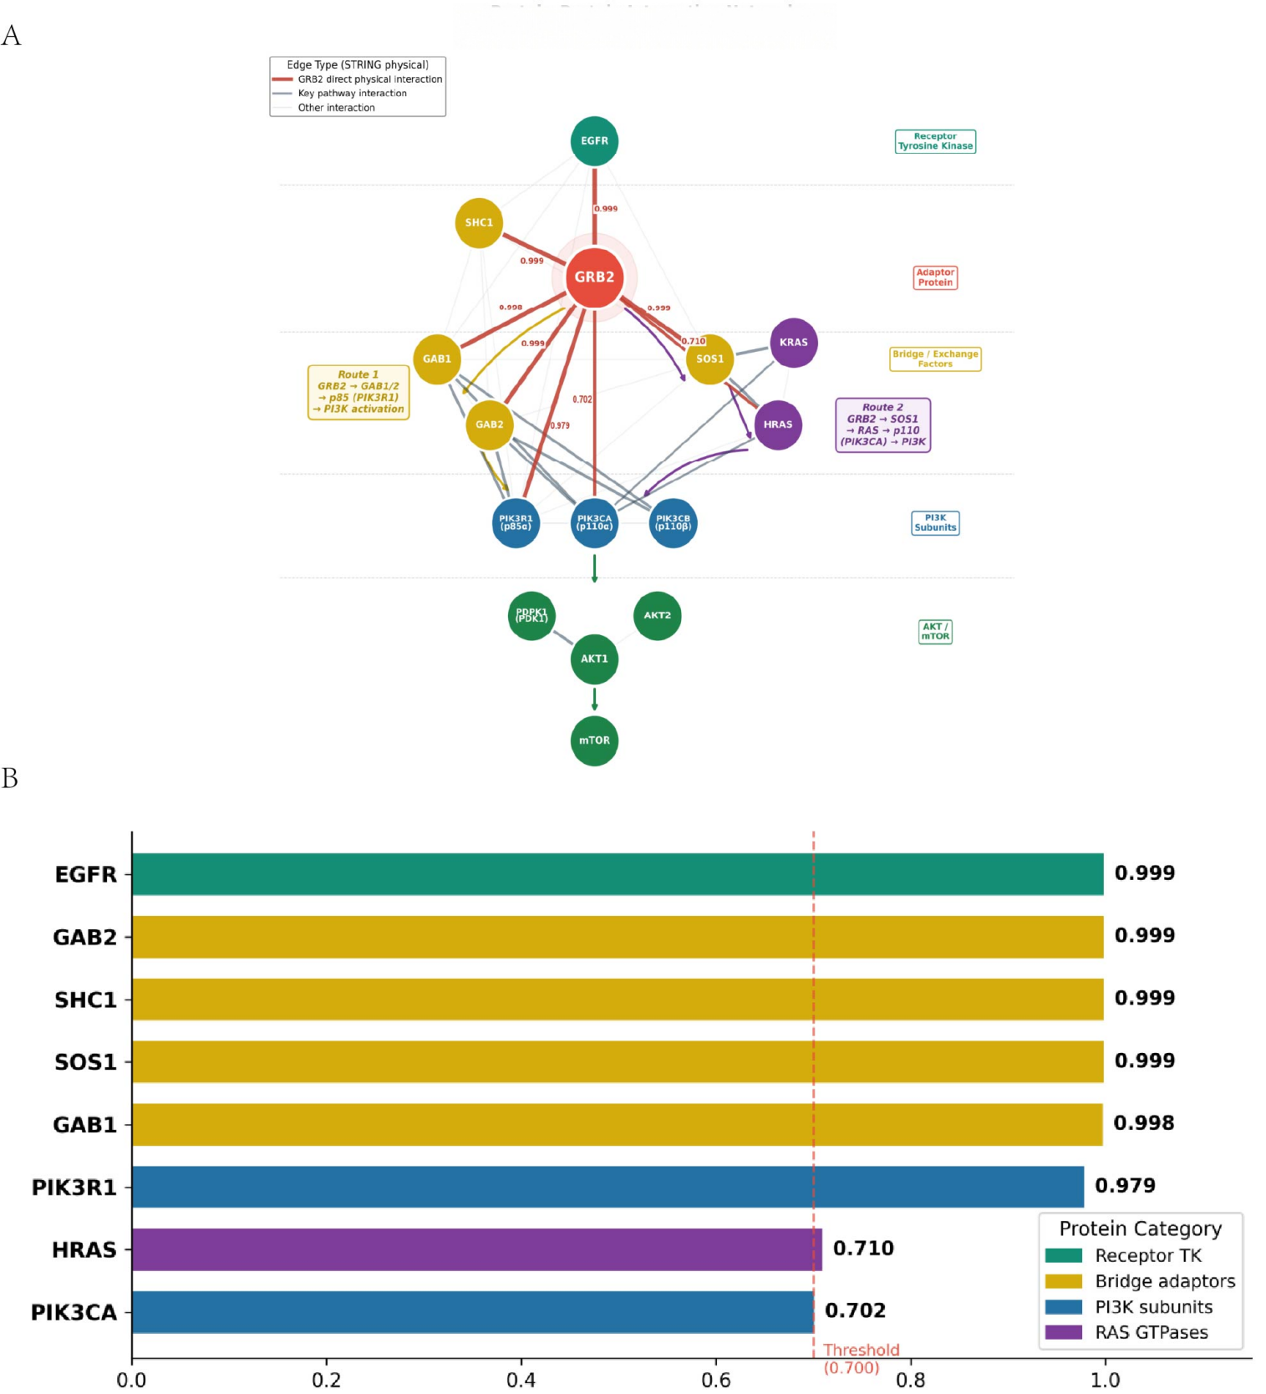

Supplementary Figure 2. A.STRING protein–protein interaction network；B.physical interaction scores between GRB2 and PI3K/AKT pathway components.

Supplementary Table 1.CCK-8 dose-response data and IC50 values of sorafenib in Huh7 cells
24h
Sorafenib  (μM) | Normoxia — Cell viability (%) |  |  |  |  | Mean ± SD | Hypoxia — Cell viability (%) |  |  |  |  | Mean ± SD
Sorafenib  (μM) | Rep1 | Rep2 | Rep3 | Rep4 | Rep5 | Mean ± SD | Rep1 | Rep2 | Rep3 | Rep4 | Rep5 | Mean ± SD
0 | 102.2 | 97.2 | 111.1 | 99.2 | 90.4 | 100.0 ± 7.6 | 81.7 | 131.6 | 91 | 90.5 | 102.2 | 99.4 ± 19.4
5 | 42.3 | 55.2 | 59.4 | 51.6 | 46.5 | 51.0 ± 6.8 | 65.8 | 56.6 | 74 | 70 | 74.3 | 68.1 ± 7.3
10 | 25.8 | 28.4 | 28.2 | 24.2 | 38.3 | 29.0 ± 5.5 | 45.4 | 50.2 | 49.1 | 49.3 | 41 | 47.0 ± 3.8
20 | 15.8 | 20.6 | 18.2 | 19.9 | 15.5 | 18.0 ± 2.3 | 34.6 | 29.6 | 33.4 | 26.6 | 32.8 | 31.4 ± 3.3
40 | 1.7 | 4.2 | 4.1 | 3.1 | 4.5 | 3.5 ± 1.1 | 2.7 | 5.6 | 4.4 | 3 | 3.2 | 3.8 ± 1.2
IC50（μM） | 5.519 |  |  |  |  |  | 9.177

48h
Sorafenib  (μM) | Normoxia — Cell viability (%) |  |  |  |  | Mean ± SD | Hypoxia — Cell viability (%) |  |  |  |  | Mean ± SD
Sorafenib  (μM) | Rep1 | Rep2 | Rep3 | Rep4 | Rep5 | Mean ± SD | Rep1 | Rep2 | Rep3 | Rep4 | Rep5 | Mean ± SD
0 | 116 | 101.9 | 92.4 | 107.7 | 83.7 | 100.3 ± 12.7 | 96.5 | 105 | 98.2 | 95.9 | 107.6 | 100.6 ± 5.3
5 | 23.2 | 25.9 | 27.1 | 21.7 | 23.6 | 24.3 ± 2.2 | 33.7 | 40.4 | 39.6 | 35.7 | 35.4 | 37.0 ± 2.9
10 | 11.5 | 13.4 | 11.9 | 13.3 | 14.7 | 13.0 ± 1.3 | 29.7 | 27.6 | 35.2 | 33 | 21.5 | 29.4 ± 5.3
20 | 5.6 | 6.1 | 5.8 | 4.5 | 5.6 | 5.5 ± 0.6 | 16.3 | 16.5 | 14.8 | 17.6 | 15.8 | 16.2 ± 1.0
40 | 0.3 | 3.5 | 4.2 | 2.2 | 3.2 | 2.7 ± 1.5 | 1.6 | 4.6 | 5.3 | 3.9 | 3.2 | 3.7 ± 1.4
72h
Sorafenib  (μM) | Normoxia — Cell viability (%) |  |  |  |  | Mean ± SD | Hypoxia — Cell viability (%) |  |  |  |  | Mean ± SD
Sorafenib  (μM) | Rep1 | Rep2 | Rep3 | Rep4 | Rep5 | Mean ± SD | Rep1 | Rep2 | Rep3 | Rep4 | Rep5 | Mean ± SD
0 | 85.6 | 105.4 | 113.2 | 90.8 | 106.6 | 100.3 ± 11.6 | 100.3 | 92.7 | 99.7 | 105.5 | 100.6 | 99.8 ± 4.6
5 | 15.8 | 16.1 | 18.2 | 17.3 | 16.3 | 16.7 ± 1.0 | 10.4 | 11.4 | 18.5 | 14.8 | 13.4 | 13.7 ± 3.2
10 | 7.3 | 8 | 7.2 | 9 | 6.4 | 7.6 ± 1.0 | 9.9 | 8.1 | 13.5 | 9.2 | 7 | 9.6 ± 2.5
20 | 3.9 | 4.5 | 3.5 | 3 | 4.1 | 3.8 ± 0.6 | 3.2 | 4.8 | 4.4 | 4.7 | 3.9 | 4.2 ± 0.7
40 | 2.7 | 2 | 2.7 | 2.5 | 1.9 | 2.4 ± 0.4 | 0.5 | 1.3 | 1.2 | 0.7 | 0.6 | 0.9 ± 0.4

Notes:
Cell viability was measured by CCK-8 assay. Values represent percentage of cell viability relative to untreated control.
Data are from five biological replicates (n = 5).
IC50 values were determined by nonlinear regression (dose-response curve fitting).

