Supplementary Table 1. Inter-scorer reliability across participating PSG scoring teams

Scorer pair | Sleep-stage agreement, % | Cohen’s kappa for sleep stages | Respiratory-event agreement, % | Desaturation agreement, %
TVGH / CMUH | 90 | 0.830 | 88.9 | 98.4
TVGH / HTCH | 85 | 0.751 | 88.9 | 98.3
CMUH / HTCH | 82 | 0.711 | 88.6 | 99.0
Sleep-stage agreement was calculated as pairwise percent agreement across the reliability dataset, and Cohen’s kappa was used to account for chance agreement in sleep-stage classification. Respiratory-event and desaturation agreement values represent pairwise percent agreement obtained from epoch-level event comparison summaries. Pairwise comparisons were performed among the three participating PSG scoring teams.
TVGH, Taipei Veterans General Hospital; CMUH, China Medical University Hospital; HTCH, Hualien Tzu Chi Hospital; PSG, polysomnography.

Supplementary Table 2. Baseline Demographic, Clinical, and Sleep-Study Characteristics of the Participants, According to OSA Severity.
 |  | Total  (N=479) | Normal  (N=134) |  | Mild OSA  (N=105) | Moderate OSA  (N=83) |  | Severe OSA  (N=157) | p-value
Baseline demographics
 | Age, years | 42.0 (33.0-54.0) | 35.0 (28.0-47.0) | 45.0 (34.5-53.5) |  |  | 46.0 (34.0-57.0) | 46.0 (34.5-55.0) | <0.001
 | Male, n (%) | 372 (77.7%) | 86 (64.2%) | 79 (75.2%) |  |  | 62 (74.7%) | 145 (92.4%) | <0.001
 | Body mass index, kg/m² | 27.5 (24.8-30.9) | 25.0 (22.8-27.6) | 27.2 (25.0-29.4) |  |  | 27.9 (24.6-30.7) | 30.0 (27.3-33.6) | <0.001
 | Neck circumference, cm | 38.5 (36.2-41.0) | 37.0 (34.0-38.5) | 38.0 (36.2-40.0) |  |  | 38.0 (36.4-40.0) | 41.0 (39.0-43.0) | <0.001
Comorbidities, n (%)
 | Hypertension | 132 (27.6%) | 23 (17.2%) |  | 24 (22.9%) | 23 (27.7%) |  | 62 (39.5%) | <0.001
 | CAD | 25 (5.2%) | 5 (3.7%) |  | 4 (3.8%) | 4 (4.8%) |  | 12 (7.6%) | 0.405
 | Heart failure | 13 (2.7%) | 4 (3.0%) |  | 2 (1.9%) | 1 (1.2%) |  | 6 (3.8%) | 0.627
 | Arrhythmia | 27 (5.6%) | 6 (4.5%) |  | 7 (6.7%) | 3 (3.6%) |  | 11 (7.0%) | 0.628
 | Stroke | 6 (1.3%) | 1 (0.7%) |  | 0 (0.0%) | 0 (0.0%) |  | 5 (3.2%) | 0.059
 | Diabetes mellitus | 40 (8.4%) | 10 (7.5%) |  | 8 (7.6%) | 3 (3.6%) |  | 19 (12.1%) | 0.136
 | Chronic kidney disease | 20 (4.2%) | 6 (4.5%) |  | 2 (1.9%) | 2 (2.4%) |  | 10 (6.4%) | 0.269
 | End-stage renal disease | 3 (0.6%) | 0 (0.0%) |  | 1 (1.0%) | 0 (0.0%) |  | 2 (1.3%) | 0.457
 | Chronic lung diseases | 33 (6.9%) | 5 (3.7%) |  | 9 (8.6%) | 7 (8.4%) |  | 12 (7.6%) | 0.393
 | Chronic liver diseases | 56 (11.7%) | 10 (7.5%) |  | 11 (10.5%) | 10 (12.0%) |  | 25 (15.9%) | 0.156
 | Malignancy | 11 (2.3%) | 2 (1.5%) |  | 1 (1.0%) | 5 (6.0%) |  | 3 (1.9%) | 0.087
Sleep test related variables
 | AHI (events/h) | 15.0 (4.3-39.4) | 1.7 (0.9-3.2) |  | 9.9 (6.8-11.8) | 20.9 (17.6-26.1) |  | 54.8 (40.7-68.2)
 | ODI (events/h) | 13.0 (3.4-36.2) | 1.4 (0.6-2.6) |  | 7.8 (5.7-9.9) | 18.4 (15.3-23.8) |  | 50.4 (36.3-65.7) | <0.001
 | REI (events/h) | 17.7 (3.6-41.2) | 2.1 (0.8-4.3) |  | 11.3 (4.3-19.4) | 19.9 (10.8-32.3) |  | 53.0 (40.4-69.1) | <0.001
Data are presented as the median (IQR) and number (%) unless otherwise indicated.
Normal was defined as AHI <5 events/h; mild OSA as AHI 5 to <15 events/h; moderate OSA as AHI 15 to <30 events/h; and severe OSA as AHI ≥30 events/h.
OSA: obstructive sleep apnea; CAD: coronary artery disease; AHI: apnea-hypopnea index; REI: respiratory event index; ODI: oxygen desaturation index; IQR: interquartile range

Supplementary Table 3. Correlation Between AHI, ODI, and REI in Subjects with Varying OSA Severities
 | Coefficient, ρ | 95% Confidence interval | p-value
Correlation between AHI and ODI in overall subjects | 0.987 | 0.98-0.99 | <0.001
Correlation between AHI and REI in overall subjects | 0.889 | 0.87-0.91 | <0.001
Correlation between REI and ODI in overall subjects | 0.870 | 0.85-0.89 | <0.001
Correlation between AHI and REI in moderate OSA subjects | 0.605 | 0.44-0.73 | <0.001
Correlation between AHI and REI in severe OSA subjects | 0.763 | 0.69-0.82 | <0.001
Correlation between AHI and REI in moderate to severe OSA subjects | 0.843 | 0.80-0.88 | <0.001
ρ was obtained from Spearman correlation.
AHI: apnea-hypopnea index; ODI: oxygen desaturation index; REI: respiratory event index; OSA: obstructive sleep apnea.

Supplementary Table 4. ROC analysis and diagnostic performance of CPC-derived REI at ROC-derived practical classification thresholds for three PSG-AHI cutoffs
 | AHI ≥ 5 events/h | AHI ≥ 15 events/h | AHI ≥ 30 events/h
PSG-AHI positive at threshold, n | 345 | 240 | 157
PSG-AHI negative at threshold, n | 134 | 239 | 322
ROC Analysis
AUC (95% CI) | 0.923 (0.91–0.95) | 0.929 (0.90–0.95) | 0.967 (0.95–0.98)
Optimal REI threshold (events/h) | 10.2 | 25.8 | 32.4
Youden index (J) | 0.722 | 0.716 | 0.824
Classification at ROC-derived optimal threshold
True positives (TP), n | 280 | 182 | 141
False positives (FP), n † | 12 | 10 | 24
False negatives (FN), n ‡ | 65 | 58 | 16
True negatives (TN), n | 122 | 229 | 298
Sensitivity, % | 81.2 | 75.8 | 89.8
Specificity, % | 91.0 | 95.8 | 92.5
PPV, % | 95.9 | 94.8 | 85.5
NPV, % | 65.2 | 79.8 | 94.9
Accuracy, % | 83.9 | 85.8 | 91.6
Optimal REI thresholds were derived from ROC analysis using Youden’s index. Because SPSS reports midpoint cutoffs between adjacent observed values, while REI values in the dataset were recorded to one decimal place, classification was implemented using the next observed REI value (≥10.2, ≥25.8, and ≥32.4), which yielded the reported diagnostic performance.
† False positives: participants who were PSG-negative at the specified AHI threshold but were classified as positive by CPC-derived REI at the corresponding ROC-derived threshold.
‡ False negatives: participants who were PSG-positive at the specified AHI threshold but were classified as negative by CPC-derived REI at the corresponding ROC-derived threshold.
AHI, apnea-hypopnea index; AUC, area under the receiver operating characteristic curve; CI, confidence interval; NPV, negative predictive value; PPV, positive predictive value; PSG, polysomnography; REI, respiratory event index.

Supplementary Table 5. Baseline characteristics of participants with and without supplemental pulse oximetry.
Variable | With supplemental oximetry  (n = 109) | Without supplemental oximetry  (n = 370) | p-value
Demographics
Age, years, median (IQR) | 44.0 (33.0–55.0) | 41.9 (33.0–53.0) | 0.635
Male sex, n (%) | 89 (81.7%) | 283 (76.5%) | 0.314
BMI, kg/m², median (IQR) | 27.9 (25.6–30.8) | 27.3 (24.8–30.9) | 0.771
Enrolling center, n (%)
CMUH | 19 (17.4%) | 181 (48.9%) | < 0.001 ‡
TVGH | 80 (73.4%) | 113 (30.5%)
HTCH | 10 (9.2%) | 76 (20.5%)
OSA severity, n (%)
Normal (AHI < 5) | 26 (23.9%) | 108 (29.2%) | 0.358 †
Mild (AHI 5 to <15) | 21 (19.3%) | 84 (22.7%)
Moderate (AHI 15 to <30) | 19 (17.4%) | 64 (17.3%)
Severe (AHI ≥ 30) | 43 (39.4%) | 114 (30.8%)
Values are median (IQR) unless otherwise stated. p-values derived from Mann-Whitney U test for continuous variables and chi-square test for categorical variables.
† p-value for overall OSA severity distribution (chi-square test).
‡ p-value for overall enrolling center distribution (chi-square test). The higher proportion of oximetry participants at TVGH likely reflected site-level equipment availability during the study period.
AHI, apnea-hypopnea index; BMI, body mass index; CMUH, China Medical University Hospital; IQR, interquartile range; HTCH, Hualien Tzu Chi Hospital; TVGH, Taipei Veterans General Hospital.

Supplementary Table 6. Diagnostic Performance of the Combined REI + Oximetry Model for Detecting OSA
 | Area under the ROC curve | 95% CI | Optimal Criterion | Youden index (J) | p-value
AHI ≥5 events/h | 0.981 | 0.934-0.998 | >6.5 | 0.892 | <0.001
AHI ≥15 events/h | 0.984 | 0.939-0.998 | >13 | 0.861 | <0.001
AHI ≥30 events/h | 0.992 | 0.952-1.000 | >23.6 | 0.916 | <0.001
ROC: Receiver operating characteristic; CI: confidence interval; AHI: apnea-hypopnea index; REI: respiratory event index; OSA: obstructive sleep apnea.

Supplementary Figure 1. Correlation between CPC-derived REI and PSG-derived AHI in participants with moderate-to-severe OSA.
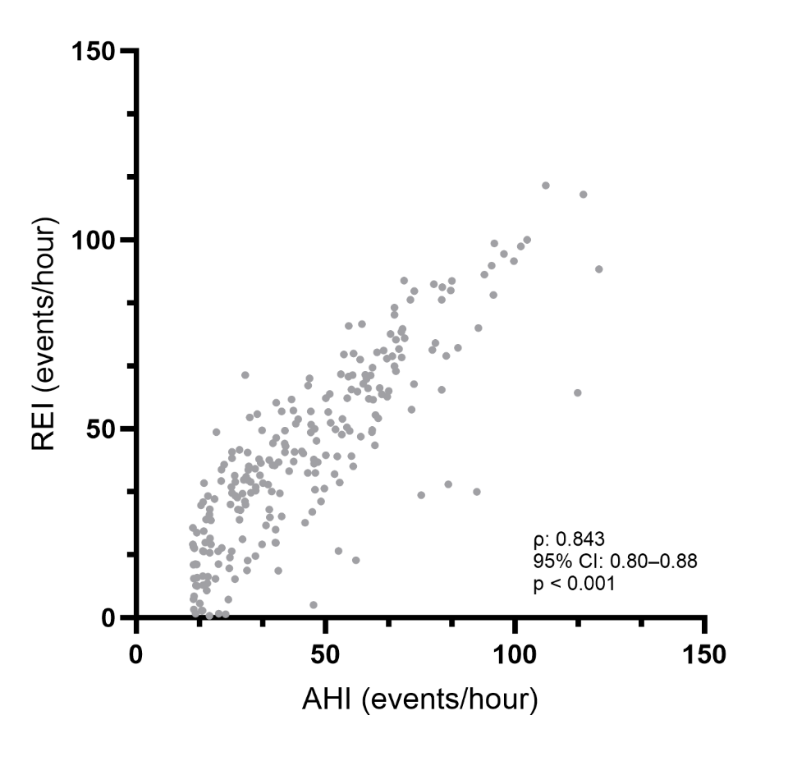
Scatter plot showing CPC-derived REI versus PSG-derived AHI among participants with PSG-defined moderate-to-severe OSA. Spearman’s ρ = 0.843 (95% CI, 0.80–0.88; p<0.001).
CPC, cardiopulmonary coupling; REI, respiratory event index; PSG, polysomnography; AHI, apnea-hypopnea index; OSA, obstructive sleep apnea.
Supplementary Figure 2. ROC curves for CPC-derived indices combined with supplemental pulse oximetry in detecting PSG-defined OSA thresholds.
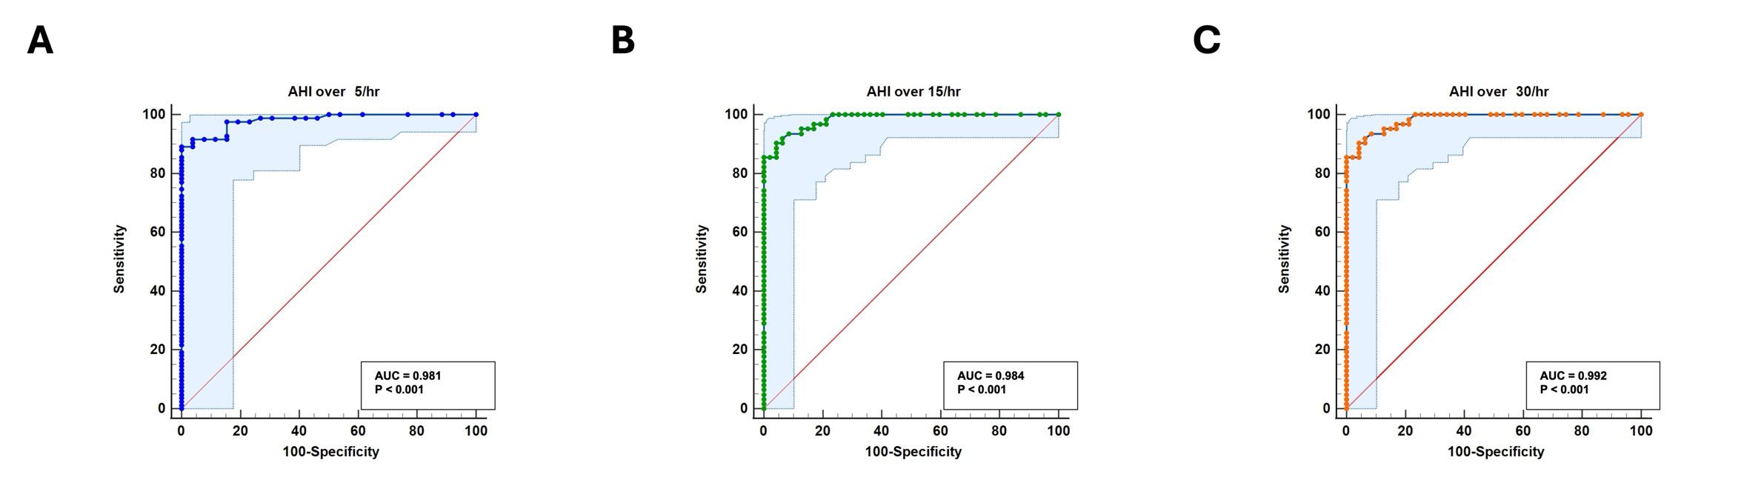
Supplementary Figure 2A. ROC curve for PSG-derived AHI ≥5 events/h. The AUC was 0.981 (p<0.001).
Supplementary Figure 2B. ROC curve for PSG-derived AHI ≥15 events/h. The AUC was 0.984 (p<0.001).
Supplementary Figure 2C. ROC curve for PSG-derived AHI ≥30 events/h. The AUC was 0.992 (p<0.001).

