eSUPPLEMENT MATERIALS
Supplementary methods
For categorical variables, the number and proportion of patients were reported. Patient characteristics were described for the overall type 2 severe asthma population and by their GINA treatment step 4/5 subgroups. Summary statistics were estimated for continuous variables, as appropriate. All analyses were performed in Statistical Analysis Software (SAS Institute Inc., Cary, NC, USA) version 9.4. Various measures were taken to minimize bias. Each patient’s GINA treatment step was determined based on asthma medication use in the 90 days prior to the index date to best align with GINA guidelines; as noted earlier, patients who discontinued biologic use during the 90-day window were classed as being at GINA treatment step 4. If a patient had multiple blood eosinophil values during the baseline period, the maximum value for categorization and analysis was used. When multiple claims for the same medication were recorded on the same date, the maximum values for quantities, days’ supply, and associated costs were used to impute the data. Healthcare interactions and costs were counted and summarized over the 12-months post-index period, and costs were adjusted to 2022 US dollars ($). For the assessment of asthma-related HCRU (including inpatient admissions, emergency department (ED) visits, and outpatient visits), an asthma diagnosis was required to be present on the claim (in any setting), and an asthma diagnosis code within ±2 weeks of the steroid dispensing date was required to ensure asthma-specific steroid use. When a record of service was absent, non-usage was assumed and zero was subsequently assigned for cost summaries.

eFigure 1: Patient attrition.
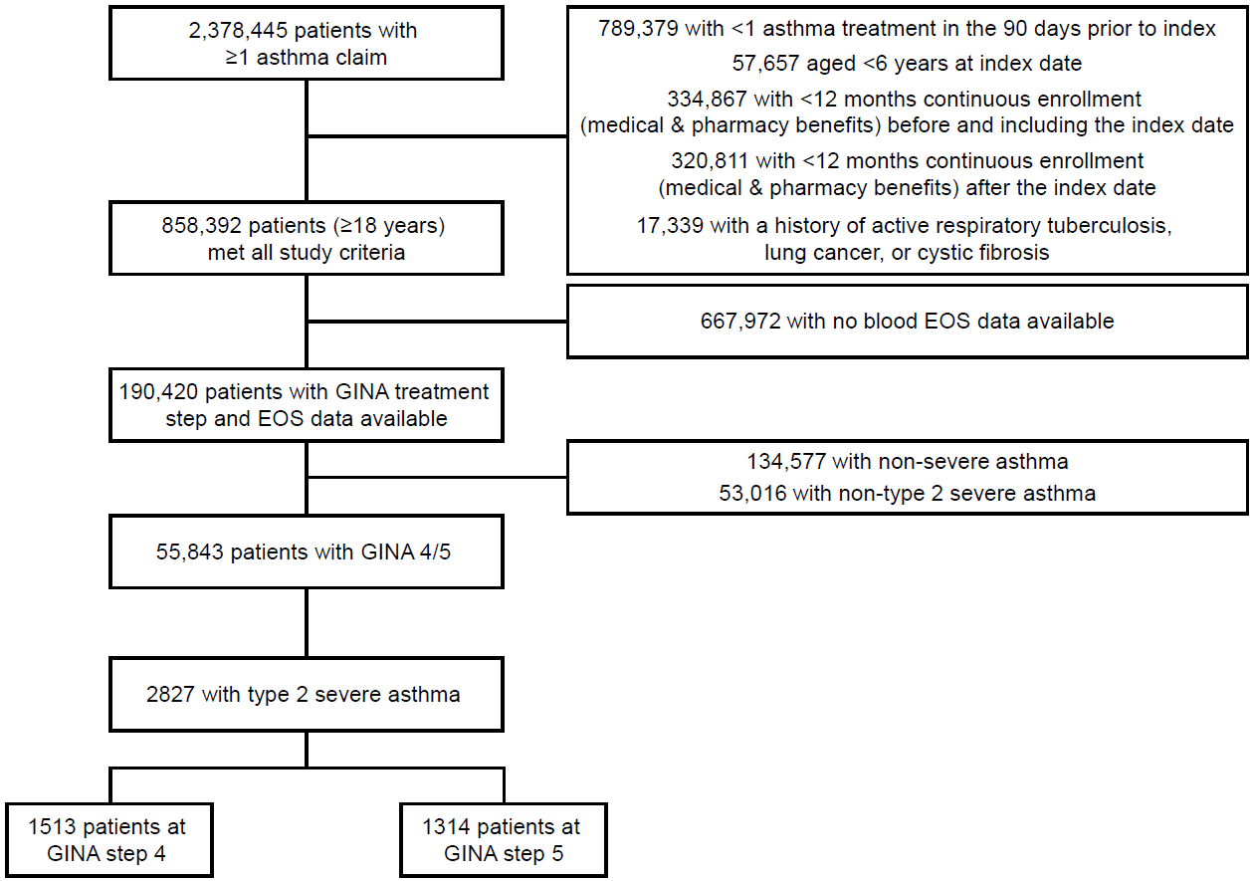
Exclusion criteria were applied in succession, for example, patients were initially excluded if they had no claim for asthma treatment in the 90 days prior to index. The remaining patients were excluded if they failed to meet the age requirement (ie., requirement to be aged ≥6 years at index date), then if they failed to meet enrollment requirements etc.
Type 2 severe asthma is defined as being at GINA treatment step 4/5 in the 90 days prior to the index diagnosis, and at least two exacerbations and a blood EOS count of ≥150 cells/μL during the
12 months pre-index.
EOS, eosinophil; GINA, Global Initiative for Asthma.
eTable 1: Baseline characteristics for patients with type 2 severe asthma at GINA treatment steps 4 and 5, stratified by receipt of biologic therapy.
 | Patients with type 2 severe asthma* at GINA step 4 (n=1513) |  | Patients with type 2 severe asthma* at GINA step 5 (n=1314)
 | Prescribed a biologic during baseline period  (n=79) | Not prescribed a biologic during baseline period  (n=1434) | Prescribed a biologic during baseline period  (n=258) | Not prescribed a biologic during baseline period  (n=1056)
Female, n (%) | 58 (73.4) | 1083 (75.5) | 172 (66.7) | 780 (73.9)
Age in years, mean (SD) | 57.4 (14.4) | 62.6 (14.4) | 58.9 (14.0) | 62.5 (14.4)
Race/ethnicity, n (%)
White | 55 (69.6) | 819 (57.1) | 165 (64.0) | 628 (59.5)
Black | 9 (11.4) | 220 (15.3) | 37 (14.3) | 168 (15.9)
Hispanic | 8 (10.1) | 264 (18.4) | 36 (14.0) | 178 (16.9)
Missing/other | 7 (8.9) | 131 (9.1) | 20 (7.8) | 82 (7.8)
Geographic region (USA), n (%)
Northeast | N<5 | 160 (11.2) | 28 (10.9) | 115 (10.9)
North Central | 9 (11.4) | 132 (8.6) | 24 (9.3) | 91 (8.6)
South | 45 (57.0) | 777 (54.2) | 140 (54.3) | 567 (53.7)
West | 21 (26.6) | 371 (25.9) | 66 (25.6) | 281 (26.6)
Missing/Unknown | 0 | 3 (0.2) | 0 | 2 (0.2)
Education level, n (%)
High school diploma | 18 (22.8) | 426 (29.7) | 57 (22.1) | 296 (28.0)
Less than a Bachelor’s degree | 46 (58.2) | 721 (50.3) | 149 (57.8) | 554 (52.5)
Bachelor’s degree or higher | 11 (13.9) | 214 (14.9) | 39 (15.1) | 151 (14.3)
Unknown/other | 1 (1.3) | 19 (1.3) | 2 (0.8) | 13 (1.2)
Index year, n (%)
2018 | 55 (69.6) | 922 (64.3) | 131 (50.8) | 696 (65.9)
Post-2018 | 24 (30.4) | 512 (35.7) | 127 (49.2) | 360 (34.1)
Comorbidities (≥25% of population), n (%)
Allergic rhinitis | 68 (86.1) | 712 (49.7) | 194 (75.2) | 574 (54.4)
Anxiety | 21 (26.6) | 435 (30.3) | 79 (30.6) | 336 (31.8)
Atopy | 68 (86.1) | 738 (51.5) | 203 (78.7) | 589 (55.8)
General cardiac disorders | 33 (41.8) | 639 (44.6) | 112 (43.4) | 490 (46.4)
General cerebrovascular disorders | 51 (64.6) | 1020 (71.1) | 176 (68.2) | 780 (73.9)
COPD† | 29 (39.2) | 646 (47.5) | 118 (50.2) | 490 (49.1)
CRS with/without nasal polyps | 40 (50.6) | 397 (27.7) | 150 (58.2) | 287 (27.1)
CRS with nasal polyps | 12 (15.2) | 87 (6.1) | 50 (19.4) | 51 (4.8)
CRS without nasal polyps | 28 (35.4) | 310 (21.6) | 100 (38.8) | 236 (22.3)
Depression | 21 (26.6) | 405 (28.2) | 63 (24.4) | 284 (26.9)
GERD | 36 (45.6) | 674 (47.0) | 138 (53.5) | 544 (51.5)
Obesity | 42 (53.2) | 880 (61.4) | 140 (54.3) | 653 (61.8)
Quan-CCI, mean (SD) | 2.8 (2.5) | 3.0 (2.5) | 2.8 (2.3) | 3.2 (2.5)
CCI components (≥15% of population), n (%)
Chronic pulmonary disease | 79 (100) | 1434 (100) | 258 (100) | 1056 (100)
Diabetes without complications | 25 (31.6) | 460 (32.1) | 79 (30.6) | 349 (33.0)
Diabetes with complications | 12 (15.2) | 240 (16.7) | 38 (14.7) | 195 (18.5)
Peripheral vascular disease | 10 (12.7) | 249 (17.4) | 37 (14.3) | 184 (17.4)
Congestive heart failure | 14 (17.7) | 222 (15.5) | 36 (14.0) | 174 (16.5)
Renal disease | 10 (12.7) | 218 (15.2) | 28 (10.9) | 175 (16.6)
Blood eosinophil count categories, n (%)
150–<300 cells/µL | 16 (20.3) | 512 (35.7) | 85 (32.9) | 378 (35.8)
>300 cells/µL | 63 (79.7) | 922 (64.3) | 173 (67.1) | 678 (64.2)
Blood eosinophil count, geometric mean (log SD) | 473.0 (0.7) | 374.9 (0.8) | 439.4 (0.8) | 376.6 (0.7)
Serum IgE testing, n (%) | 42 (53.2) | 177 (12.3) | 112 (43.4) | 203 (19.2)
Number of exacerbations, mean (SD)
Hospitalization-defined | 8 (10.1) | 94 (6.6) | 22 (8.5) | 79 (7.5)
ED-defined | 25 (31.6) | 309 (21.5) | 56 (21.7) | 232 (22.0)
Steroid-defined | 74 (93.7) | 1364 (95.1) | 248 (96.1) | 1010 (95.6)
Asthma treatments during the 12-month baseline period (≥25% of population), n (%)
SABA/SAMA | 72 (91.1) | 1303 (90.9) | 227 (88.0) | 963 (91.2)
ICS only | 34 (43.0) | 539 (37.6) | 96 (37.2) | 405 (38.4)
ICS/LABA | 73 (92.4) | 1381 (96.3) | 194 (75.2) | 839 (79.5)
LAMA only | 36 (45.6) | 338 (23.6) | 120 (46.5) | 370 (35.0)
ICS/LABA/LAMA | 35 (44.3) | 353 (24.6) | 102 (39.5) | 328 (31.1)
LTRA | 58 (73.4) | 838 (58.4) | 188 (72.9) | 711 (67.3)
OCS maintenance | 46 (58.2) | 518 (36.1) | 151 (58.5) | 517 (49.0)
Payer, n (%)
Commercial | 45 (57.0) | 466 (32.5) | 97 (37.6) | 341 (32.3)
Medicare | 34 (43.0) | 966 (67.4) | 161 (62.4) | 715 (67.7)
Insurance plan type, n (%)
Point of service | 34 (43.0) | 317 (22.1) | 69 (26.7) | 245 (23.2)
HMO | 15 (19.0) | 285 (19.9) | 49 (19.0) | 177 (16.8)
Other/unknown‡ | 30 (38.0) | 832 (58.0) | 140 (54.3) | 634 (60.0)
*Type 2 severe asthma was defined as being at GINA step 4 or 5 and having experienced ≥2 exacerbations with a blood eosinophil count of ≥150 cells/μL during the 12 months pre-index; †Reported out of patients ≥35 years of age; ‡The ‘Other’ category constituted a minimum of 27.0% in all subgroups. In cases where fewer than 5 patients were included in a category, these data have been represented as ‘N<5’ in order to maintain anonymity.
CCI, Charlson comorbidity index; COPD, chronic obstructive pulmonary disease; CRS, chronic rhinosinusitis; ED, emergency department; GERD, gastro-esophageal reflux; GINA, Global Initiative for Asthma; HMO, health maintenance organization; ICS, inhaled corticosteroid; IgE, immunoglobulin E; LABA, long-acting β₂-agonist; LAMA, long-acting muscarinic antagonist; LTRA, leukotriene receptor antagonists; OCS, oral corticosteroids; SABA, short-acting β₂-agonist; SAMA, short-acting muscarinic antagonist; SD, standard deviation; USA, United States of America.

eTable 2: Exacerbations During the 12-Month Follow-up for patients with type 2 severe asthma at GINA treatment steps 4 and 5
GINA step | Patients with type 2 severe asthma* at GINA step 4 (n=1513) | Patients with type 2 severe asthma* at GINA step 5 (n=1314)
Number of patients with data available | 1083 | 927
Proportion of patients with 0 Exacerbations, n (%) | 430 (28.4) | 387 (29.5)
Proportion of patients with 1 Exacerbation, n (%) | 520 (34.4) | 366 (27.9)
Proportion of patients with 2 Exacerbations, n (%) | 253 (16.7) | 255 (19.4)
Proportion of patients with ≥3 Exacerbations, n (%) | 310 (20.5) | 306 (23.3)
*Type 2 severe asthma was defined as being at GINA step 4 or 5 and having experienced ≥2 exacerbations with a blood eosinophil count of ≥150 cells/μL during the 12 months pre-index
GINA, Global Initiative for Asthma

eTable 3: Number of visits and associated costs for patients split by GINA treatment step and receipt of biologics.
 | Patients with type 2 severe asthma* at GINA step 4 (n=1513) |  | Patients with type 2 severe asthma* at GINA step 5 (n=1314)
 | Prescribed a biologic during baseline period  (n=79) | Not prescribed a biologic during baseline period  (n=1434) | Prescribed a biologic during baseline period  (n=258) | Not prescribed a biologic during baseline period  (n=1056)
Any all-cause inpatient admissions, n (%)  Number of inpatient visits, mean (SD) | 18 (22.8)  1.5 (1.3) | 354 (24.7)  1.9 (1.7) | 65 (25.2)  1.6 (1.3) | 287 (27.2)  52.3 (1.9)
Any all-cause ED visits, n (%)  Number of ED visits, mean (SD) | 45 (57.0)  4.2 (3.9) | 762 (53.1)  3.6 (5.2) | 129 (50.0)  3.6 (4.5) | 602 (57.0)  3.6 (4.8)
Any all-cause outpatient visits, n (%)  Number of all-cause outpatient visits, mean (SD) | 79 (100)  41.7 (24.0) | 1430 (99.7)  35.7 (31.3) | 258 (100)  44.8 (28.4) | 1056 (100)  37.7 (29.1)
Any all-cause outpatient pharmacy visits, n (%)  Number of all-cause outpatient pharmacy visits, mean (SD) | 79 (100)  38.1 (21.7) | 1434 (100)  37.3 (23.5) | 257 (99.6)  48.6 (25.0) | 1056 (100)  40.9 (22.5)
Any asthma-related inpatient admissions, n (%)  Number of asthma-related inpatient admissions, mean (SD) | 1 (1.3)  1 (NA) | 46 (3.2)  1.2 (0.6) | 14 (5.4)  1.1 (0.4) | 44 (4.2)  1.3 (0.8)
Any asthma-related ED visits, n (%)  Number of asthma-related ED visits, mean (SD) | 26 (32.9)  3.7 (3.3) | 444 (31.0)  2.2 (2.4) | 78 (30.2)  2.5 (2.6) | 342 (32.4)  2.4 (2.4)
Any asthma-related outpatient visits, n (%)  Number of asthma-related outpatient visits, mean (SD) | 76 (96.2)  17.5 (12.1) | 1326 (92.5)  8.9 (15.4) | 258 (100)  15.7 (10.4) | 1003 (95.0)  9.5 (9.9)
Any asthma-related outpatient pharmacy visits, n (%)  Number of asthma-related outpatient pharmacy visits, mean (SD) | 79 (100)  23.4 (12.4) | 1420 (99.0)  14.1 (9.4) | 257 (99.6)  25.9 (12.0) | 1050 (99.4)  16.7 (10.4)
Any all-cause inpatient admission costs  Mean (SD)  Median (IQR) | $50,932.7 (66,337.6)  $20,089.8 (11,891.2, 59,019.3) | $49,981.1 (60,741.5)  $29,746.9 (15,118.6, 58,288.6) | $34,777.7 (34,610.5)  $20,530.8 (14,652.8, 44,628.9) | $60,962.3 (77,897.3)  $33,528.0 (16,647.7, 65,271.8)
Any all-cause ED visit costs  Mean (SD)  Median (IQR) | $6401.9 (8519.2)  $3730.0 (1867.8, 7574.4) | $6187.8 (9810.1)  $3426.9 (1785.1, 7036.2) | $6625.2 (10,214.5)  $3663.24 (1750.2, 7718.8) | $6574.7 (9904.2)  $3783.4 (1907.2, 7245.3)
Any all-cause outpatient visit costs  Mean (SD)  Median (IQR) | $37,443.0 (28,460.5)  $31,989.0 (14,105.4, 54,893.2) | $19,155.3 (30,793.3)  $10,275.7 (4184.1, 22,204.9) | $31,532.4 (32,286.4)  $22,286.3 (8471.2, 43,816.4) | $21,015.6 (28,330.6)  $11,810.0 (4914.1, 26,212.4)
Any all-cause outpatient pharmacy costs  Mean (SD)  Median (IQR) | $12,930.5 (19,137.7)  $7045.3 (3183.4, 15,794.0) | $9545.6 (16,304.9)  $5018.0 (2475.2, 10169.0) | $32,099.5 (27,319.1)  $28,694.3 (9496.1, 45,818.9) | $11,815.1 (17,458.3)  $6377.6 (3521.2, 12,369.2)
Total all-cause medical expenditures  Mean (SD)  Median (IQR) | $52,694.6 (47,307.3)  $42,165.1 (19,862.5, 67,153.9) | $34,825.5 (57,766.2)  $14,623.6 (5242.4, 39,932.9) | $43,606.8 (45,903.7)  $32,751.3 (9812.2, 59,797.9) | $41,332.0 (69,214.6)  $16,888.6 (6104.4, 46,184.4)
Total all-cause healthcare expenditures  Mean (SD)  Median (IQR) | $65,625.1 (56,463.7)  $52,302.3 (30,166.0, 79,971.9) | $44,273.9 (61,716.8)  $22,720.0 (10,332.5, 53,318.2) | $75,581.9 (52,934.6)  $64,511.3 (39,754.8, 98,085.0) | $53,147.1 (74,007.0)  $28,273.2 (12,416.5, 61,241.9)
Any asthma-related inpatient admission  Costs  Mean (SD)  Median (IQR) | $10,870.7(NA)  NA (n=1) | $22,478.7 (39,591.5)  $14,822.2 (11,292.5, 15,509.0) | $15,649.9 (4552.8)  $14,737.5 (14,054.8, 15,509.0) | $19,519.8 (20,187.4)  $14,926.5 (14,353.8, 15,829.1)
Any asthma-related ED visit costs  Mean (SD)  Median (IQR) | $7031.8 (10,004.5)  $3828.5 (1764.7, 7650.7) | $3877.7 (4910.5)  $2298.7 (1556.3, 4668.9) | $5897.4 (11,917.2)  $2287.0 (1692.7, 5410.5) | $4370.5 (5764.2)  $2783.6 (1620.7, 4980.4)
Any asthma-related outpatient visit costs  Mean (SD)  Median (IQR) | $25,810.0 (26,260.5)  $18,098.6 (4116.4, 36,650.3) | $5582.1 (17,096.0)  $1333.2 (553.3, 3933.5) | $17,251.9 (22,430.4)  $5888.5 (1672.7, 28,405.9) | $6228.4 (11,713.8)  $1675.5 (695.1, 5393.1)
Any asthma-related outpatient pharmacy costs  Mean (SD)  Median (IQR) | $24,945.5 (19,818.1)  $24,144.2 (8567.4, 36,734.2) | $4240.2 (5878.7)  $2794.5 (1279.9, 4878.6) | $33,700.1 (22,425.9)  $32,184.7 (15,806.5, 45,193.7) | $5820.6 (7909.3)  $3923.0 (1767.1, 6402.8)
Total asthma-related medical expenditures  Mean (SD)  Median (IQR) | $27,990.3(26,777.1)  $22,921.9 (6746.1, 37,478.6) | $7643.0(20,806.3)  $1805.2 (603.5, 7011.4) | $19,884.0(24,649.2)  $7222.8 (1976.3, 34,266.2) | $8557.9(15,738.9)  $2334.8 (751.4, 8698.1)
Total asthma-related healthcare expenditures  Mean (SD)  Median (IQR) | $52,227.2 (41,335.6)  $47,843.0 (17,054.1, 76,719.5) | $11,329.6 (21,675.7)  $5603.6 (2819.4, 11,703.6) | $53,453.6 (39,442.3)  $45,308.7 (24,790.7, 74,525.0) | $13,945.3 (19,113.3)  $7199.5 (4148.0, 15,412.8)
*Type 2 severe asthma was defined as being at GINA step 4 or 5 and having experienced ≥2 exacerbations with a blood eosinophil count of ≥150 cells/μL during the 12 months pre-index
ED, emergency department; GINA, Global Initiative for Asthma; SD, standard deviation.

