Supplementary Table 1:Baseline Characteristics of Patients in the Non-Progression group and Progression Sets
 |  | Non-Progression | Progression | P value
 |  | （n=494） | （n=594）
Gender,n(%) |  |  |  | <0.001
 | Male | 177 (35.8) | 298 (50.2)
 | Female | 317 (64.2) | 296 (49.8)
Smoking status,n(%) |  |  |  | <0.001
 | Never | 403 (81.6) | 391 (65.8)
 | Former | 41 ( 8.3) | 71 (12.0)
 | Current | 50 (10.1) | 132 (22.2)
Hypertension,n(%) |  |  |  | <0.001
 | No | 433 (87.7) | 365 (61.4)
 | Yes | 61 (12.3) | 229 (38.6)
Diabetes,n(%) |  |  |  | <0.001
 | No | 451 (91.3) | 413 (69.5)
 | Yes | 43 ( 8.7) | 181 (30.5)
Age,y |  | 52.5 | 58 | <0.001
 |  | (46.00, 58.00) | (52.00, 66.00)
BMI, kg/m2 |  | 23.21 | 23.96 | <0.001
 |  | (20.58, 25.66) | (22.04, 25.95)
MMEF% |  | 52.06 | 44.12 | <0.001
 |  | (41.10, 61.36) | (37.01, 51.71)
MEF50% |  | 59.81 | 49.86 | <0.001
 |  | (49.11, 72.90) | (41.81, 59.05)
MEF25% |  | 36.95 | 35.38 | 0.004
 |  | (28.83, 49.08) | (28.38, 43.47)
FEV₁% |  | 85.12 | 89.6 | 0.005
 |  | (74.81, 100.00) | (78.00, 100.95)
FEV₁/FVC ratio |  | 0.78 | 0.72 | <0.001
 |  | (0.74, 0.82) | (0.71, 0.74)
Red blood cell |  | 4.59 | 4.65 | 0.049
(×10¹²/L) |  | (4.28, 4.94) | (4.33, 5.01)
Hemoglobin |  | 136 | 141 | <0.001
(g/L) |  | (127.00, 146.00) | (132.00, 152.00)
Platelet |  | 184 | 178 | 0.257
(×10⁹/L) |  | (142.00, 228.75) | (143.00, 220.75)
White blood cell |  | 5.73 | 5.73 | 0.975
(×10⁹/L) |  | (4.81, 6.85) | (4.81, 7.00)
Neutrophil |  | 3.38 | 3.53 | 0.273
(×10⁹/L) |  | (2.66, 4.37) | (2.74, 4.50)
Lymphocyte |  | 1.71 | 1.62 | 0.052
(×10⁹/L) |  | (1.37, 2.09) | (1.34, 2.00)
Monocyte |  | 0.33 | 0.34 | 0.806
(×10⁹/L) |  | (0.26, 0.44) | (0.26, 0.44)
Eosinophil |  | 0.09 | 0.1 | 0.248
(×10⁹/L) |  | (0.06, 0.16) | (0.06, 0.17)
Basophil |  | 0.02 | 0.03 | 0.017
(×10⁹/L) |  | (0.02, 0.03) | (0.02, 0.04)
Albumin |  | 46.2 | 46.3 | 0.738
(g/L) |  | (43.50, 48.20) | (43.70, 48.40)
Glucose |  | 4.98 | 5.11 | 0.005
(mmol/L) |  | (4.60, 5.44) | (4.67, 5.59)
Triglyceride |  | 1.24 | 1.34 | 0.024
(mmol/L) |  | (0.90, 1.76) | (0.96, 1.84)
Cholesterol |  | 4.78 | 4.95 | 0.002
(mmol/L) |  | (3.97, 5.61) | (4.28, 5.69)
Abbreviations：BMI，Body mass index；COPD，Chronic Obstructive Pulmonary Disease；MMEF%，Maximum Mid-Expiratory Flow；MEF50%，Maximum Expiratory Flow at 50% of Vital Capacity；MEF25%，Maximum Expiratory Flow at 25% of Vital Capacity；FEV₁%，Forced Expiratory Volume in 1 Second Percentage Predicted.

Supplementary Figure 1:Time-dependent ROC curve

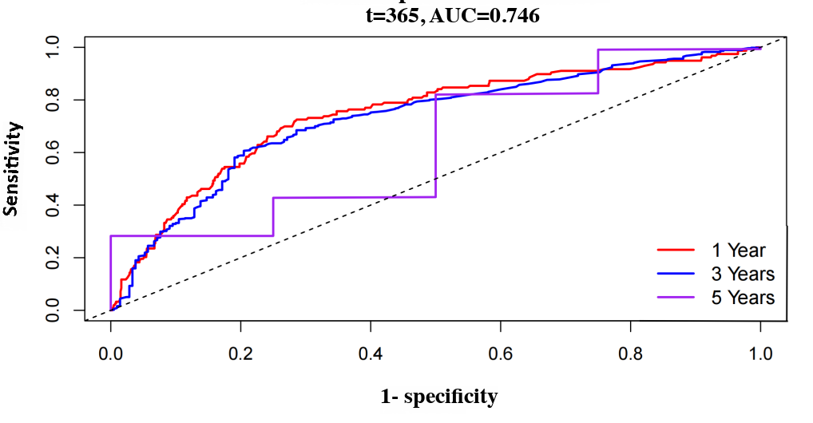

Supplementary Figure 1. Time-dependent ROC curves for evaluating the predictive performance of the Cox model at 1, 3, and 5 years. At 1 year, the area under the curve (AUC) was 0.746; at 3 years, AUC was 0.729; and at 5 years, AUC was 0.632. The model showed moderate predictive accuracy for 1- and 3- year outcomes, while its performance declined at 5 years, implying a gradual reduction in discriminative ability over time.

Supplementary Figure 2:Kaplan - Meier Survival Curves Comparing High - Risk and Low - Risk Groups
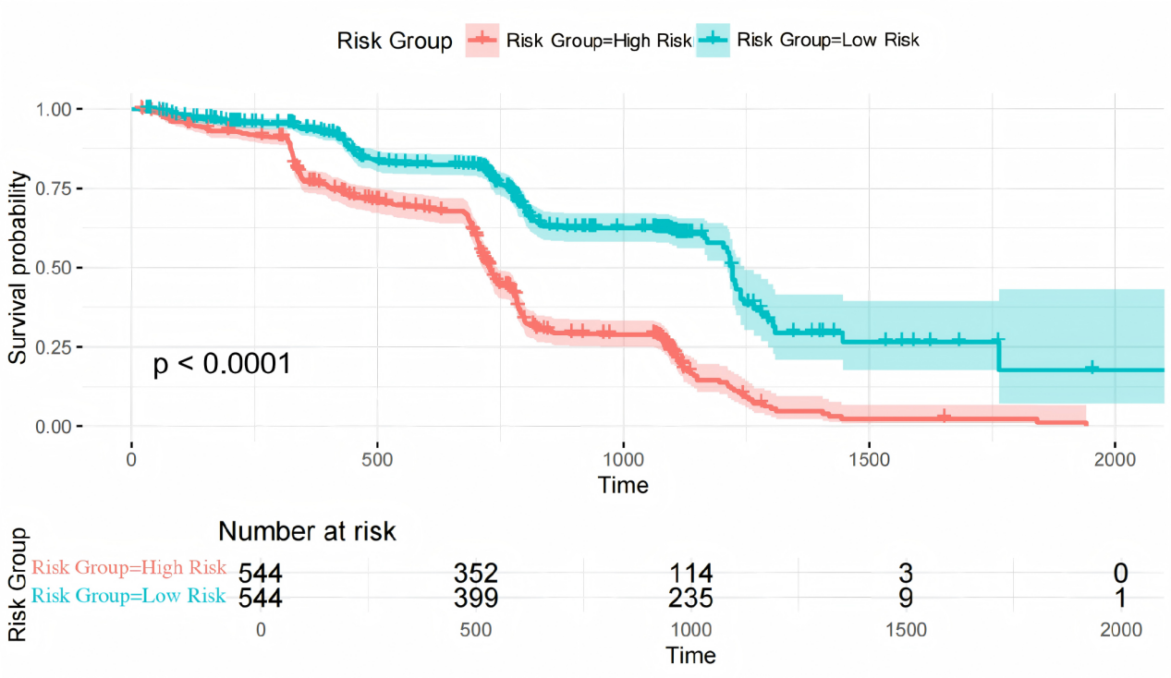
Supplementary Figure 2. Kaplan - Meier survival curve comparing high-risk and low-risk groups classified by sample risk scores relative to the median. The curve shows a significant difference in survival progression between the two groups (p < 0.0001). The "Number at risk" table below depicts the number of samples at risk in each group at different time points.

