Supplementary Material

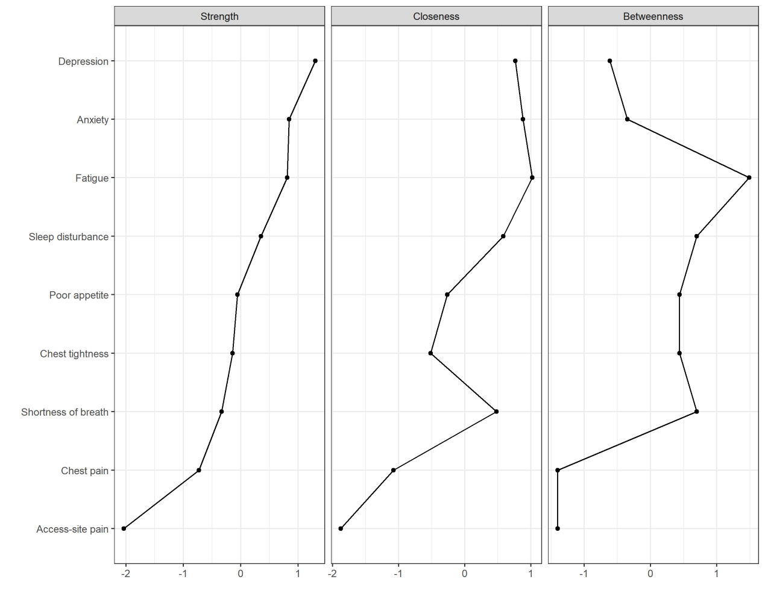
Supplementary Figure 1.Centrality indices of the symptom network in ACS patients post–PCI

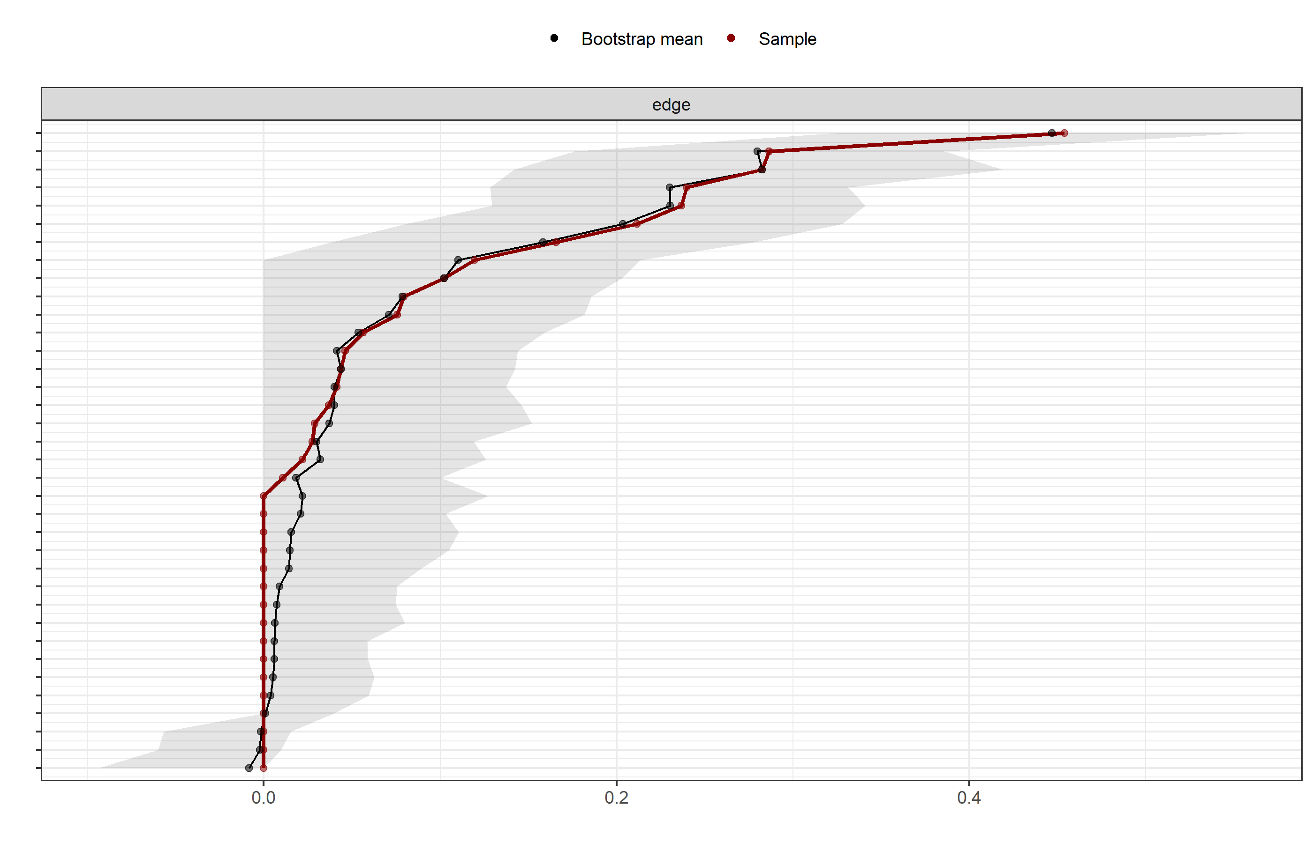
Supplementary Figure 2: Bootstrap confidence intervals for edge weights in the symptom network.

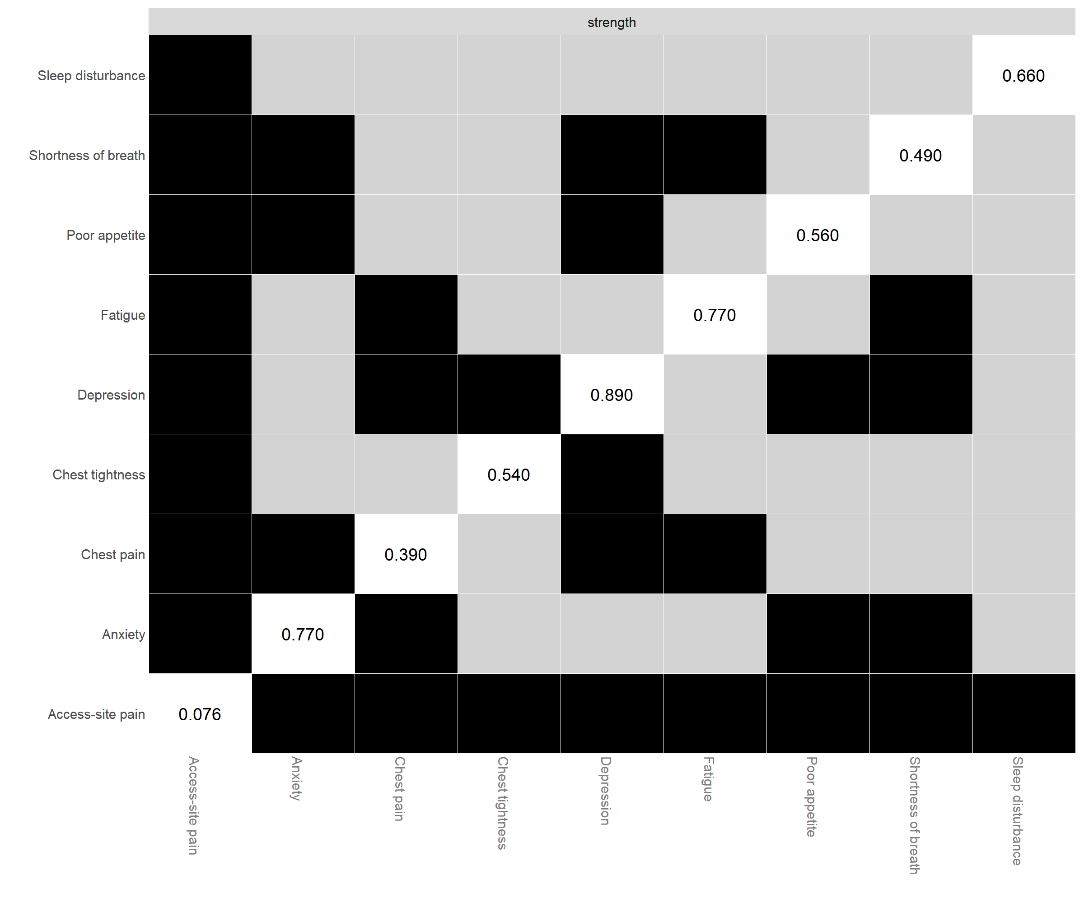

Supplementary Figure 3: Bootstrap difference test for node strength centrality.

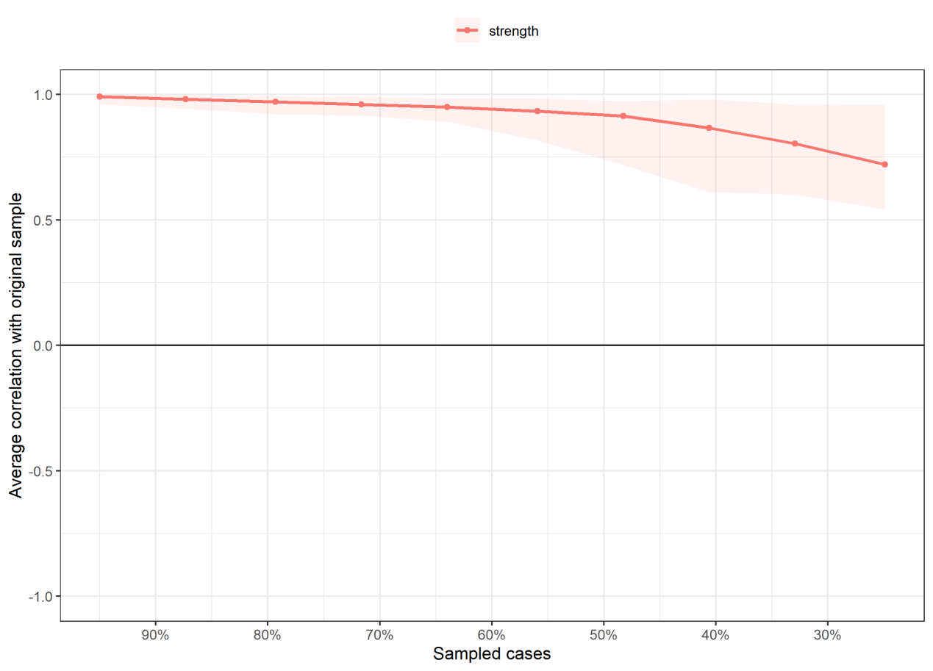

Supplementary Figure 4: Case-dropping bootstrap analysis for network stability.

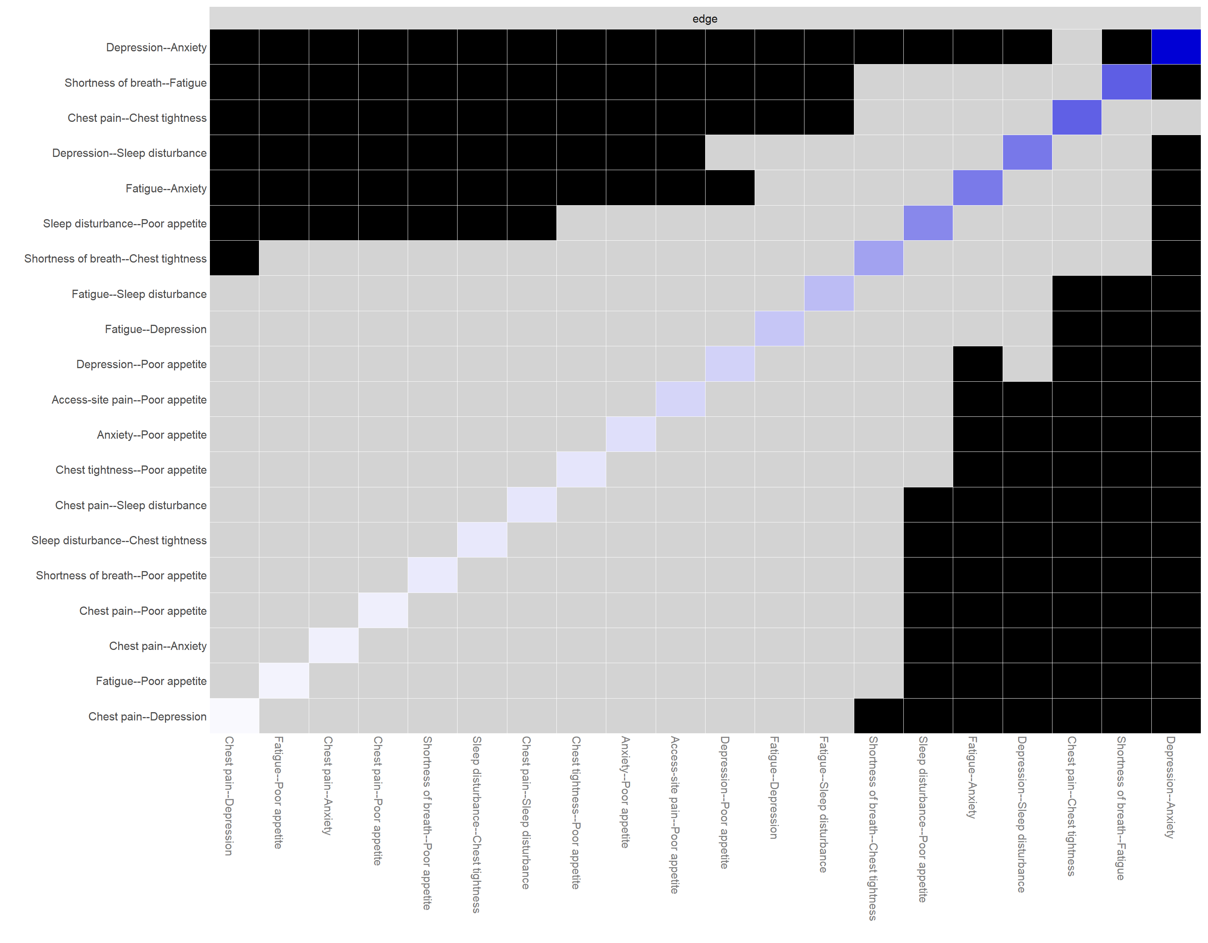

Supplementary Figure 5: Edge-weight difference test in the symptom network.

Supplementary Table 1: Partial correlations (edge weights) among post-PCI symptoms in ACS patients.
Symptom | Chest pain | Shortness of breath | Fatigue | Depression | Sleep disturbance | Access-site pain | Chest tightness | Anxiety | Poor appetite
Chest pain | 0 | 0 | 0 | 0.011 | 0.044 | 0 | 0.283 | 0.028 | 0.029
Shortness of breath | 0 | 0 | 0.287 | 0 | 0 | 0 | 0.166 | 0 | 0.037
Fatigue | 0 | 0.287 | 0 | 0.102 | 0.119 | 0 | 0 | 0.237 | 0.022
Depression | 0.011 | 0 | 0.102 | 0 | 0.24 | 0 | 0 | 0.454 | 0.079
Sleep disturbance | 0.044 | 0 | 0.119 | 0.24 | 0 | 0 | 0.041 | 0 | 0.212
Access-site pain | 0 | 0 | 0 | 0 | 0 | 0 | 0 | 0 | 0.076
Chest tightness | 0.283 | 0.166 | 0 | 0 | 0.041 | 0 | 0 | 0 | 0.046
Anxiety | 0.028 | 0 | 0.237 | 0.454 | 0 | 0 | 0 | 0 | 0.056
Poor appetite | 0.029 | 0.037 | 0.022 | 0.079 | 0.212 | 0.076 | 0.046 | 0.056 | 0
Note: Values represent partial correlation coefficients (edge weights) between symptoms. Higher absolute values indicate stronger associations.

