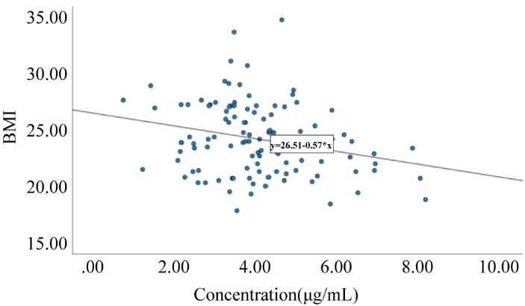
Supplementary Figure 1. Plasma vitamin C concentration is negatively correlated with BMI in patients with benign breast tumors.

Supplementary Figure 2. Representative UPLC-MS/MS chromatograms of vitamin C detection.
(A) Blank plasma chromatogram; (B) Color spectrum of blank plasma+vitamin C standard+internal standard; (C) Vitamin C standard color spectrum; (D) Internal standard L-Ascorbic Acid-1-13C chromatogram; (E) Patient plasma sample chromatogram; (F) Vitamin C chromatogram in patient plasma sample; (G) Chromatogram of L-Ascorbic Acid-1-13C internal standard in patient plasma sample.

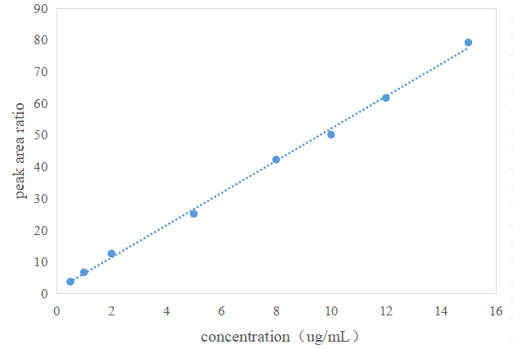
Supplementary Figure 3. Calibration curve for vitamin C quantification by UPLC-MS/MS.

Nominal Concentration (μg/mL) | Measured Concentration (μg/mL) | RE ％ | Intra-day Precision (n=5), RSD (%) | Inter-day Precision (n=3), RSD (%)
1 | 1.02±0.02 | 2.00％ | 1.51％ | 4.28％
5 | 5.42±0.24 | 8.40％ | 4.38％ | 6.53％
10 | 10.19±0.31 | 1.90％ | 2.42％ | 5.57％
Supplementary Table 1. Intra-day precision and inter-day precision of vitamin C

Supplementary Table 2. Evaluation of extraction recovery and matrix effect for vitamin C
Nominal Concentration (μg/mL) | Extraction Recovery |  | Matrix Effect
Nominal Concentration (μg/mL) | Mean ± SD (%) | RSD（％） | Mean ± SD (%) | RSD（％）
1 | 100.90±2.85 | 2.84 | 101.83±4.39 | 4.31
5 | 100.26±7.55 | 7.53 | 98.67±3.11 | 3.15
10 | 101.93±2.51 | 2.46 | 99.11±5.10 | 5.15

Supplementary Table 3. Evaluation of vitamin C stability
Matrix | conditions | Time | Nominal Concentration | Measured Concentration | RE(%) | RSD(%)
Matrix | conditions | Time | (μg/mL) | (μg/mL) | RE(%) | RSD(%)
Plasma | RT | 0.5h | 1 | 0.97±0.03 | 2.91 | 3.09
 |  |  | 10 | 9.01 ±0.21 | 9.89 | 2.33
 |  | 1h | 1 | 0.90±0.07 | 9.87 | 7.77
 |  |  | 10 | 8.29±0.24 | 17.11 | 2.89
 |  | 2h | 1 | 0.82±0.07 | 18.14 | 8.53
 |  |  | 10 | 8.03±0.20 | 19.97 | 2.49
 |  | 4h | 1 | 0.76±0.13 | 24.33 | 1.71
 |  |  | 10 | 7.24±0.34 | 27.56 | 4.69
 | 4℃ | 0.5h | 1 | 1.01±0.05 | 1.24 | 4.95
 |  |  | 10 | 9.65±0.18 | 3.44 | 1.86
 |  | 1h | 1 | 0.97±0.07 | 3.28 | 7.21
 |  |  | 10 | 9.13±0.16 | 8.99 | 1.75
 |  | 2h | 1 | 0.91±0.04 | 9.16 | 4.39
 |  |  | 10 | 8.87±0.13 | 11.33 | 1.46
 |  | 4h | 1 | 0.81±0.33 | 19.09 | 3.09
 |  |  | 10 | 7.83±0.41 | 21.96 | 5.23
 | -20℃ | 1d | 1 | 0.93±0.02 | 6.45 | 2.15
 |  |  | 10 | 9.78±0.24 | 2.22 | 2.45
 |  | 2d | 1 | 0.90±0.04 | 9.56 | 4.45
 |  |  | 10 | 9.44±0.28 | 5.74 | 2.96
 |  | 3d | 1 | 0.84±0.06 | 15.54 | 7.14
 |  |  | 10 | 8.99±0.27 | 10.87 | 3.01
 | -80℃ | 1d | 1 | 0.97 ±0.03 | 3.41 | 2.56
 |  |  | 10 | 9.84 ±0.24 | 1.63 | 2.44
 |  | 3d | 1 | 0.93 ±0.04 | 7.36 | 4.31
 |  |  | 10 | 9.56 ±0.22 | 4.43 | 2.19
 |  | 5d | 1 | 0.90 ±0.04 | 9.62 | 4.45
 |  |  | 10 | 9.18 ±0.26 | 8.23 | 2.83
In Precipitated Agent | RT | 0.5h | 1 | 0.95 ±0.06 | 4.24 | 6.31
 |  |  | 10 | 10.14 ±0.22 | 1.49 | 2.16
 |  | 1h | 1 | 0.92 ±0.07 | 8.17 | 7.61
 |  |  | 10 | 8.95 ±0.18 | 10.04 | 2.01
 |  | 2h | 1 | 0.89 ±0.08 | 10.23 | 8.98
 |  |  | 10 | 8.12 ±0.24 | 18.66 | 2.95
 |  | 4h | 1 | 0.76±0.04 | 23.83 | 5.26
 |  |  | 10 | 7.43 ±0.31 | 25.14 | 4.17
 | 4℃ | 0.5h | 1 | 1.07 ±0.10 | 7.35 | 9.34
 |  |  | 10 | 10.42 ±0.29 | 4.19 | 2.83
 |  | 1h | 1 | 1.02 ±0.06 | 2.48 | 5.88
 |  |  | 10 | 9.76 ±0.31 | 2.49 | 3.17
 |  | 2h | 1 | 0.89 ±0.07 | 10.27 | 7.86
 |  |  | 10 | 8.98 ±0.19 | 10.15 | 2.12
 |  | 4h | 1 | 0.83 ±0.07 | 16.76 | 8.43
 |  |  | 10 | 7.99 ±0.33 | 21.23 | 4.13
 | -20℃ | 1d | 1 | 0.98 ±0.04 | 1.41 | 2.15
 |  |  | 10 | 9.77 ±0.25 | 2.36 | 2.55
 |  | 2d | 1 | 0.95 ±0.06 | 5.17 | 6.31
 |  |  | 10 | 9.61 ±0.27 | 4.24 | 2.81
 |  | 3d | 1 | 0.89 ±0.05 | 10.05 | 5.61
 |  |  | 10 | 9.31 ±0.23 | 6.63 | 2.47
 | -80℃ | 1d | 1 | 0.96 ±0.05 | 4.87 | 5.21
 |  |  | 10 | 9.89 ±0.09 | 1.14 | 0.91
 |  | 3d | 1 | 0.91 ±0.07 | 8.62 | 7.69
 |  |  | 10 | 9.75 ±0.22 | 2.49 | 2.26
 |  | 5d | 1 | 0.93 ±0.11 | 7.44 | 11.82
 |  |  | 10 | 9.21 ±0.15 | 7.94 | 1.63
 | Auto-sampler | 1h | 1 | 0.92 ±0.03 | 7.86 | 3.26
 |  |  | 10 | 9.13 ±0.29 | 8.71 | 3.17
 |  | 2h | 1 | 0.90 ±0.04 | 9.41 | 3.46
 |  |  | 10 | 9.02 ±0.27 | 9.91 | 4.07
 | Repeated Freeze-thaw at -80°C |  | 1 | 0.90 ±0.04 | 9.12 | 4.44
 |  |  | 10 | 9.34 ±0.37 | 6.55 | 3.96

