Supplementary Table 1. Information of identified SNPs in exposure (AS) and outcomes (HS).
SNP |  |  |  |  |  | Exposure  （AS) |  |  |  |  |  |  |  |  | Outcome  (HS) |  |  |  |  |  |  |  | F statistics
RS ID |  | effect_allele |  | other_allele |  | beta |  |  | se |  | pval |  | eaf |  | beta |  | se |  | pval |  | eaf
rs1020396 |  | T |  | C |  | 0.017447 |  |  | 0.004243 |  | 3.92E-05 |  | NA |  | -0.0893 |  | 0.0706 |  | 0.2061 |  | 0.5692 |  | 16.90865
rs10244904 |  | A |  | G |  | 0.025473 |  |  | 0.005471 |  | 3.22E-06 |  | NA |  | 0.0278 |  | 0.0899 |  | 0.757201 |  | 0.1849 |  | 21.6776
rs10245971 |  | T |  | G |  | 0.029268 |  |  | 0.006733 |  | 1.38E-05 |  | NA |  | 0.1401 |  | 0.1308 |  | 0.2841 |  | 0.07858 |  | 18.88979
rs1041926 |  | A |  | G |  | -0.07483 |  |  | 0.011692 |  | 1.55E-10 |  | NA |  | -0.3462 |  | 0.2336 |  | 0.1383 |  | 0.9776 |  | 40.95401
rs11065898 |  | T |  | C |  | 0.026252 |  |  | 0.004806 |  | 4.71E-08 |  | NA |  | -0.0152 |  | 0.0877 |  | 0.8623 |  | 0.1966 |  | 29.82734
rs11190133 |  | T |  | C |  | -0.03387 |  |  | 0.004494 |  | 4.84E-14 |  | NA |  | -0.0139 |  | 0.0713 |  | 0.846 |  | 0.3921 |  | 56.78141
rs11209026 |  | A |  | G |  | -0.10358 |  |  | 0.009545 |  | 1.94E-27 |  | NA |  | -0.3756 |  | 0.166 |  | 0.02367 |  | 0.04598 |  | 117.7522
rs1128905 |  | C |  | T |  | -0.02372 |  |  | 0.004095 |  | 6.95E-09 |  | NA |  | -0.1112 |  | 0.0695 |  | 0.1096 |  | 0.503 |  | 33.54274
rs11624293 |  | C |  | T |  | 0.042868 |  |  | 0.006692 |  | 1.49E-10 |  | NA |  | 0.062 |  | 0.1275 |  | 0.626599 |  | 0.08138 |  | 41.03188
rs1250550 |  | A |  | C |  | -0.02604 |  |  | 0.004305 |  | 1.46E-09 |  | NA |  | -0.0895 |  | 0.0711 |  | 0.208 |  | 0.4039 |  | 36.57556
rs12615545 |  | C |  | T |  | 0.025473 |  |  | 0.004173 |  | 1.03E-09 |  | NA |  | -0.045 |  | 0.0696 |  | 0.5185 |  | 0.5123 |  | 37.25898
rs130075 |  | T |  | C |  | 0.335829 |  |  | NA |  | 1.00E-200 |  | NA |  | -0.0405 |  | 0.1494 |  | 0.7862 |  | 0.05767 |  | NA
rs13327021 |  | T |  | C |  | 0.021859 |  |  | 0.004232 |  | 2.40E-07 |  | NA |  | 0.0455 |  | 0.0729 |  | 0.5328 |  | 0.3475 |  | 26.67885
rs13390874 |  | T |  | C |  | -0.02153 |  |  | 0.005046 |  | 1.98E-05 |  | NA |  | 0.0637 |  | 0.0828 |  | 0.4417 |  | 0.229 |  | 18.20186
rs17233311 |  | G |  | A |  | 0.016841 |  |  | 0.004145 |  | 4.85E-05 |  | NA |  | -0.0706 |  | 0.0716 |  | 0.3245 |  | 0.6038 |  | 16.50229
rs1734907 |  | G |  | A |  | -0.0283 |  |  | 0.005849 |  | 1.31E-06 |  | NA |  | 0.0893 |  | 0.0881 |  | 0.3106 |  | 0.8108 |  | 23.40205
rs17765610 |  | G |  | A |  | 0.035657 |  |  | 0.006554 |  | 5.31E-08 |  | NA |  | 0.103 |  | 0.1393 |  | 0.4596 |  | 0.06686 |  | 29.59399
rs1800682 |  | G |  | A |  | -0.01816 |  |  | 0.004107 |  | 9.74E-06 |  | NA |  | 0.0139 |  | 0.07 |  | 0.8429 |  | 0.4365 |  | 19.55777
rs1801274 |  | G |  | A |  | 0.025318 |  |  | 0.004177 |  | 1.35E-09 |  | NA |  | -0.0409 |  | 0.0694 |  | 0.555199 |  | 0.5028 |  | 36.734
rs1860545 |  | A |  | G |  | -0.02747 |  |  | 0.004354 |  | 2.78E-10 |  | NA |  | 0.0237 |  | 0.0703 |  | 0.7364 |  | 0.4222 |  | 39.81338
rs2058813 |  | C |  | T |  | 0.021632 |  |  | 0.005108 |  | 2.29E-05 |  | NA |  | 0.1509 |  | 0.0996 |  | 0.1296 |  | 0.8579 |  | 17.93136
rs2273684 |  | G |  | T |  | 0.018331 |  |  | 0.004146 |  | 9.80E-06 |  | NA |  | 0.0584 |  | 0.0697 |  | 0.4018 |  | 0.4909 |  | 19.54596
rs2283790 |  | G |  | A |  | 0.02635 |  |  | 0.004907 |  | 7.90E-08 |  | NA |  | 0.0243 |  | 0.0748 |  | 0.7452 |  | 0.3182 |  | 28.82575
rs2402752 |  | C |  | T |  | -0.02276 |  |  | 0.004519 |  | 4.76E-07 |  | NA |  | -0.0469 |  | 0.0841 |  | 0.577301 |  | 0.2219 |  | 25.35365
rs2531875 |  | T |  | G |  | -0.02732 |  |  | 0.004245 |  | 1.22E-10 |  | NA |  | 0.0454 |  | 0.072 |  | 0.5285 |  | 0.6305 |  | 41.42904
rs2663043 |  | A |  | G |  | -0.01882 |  |  | 0.004111 |  | 4.68E-06 |  | NA |  | -0.0409 |  | 0.0705 |  | 0.562 |  | 0.5686 |  | 20.96024
rs27529 |  | G |  | A |  | -0.06204 |  |  | 0.004299 |  | 3.28E-47 |  | NA |  | -0.0479 |  | 0.0729 |  | 0.5109 |  | 0.6485 |  | 208.231
rs2836883 |  | A |  | G |  | -0.03968 |  |  | 0.004748 |  | 6.46E-17 |  | NA |  | -0.191 |  | 0.0808 |  | 0.01802 |  | 0.2477 |  | 69.81901
rs28653390 |  | A |  | G |  | 0.028296 |  |  | 0.005728 |  | 7.82E-07 |  | NA |  | -0.0395 |  | 0.1009 |  | 0.6951 |  | 0.1365 |  | 24.39726
rs35164067 |  | A |  | G |  | -0.03108 |  |  | 0.00495 |  | 3.43E-10 |  | NA |  | -0.2113 |  | 0.0917 |  | 0.02119 |  | 0.1757 |  | 39.40734
rs4129267 |  | T |  | C |  | -0.03077 |  |  | 0.004226 |  | 3.32E-13 |  | NA |  | -0.0784 |  | 0.0764 |  | 0.3047 |  | 0.297 |  | 52.99826
rs41299637 |  | G |  | T |  | -0.03905 |  |  | 0.00491 |  | 1.81E-15 |  | NA |  | -0.3006 |  | 0.0857 |  | 0.000456 |  | 0.2126 |  | 63.2467
rs4672505 |  | G |  | A |  | -0.05978 |  |  | 0.004151 |  | 5.14E-47 |  | NA |  | -0.0134 |  | 0.0734 |  | 0.8552 |  | 0.6611 |  | 207.3354
rs4676410 |  | A |  | G |  | 0.028101 |  |  | 0.004902 |  | 9.90E-09 |  | NA |  | 0.2194 |  | 0.0784 |  | 0.005146 |  | 0.271 |  | 32.85496
rs4851529 |  | A |  | G |  | -0.02255 |  |  | 0.00424 |  | 1.04E-07 |  | NA |  | -0.0257 |  | 0.0718 |  | 0.7198 |  | 0.5972 |  | 28.2899
rs55957767 |  | T |  | C |  | -0.02194 |  |  | 0.00456 |  | 1.50E-06 |  | NA |  | -0.0333 |  | 0.0802 |  | 0.677801 |  | 0.2538 |  | 23.14617
rs639324 |  | C |  | T |  | 0.01847 |  |  | 0.004442 |  | 3.22E-05 |  | NA |  | 0.0127 |  | 0.0772 |  | 0.8694 |  | 0.7087 |  | 17.2822
rs6547632 |  | G |  | A |  | 0.017248 |  |  | 0.004205 |  | 4.10E-05 |  | NA |  | 0.0464 |  | 0.0727 |  | 0.5231 |  | 0.6417 |  | 16.82343
rs6556416 |  | C |  | A |  | 0.025215 |  |  | 0.0046 |  | 4.22E-08 |  | NA |  | 0.1434 |  | 0.0805 |  | 0.074981 |  | 0.7445 |  | 30.03929
rs6600247 |  | C |  | T |  | 0.032833 |  |  | 0.004151 |  | 2.58E-15 |  | NA |  | -0.1449 |  | 0.07 |  | 0.03861 |  | 0.5386 |  | 62.55532
rs6879529 |  | A |  | G |  | -0.02163 |  |  | 0.004214 |  | 2.85E-07 |  | NA |  | 0.1514 |  | 0.0704 |  | 0.03147 |  | 0.4265 |  | 26.3412
rs7191548 |  | C |  | T |  | 0.024985 |  |  | 0.004285 |  | 5.51E-09 |  | NA |  | -0.0123 |  | 0.0704 |  | 0.8614 |  | 0.4593 |  | 33.99381
rs73530203 |  | A |  | G |  | 0.018233 |  |  | 0.004393 |  | 3.32E-05 |  | NA |  | 0.0118 |  | 0.071 |  | 0.8684 |  | 0.3952 |  | 17.22314
rs7374183 |  | A |  | G |  | 0.019489 |  |  | 0.004177 |  | 3.07E-06 |  | NA |  | -0.019 |  | 0.0729 |  | 0.7938 |  | 0.6386 |  | 21.76753
rs7933433 |  | T |  | G |  | 0.020685 |  |  | 0.004268 |  | 1.26E-06 |  | NA |  | -0.0838 |  | 0.0798 |  | 0.2935 |  | 0.2598 |  | 23.47925
rs7954567 |  | A |  | G |  | 0.023912 |  |  | 0.004526 |  | 1.27E-07 |  | NA |  | 0.0205 |  | 0.0733 |  | 0.7801 |  | 0.3529 |  | 27.90247
rs9033 |  | G |  | A |  | 0.017447 |  |  | 0.004148 |  | 2.60E-05 |  | NA |  | 0.005 |  | 0.0702 |  | 0.9436 |  | 0.4636 |  | 17.68436
rs9901869 |  | A |  | G |  | 0.031904 |  |  | 0.004089 |  | 6.04E-15 |  | NA |  | 0.0973 |  | 0.0694 |  | 0.1612 |  | 0.4906 |  | 60.8784
Footnotes: AS:ankylosing spondylitis, HS: hidradenitis suppurativa
Supplementary Table 2. Information of identified SNPs in exposure (HS) and outcomes (AS).
SNP |  |  |  |  | Exposure  （AS) |  |  |  |  |  |  | Outcome  (HS) |  |  |  |  |  |  |  | F statistics
RS ID | effect_allele |  | other_allele |  | beta |  | se | pval |  | eaf |  | beta |  | se |  | pval |  | eaf
rs11714468 | G |  | C |  | -0.2955 |  | 0.0713 | 3.43E-05 |  | 0.4085 |  | 1.95E-05 |  | 0.000115 |  | 0.87 |  | 0.373278 |  | 17.17639
rs12536243 | A |  | G |  | 0.3197 |  | 0.0739 | 1.5E-05 |  | 0.3394 |  | -0.0002 |  | 0.00012 |  | 0.092001 |  | 0.306521 |  | 18.71511
rs1549105 | C |  | T |  | -0.3319 |  | 0.0757 | 1.16E-05 |  | 0.6859 |  | -1.8E-05 |  | 0.000113 |  | 0.88 |  | 0.604905 |  | 19.22289
rs1592813 | C |  | T |  | 0.3371 |  | 0.0786 | 1.78E-05 |  | 0.2918 |  | 2.7E-05 |  | 0.000122 |  | 0.82 |  | 0.305339 |  | 18.39367
rs35691190 | T |  | A |  | -0.3112 |  | 0.0746 | 3.04E-05 |  | 0.3268 |  | -0.00013 |  | 0.000112 |  | 0.25 |  | 0.410365 |  | 17.40193
rs361755 | C |  | G |  | 0.2965 |  | 0.0727 | 4.5E-05 |  | 0.4307 |  | 5.86E-05 |  | 0.000115 |  | 0.61 |  | 0.521469 |  | 16.63323
rs4758368 | C |  | T |  | -0.3112 |  | 0.073 | 2.01E-05 |  | 0.3595 |  | 5.21E-05 |  | 0.000115 |  | 0.649999 |  | 0.35428 |  | 18.17311
rs4800194 | G |  | A |  | -0.3474 |  | 0.0703 | 7.67E-07 |  | 0.5421 |  | -0.00016 |  | 0.000111 |  | 0.14 |  | 0.564372 |  | 24.41996
rs4906129 | A |  | C |  | -0.3024 |  | 0.0724 | 2.94E-05 |  | 0.6292 |  | 0.000183 |  | 0.000114 |  | 0.11 |  | 0.620044 |  | 17.44546
rs553103 | C |  | G |  | 0.3013 |  | 0.0721 | 2.97E-05 |  | 0.376 |  | -1E-05 |  | 0.000115 |  | 0.93 |  | 0.363234 |  | 17.46319
rs590937 | C |  | T |  | 0.4062 |  | 0.0951 | 1.93E-05 |  | 0.4178 |  | 8.96E-05 |  | 0.00011 |  | 0.42 |  | 0.465697 |  | 18.24377
rs639108 | T |  | C |  | 0.2953 |  | 0.0704 | 2.74E-05 |  | 0.4748 |  | 0.00017 |  | 0.000111 |  | 0.13 |  | 0.465903 |  | 17.59452
rs7625853 | G |  | T |  | 0.3008 |  | 0.0719 | 2.87E-05 |  | 0.6063 |  | -2E-05 |  | 0.000113 |  | 0.86 |  | 0.596406 |  | 17.50225

Footnotes: AS:ankylosing spondylitis, HS: hidradenitis suppurativa

Supplementary Figure 1. AS-HS funnel plot
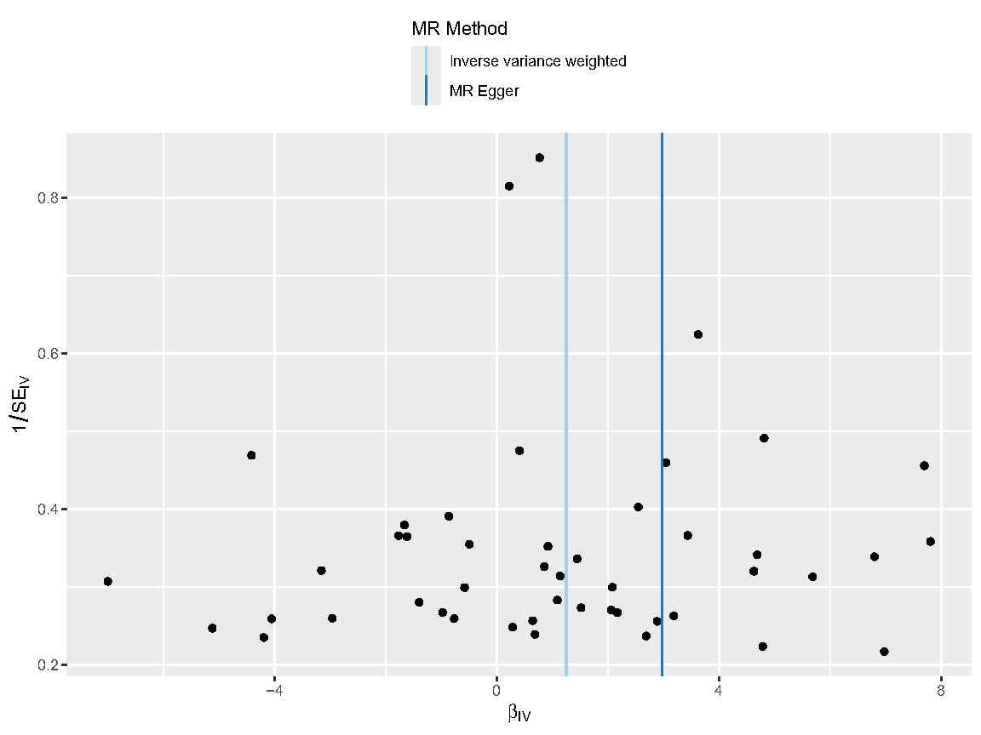

Supplementary Figure 2. HS-AS funnel plot
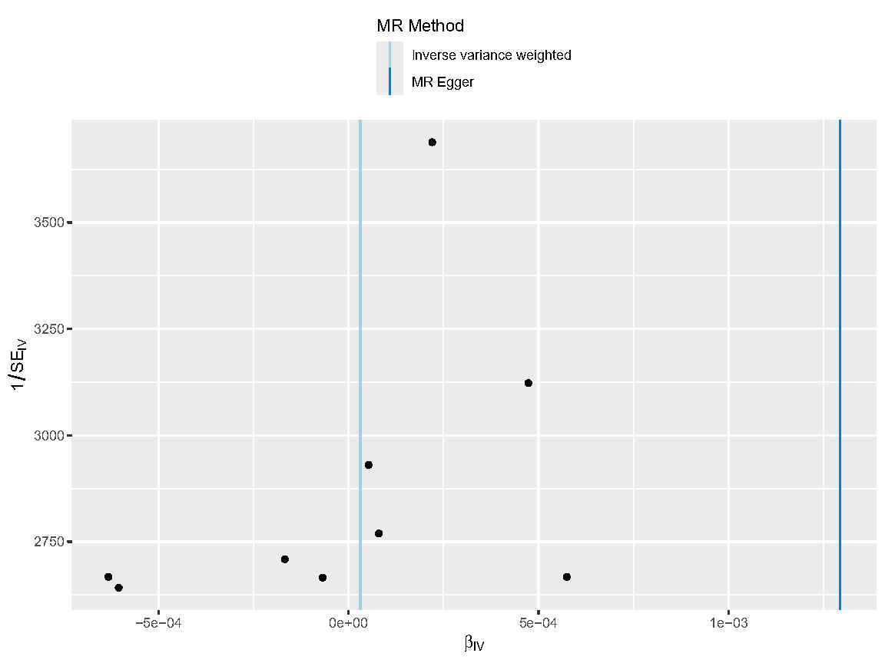

Supplementary Note 1
Estimation Approach
1. Per-SD Risk Increase:
- Formula: OR_per_SD = exp(ln(OR)/SD)
- Assumptions:
SD=1.3 (PLINK-normalized PRS distribution
*Study-derived OR=3.49
- Calculation: exp(ln(3.49)/1.3) ≈ 2.38

2. Attributable Patient Proportion Calculation
• Baseline HS prevalence: 1-4% (reference value from literature [2])
• Expected prevalence in AS patients: 1-4% × 3.49 ≈ 3.5-14%
• Attributable fraction: (3.5-14%) - (1-4%) ≈ 2-10%）

