Supplementary Table 1. Plasma metabolite profiles according to asthma clusters based on metabolites
Metabolites | Cluster 1  (N=6) | Cluster 2  (N=22) | Cluster 3  (N=26) | P-value*
2-Aminobutyrate | 16.1±7.5 | 36.7±7.1 | 28.9±8.4 | <0.001
3-Hydroxybutyrate | 22.9±8.8 | 46.4±11.0 | 33.1±5.3 | <0.001
Acetate | 38.7±12.7 | 65.5±49.7 | 49.5±25.7 | 0.179
Acetoacetate | 9.0±3.3 | 18.0±5.3 | 11.5±4.6 | <0.001
Alanine | 33.7±12.3 | 64.6±8.7 | 49.7±10.4 | <0.001
Arginine | 27.3±20.8 | 71.7±20.7 | 28.5±19.9 | <0.001
Butyrate | 1.5±0.9 | 0.8±0.6 | 0.8±0.9 | 0.129
Caproate | 0.9±0.7 | 0.5±0.3 | 0.4±0.4 | 0.04
Choline | 10.8±3.8 | 17.1±2.6 | 17.0±3.7 | <0.001
Citrate | 17.8±14.6 | 51.9±13.5 | 28.6±9.8 | <0.001
Creatine | 9.8±3.4 | 19.6±2.5 | 16.5±2.8 | <0.001
Dimethylamine | 10.5±4.1 | 16.1±3.1 | 17.6±2.6 | <0.001
Formate | 13.0±3.4 | 16.6±6.6 | 16.7±5.3 | 0.349
Glucose | 524.2±147.4 | 794.8±244.7 | 757.4±157.3 | 0.016
Glutamate | 37.5±14.2 | 84.3±12.0 | 54.8±11.4 | <0.001
Glutamine | 61.9±19.5 | 96.6±27.7 | 97.5±15.0 | 0.002
Glycerol | 10.0±4.8 | 17.4±7.0 | 19.8±6.9 | 0.01
Glycine | 13.5±5.4 | 22.0±4.4 | 20.6±4.9 | 0.001
Heptanoate | 0.4±0.3 | 0.2±0.1 | 0.1±0.2 | 0.035
Histidine | 8.0±3.6 | 11.2±3.0 | 11.2±2.8 | 0.062
Isoleucine | 39.7±13.2 | 81.5±15.5 | 67.0±12.5 | <0.001
Lactate | 129.7±65.7 | 255.7±72.9 | 185.1±37.4 | <0.001
Leucine | 55.3±23.5 | 144.1±45.4 | 104.3±26.8 | <0.001
Malonate | 166.2±58.4 | 252.6±39.4 | 265.0±30.6 | <0.001
Mannose | 90.2±76.4 | 163.1±63.0 | 141.1±58.3 | 0.045
Methanol | 4.2±4.2 | 6.2±3.1 | 2.5±1.1 | <0.001
Methionine | 9.2±3.4 | 17.4±4.6 | 14.3±2.7 | <0.001
Myo-Inositol | 17.2±6.5 | 47.2±23.0 | 27.6±19.7 | 0.001
N,N-Dimethylglycine | 2.5±1.1 | 5.3±0.7 | 4.0±0.5 | <0.001
O-Phosphocholine | 7.8±2.6 | 13.8±4.3 | 16.3±4.6 | <0.001
Phenylalanine | 15.8±7.0 | 24.1±5.3 | 20.9±3.3 | 0.001
Proline | 27.8±20.3 | 59.2±18.8 | 29.1±16.5 | <0.001
Propionate | 2.2±1.4 | 1.6±1.5 | 2.1±2.4 | 0.608
Pyruvate | 9.2±4.3 | 19.2±4.8 | 15.8±4.9 | <0.001
Succinate | 3.3±1.6 | 7.8±1.2 | 4.8±1.1 | <0.001
Taurine | 21.1±9.8 | 35.5±21.1 | 24.0±16.8 | 0.063
Threonine | 21.0±18.1 | 57.2±21.6 | 49.1±25.8 | 0.006
Tyrosine | 23.5±8.6 | 45.4±14.7 | 33.3±5.4 | <0.001
Valerate | 0.8±0.8 | 0.3±0.3 | 0.3±0.4 | 0.024
Valine | 19.7±7.1 | 41.6±9.4 | 27.9±6.6 | <0.001
*P-values were calculated using ANOVA or the Wilcoxon rank-sum test, depending on the distribution.
IQR, interquartile range

Supplementary table 2. Post-hoc pairwise comparisons for variables with significant overall differences among clusters

 | Cluster 1 vs 2  (P-value) | Cluster 1 vs 3  (P-value) | Cluster 2 vs 3  (P-value)
Smoking_status | 0.188 | 0.15 | 0.706
IOS parameters
R5-R20 | 0.974 | 0.723 | 0.989
Serum CRP (mg/dL) | 0.679 | 0.564 | 1.000
CT parameters
Pi10 (mm) | 0.423 | 0.0037 | 0.027
Wall area (%) | 0.667 | 0.0076 | 0.034
P-values were adjusted using the Bonferroni correction.
IOS, impulse oscillometry; R5-R20, difference between resistance at 5 Hz and 20 Hz; CRP, C-reactive protein; CT, computed tomography; Pi10, square root of wall area of a hypothetical airway with an internal perimeter of 10 mm

Supplementary Table 3. Univariate association analysis between potential predictors and SAD parameters
Variables | R5-R20 (P-value) | AX (P-value) | Fres (P-value) | X5 (P-value)
Target Metabolites
Dimethylamine | 0.0075 | 0.0025 | 0.0229 | 0.011
Methanol | 0.0022 | 0.0063 | 0.0562 | 0.0998
Phenylalanine | 0.0181 | 0.0101 | 0.0496 | 0.001
Malonate | 0.0094 | 0.0143 | 0.1067 | 0.0124
Covariates
Age | 0.0107 | 0.0047 | 0.0015 | 0.0017
Sex | 0.2603 | 0.1913 | 0.6689 | 0.4897
BMI | 0.6963 | 0.7842 | 0.674 | 0.3093
Smoking Status | 0.3865 | 0.3118 | 0.7245 | 0.8577
Supplementary Table 4. Linear regression results of metabolites in relation to SAD parameters
SAD parameter | Metabolites | Estimate | 95%CI | t-value | p.value | R² | Adj R²
R5-R20
 | Methanol | 0.048 | [0.019, 0.077] | 3.220 | 0.002 | 0.166 | 0.150
 | Dimethylamine | -0.042 | [-0.071, -0.013] | -2.785 | 0.007 | 0.130 | 0.113
 | Malonate | -0.041 | [-0.070, -0.012] | -2.695 | 0.009 | 0.123 | 0.11
 | Phenylalanine | -0.038 | [-0.067, -0.009] | -2.44 | 0.018 | 0.103 | 0.085
AX
 | Dimethylamine | -0.509 | [-0.823, -0.195] | -3.173 | 0.002 | 0.162 | 0.146
 | Methanol | 0.467 | [0.146, 0.788] | 2.849 | 0.006 | 0.135 | 0.118
 | Phenylalanine | -0.439 | [-0.760, -0.118] | -2.670 | 0.010 | 0.121 | 0.104
 | Malonate | -0.420 | [-0.745, -0.095] | -2.535 | 0.014 | 0.110 | 0.093
 | Glycerol | -0.341 | [-0.672, -0.010] | -2.020 | 0.048 | 0.073 | 0.055
Fres
 | Dimethylamine | -1.799 | [-3.304, -0.294] | -2.344 | 0.022 | 0.096 | 0.078
 | Phenylalanine | -1.563 | [-3.086, -0.040] | -2.010 | 0.050 | 0.072 | 0.054
X5
 | Phenylalanine | 0.039 | [0.017, 0.061] | 3.483 | 0.001 | 0.189 | 0.174
 | Dimethylamine | 0.031 | [0.007, 0.055] | 2.635 | 0.011 | 0.118 | 0.101
 | Malonate | 0.030 | [0.006, 0.054] | 2.590 | 0.012 | 0.114 | 0.097

Supplementary Figure 1. PCA loadings and extended visualization of metabolomic profiles
(A) Top 10 metabolite loadings for PC1, dominated by amino acid–related metabolites (e.g., N,N-dimethylglycine, creatine).
(B) Top 10 metabolite loadings for PC2, driven by short-chain fatty acids (caproate, butyrate, heptanoate, valerate) and O-phosphocholine.

A)
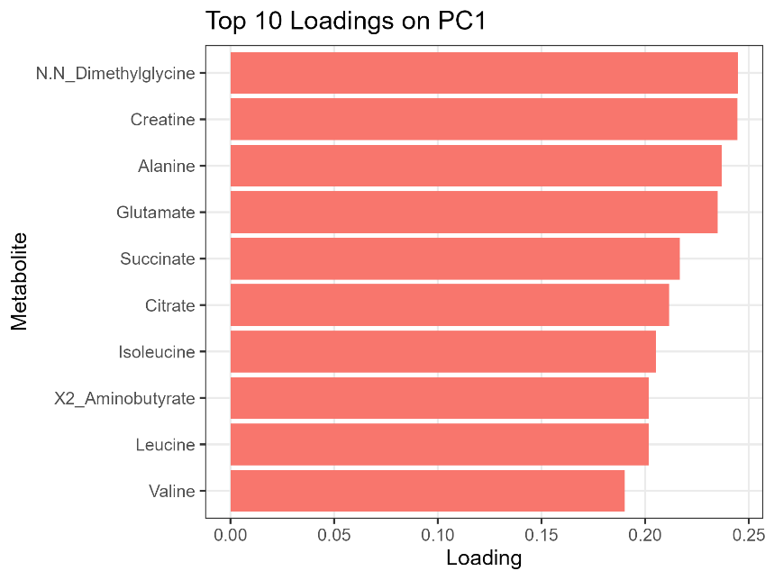
B)
