Supplementary Information
Supplementary material is available online for this article.
- Online Resource 1: Supplementary Table 1 – Glasgow Prognostic Score (GPS/mGPS)
- Online Resource 2: Supplementary Table 2 – CONUT Score
- Online Resources 3–9: Supplementary Tables 3–8 – Extended demographic, laboratory, pathology, and treatment-related data; Supplementary Table 9 – Demographic, baseline, and pathological findings of IgAN patients in different HALP score groups
- Online Resource 10: Supplementary Figures 1a–b – Additional visual analyses of renal outcomes

Supplementary Table 1. Glasgow Prognostic Score (GPS)
Glasgow Prognostic Score (GPS)
Criteria | Score
CRP ⩽ 10 mg/L and Albumin ⩾ 35 g/L | 0
CRP ⩽ 10 mg/L and Albumin < 35 g/L | 1
CRP > 10 mg/L and Albumin > 35 g/L | 1
CRP > 10 mg/L and Albumin < 35 g/L | 2
Modified Glasgow Prognostic Score (mGPS)
Criteria | Score
CRP ⩽ 10 mg/L, any Albumin value | 0
CRP > 10 mg/L and Albumin > 35 g/L | 1
CRP > 10 mg/L and Albumin < 35 g/L | 2
Notes: The Glasgow Prognostic Score (GPS) and modified Glasgow Prognostic Score (mGPS) are calculated based on serum C-reactive protein and albumin levels. Higher scores indicate greater systemic inflammation and poorer nutritional status.
Abbreviations:
GPS, Glasgow Prognostic Score; mGPS, modified Glasgow Prognostic Score; CRP, C-reactive protein.

Supplementary Table 2. Components of the CONUT score
Parameter | Value Range | Score | Nutritional Total Score
Serum Albumin Level (g/dL) | ≥ 3.5 | 0 | Normal (0–1)
 | 3.0 – 3.49 | 2 | Mild Nutritional Risk (2–4)
 | 2.5 – 2.99 | 4 | Moderate Nutritional Risk (5–8)
 | < 2.5 | 6 | Severe Nutritional Risk (9–12)
Absolute Lymphocyte Count (/mm³) | ≥ 1600 | 0
 | 1200 – 1599 | 1
 | 800 – 1199 | 2
 | < 800 | 3
Total Cholesterol Level (mg/dL) | ≥ 180 | 0
 | 140 – 179 | 1
 | 100 – 139 | 2
 | < 100 | 3
Notes: The CONUT score is calculated as the sum of points assigned for serum albumin, absolute lymphocyte count, and total cholesterol. Total scores are categorized as follows: normal nutritional status (0–1), mild nutritional risk (2–4), moderate nutritional risk (5–8), and severe nutritional risk (9–12). Higher scores indicate worse nutritional status.
Abbreviations: CONUT, Controlling Nutritional Status; Alb, Albumin; TC, Total Cholesterol; TLC, Total Lymphocyte Count.

Supplementary Table 3. Demographic and Clinical Characteristics of Patients
Variable |  | Total (n=204) | <30% Decline in eGFR (n=145) | ≥30% Decline in eGFR (n=24) | ESKD (n=35) | p
Presence of CVD at diagnosis, n (%) |  | 15 (7.4) | 11 (7.6) | 1 (4.2) | 3 (8.6) | 0.800
Presence of CVA at diagnosis, n (%) |  | 4 (2.0) | 4 (2.8) | 0 (0.0) | 0 (0.0) | 0.436
Systolic BP at diagnosis (mmHg) (IQR) |  | 128.0 (22) | 124.0 (19.2)ᵇ | 129.5 (27.8)ᶜ | 140.0 (31.5) | <0.001
Diastolic BP at diagnosis (mmHg) (SD) |  | 80.5 ± 13.2 | 78.0 ± 11.7ᵇ | 81.9 ± 16.4ᶜ | 89.5 ± 13.3 | <0.001
Notes: Values are presented as number (percentage), mean ± standard deviation, or median (interquartile range), as appropriate.
ᵇ Significant difference between the <30% decline in eGFR and ESKD groups.
ᶜ Significant difference between the ≥30% decline in eGFR and ESKD groups.
A p value < 0.05 was considered statistically significant.
Abbreviations: eGFR, estimated glomerular filtration rate; ESKD, end-stage kidney disease; CVD, cardiovascular disease; CVA, cerebrovascular accident; BP, Blood Pressure; RAS, renin–angiotensin system; IQR, interquartile range; SD, standard deviation.

Supplementary Table 4. Clinical Outcomes
Variable | Number (n) | %
<30% Decline in eGFR | 145 | 71.08
≥30% Decline in eGFR | 24 | 11.76
ESKD | 35 | 17.16
Note: Values are presented as number (n) and percentage (%).
Abbreviations: eGFR: estimated Glomerular Filtration Rate; ESKD: End-Stage Kidney Disease.

Supplementary Table 5. Analysis of Laboratory Parameters
Variable | Total (n=204) | <30% Decline in eGFR (n=145) | ≥30% Decline in eGFR (n=24) | ESKD (n=35) | p
Hematuria HPF | 14 (6–32) | 15 (30) | 13.5 (22) | 10 (21) | 0.505
Albumin (g/L) | 40.6 (37–43) | 40.6 (6) | 43 (4.6)ᵇ | 39 (9)ᵃ | 0.003
Total Protein (g/L) | 67.2 (63–71) | 67 (8)ᵃᵇ | 70 (6.5)ᵃ | 65 (8.4)ᵇ | 0.014
Uric Acid (mg/dL) | 6.76 ± 1.68 | 6.3 (2.2)ᵃ | 7.1 (1.5)ᵃᵇ | 7.4 (1.7)ᵇ | 0.001
IgG (g/L) | 10.6 (8.9–12.2) | 10.7 (3.3) | 11.2 (6.6) | 9.8 (4.4) | 0.088
IgA (g/L) | 2.9 (2.3–3.7) | 2.9 (1.4) | 3.3 (1.7) | 2.8 (0.9) | 0.302
C3 (mg/dL) | 120 (108–135) | 123 (31) | 108 (28) | 114 (21) | 0.060
C4 (mg/dL) | 29.64 ± 9.07 | 29 (11.5) | 26 (10) | 30.5 (8.5) | 0.327
CRP (mg/L) | 1.80 (0.89–4.54) | 2 (4.9) | 1.5 (2.8) | 1.7 (2.6) | 0.448
LDL (mg/dL) | 124.79 ± 39.05 | 117.5 (47.2)ᵃ | 115 (37.2)ᵃ | 146.5 (48.2)ᵇ | 0.001
HDL (mg/dL) | 46.28 ± 17.75 | 44 (17) | 45 (20.5) | 41 (16.2) | 0.345
Triglyceride (mg/dL) | 148 (96–205) | 142.5 (113.3) | 131 (118.3) | 162 (126.5) | 0.203
Total Cholesterol (mg/dL) | 205.01 ± 45.98 | 193 (56)ᵃ | 198.5 (40)ᵃᵇ | 224 (86)ᵇ | 0.013
Ferritin (µg/L) | 87.7 (38.8–170.5) | 76.6 (127.4) | 76.3 (112.6) | 152.8 (179.1) | 0.105
HbA1c (%) | 5.68 ± 0.8 | 5.71 ± 0.88 (90) | 5.75 ± 0.48 (12) | 5.44 ± 0.54 (17) | 0.159
Parathormone (ng/L) | 58.4 (33.1–88.1) | 53 (40.4)ᵃ | 41.3 (53.2)ᵃ | 106 (55)ᵇ | <0.001
Hemoglobin (g/dL) | 12.90 ± 1.91 | 13 ± 1.9ᵃ | 13.4 ± 1.9ᵃ | 12.3 ± 1.9ᵇ | 0.011
Neutrophils (/µL) | 4670 (3767–6095) | 4710 (2265) | 4295 (2657.5) | 4670 (2470) | 0.767
Lymphocytes (/µL) | 2130 (1660–2592) | 2220 (965) | 1825 (835) | 1910 (520) | 0.097
Platelets (10³/µL) | 250 (213–299) | 256 (96) | 229.5 (80) | 255 (72) | 0.610
Notes: Values are presented as number (percentage), mean ± standard deviation, or median (interquartile range), as appropriate.
ᵃ Significant difference between the <30% and ≥30% decline in eGFR groups.
ᵇ Significant difference between the <30% decline in eGFR and ESKD groups.
ᵃᵇ Significant difference between the ≥30% decline in eGFR and ESKD groups.
Group comparisons were performed using appropriate parametric or non-parametric tests according to data distribution.
When a value carries multiple superscript letters (e.g., ᵃᵇ), it is significant in each corresponding pairwise comparison.
A p value < 0.05 was considered statistically significant.
Abbreviations: eGFR: estimated Glomerular Filtration Rate; ESKD, end-stage kidney disease; HPF, high-power field; CRP, C-reactive protein; LDL, low-density lipoprotein; HDL, high-density lipoprotein; IgG, immunoglobulin G; IgA, immunoglobulin A; C3, C4, complement components 3 and 4; HbA1c, glycated hemoglobin; IQR, interquartile range; SD, standard deviation.

Supplementary Table 6. Histopathological Findings
Variable | Total | <30% decline in eGFR | ≥30% decline in eGFR | ESKD | p value
Global sclerosis, n (%) | 5 (7) | 4 (5)ᵃ | 8 (9)ᵃ | 12 (14)ᵇ | <0.001
Segmental sclerosis, n (%) | 2 (3) | 2 (3) | 2 (3) | 3 (5) | 0.573
Mesangial hypercellularity
M0 | 89 (43.6) | 66 (45.5) | 8 (33.3) | 15 (42.9)
M1 | 115 (56.4) | 79 (54.5) | 16 (66.7) | 20 (57.1) | 0.534
Endocapillary hypercellularity
E0 | 141 (69.1) | 99 (68.3) | 20 (83.3) | 22 (62.9)
E1 | 63 (30.9) | 46 (31.7) | 4 (16.7) | 13 (37.1) | 0.227
Segmental sclerosis (Oxford)
S0 | 34 (16.7) | 24 (16.6) | 4 (16.7) | 6 (17.1)
S1 | 170 (83.3) | 121 (83.4) | 20 (83.3) | 29 (82.9) | 0.996
Cellular crescent
C0 | 186 (91.2) | 132 (91.0) | 23 (95.8) | 31 (88.6)
C1 | 18 (8.8) | 13 (9.0) | 1 (4.2) | 4 (11.4) | 0.677
C2 | 0 (0) | 0 (0) | 0 (0) | 0 (0)

Notes: All variables are categorical and presented as number (percentage). Group comparisons were performed using the Pearson chi-square test or the Fisher–Freeman–Halton test, as appropriate.
ᵃ Significant difference between the <30% and ≥30% decline in eEGFR groups.
ᵇ Significant difference between the <30% decline in eEGFR and ESKD groups.
A p value < 0.05 was considered statistically significant.
Abbreviations: eGFR ,estimated glomerular filtration rate; ESKD, end-stage kidney disease; M, mesangial hypercellularity; E, endocapillary hypercellularity; S, segmental sclerosis; C, cellular crescent.

Supplementary Table 7. Treatment outcomes after PSM
Variable | Total (n) | <30% decline in eGFR | >30% decline in eGFR | ESKD | p
RAS blocker absent | 35 | 21 (44.7%) | 4 (57.1%) | 10 (62.5%)
RAS blocker present | 35 | 26 (55.3%) | 3 (42.9%) | 6 (37.5%) | 0.433
Notes: Values are presented as number (percentage). Group comparisons were performed using the Pearson chi-square test. Propensity scores were calculated using age, sex, and baseline serum creatinine. One-to-one nearest-neighbor matching without replacement was applied with a caliper width of 0.1. The total sample size reflects the matched cohort.
Abbreviations: eGFR, estimated glomerular filtration rate; ESKD, end-stage kidney disease; RAS, renin–angiotensin system.

Supplementary Table 8. Identification of factors associated with outcomes

Variables | OR | 95% CI | p
>30% decline in eGFR

Constant | - | - | 0.01
Male sex | 1.083 | (0.309–3.796) | 0.901
24-hour proteinuria, g/day | 1.568 | (1.012–2.431) | 0.044
eGFR | 0.999 | (0.976–1.022) | 0.914
Uric acid | 0.857 | (0.580–1.640) | 0.436
Total cholesterol | 0.993 | (0.980–1.007) | 0.323
Hemoglobin | 1.091 | (0.744–1.600) | 0.657
Number of global sclerosis | 1.070 | (0.987–1.159) | 0.100
Age at diagnosis | 0.991 | (0.948–1.036) | 0.697
Presence of hypertension | 5.426 | (1.621–18.161) | 0.006
Use of RAS blockade | 0.372 | (0.076–1.824) | 0.233
ESKD

Male sex | 4.764 | (0.644–35.239) | 0.126
24-hour proteinuria, g/day | 2.140 | (1.324–3.458) | 0.002
eGFR | 0.923 | (0.883–0.965) | <0.001
Uric acid | 0.956 | (0.598–1.527) | 0.850
Total cholesterol | 1.010 | (0.994–1.027) | 0.225
Hemoglobin | 0.650 | (0.387–1.094) | 0.105
Number of global sclerosis | 1.160 | (1.069–1.259) | <0.001
Age at diagnosis | 0.908 | (0.852–0.967) | 0.003
Presence of hypertension | 3.267 | (0.737–14.478) | 0.119
Use of RAS blockade | 0.178 | (0.028–1.126) | 0.067
Notes: Binary logistic regression analysis was performed using the enter method. Results are presented as odds ratios (ORs) with 95% confidence intervals (CIs). A p value < 0.05 was considered statistically significant.
Abbreviations: OR, odds ratio; CI, confidence interval; eGFR, estimated glomerular filtration rate; ESKD, end-stage kidney disease; RAS, renin–angiotensin system.

Supplementary Table 9. Demographic, baseline and pathological findings of IgAN patients in different HALP score groups
Variable | Total | Group 1 | Group 2 | Group 3 | p value
Sex, n (%)
Male | 137 (67.2) | 37 (54.4) | 47 (70.1) | 53 (76.8) | 0.017
Female | 67 (32.8) | 31 (45.6) | 20 (29.9) | 16 (23.2)
Age at diagnosis, years | 42.3 ± 14.1 | 45.7 ± 15.7ᵃ | 43.2 ± 13.6 | 38.1 ± 11.6ᵇ | 0.005
Presence of hypertension, n (%) | 108 (52.9) | 42 (61.8) | 37 (55.2) | 29 (42.0) | 0.020
Body mass index, kg/m² | 26.4 ± 4.8 | 26.1 ± 3.8 | 26.4 ± 4.0 | 26.6 ± 4.8 | 0.787
Systolic blood pressure, mmHg | 130.4 ± 19.5 | 130.3 ± 18.6 | 132.3 ± 23.1 | 128.5 ± 16.4 | 0.523
Diastolic blood pressure, mmHg | 80.4 ± 13.2 | 79.1 ± 13.5 | 80.9 ± 14.6 | 81.2 ± 11.5 | 0.624
24-hour proteinuria, g/day | 1.7 ± 1.7 | 2.05 ± 2.07 | 1.74 ± 1.5 | 1.5 ± 1.4 | 0.193
Hematuria, HPF | 44.3 ± 77 | 54.7 ± 94 | 34.0 ± 62 | 44.0 ± 71 | 0.303
eGFR, mL/min/1.73 m² | 68.7 ± 34.6 | 57.1 ± 34.1ᵃ | 69.7 ± 33.4 | 79.1 ± 33.1ᵇ | <0.001
Serum creatinine, mg/dL | 1.6 ± 1.08 | 1.9 ± 1.4ᵃ | 1.4 ± 0.7ᵇ | 1.3 ± 0.7ᵇ | 0.020
Albumin, g/L | 39.9 ± 4.7 | 37.1 ± 5.5ᵃ | 40.5 ± 3.8ᵇ | 42.1 ± 3.2ᵇ | <0.001
Uric acid, mg/dL | 6.7 ± 1.6 | 6.6 ± 1.7 | 6.8 ± 1.6 | 6.7 ± 1.6 | 0.780
IgG, g/L | 10.8 ± 3.2 | 10.2 ± 3.4 | 11.5 ± 3.0 | 10.5 ± 3.1 | 0.195
IgA, g/L | 3.1 ± 1.1 | 3.06 ± 1.05 | 3.2 ± 1.1 | 3.01 ± 1.2 | 0.502
C3, mg/dL | 122.9 ± 23.3 | 122.3 ± 24.4 | 127.7 ± 24.1 | 118.8 ± 21.0 | 0.097
C4, mg/dL | 29.6 ± 9.1 | 30.2 ± 8.0 | 30.3 ± 10.2 | 28.3 ± 8.7 | 0.366
CRP, mg/L | 10.7 ± 33.7 | 19.5 ± 51.0ᵃ | 9.4 ± 24.0ᵃᵇ | 3.5 ± 7.5ᵇ | 0.021
Ferritin, µg/L | 143 ± 318 | 208 ± 541 | 114 ± 78 | 108 ± 86 | 0.172
Hemoglobin, g/dL | 12.8 ± 1.9 | 11.6 ± 1.7ᵃ | 12.9 ± 1.5ᵇ | 14.0 ± 1.5ᶜ | <0.001
Neutrophils (/µL) | 5128 ± 2177 | 5452 ± 2510 | 5199 ± 1795 | 4740 ± 2133 | 0.152
Lymphocytes (/µL) | 2198 ± 751 | 1720 ± 630ᵃ | 2198 ± 552ᵇ | 2670 ± 735ᶜ | <0.001
Platelets (10³/µL) | 265 ± 76 | 297 ± 94ᵃ | 265 ± 64ᵇ | 233 ± 48ᶜ | <0.001
Pathological findings
Number of globally sclerotic glomeruli | 7.3 ± 7.1 | 8.1 ± 7.2 | 6.9 ± 7.4 | 6.9 ± 6.7 | 0.517
Mesangial hypercellularity
M0 | 89 (43.6) | 29 (42.6) | 30 (44.8) | 30 (43.5)
M1 | 115 (56.4) | 39 (57.4) | 37 (55.2) | 39 (56.5) | 0.969
Endocapillary hypercellularity
E0 | 141 (69.1) | 41 (60.3) | 49 (73.1) | 51 (73.9)
E1 | 63 (30.9) | 27 (39.7) | 18 (26.9) | 18 (29.1) | 0.155
Segmental sclerosis
S0 | 34 (16.7) | 8 (11.8) | 16 (23.9) | 10 (14.5)
S1 | 170 (83.3) | 60 (88.2) | 51 (76.1) | 59 (85.5) | 0.141
Tubular atrophy / interstitial fibrosis
T0 | 36 (17.6) | 12 (17.6) | 13 (19.4) | 11 (15.9)
T1 | 98 (48.0) | 27 (39.7) | 29 (43.3) | 42 (60.9)
T2 | 70 (34.4) | 29 (42.7) | 25 (37.3) | 16 (23.2) | 0.094
Cellular crescent
C0 | 186 (91.2) | 58 (85.3) | 62 (92.5) | 66 (95.7)
C1–2 | 18 (8.8) | 10 (14.7) | 5 (7.5) | 3 (4.3) | 0.033
Notes: Values are presented as mean ± standard deviation or number (percentage), as appropriate. One-way analysis of variance (ANOVA) with Bonferroni post hoc correction was applied for continuous variables with significant overall differences. Pearson chi-square test was used for categorical variables.
ᵃ Significant difference between Group 1 and Group 2.
ᵇ Significant difference between Group 1 and Group 3.
ᶜ Significant difference between Group 2 and Group 3.
A p value < 0.05 was considered statistically significant.
Abbreviations: BMI, body mass index; BP, blood pressure; eGFR, estimated glomerular filtration rate; IgG, immunoglobulin G; IgA, immunoglobulin A; CRP, C-reactive protein; M, mesangial hypercellularity; E, endocapillary hypercellularity; S, segmental sclerosis; T, tubular atrophy/interstitial fibrosis; C, cellular crescent.

Supplementary Figures Legend
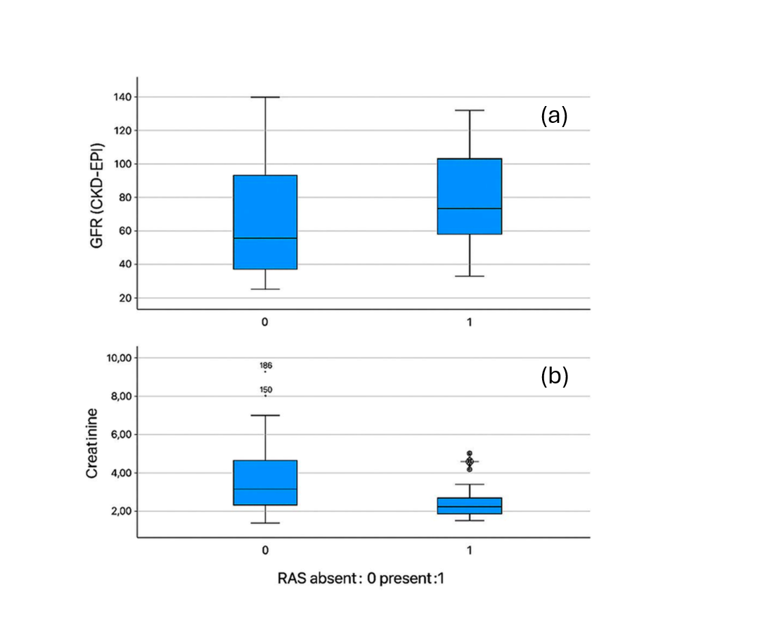
Supplementary Figure 1a-b. Baseline renal function parameters according to RAS blockade status.
(a) Baseline eEGFR (CKD-EPI) levels in patients with and without RAS blockade.
(b) Baseline serum creatinine levels in patients with and without RAS blockade.

