Supplementary Table 1. CONSORT 2010 checklist
Section/Topic | Item No | Checklist item | Reported on page No
Title and abstract
 | 1a | Identification as a randomised trial in the title | 1
 | 1b | Structured summary of trial design, methods, results, and conclusions (for specific guidance see CONSORT for abstracts) | 1
Introduction
Background and objectives | 2a | Scientific background and explanation of rationale | 1-2
Background and objectives | 2b | Specific objectives or hypotheses | 2
Methods
Trial design | 3a | Description of trial design (such as parallel, factorial) including allocation ratio | 2-3
Trial design | 3b | Important changes to methods after trial commencement (such as eligibility criteria), with reasons | Supplementary table 2
Participants | 4a | Eligibility criteria for participants | 3
Participants | 4b | Settings and locations where the data were collected | 2
Interventions | 5 | The interventions for each group with sufficient details to allow replication, including how and when they were actually administered | 3
Outcomes | 6a | Completely defined pre-specified primary and secondary outcome measures, including how and when they were assessed | 3-4
Outcomes | 6b | Any changes to trial outcomes after the trial commenced, with reasons | Supplementary table 2
Sample size | 7a | How sample size was determined | 4
Sample size | 7b | When applicable, explanation of any interim analyses and stopping guidelines | NA
Randomisation
Sequence generation | 8a | Method used to generate the random allocation sequence | 2
Sequence generation | 8b | Type of randomisation; details of any restriction (such as blocking and block size) | 2
Allocation concealment mechanism | 9 | Mechanism used to implement the random allocation sequence (such as sequentially numbered containers), describing any steps taken to conceal the sequence until interventions were assigned | 2
Implementation | 10 | Who generated the random allocation sequence, who enrolled participants, and who assigned participants to interventions | 2
Blinding | 11a | If done, who was blinded after assignment to interventions (for example, participants, care providers, those assessing outcomes) and how | 2-3
Blinding | 11b | If relevant, description of the similarity of interventions | 3
Statistical methods | 12a | Statistical methods used to compare groups for primary and secondary outcomes | 4
Statistical methods | 12b | Methods for additional analyses, such as subgroup analyses and adjusted analyses | Supplementary table 2
Results
Participant flow (a diagram is strongly recommended) | 13a | For each group, the numbers of participants who were randomly assigned, received intended treatment, and were analysed for the primary outcome | 5, Figure 1
Participant flow (a diagram is strongly recommended) | 13b | For each group, losses and exclusions after randomisation, together with reasons | Figure 1
Recruitment | 14a | Dates defining the periods of recruitment and follow-up | 5
Recruitment | 14b | Why the trial ended or was stopped | NA
Baseline data | 15 | A table showing baseline demographic and clinical characteristics for each group | Table 1
Numbers analysed | 16 | For each group, number of participants (denominator) included in each analysis and whether the analysis was by original assigned groups | 5, Figure 1
Outcomes and estimation | 17a | For each primary and secondary outcome, results for each group, and the estimated effect size and its precision (such as 95% confidence interval) | 7-9,Table 2-4, Figure 2, Supplementary table 5-6,
Outcomes and estimation | 17b | For binary outcomes, presentation of both absolute and relative effect sizes is recommended | 7, Table 2
Ancillary analyses | 18 | Results of any other analyses performed, including subgroup analyses and adjusted analyses, distinguishing pre-specified from exploratory | 9,Supplementary table 7-8
Harms | 19 | All important harms or unintended effects in each group (for specific guidance see CONSORT for harms) | 3-4
Discussion
Limitations | 20 | Trial limitations, addressing sources of potential bias, imprecision, and, if relevant, multiplicity of analyses | 11-12
Generalisability | 21 | Generalisability (external validity, applicability) of the trial findings | 12
Interpretation | 22 | Interpretation consistent with results, balancing benefits and harms, and considering other relevant evidence | 10-12
Other information
Registration | 23 | Registration number and name of trial registry | 1
Protocol | 24 | Where the full trial protocol can be accessed, if available | 2
Funding | 25 | Sources of funding and other support (such as supply of drugs), role of funders | 13
Note: The CONSORT table was adapted from Schulz KF, Altman DG, Moher D, et al. CONSORT 2010 statement: updated guidelines for reporting parallel group randomized trials. Ann Intern Med. 2010;152(11):726-732.PMID: 20335313. doi:10.7326/0003-4819-152-11-201006010-00232
Supplementary Table 2. Deviations between the Protocol and the Trial Implementation
Domain | Protocol specification | Trial implementation | Rationale
Sample size | Target = 80 | Final = 82 | During the recruitment process, several eligible participants enrolled simultaneously.
Primary outcome | ISI score reduction from week 0 to week 8 | ISI score reduction from week 0 to week 8 and insomnia remission rate at week 8 | Remission rate provides greater clinical interpretability and complements continuous ISI change; both outcomes are based on the same instrument and showed consistent results.
Secondary outcomes | ATSPPH-SF, DBAS-16, FFMQ specified as secondary outcomes | Not reported in the current manuscript | These measures are exploratory and mechanism oriented. In this report, we maintain focus on sleep outcomes and avoid outcome overload, analyses are deferred to future reports.
Statistical software | SPSS version 25.0 | SPSS version 26.0 | Minor technical update with no impact on analytical approach or results.
Statistical significance threshold | Two-sided p < 0.05 | Multiple comparison correction applied | Implemented to reduce the risk of type I error given multiple secondary outcomes.
Primary outcome analysis | Univariable linear regression for ISI reduction | Effect size (Cohen’s d) reported | Cohen’s d facilitates clinical interpretability and comparability with prior insomnia trials.
Secondary outcome analysis | No explicit hierarchy specified among secondary outcomes | Secondary outcomes were grouped into conceptual families and analyzed hierarchically | To reduce inflation of type I error associated with multiple secondary outcomes.
Sensitivity analysis | Multivariable linear regression adjusting for demographic covariates and baseline ISI | Sensitivity analysis addressing missing actigraphy data at week 20 | Missing data at long-term follow-up could be a more relevant source of bias.
Exploratory analyses | Subgroup analyses, dose–response analysis, and structural equation models for mediators or moderators | Not conducted in the current manuscript | These analyses are ongoing and will be reported separately to avoid overinterpretation.
Note: ISI: Insomnia Severity Index; ATSPPH-SF: The Attitudes Toward Seeking Professional Psychological Help Scale-Short Form; DBAS-16: Dysfunctional Beliefs and Attitudes about Sleep Scale 16-item version; FFMQ: The Five Facet Mindfulness Questionnaire

Supplementary Table 3. The outline of the 8-week iMBCT-I program
Session theme | Main content
Session 1 (90 mins):  Awareness and Automatic Pilot | - Brief introduction to CBT-I and its effects on insomnia  - How to keep sleep diaries and calculate sleep efficiency  - Development and implementation of sleep restriction  - Stimulus control guidelines  - Brief introduction to mindfulness and its effects on insomnia  - Mindfulness practices and discussion
Session 2 (90 mins):  Recognizing the Dysfunctional Beliefs in Insomnia | - Recognizing dysfunctional beliefs and habits  - 7-step of cognitive restructuring  - Discussion and feedback on homework  - Using “Pleasant Event Records” to track the relationship between emotions and thoughts  - Mindfulness practices and discussion
Session 3 (90 mins):  Thoughts Are Not Facts | - Recognizing dysfunctional beliefs and habits  - Discussion and feedback on homework  - Introducing the concept that “thoughts are not facts”  - Using “Unpleasant Event Records” to track the relationship between emotions and thoughts  - Mindfulness practices and discussion
Session 4 (90 mins):  A New Perspective | - Recognizing dysfunctional beliefs and habits  - Discussion and feedback on homework  - Mindfulness practices and discussion
Session 5 (90 mins):  Awareness is the Start of Change | - Recognizing dysfunctional beliefs and habits  - Challenging catastrophic thinking and dysfunctional beliefs related to sleep  - Discussion and feedback on homework  - Learning to observe thoughts non-judgmentally  - Mindfulness practices and discussion
Session 6 (90 mins):  Allowing/Letting Be | - Discussion and feedback on homework  - Mindfulness practices and review  - Fostering an attitude of acceptance toward internal experiences  - Interactive feedback session
Session 7 (90 mins):  How Can I Best Take Care of Myself? | - Discussion and feedback on homework  - Developing personalized early warning systems and action plans for insomnia relapse  - Identifying nurturing and energy-draining activities  - Mindfulness practices and review  - Interactive feedback session
Session 8 (90 mins):  Maintaining and Extending New Learning | - Mindfulness practices and discussion  - Discussing strategies to maintain motivation for long-term self-care  - Conclude the course, share blessings, expectations, and future arrangements

Supplementary Table 4. Number and Reasons for Missing Data on Sleep Diary and Actigraphy
Group | Timepoint | Sleep diary |  | Actigraphy
Group | Timepoint | n | Reasons | n | Reasons
iMBCT-I | week 0 | 0 | / | 0 | /
iMBCT-I | week 8 | 4 | Forgot to write (n = 1)  Refuse to keep (n = 2)  No response (n = 1) | 3 | Forgot to wear (n = 2)  Device lost (n = 1)
iMBCT-I | week 20 | 8 | Lost to follow-up (n = 5)  Refuse to keep (n = 2)  No response (n = 1) | 6 | Lost to follow-up (n = 5)  Device lost (n = 1)
SHE | week 0 | 0 | / | 0 | /
SHE | week 8 | 4 | Lost to follow-up (n = 1)  Refuse to keep (n = 2)  No response (n = 1) | 3 | Lost to follow-up (n = 1)  Forgot to wear (n = 1)  Device lost (n = 1)
SHE | week 20 | 11 | Lost to follow-up (n = 6)  Forgot to write (n = 3)  Refuse to keep (n = 1)  No response (n = 1) | 13 | Lost to follow-up (n = 6)  Forgot to wear (n = 3)  Device lost (n = 3)  Device malfunction (n = 1)
Note: iMBCT-I: internet-delivered Mindfulness-Based Cognitive Therapy for Insomnia; SHE: Sleep Hygiene Education

Supplementary Table 5. Comparison of the Mean Change Scores of Each Sleep Architecture from Week 0 to Week 8 (ITT analysis)
Outcome | iMBCT-I (n = 41) | SHE(n = 41) | Between-Group Difference  (95% CI) | t | p
Outcome | Mean (SD) | Mean (SD) | Between-Group Difference  (95% CI) | t | p
Deep sleep (min) | -0.36 (14.26) | 3.11 (12.94) | -3.47 (-9.46,2.51) | -1.154 | 0.252
Light sleep (min) | 14.36 (26.04) | 1.79 (23.60) | 12.56 (1.64, 23.49) | 2.289 | 0.025
REM sleep (min) | 22.03 (17.68) | 6.98 (12.65) | 15.05 (8.30, 21.81) | 4.434 | <0.001
Note: Missing data were imputed using Last Observation Carried Forward (LOCF); iMBCT-I: internet-delivered Mindfulness-Based Cognitive Therapy for Insomnia; SHE: Sleep Hygiene Education; ITT: intention-to-treat ; SD: standard deviation; 95% CI: 95% Confidence Interval

Supplementary Table 6. Efficacy of Primary and Secondary Outcomes at Follow-up Points: Mixed Effects Model Analysis (ITT analysis)
Outcome | iMBCT-I |  | SHE |  | Cohen's d |  | p
Outcome | EMM (SE) | 95% CI | EMM (SE) | 95% CI |  |  | Group effect | Time effect | Interaction effect (Group×Time)
Insomnia Severity Index, ISI (score)
Week 8 | 8.14 (0.63) | 6.90, 9.38 | 12.30 (2.39) | 11.04, 13.56 | -1.43 |  | <0.001 | 0.857 | 0.638
Week 20 | 7.83 (0.66) | 6.52, 9.13 | 12.44 (2.64) | 11.12, 13.76 | -1.58 |  | <0.001 | 0.857 | 0.638
Sleep diary
Sleep onset latency, SOL (min)
Week 8 | 36.67 (3.13) | 30.47, 42.87 | 56.51 (3.13) | 50.32, 62.70 | -1.29 |  | <0.001 | 0.008 | 0.727
Week 20 | 29.95 (3.28) | 23.45, 36.44 | 47.83 (3.73) | 40.47, 55.20 | -1.16 |  | <0.001 | 0.008 | 0.727
Number of awakenings
Week 8 | 1.12 (0.11) | 0.92, 1.33 | 1.38 (0.10) | 1.17, 1.58 | -0.48 |  | 0.002 | 0.246 | 0.125
Week 20 | 1.09 (0.11) | 0.87, 1.30 | 1.63 (0.12) | 1.39, 1.88 | -1.05 |  | 0.002 | 0.246 | 0.125
Wake time after sleep onset, WASO (min)
Week 8 | 13.87 (2.40) | 9.13, 18.62 | 43.19 (2.39) | 38.45, 47.92 | -2.45 |  | <0.001 | 0.521 | 0.264
Week 20 | 17.54 (2.52) | 12.56, 22.53 | 42.19 (2.64) | 36.97, 47.40 | -2.06 |  | <0.001 | 0.521 | 0.264
Total sleep time, TST (min)
Week 8 | 384.13 (6.40) | 371.47, 396.79 | 352.95 (6.43) | 340.24, 365.67 | 0.79 |  | 0.004 | 0.189 | 0.094
Week 20 | 363.67 (6.77) | 350.27, 377.06 | 355.46 (7.08) | 341.46, 369.46 | 0.21 |  | 0.004 | 0.189 | 0.094
Sleep efficiency, SE
Week 8 | 0.89 (0.02) | 0.86, 0.92 | 0.78 (0.0.02) | 0.75, 0.81 | 1.19 |  | <0.001 | 0.947 | 0.534
Week 20 | 0.88 (0.02) | 0.85, 0.92 | 0.79 (0.02) | 0.76, 0.83 | 0.98 |  | <0.001 | 0.947 | 0.534
Pittsburgh Sleep Quality Index, PSQI (score)
Week 8 | 8.14 (0.33) | 7.49,8.80 | 10.22 (0.34) | 9.56, 10.88 | -1.38 |  | <0.001 | 0.100 | 0.864
Week 20 | 8.61 (0.37) | 7.88. 9.34 | 10.60 (0.35) | 9.91, 11.29 | -1.32 |  | <0.001 | 0.100 | 0.864
Patient Health Questionnaire-9, PHQ-9 (score)
Week 8 | 5.78 (0.65) | 4.51, 7.06 | 7.69 (0.65) | 6.42, 8.97 | -0.54 |  | 0.079 | 0.235 | 0.322
Week 20 | 7.05 (0.69) | 5.69, 8.40 | 7.81 (0.70) | 6.43, 9.18 | -0.22 |  | 0.079 | 0.235 | 0.322
Generalized Anxiety Disorder 7-item scale, GAD-7 (score)
Week 8 | 3.92 (0.64) | 2.65, 5.19 | 4.44 (0.65) | 3.15, 5.72 | -0.15 |  | 0.218 | 0.036 | 0.451
Week 20 | 4.69 (0.68) | 3.34, 6.03 | 6.05 (0.69) | 4.69, 7.41 | -0.40 |  | 0.218 | 0.036 | 0.451
12-item Short Form Health Survey, SF-12 (score)
Physical Component Summary, PCS (score)
Week 8 | 48.93 (0.83) | 47.29, 50.57 | 45.93 (0.84) | 44.27, 47.59 | 0.83 |  | 0.047 | 0.735 | 0.148
Week 20 | 47.85 (0.87) | 46.14, 49.57 | 46.61 (0.88) | 44.87, 48.35 | 0.34 |  | 0.047 | 0.735 | 0.148
Mental Component Summary, MCS (score)
Week 8 | 46.68 (0.98) | 44.74, 48.62 | 43.62 (1.00) | 41.65, 45.59 | 0.61 |  | 0.004 | 0.205 | 0.614
Week 20 | 46.05 (1.04) | 43.99, 48.10 | 42.14 (1.05) | 40.06, 44.23 | 0.77 |  | 0.004 | 0.205 | 0.614
Actigraphy
Number of awakenings
Week 8 | 1.18 (0.12) | 0.94, 1.42 | 1.44 (0.12) | 1.21, 1.68 | -0.41 |  | 0.003 | 0.468 | 0.163
Week 20 | 1.10 (0.12) | 0.86, 1.35 | 1.68 (0.14) | 1.41, 1.96 | -0.90 |  | 0.003 | 0.468 | 0.163
Wake time after sleep onset, WASO (min)
Week 8 | 30.73 (2.26) | 26.25, 35.21 | 43.39 (2.26) | 38.91, 47.87 | -1.30 |  | <0.001 | 0.033 | 0.362
Week 20 | 28.58 (2.33) | 23.96, 33.20 | 38.11 (2.54) | 33.09, 43.14 | -0.98 |  | <0.001 | 0.033 | 0.362
Total sleep time, TST (min)
Week 8 | 398.06 (4.04) | 390.04, 406.08 | 372.32 (4.04) | 364.31, 380.34 | 1.65 |  | 0.001 | 0.184 | 0.007
Week 20 | 394.10 (4.15) | 385.87, 402.32 | 383.68 (4.48) | 374.81, 392.54 | 0.60 |  | 0.001 | 0.184 | 0.007
Deep sleep duration (min)
Week 8 | 86.67 (1.78) | 83.12, 90.21 | 87.22 (1.78) | 83.69, 90.76 | -0.10 |  | 0.551 | 0.357 | 0.360
Week 20 | 84.88 (1.81) | 81.28, 88.49 | 87.22 (1.92) | 83.42, 91.01 | -0.43 |  | 0.551 | 0.357 | 0.360
Light sleep duration (min)
Week 8 | 223.75 (3.35) | 217.12, 230.38 | 214.89 (3.35) | 208.25, 221.53 | 0.62 |  | 0.471 | 0.004 | 0.026
Week 20 | 225.65 (3.46) | 218.80, 232.50 | 228.36 (3.78) | 220.89, 235.82 | -0.31 |  | 0.471 | 0.004 | 0.026
Rapid eye movement sleep, REM sleep duration (min)
Week 8 | 87.05 (1.68) | 83.71, 90.38 | 70.97 (1.68) | 67.63, 74.30 | 2.76 |  | <0.001 | 0.004 | 0.205
Week 20 | 82.62 (1.72) | 79.22, 86.03 | 69.18 (1.83) | 65.55, 72.81 | 2.31 |  | <0.001 | 0.004 | 0.205
Note: (a) Missing data were not imputed. EMM (SE) was estimated marginal means (standard error) derived from linear mixed-effects models. (b) The baseline scores of outcomes were adjusted as covariates in their models. (c) Cohen’s d was calculated for between-group differences at each time point using the formula: d =(M_{iMBCT-I} -M_{SHE})/SD_{pooled}, where M represents the estimated marginal mean at each time point and SD_{pooled} is the residual standard deviation from the model. (d) iMBCT-I: internet-delivered Mindfulness-Based Cognitive Therapy for Insomnia; SHE: Sleep Hygiene Education; 95% CI: 95% Confidence Interval; ITT = intention-to-treat.

Supplementary Table 7. Comparison of the Changes in Sleep Condition, Depressive and Anxiety Symptoms, and Quality of Life from Week 0 to Week 8 (Sensitivity Analysis Using Pre-protocol Dataset)
Outcome | iMBCT-I  (n = 36) | SHE  (n = 35) | Between-Group Difference  (95% CI) | t | p
Outcome | Mean (SD) | Mean (SD) | Between-Group Difference  (95% CI) | t | p
Insomnia Severity Index, ISI (score) | -9.39(3.64) | -4.71(4.11) | -4.67 (-6.51,-2.84) | -5.078 | <0.001
Pittsburgh Sleep Quality Index, PSQI (score) | -3.14(2.31) | -1.26(2.29) | -1.88 (-2.97,-0.79) | -3.447 | 0.001
Patient Health Questionnaire-9, PHQ-9 (score) | -2.72(4.29) | -1.66(4.08) | -2.88 (-4.65,-1.12) | -3.270 | 0.002
Generalized Anxiety Disorder 7-item scale, GAD-7 (score) | -3.03(3.97) | -0.14(3.43) | -1.06 (-3.05,0.92) | -1.072 | 0.288
12-item Short Form Health Survey, SF-12 (score)
Physical Component Summary, PCS (score) | 2.15(6.25) | -0.95(6.77) | 3.11 (0.03, 6.19) | 2.011 | 0.048
Mental Component  Summary, MCS (score) | 6.11(8.51) | 1.34(8.73) | 4.77 (0.69,8.85) | 2.332 | 0.023
Note: Missing data were not imputed; iMBCT-I: internet-delivered Mindfulness-Based Cognitive Therapy for Insomnia; SHE: Sleep Hygiene Education; PP: per-protocol ; SD: standard deviation; 95% CI: 95% Confidence Interval

Supplementary Table 8. Comparison of the Changes of Subjective and Objective Sleep Data from Week 0 to Week 8 (Sensitivity Analysis Using Pre-protocol Dataset)
Outcome | iMBCT-I  (n = 34) | SHE  (n = 31) | Between-Group Difference  (95% CI) | t | p
Outcome | Mean (SD) | Mean (SD) | Between-Group Difference  (95% CI) | t | p
Sleep diary
Sleep onset latency, SOL (min) | -20.84 (33.03) | 3.19 (28.87) | -24.03 (-39.48, 8.59) | -3.110 | 0.003
Number of awakenings | 0.85 (0.15) | 1.18 (0.22) | -0.33 (-0.85, 0.20) | -1.250 | 0.216
Wake time after sleep onset, WASO (min) | -17.81 (23.20) | 2.69 (15.78) | -20.50 (-30.43, -10.57) | -4.124 | <0.001
Total sleep time, TST (min) | 15.87 (73.12) | 2.57 (46.05) | 13.30 (-17.33, 43.94) | 0.868 | 0.389
Sleep efficiency, SE | 0.09 (0.17) | -0.01 (0.07) | 0.10 (0.03, 0.17) | 2.950 | 0.004
Actigraphy
Number of awakenings | -0.19 (0.63) | 0.12 (0.75) | -0.31 (-0.66, 0.03) | -1.828 | 0.072
Wake time after sleep onset, WASO (min) | -6.01 (17.26) | 4.52 (22.53) | -10.53 (-20.42, -0.63) | -2.125 | 0.037
Total sleep time, TST (min) | 40.16 (34.03) | 13.58 (31.13) | 26.58 (10.36, 42.80) | 3.275 | 0.002
Deep sleep duration (min) | -0.37 (20.61) | 2.95 (14.54) | -3.32 (-12.11,5.48) | -0.743 | 0.460
Light sleep duration (min) | 15.35 (27.84) | 4.80 (22.99) | 10.55 (-2.18,23.28) | 1.657 | 0.103
Rapid eye movement sleep, REM sleep duration (min) | 25.42 (17.13) | 5.83 (12.18) | 19.59 (12.15, 27.02) | 5.264 | <0.001
Note: Missing data were not imputed; iMBCT-I: internet-delivered Mindfulness-Based Cognitive Therapy for Insomnia; SHE: Sleep Hygiene Education; PP: per-protocol ; SD: standard deviation; 95% CI: 95% Confidence Interval

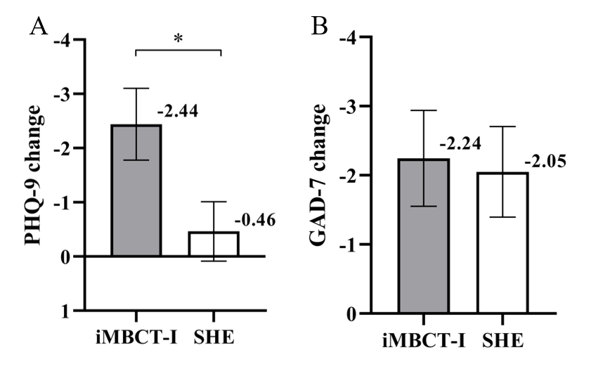
Supplementary Figure 1. Comparison of the Mean Change Scores of Depressive and Anxiety Symptoms from Week 0 to Week 8 (ITT analysis)
- Changes in Patient Health Questionnaire-9 (PHQ-9). (B) Changes in Generalized Anxiety Disorder 7-item scale (GAD-7).
Note: iMBCT-I: internet-delivered Mindfulness-Based Cognitive Therapy for Insomnia; SHE: Sleep Hygiene Education; Error bars represent standard errors; ITT: intention-to-treat; * p < 0.05

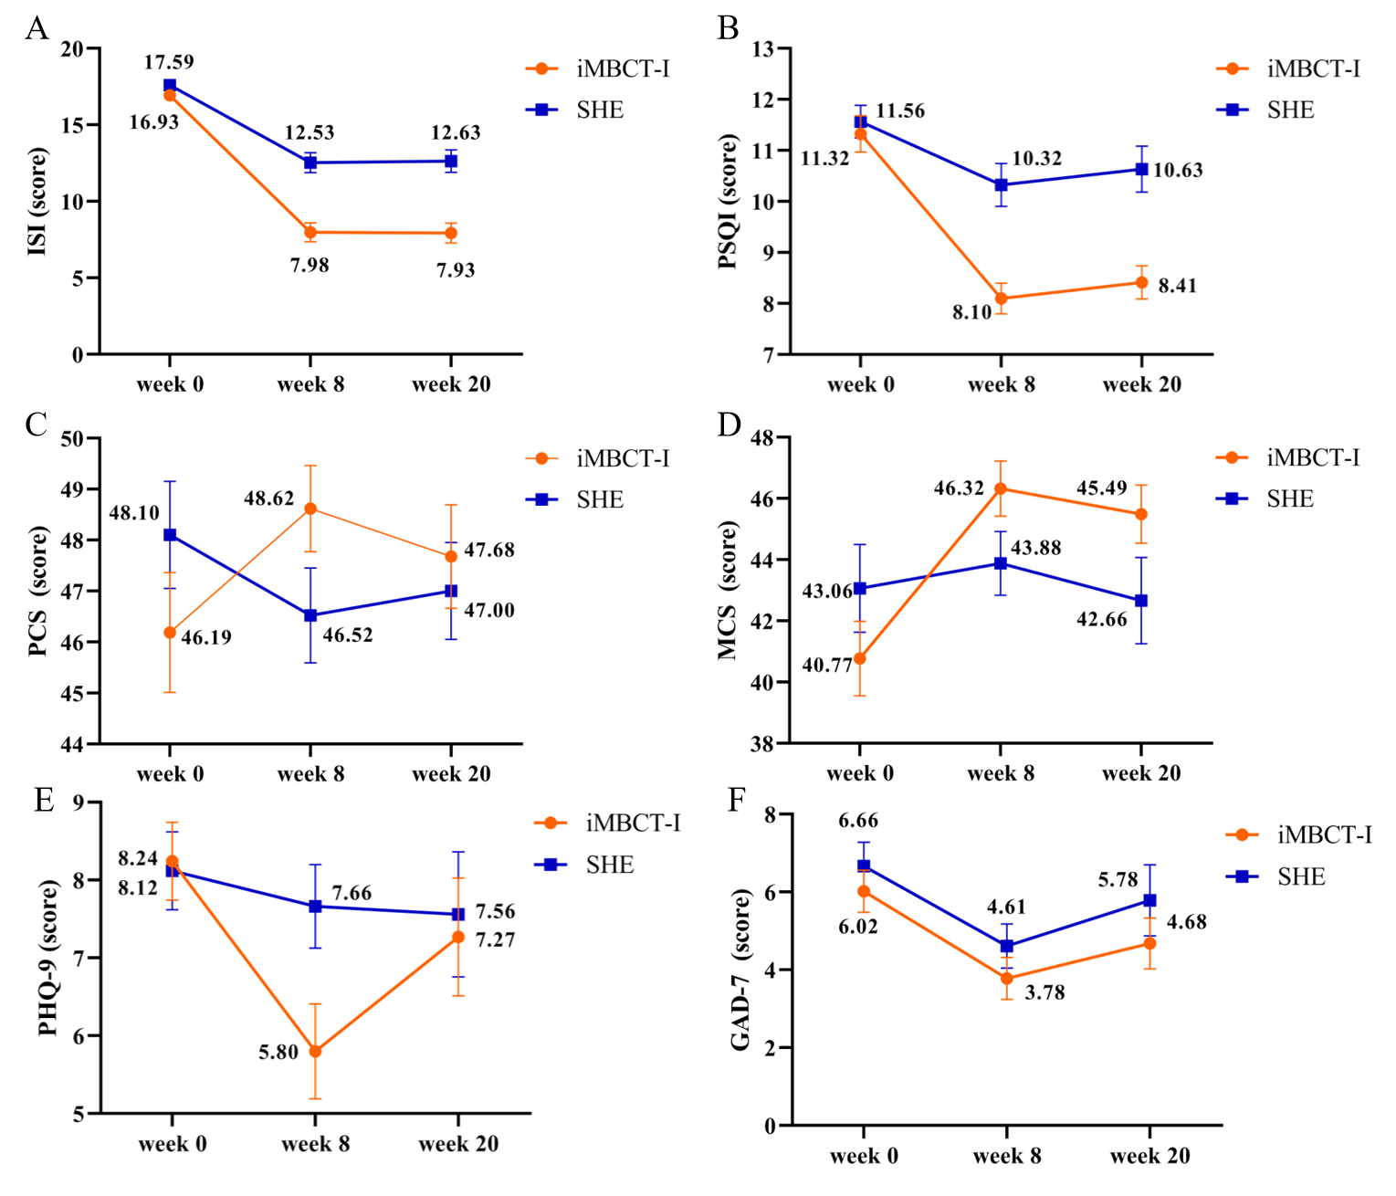
Supplementary Figure 2. Changes in the scores of ISI, PSQI, PCS, MCS, PHQ-9, and GAD-7 from week 0 to week 20 in both groups (ITT analysis)
- Changes in the score of Insomnia Severity Index (ISI). (B) Changes in the score of Pittsburgh Sleep Quality Index (PSQI). (C) Changes in in the score of Physical Component Summary (PCS) of 12-item Short Form Health Survey (SF-12). (D) Changes in in the score of Mental Component Summary (MCS) of SF-12. (E) Changes in in the score of Patient Health Questionnaire-9 (PHQ-9). (F) Changes in in the score of Generalized Anxiety Disorder 7-item scale (GAD-7).
Note: iMBCT-I: internet-delivered Mindfulness-Based Cognitive Therapy for Insomnia; SHE: Sleep Hygiene Education; ITT: intention-to-treat; Error bars represent standard errors.

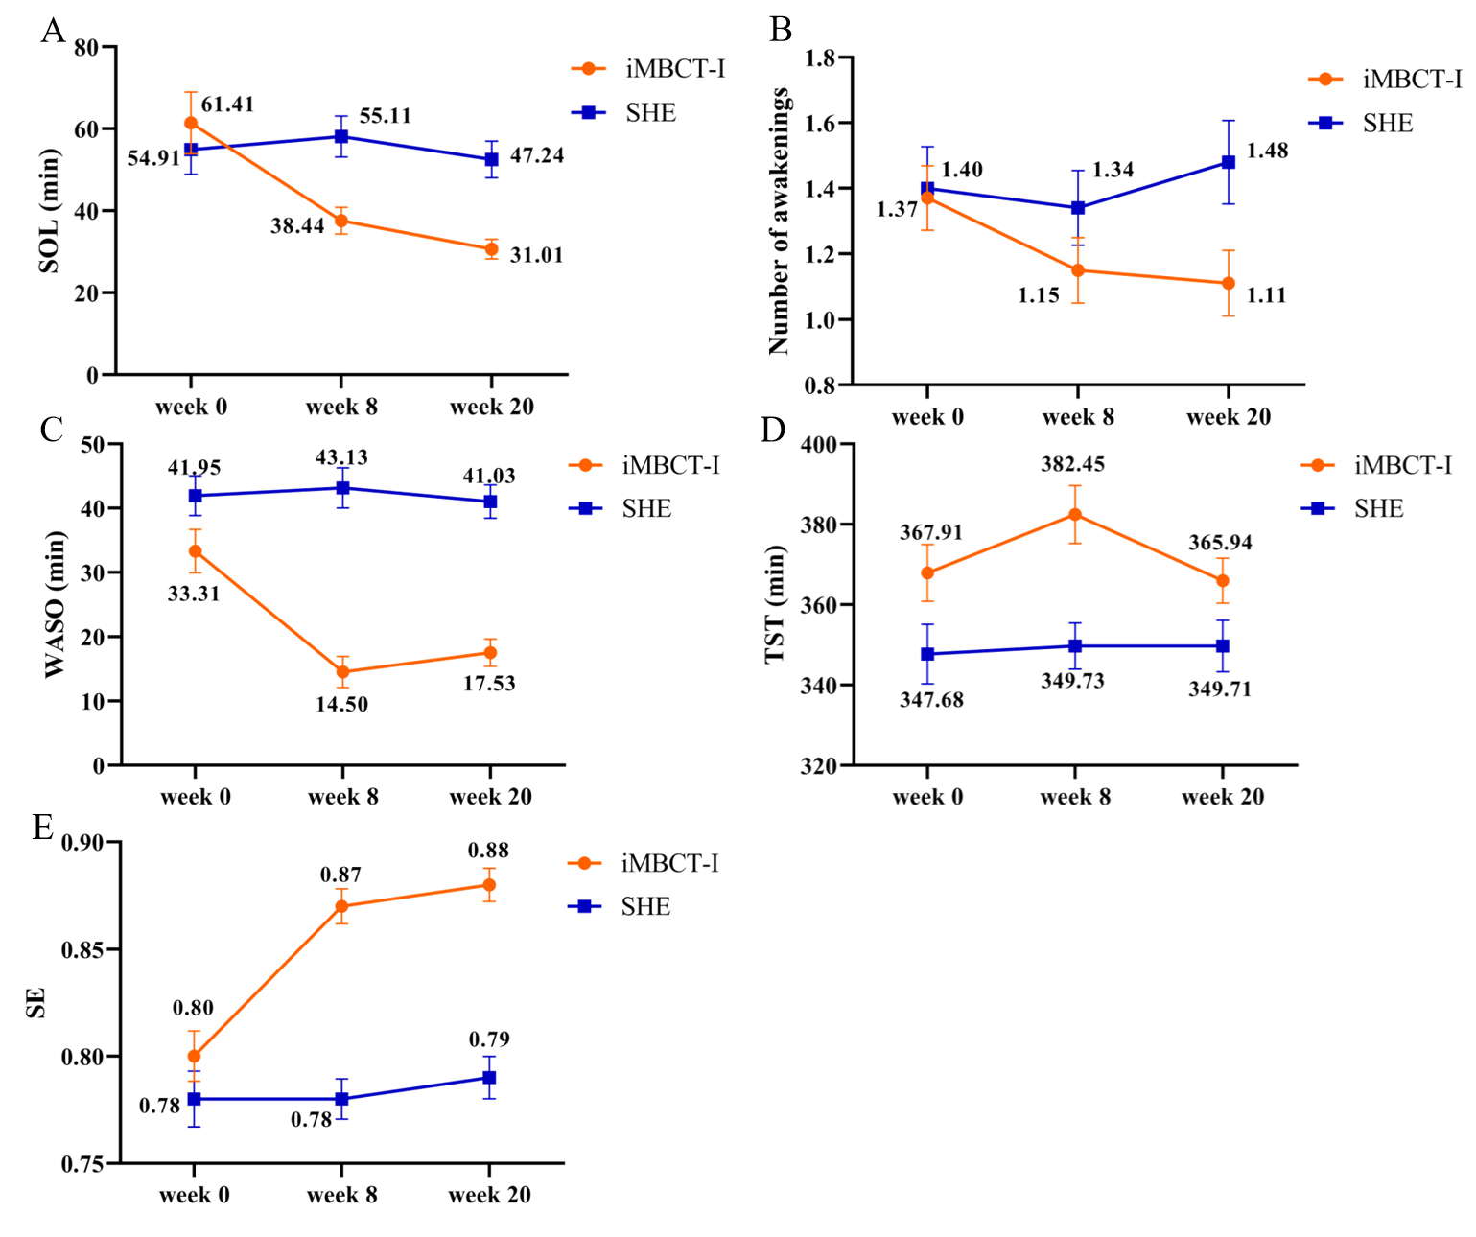
Supplementary Figure 3. Changes in Sleep Diaries from Week 0 to Week 20 between the iMBCT-I Group and SHE Group (ITT Analysis)
- Changes in sleep onset latency (SOL). (B) Changes in number of awakenings. (C) Changes in wake time after sleep onset (WASO). (D) Changes in total sleep time (TST). (E) Changes in sleep efficiency (SE).
Note: iMBCT-I: internet-delivered Mindfulness-Based Cognitive Therapy for Insomnia; SHE: Sleep Hygiene Education; ITT: intention-to-treat; Error bars represent standard errors of the mean

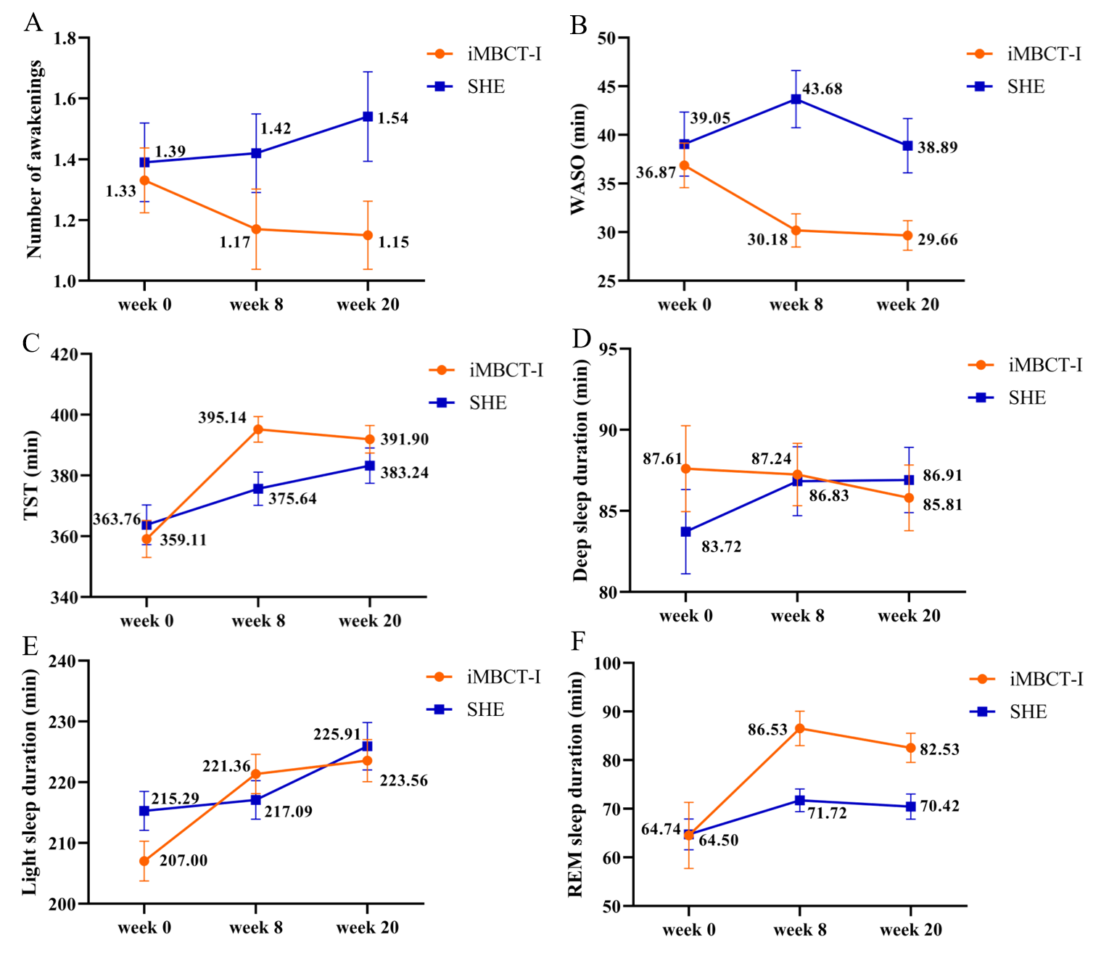
Supplementary Figure 4. Changes in Actigraphy from Week 0 to Week 20 between the iMBCT-I Group and SHE Group (ITT Analysis)
- Changes in number of awakenings. (B) Changes in wake time after sleep onset (WASO). (C) Changes in total sleep time (TST). (D) Changes in deep sleep duration. (E) Changes in light sleep duration. (F) Changes in rapid eye movement sleep (REM) sleep duration.
Note: iMBCT-I: internet-delivered Mindfulness-Based Cognitive Therapy for Insomnia; SHE: Sleep Hygiene Education; ITT: intention-to-treat; Error bars represent standard errors of the mean

