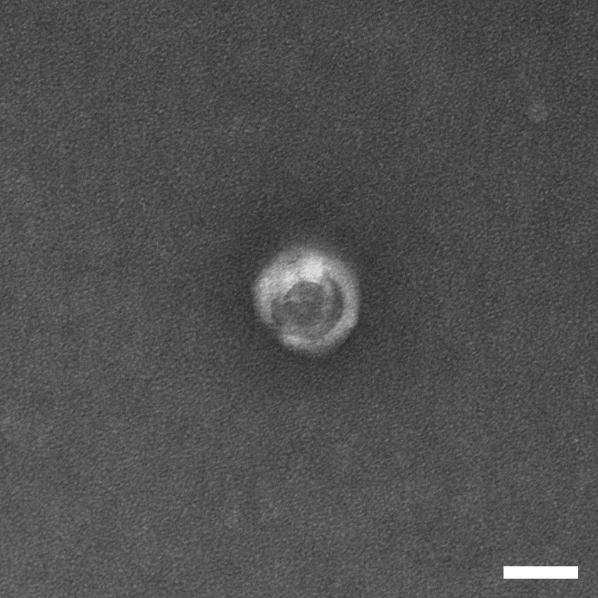
Supplementary Figure S1. TEM images of Exos-AM. Bar = 100nm.

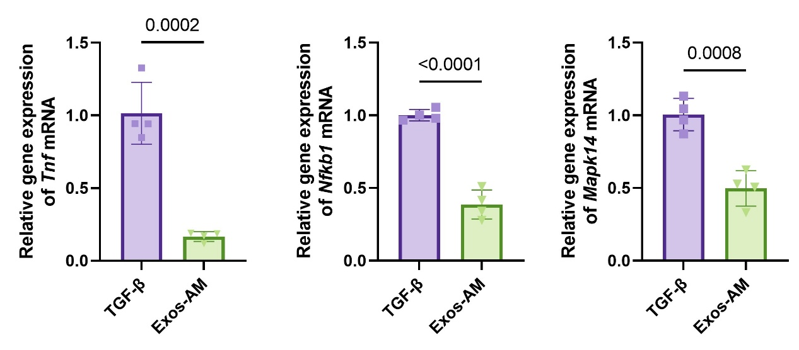
Supplementary Figure S2. Relative mRNA expression levels of Tnf, Nfkb1, and Mapk14 in RAW264.7. Data are presented as mean ± SD.

