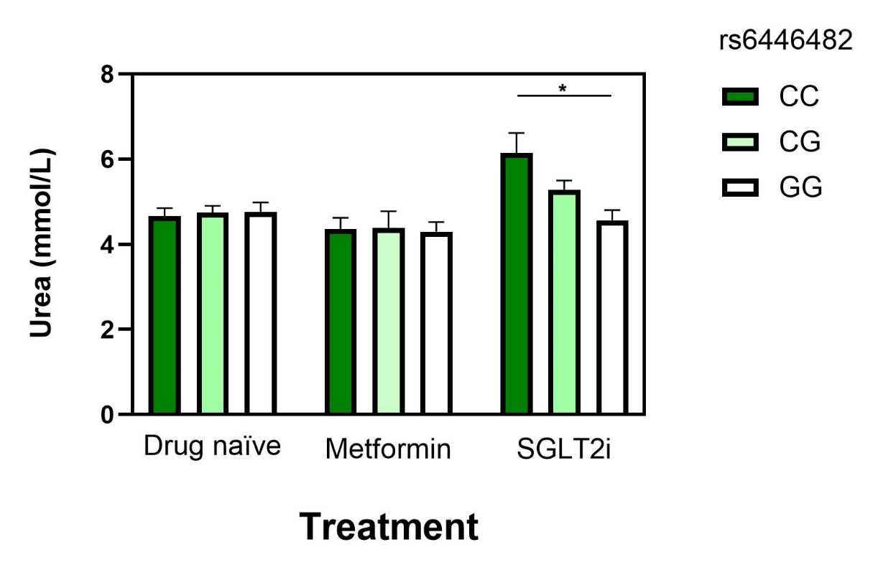
Supplementary Figure S1. Serum urea levels (mmol/L) are shown across the three treatment groups: drug-naïve, metformin-treated, and SGLT2i-treated. Within each group, data are further stratified by the rs6446482 genotype (CC, CG, GG). Data are presented as mean ± SEM. *p < 0.01 for post-hoc comparisons between genotype groups within the SGLT2i cohort after one-way ANOVA.
Supplementary table S1. List of the genetic variants investigated in this study.
Gene | Variant
SLC5A2 | rs3813008
SLC5A2 | rs4536493
SLC5A2 | rs9934336
SLC5A2 | rs3116150
SLC5A2 | rs9927250
SLC5A2 | rs34081766
SLC5A2 | rs3116150
SLC5A2 | rs11646054
SLC5A2 | rs3813008
SLC5A4 | rs62239058
SLC5A9 | rs850763
SLC2A1 | rs1385129
SLC2A9 | rs1689079
WFS1 | rs10010131
UGT2B4 | rs1080755
UGT1A9 | rs72551330
Supplementary table S2. Clinical and biochemical characteristics of SGLT2i-treated patients stratified by rs10010131 genotype.
Variable | AA  N=17 | AG  N=33 | GG  N=19 | AA vs AG  FDR | AA vs GG  FDR
Fasting blood glucose (mmol/L) | 6.65 (6.05-9.68) | 7.7 (6.5-9.4) | 7.6 (4.6-9.2) | 0.32 | 0.33
HbA₁C (%) | 8.2 (1.5) | 7.7 (1.1) | 7.8 (1.2) | 0.7 | 0.9
Total cholesterol (mmol/L) | 4.34 (1.03) | 4.78 (0.89) | 4.46 (0.89) | 0.3 | 0.9
HDL-cholesterol (mmol/L) | 1.42 (0.36) | 1.37 (0.42) | 1.22 (0.26) | 0.9 | 0.35
LDL-cholesterol (mmol/L) | 2.28 (0.86) | 2.71 (0.86) | 2.35 (0.84) | 0.3 | 0.9
Triglyceride (mmol/L) | 1.41 (0.6) | 1.59 (1.0) | 1.97 (1.5) | 0.9 | 0.44
Creatinine (µmol/L) | 74.4 (22.8) | 63.3 (13.9) | 65.4 (17.3) | 0.1 | 0.37
Uric acid | 290.9 (92.3) | 243.7 (66.1) | 243.4 (56.6) | 0.09 | 0.15
Calcium | 2.41 (0.07) | 2.41 (0.09) | 2.38 (0.09) | 0.9 | 0.9
Hematocrit | 43.06 (5.36) | 42.39 (3.87) | 41.21 (4.88) | 0.9 | 0.7

