Supplementary information

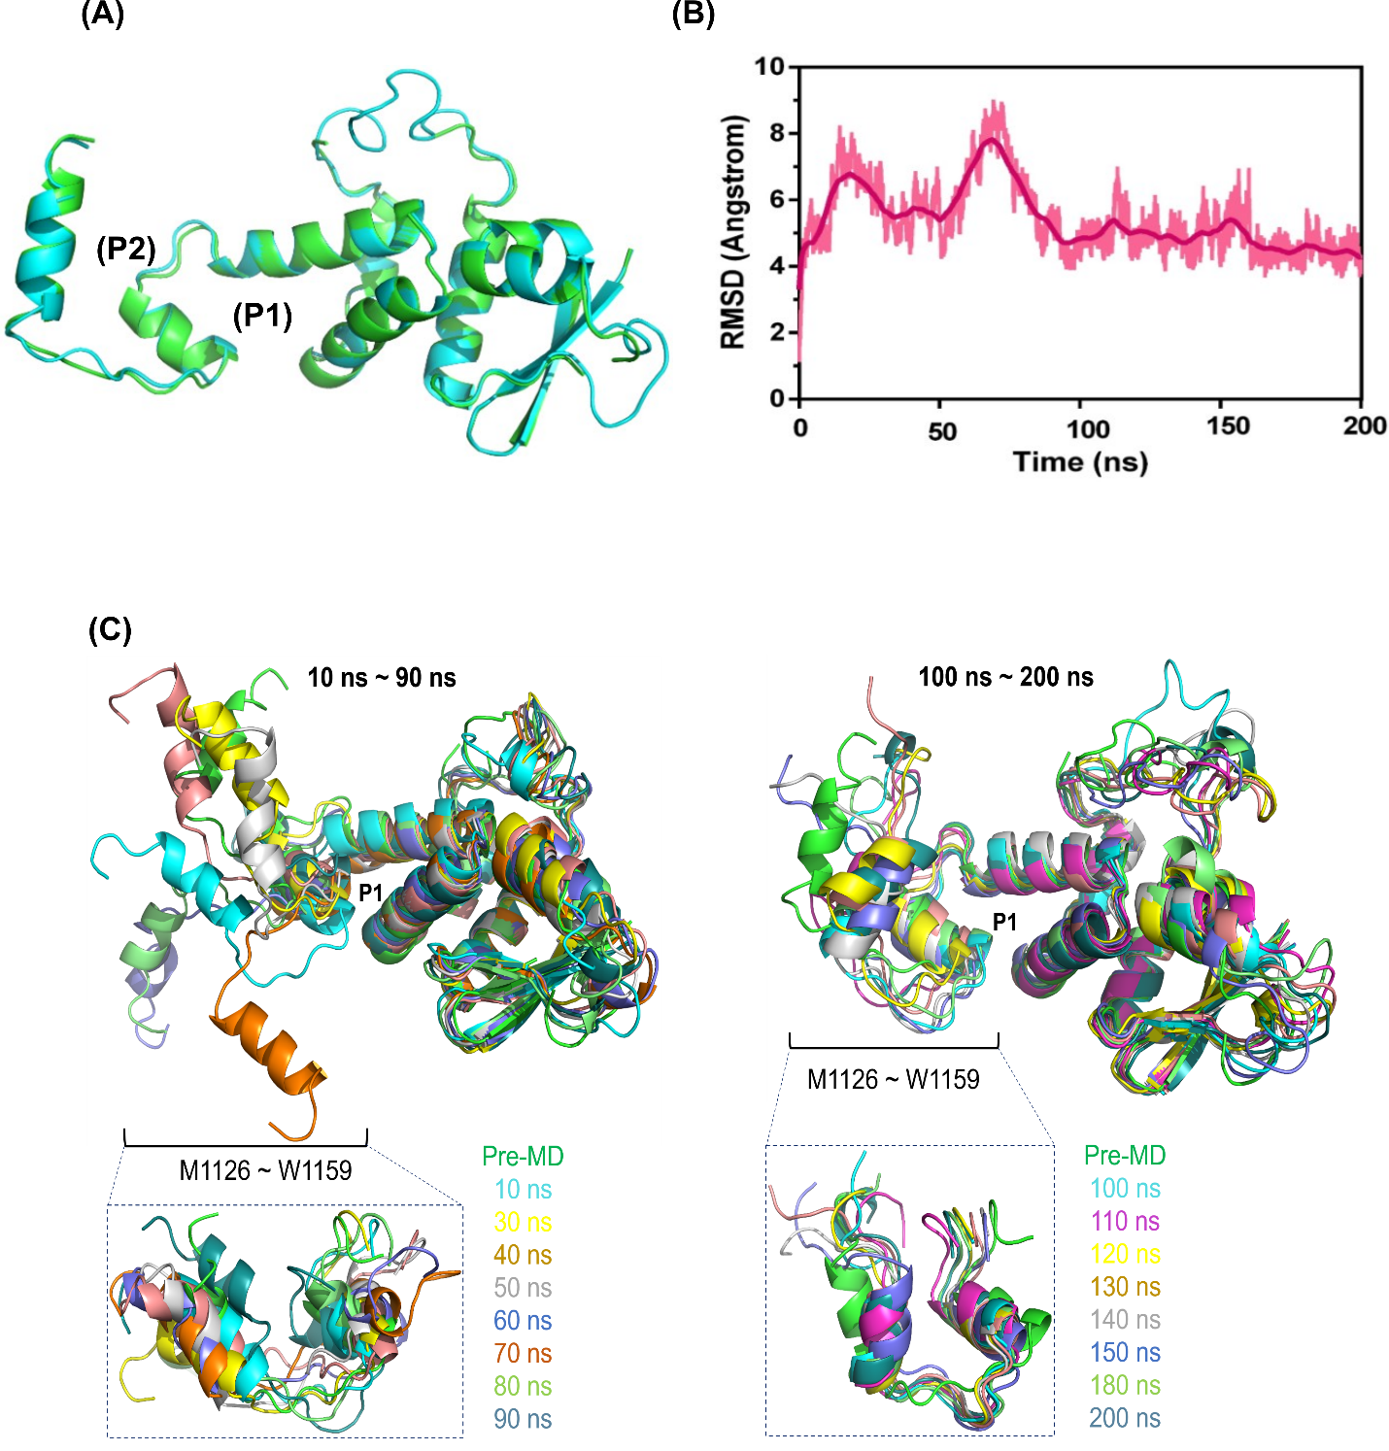

Figure S1: Molecular dynamics of Skp1. (A) The Skp1 model (cyan) used for MD simulations was generated and adopted from our previous study ²¹. (B) RMSD profile of apo Skp1 generated from 200 ns MD simulations. (C) Conformational analysis of H8-helix region of Skp1 across MD trajectory, highlighting local flexibility and dynamic behavior.
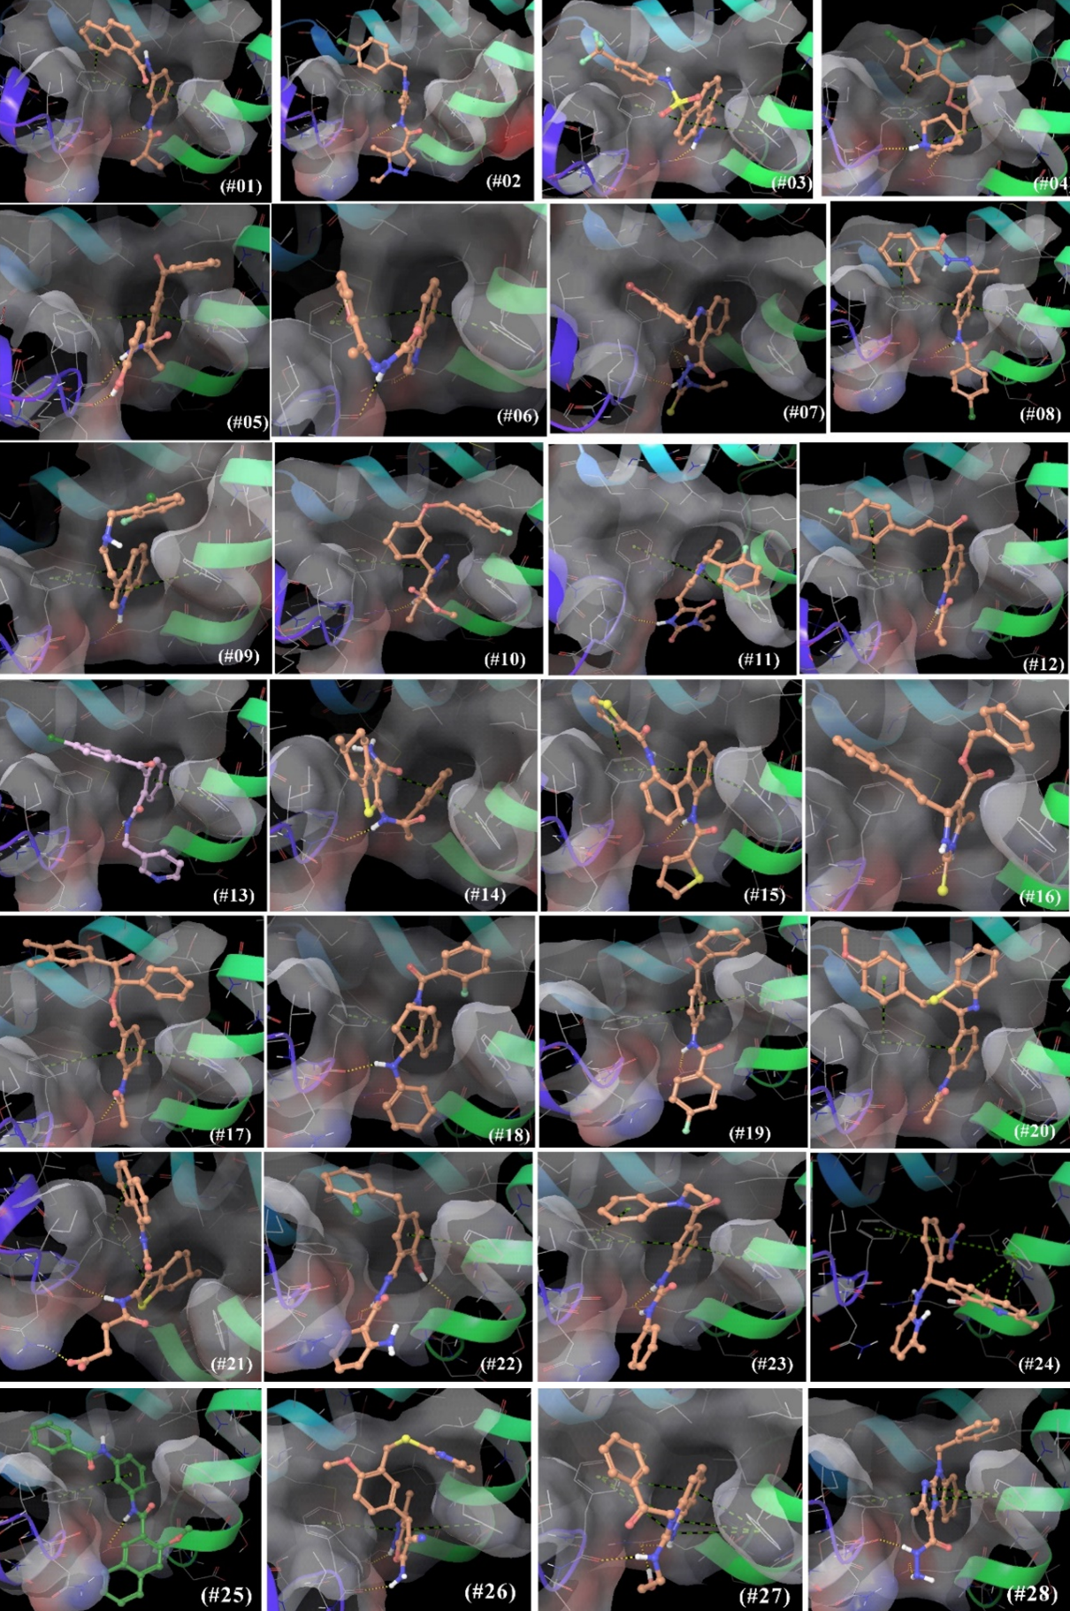
Figure S2: Glide binding poses of 28 compounds selected from SBVS. # denotes compound number. Green dotted lines indicate π-π or π-cation interactions, while the yellow dotted lines represent H-bonding interactions.

