Supplementary Methods
Supplementary Methods 1: Coomassie brilliant blue staining.
After electrophoresis, the SDS-PAGE gel was carefully removed and washed in 50–100 mL distilled water with gentle shaking for 5 minutes, repeated three times; after discarding the distilled water, an appropriate amount of Coomassie Brilliant Blue fast staining solution was added to completely cover the gel, and staining was performed on a shaker until the target protein bands were clearly visible; after staining, the staining solution was recovered, and an appropriate amount of distilled water was added to terminate the staining reaction; subsequently, the gel was immersed in decolorization solution (800 mL methanol, 80 mL glacial acetic acid, topped up with double-distilled water to 1000 mL) and decolorized on a shaker at room temperature for 12 hours, with the decolorization solution changed three times during this period, until the gel background blue was largely faded and the protein bands were clearly visible.
Supplementary Methods 2: Western blot
According to the kit instructions, 10% SDS-PAGE separation gel and 4% stacking gel were prepared. The loading volume was calculated and applied based on the sample protein concentration. Electrophoresis was initiated at a constant voltage of 80 V through the stacking gel. After the indicator band showed clear separation, the voltage was switched to 120 V to continue electrophoresis for 1–2 hours. Following electrophoresis, the gel was carefully retrieved. A PVDF membrane was activated in methanol and rinsed with distilled water, followed by wet transfer. The transfer current was set between 200–300 mA according to the target protein's molecular weight, for a duration of 1–2 hours. After transfer, the membrane was placed on a shaker and rinsed with TBST buffer. Blocking was then performed using 5% BSA blocking buffer at room temperature for 2 hours. After another TBST rinse, the membrane was placed in a humidified chamber and incubated with an appropriately diluted primary antibody at 4°C overnight. The membrane was then retrieved and washed three times for 5 minutes each with TBST on a shaker. Subsequently, it was incubated with the diluted secondary antibody at room temperature for 2 hours. Following another three washes with TBST, ECL developing solution was prepared by mixing components at a 1:1 ratio, applied evenly onto the membrane surface, and chemiluminescence detection was performed.
Supplementary Methods 3: Ca²⁺ detection
Intracellular calcium was detected using the Fluo-4 AM fluorescent probe. Briefly, Fluo-4 AM was diluted to a final concentration of 5 µM in HBSS buffer to prepare the staining working solution. After removing the original cell culture medium, 0.5 mL of the working solution was added to each well, followed by incubation at 37 °C in the dark for 20 minutes. The solution was then replaced with HBSS buffer containing 1% fetal bovine serum and incubation continued at 37 °C in the dark for another 40 minutes. After incubation, the cells were gently washed twice with pre-warmed HBSS buffer, and finally the intracellular calcium fluorescence signals were detected under a fluorescence microscope.
Supplementary Methods 4: JC-1 detection
Mitochondrial membrane potential was assessed using the JC-1 fluorescent probe. Briefly, JC-1 was diluted 1:200 with ultrapure water and vortexed or pipetted until completely dissolved, followed by addition of JC-1 staining buffer (5×) at a 1:50 volume ratio to prepare the JC-1 working solution. This working solution was then diluted 1:4 with an appropriate buffer or culture medium to obtain the final staining solution. A volume of 0.5 mL of the JC-1 staining solution was added to each well, gently mixed, and incubated at 37 °C in the dark for 20 minutes. After incubation, the supernatant was removed, and the cells were washed twice with pre-cooled (4 °C) JC-1 staining buffer. Finally, 1 mL of pre-warmed fresh culture medium was added to each well, and fluorescence signals were immediately observed and captured under a fluorescence microscope.
Supplementary Methods 5: Mitochondrial detection
Mitochondrial staining was performed using the MitoTracker® Green FM fluorescent probe. The 1 mM stock solution was diluted to 50 nM in pre-warmed complete medium to prepare the staining working solution. After removing the original medium from the culture plate, the pre-warmed (37 °C) working solution was gently added to completely cover the cells, followed by incubation at 37 °C with 5% CO₂ in the dark for 30 minutes. After incubation, the working solution was aspirated, and the cells were gently washed twice with fresh pre-warmed complete medium. Finally, the medium was replaced with fresh complete medium, and mitochondrial fluorescence signals were immediately observed and captured under a fluorescence microscope.
Supplementary Methods 6: Masson staining
Deparaffinized tissue sections were immersed in 2.5% potassium dichromate solution for overnight treatment, followed by thorough rinsing under running tap water. The sections were then stained with Masson's Ponceau Acid Fuchsin solution for 5–10 minutes, briefly rinsed with 2% acetic acid aqueous solution, and differentiated with 1% phosphomolybdic acid aqueous solution for 5 minutes. This was followed by counterstaining with aniline blue solution for 5 minutes and another brief rinse with 0.2% acetic acid aqueous solution. The sections were subsequently dehydrated through sequential treatments with 95% ethanol and absolute ethanol, cleared in xylene, and finally mounted with neutral balsam.
Supplementary Methods 7: Immunohistochemistry and immunofluorescence staining
Paraffin-embedded tissue sections were baked at 65°C for 2 hours, followed by deparaffinization in xylene and hydration through a graded ethanol series. After rinsing three times with PBS, the sections were placed in citrate-based antigen retrieval solution (pH 6.0) and subjected to microwave-assisted epitope retrieval using heat-resistant plastic slide holders: heating at medium power until boiling followed by maintenance for 10 minutes. After natural cooling, the sections were sequentially rinsed twice with distilled water and three times with PBS. Endogenous peroxidase activity was blocked by incubating with 3% H₂O₂ solution at room temperature for 10 minutes, followed by three PBS washes. Blocking was performed by applying blocking buffer at room temperature for 2 hours. After removing the blocking solution, the sections were incubated with primary antibody at 4°C overnight. The following day, after 30 minutes of rewarming, the sections were washed three times with PBS. Subsequently, corresponding secondary antibodies were applied based on the primary antibody species and incubated at room temperature for 2 hours, followed by another three PBS washes. DAB developing solution was prepared by mixing solutions A and B at a 1:1 ratio, applied to the sections, and developed at room temperature for 2–5 minutes with development progress monitored under a microscope. The reaction was terminated by thorough rinsing with tap water. Counterstaining was performed with hematoxylin, followed by dehydration through a graded ethanol series and mounting with neutral balsam. Observation was carried out under a light microscope.
For the immunofluorescence detection procedure, after primary antibody incubation, fluorescently labeled secondary antibodies were applied and incubated at room temperature protected from light for 2 hours, followed by three PBS washes. Subsequently, nuclei were stained with DAPI for 3 minutes, followed by another three PBS washes. Finally, sections were mounted with anti-fade mounting medium and observed under a fluorescence microscope.

Supplementary Results
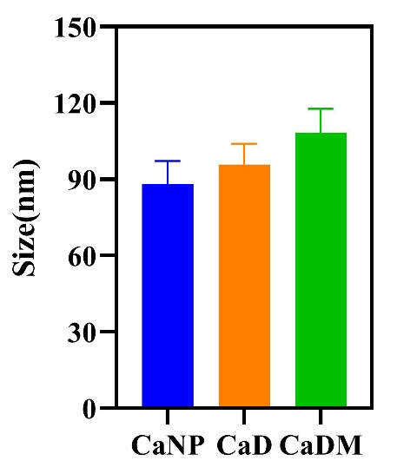
Figure S1. Average particle size of CaNP, CaD, and CaDM.

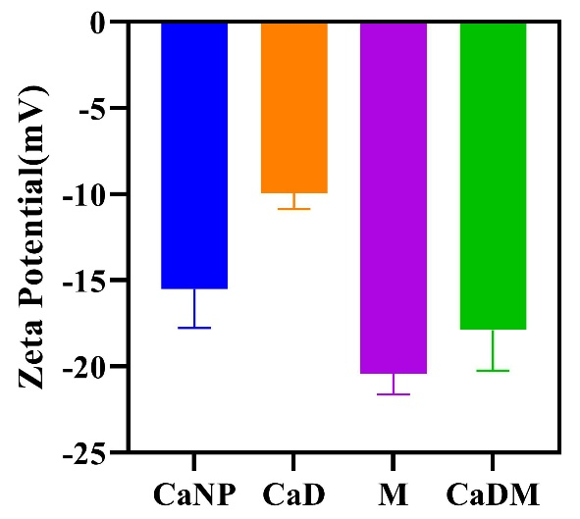
Figure S2. Zeta potentials of CaNP, CaD, M, and CaDM.

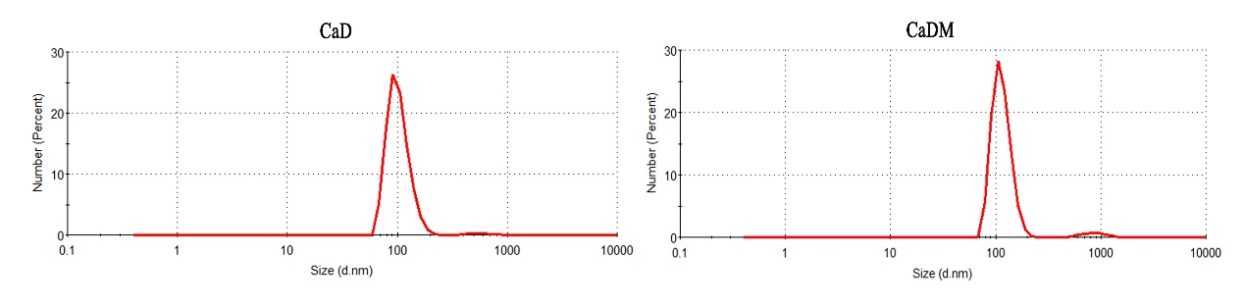
Figure S3. DLS size distribution behaviors of CaD and CaDM.

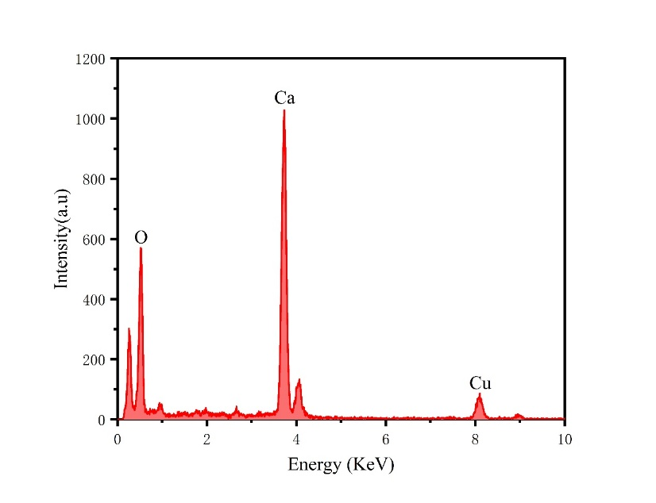
Figure S4. EDS spectrum of CaD.

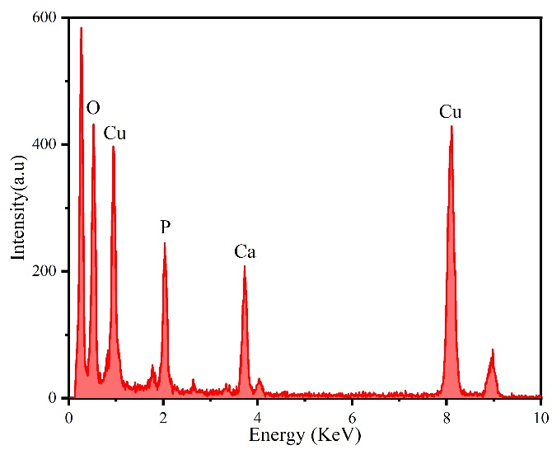
Figure S5. EDS spectrum of CaDM.

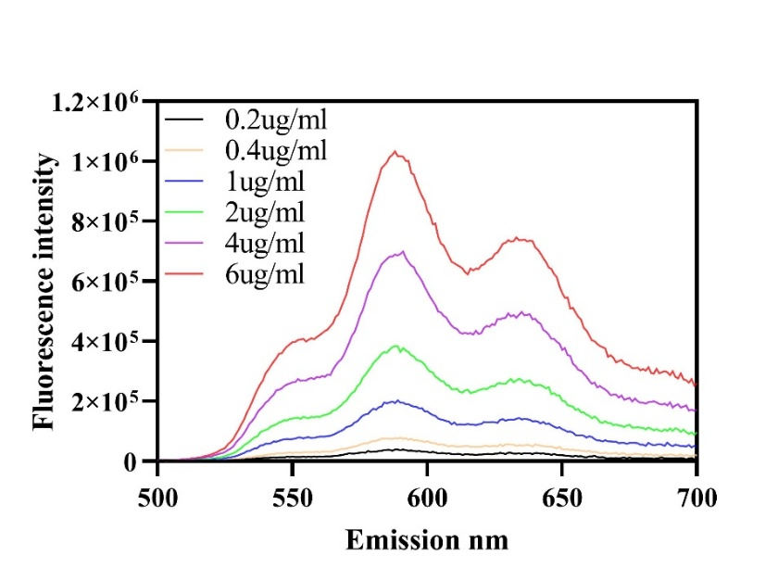
Figure S6. Fluorescence intensity of CaDM at different concentrations.
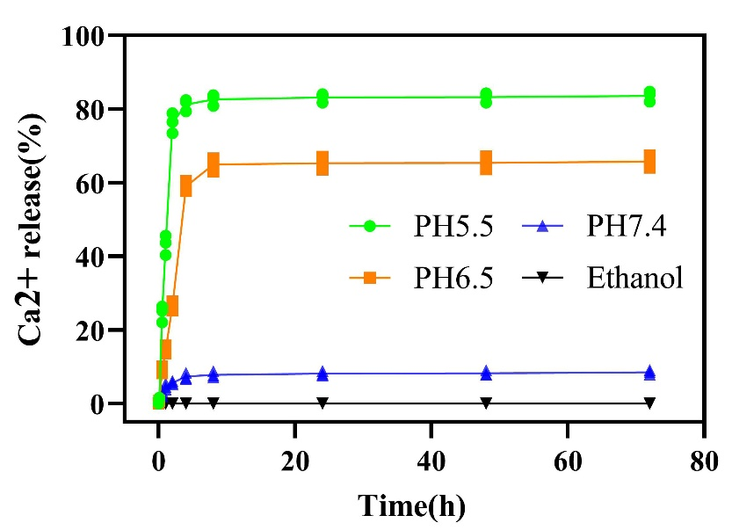
Figure S7. Release of Ca²⁺ from CaDM at pH 7.4, 6.5, and 5.5.
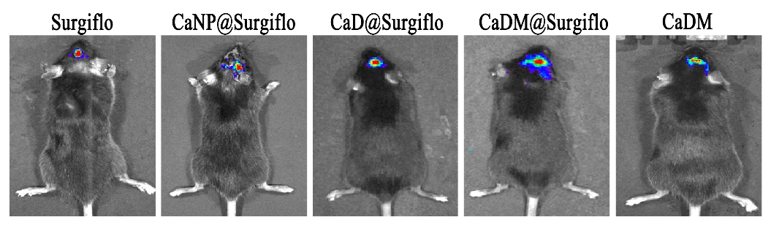
Figure S8. In vivo bioluminescence images of glioma-bearing mice before surgical resection.

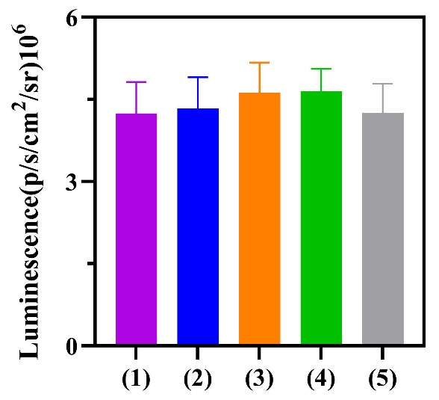
Figure S9. Semi-quantitative analysis of in vivo bioluminescence images of glioma-bearing mice before surgical resection. (1) Surgiflo, (2) CaNP@ Surgiflo, (3) CaD@ Surgiflo, (4) CaDM@ Surgiflo, (5) CaDM.

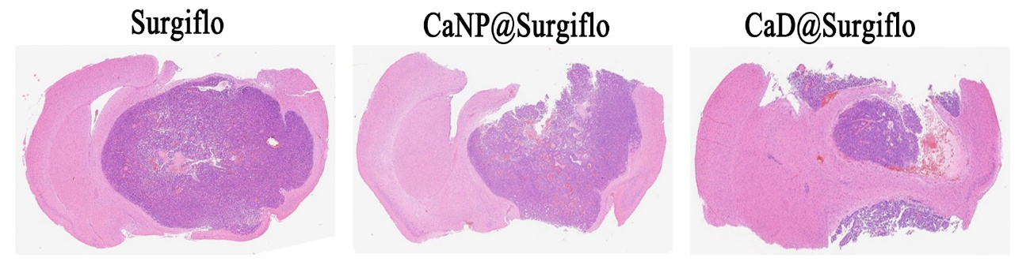
Figure S10. H&E-stained images of brain sections from Surgiflo, CaNP@Surgiflo, and CaD@Surgiflo groups.

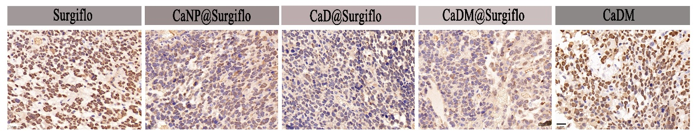
Figure S11. Immunohistochemical-stained images of PCNA in tumor tissues of various groups. Scale bar is 20μm.

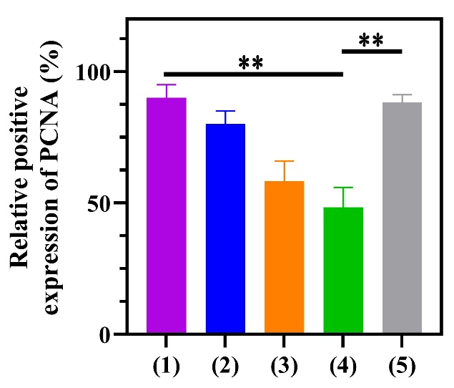
Figure S12. Semi-quantitative analysis of immunohistochemical staining for PCNA. (1) Surgiflo, (2) CaNP@ Surgiflo, (3) CaD@ Surgiflo, (4) CaDM@ Surgiflo, (5) CaDM. **P < 0.01.

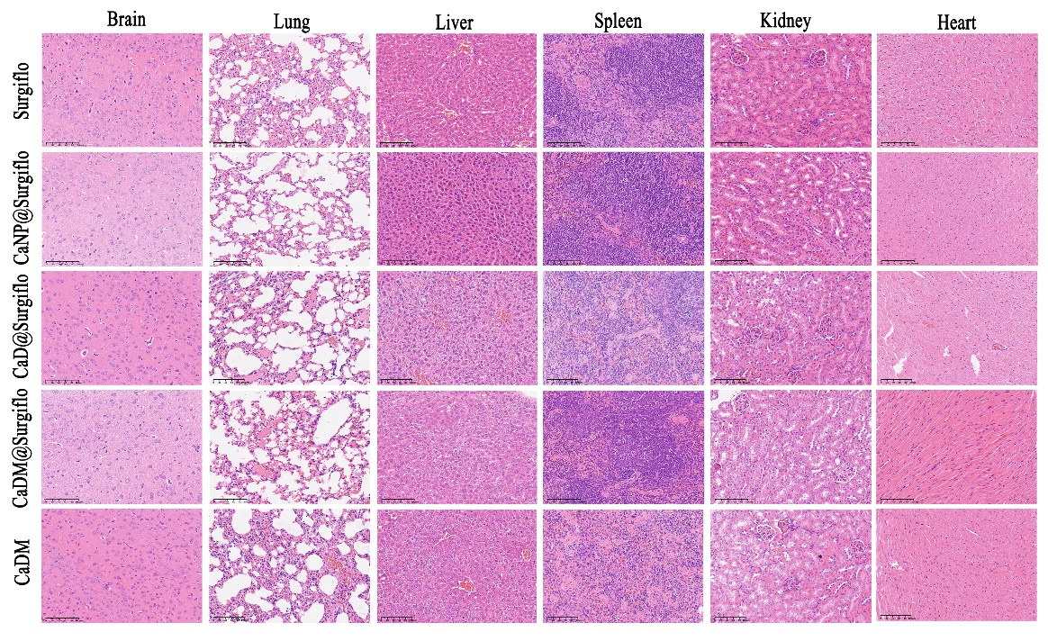
Figure S13. H&E-stained images of the six main organs in glioma-bearing mice. Scale bar is 100μm.
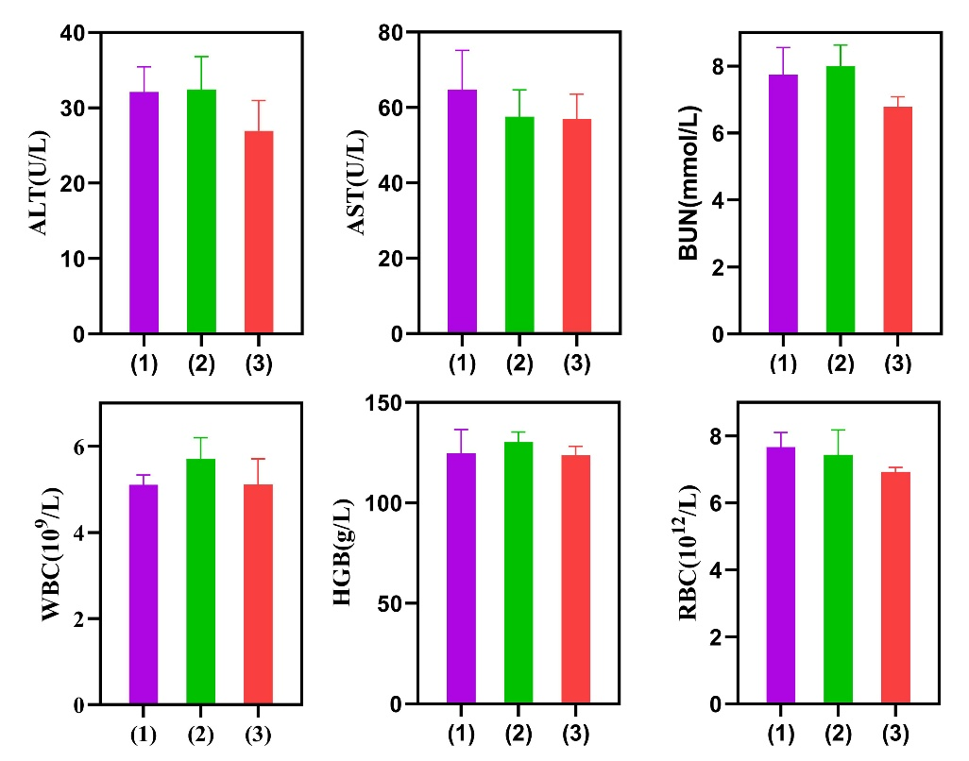
Figure S14. Serum ALT, AST, BUN, WBC, HGB, and RBC of mice at 2 weeks. (1) Surgiflo, (2) CaDM, (3) CaDM@Surgiflo.

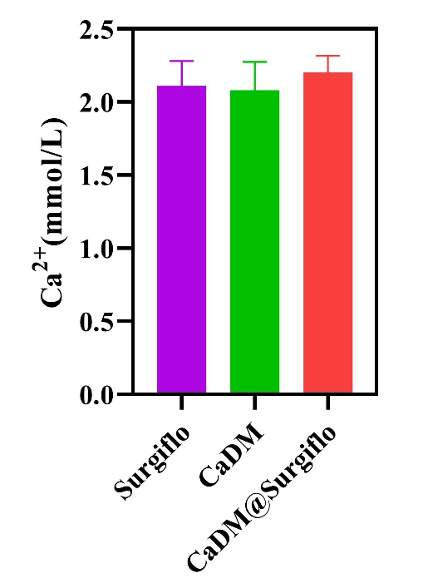
Figure S15. Serum Ca²⁺ of mice at 2 weeks.

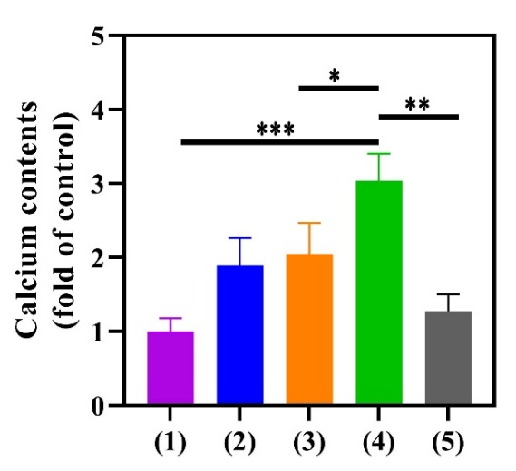
Figure S16. The calcium contents of glioma tissue in vivo. (1) Surgiflo, (2) CaNP@ Surgiflo, (3) CaD@ Surgiflo, (4) CaDM@ Surgiflo, (5) CaDM. *P < 0.05, **P < 0.01, and ***P < 0.001.

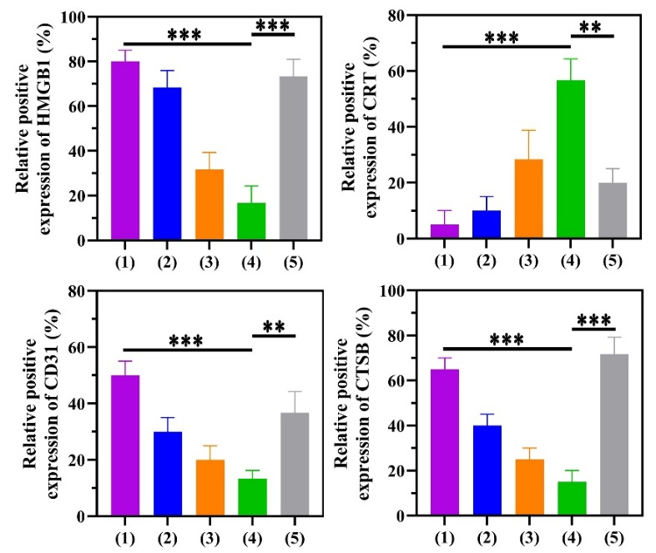
Figure S17. Semi-quantitative analysis of immunohistochemical staining for HMGB1, CRT, CD31, and CTSB. (1) Surgiflo, (2) CaNP@ Surgiflo, (3) CaD@ Surgiflo, (4) CaDM@ Surgiflo, (5) CaDM. **P < 0.01, and ***P < 0.001.

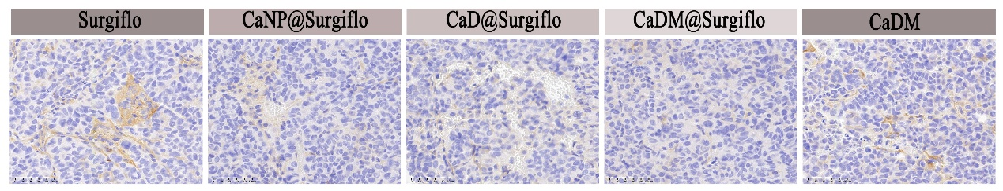
Figure S18. Immunohistochemical-stained images of VEGF in tumor tissues of various groups. Scale bar is 50μm.
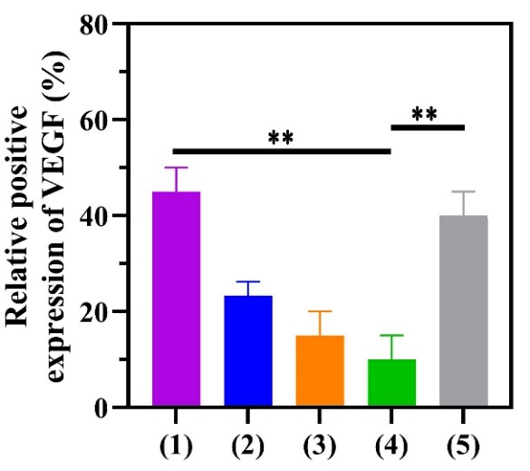
Figure S19. Semi-quantitative analysis of immunohistochemical staining for VEGF. (1) Surgiflo, (2) CaNP@ Surgiflo, (3) CaD@ Surgiflo, (4) CaDM@ Surgiflo, (5) CaDM. **P < 0.01.

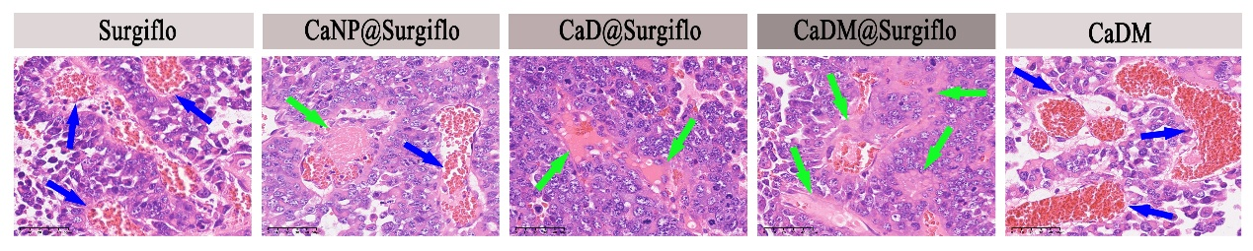
Figure S20. Thrombosis observed by H&E staining. Blue arrows indicate vascular congestion with erythrocyte sedimentation. Green arrows point to intravascular thrombi. Scale bar: 50 μm.

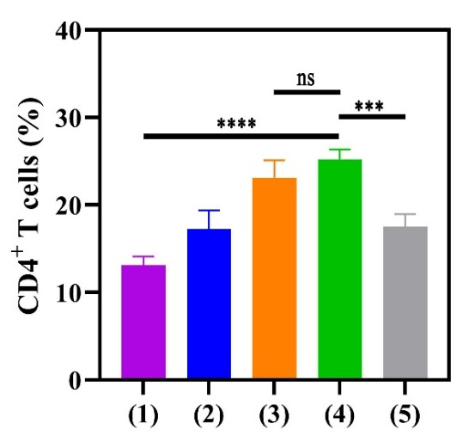
Figure S21. Flow cytometric analysis for quantification of CD4⁺ T cells in the glioma tissue. (1) Surgiflo, (2) CaNP@ Surgiflo, (3) CaD@ Surgiflo, (4) CaDM@ Surgiflo, (5) CaDM. ***P < 0.001, ****P < 0.0001 and ns represents no statistical difference.

