Supplementary Table 1. The unadjusted association between SIRI, left ventricular remodeling and poor prognosis
Groups | LV remodeling |  |  | Cardiovascular mortality |  |  | All-cause mortality
Groups | Events, n (%) | OR (95% CIs) | P | Events, n (%) | HR (95% CIs) | P | Events, n (%) | HR (95% CIs) | P
Q1 (SIRI <1.0) | 117 (1.9%) | Reference | — | 117 (1.3%) | Reference | — | 189 (3.0%) | Reference | —
Q2 (1.5>SIRI≥1.0) | 131 (2.1%) | 1.13 (0.87–1.47) | 0.352 | 127 (2.0%) | 1.60 (1.21–2.11) | 0.001 | 227 (3.6%) | 1.24 (1.02–1.5) | 0.030
Q3 (2.6>SIRI≥1.5) | 139 (2.2%) | 1.21 (0.93–1.56) | 0.152 | 134 (2.1%) | 1.79 (1.36–2.36) | <0.001 | 265 (4.2%) | 1.53 (1.27–1.85) | <0.001
Q4 (SIRI ≥2.6) | 134 (2.1%) | 1.16 (0.90–1.50) | 0.264 | 180 (2.9%) | 2.30 (1.77–2.98) | <0.001 | 341 (5.4%) | 1.88 (1.58–2.25) | <0.001
Note: Model: unadjusted.
Abbreviations: LV, left ventricular; aOR, adjusted Odd Ratio; aHR, adjusted Hazard Ratio; CIs, Confidence Intervals.

Supplementary Table 2. Sensitivity analysis
Groups | Worsening of LV systolic function (Adjusted model + AMI, N = 6307) |  |  | Worsening of LV systolic function (Adjusted model + HS-CRP, N = 2920) |  |  | LV remodeling by Teichholz formula  (Adjusted model, N = 5354)
Groups | Events, n (%) | aOR (95% CIs) | P | Events, n (%) | aOR (95% CIs) | P | Events, n (%) | aOR (95% CIs) | P
Q1 (SIRI <1.0) | 117 (1.9%) | Reference | — | 40 (1.3%) | Reference | — | 226 (4.2%) | Reference | —
Q2 (1.5>SIRI≥1.0) | 131 (2.1%) | 1.19 (0.91–1.56) | 0.199 | 63 (2.2%) | 1.67 (1.10–2.57) | 0.017 | 198 (3.7%) | 0.88 (0.71–1.09) | 0.241
Q3 (2.6>SIRI≥1.5) | 139 (2.2%) | 1.32 (1.01–1.74) | 0.042 | 66 (2.3%) | 1.91 (1.25–2.96) | 0.003 | 240 (4.5%) | 1.12 (0.91–1.38) | 0.278
Q4 (SIRI ≥2.6) | 134 (2.1%) | 1.38 (1.04–1.85) | 0.028 | 55 (1.9%) | 2.10 (1.30–3.41) | 0.002 | 285 (5.3%) | 1.46 (1.19–1.80) | <0.001
Note: Adjusted model: age, sex, hypertension, chronic kidney disease, diabetes mellitus, procedure of percutaneous coronary intervention, atrial fibrillation, valvular heart disease, anemia, left ventricular ejection fraction at baseline, and renin-angiotensin-aldosterone system inhibitor use.
Abbreviations: LV, left ventricular; aOR, adjusted Odd Ratio; aHR, adjusted Hazard Ratio; CIs, Confidence Intervals.

Supplementary Figure 1. Cumulative risk of cardiovascular and all-cause death in group with or without worsening of LV systolic function.
(A) Cumulative risk of cardiovascular death.
(B) Cumulative risk of all-cause death.
Note: Adjusted model: age, sex, hypertension, chronic kidney disease, diabetes mellitus, procedure of percutaneous coronary intervention, atrial fibrillation, valvular heart disease, anemia, left ventricular ejection fraction at baseline, and renin-angiotensin-aldosterone system inhibitor use.
Abbreviations: aHR, adjusted Hazard Ratio; CIs, Confidence Intervals.

Supplementary Figure 2. RCS curves of the SIRI for cardiovascular and all-cause death.
(A) RCS curves of the SIRI for cardiovascular death.
(B) RCS curves of the SIRI for all-cause death.
Note: Adjusted model: age, sex, hypertension, chronic kidney disease, diabetes mellitus, procedure of percutaneous coronary intervention, atrial fibrillation, valvular heart disease, anemia, left ventricular ejection fraction at baseline, and renin-angiotensin-aldosterone system inhibitor use.
Abbreviations: aHR, adjusted Hazard Ratio; CIs, Confidence Intervals; SIRI, Systemic Inflammation Response Index.

Supplementary Figure 1. Cumulative risk of cardiovascular and all-cause death in group with or without worsening of left ventricular systolic function.

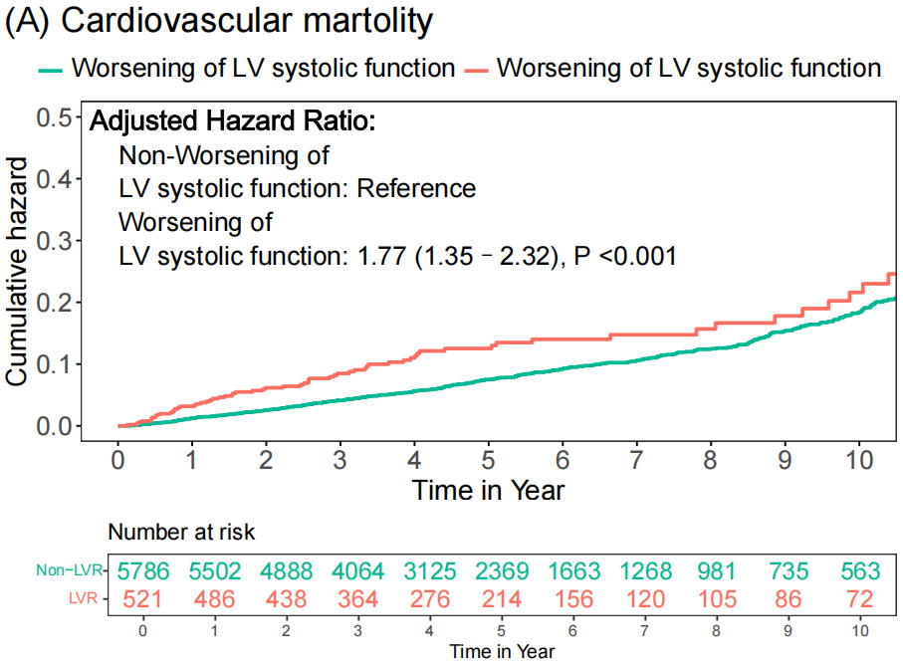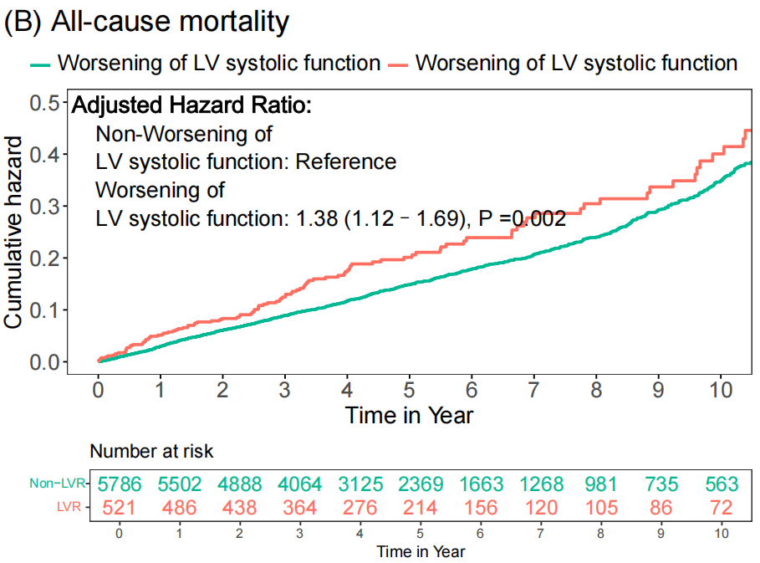
Note: Adjusted model: age, sex, hypertension, chronic kidney disease, diabetes mellitus, procedure of percutaneous coronary intervention, atrial fibrillation, valvular heart disease, anemia, left ventricular ejection fraction at baseline, and renin-angiotensin-aldosterone system inhibitor use.
Abbreviations: LV, left ventricular; aHR, adjusted Hazard Ratio; CIs, Confidence Intervals.

Supplementary Figure 2. RCS curves of the SIRI for cardiovascular and all-cause death.
Note: Adjusted model: age, sex, hypertension, chronic kidney disease, diabetes mellitus, procedure of percutaneous coronary intervention, atrial fibrillation, valvular heart disease, anemia, left ventricular ejection fraction at baseline, and renin-angiotensin-aldosterone system inhibitor use.
Abbreviations: aHR, adjusted Hazard Ratio; CIs, Confidence Intervals; SIRI, Systemic Inflammation Response Index.

