Supplementary Figures

figure legends:
Supplementary Fig 1. Path diagram of the mediation analysis of NLR on the relationship between DST and UL. The arrows indicate the direction of the hypothesized effects (paths). The numbers adjacent to the arrows represent the effect estimates (coefficients) and their statistical significance.
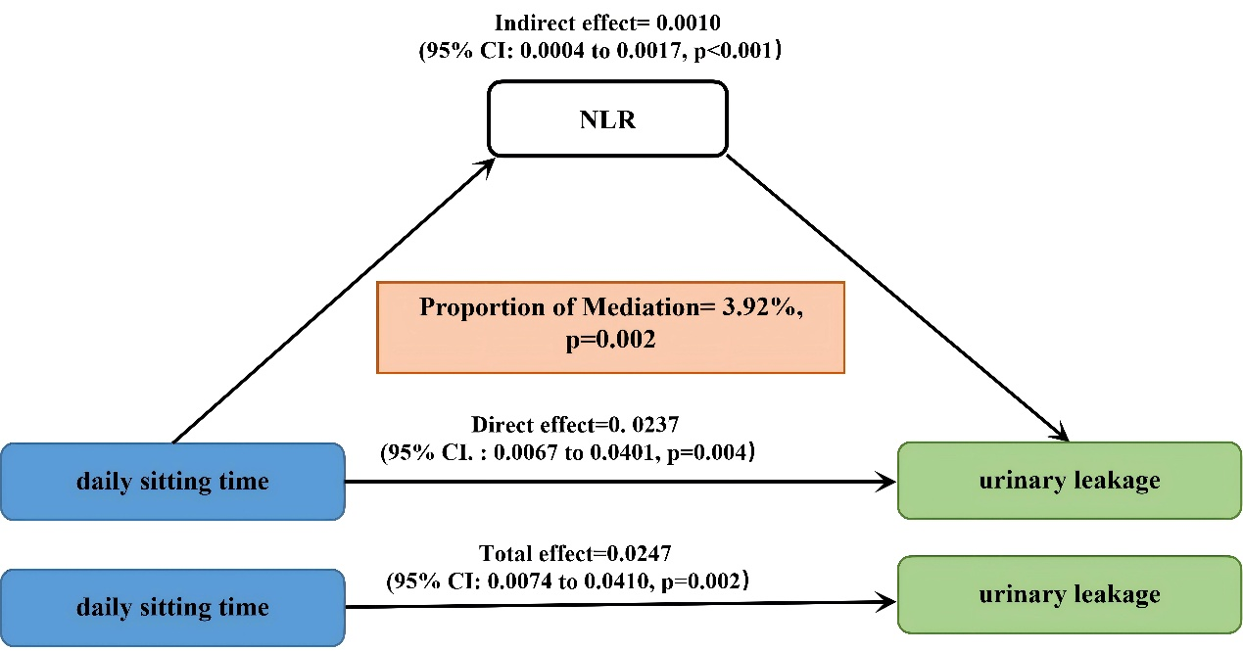
Supplementary Fig 2. RCS revealed the association between BMI and the risk of UL caused by sedentary behavior. The solid red line represents the estimated Odds Ratio (OR), and the pink shaded area indicates the 95% Confidence Interval (CI). The horizontal dashed line represents the reference risk (OR = 1.0). The vertical lines indicate the knot locations. The histograms in the background represent the distribution density of the participants for each variable.
