- Scanning parameters of HR-VWI
MR imaging was performed using a 3.0T MR scanner (Achieva TX, Philips Healthcare, Best, the Netherlands) with a 32-channel head coil. The parameters were as follows:
On imaging studies performed earlier in the study period, patients underwent 2D T1 HR-VWI (double inversion recovery, DIR) with the following parameters: TR/TE 1000 ms/9 ms; 150 mm× 150 mm field of view; 5 axial/sagittal/coronal slices; resolution 0.45 mm× 0.55 mm in-plane; and 3-mm slice thickness with a scan time of 3 minutes and 45 seconds.
Later, in the study, 3D T1 VISTA (motion sensitized driven equilibrium, MSDE) became available in our hospital and was performed with the following parameters: TR/TE 700 ms/35 ms; 200 mm × 251 mm field of view; 171 slices; matrix 252 × 314; 80° flip angle; and resolution 0.8 mm isotropic with an acquisition time of 4 minutes and 55 seconds.

Supplementary Table 1. Forward multiple logistic regression analysis for plaque enhancement of ICAS.
Variable | Odds Ratio | 95% Confidence Interval | P value
Degree of stenosis | 1.869 | 1.051-3.324 | 0.033
LMR | 0.703 | 0.539-0.918 | 0.010
Plaque burden | 58.682 | 1.424-2418.194 | 0.032
ICAS: intracranial atherosclerotic stenosis; LMR: lymphocyte-to-monocyte ratio.

Supplementary Table 2. Sensitivity, specificity, PPV and NPV of LMR at baseline for symptomatic ICAS and LMR ≤ 4.0 during follow-up for stroke recurrence.
Variable | LMR ≤ 4.0 at baseline | LMR ≤ 4.0 during follow-up
Sensitivity (%) | 74.6 | 26.8
Specificity (%) | 57.1 | 89.8
LMR: lymphocyte-to-monocyte ratio; PPV: positive predictive value; NPV: negative predictive value.

Supplementary Table 3. Univariate and Multivariate Cox analyses of factors associated with stroke recurrence.
Variable | Odds Ratio | 95% Confidence Interval | P value
Sustained medication | 3.461 | 1.143-10.479 | 0.028
LMR ≤ 4.0 | 0.356 | 0.131-0.967 | 0.043
NLR | 1.151 | 0.932-1.421 | 0.191
HDL | 0.609 | 0.095-3.896 | 0.601
Lymphocyte | 0.846 | 0.374-1.916 | 0.689
LMR: lymphocyte-to-monocyte ratio; NLR:neutrophil-to-lymphocyte ratio; HDL: high-density lipoprotein.

Supplementary Table 4. Spearman’s correlation analyses between baseline LMR and key variables.
Variable | N | Spearman coefficient | P value
Cholesterol | 130 | 0.110 | 0.211
HDL | 130 | 0.234 | 0.007
LDL | 131 | 0.060 | 0.494
Apolipoprotein E | 130 | 0.033 | 0.711
Degree of stenosis | 132 | -0.270 | 0.002
Plaque burden | 132 | -0.202 | 0.020
HDL: high-density lipoprotein; LDL: low-density lipoprotein
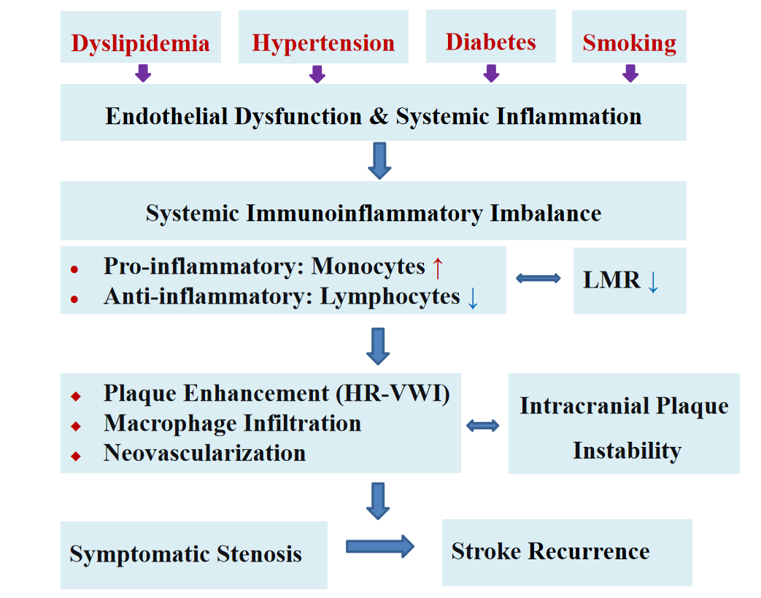
Supplementary Fig 1. The possible role of LMR in the multifactorial pathogenesis of ICAS.

