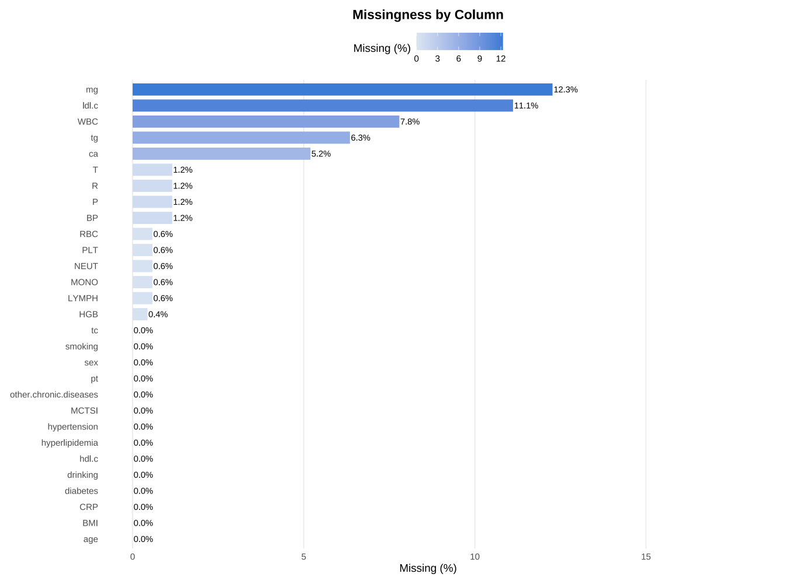
Supplementary Figure 1. Missingness of baseline variables in the study cohort.

Supplementary Table 1. Baseline clinical and laboratory characteristics of patients in the training and validation cohorts
Characteristic | Training  N = 486¹ | Validation  N = 207¹ | p-value²
Sex | 300.00 (61.73%) | 142.00 (68.60%) | 0.085
Age | 47.00 (35.00, 62.00) | 46.00 (33.00, 62.00) | 0.5
Etiology |  |  | 0.7
1 | 204.00 (41.98%) | 77.00 (37.20%)
2 | 68.00 (13.99%) | 31.00 (14.98%)
3 | 55.00 (11.32%) | 26.00 (12.56%)
4 | 159.00 (32.72%) | 73.00 (35.27%)
BMI | 26.12 (23.51, 29.38) | 26.35 (22.92, 30.19) | 0.9
Smoking | 196.00 (40.33%) | 88.00 (42.51%) | 0.6
Drinking | 191.00 (39.30%) | 91.00 (43.96%) | 0.3
Diabetes | 85.00 (17.49%) | 35.00 (16.91%) | 0.9
Hypertension | 131.00 (26.95%) | 64.00 (30.92%) | 0.3
Hyperlipidemia | 128.00 (26.34%) | 45.00 (21.74%) | 0.2
Other chronic diseases | 368.00 (75.72%) | 152.00 (73.43%) | 0.5
TC | 3.91 (2.62, 5.18) | 3.70 (2.38, 4.82) | 0.11
TG | 1.20 (0.83, 2.62) | 1.14 (0.72, 1.87) | 0.058
HDL-C | 1.16 (0.87, 1.81) | 1.15 (0.87, 1.75) | 0.8
LDL-C | 2.68 (1.96, 27.70) | 2.60 (1.99, 30.20) | >0.9
MG | 0.82 (0.75, 0.89) | 0.82 (0.74, 0.89) | 0.8
CA | 2.14 (2.02, 2.26) | 2.15 (2.00, 2.25) | 0.9
PT | 12.70 (11.90, 13.60) | 12.50 (12.00, 13.60) | 0.8
WBC | 11.25 (7.90, 14.70) | 11.20 (8.10, 14.70) | 0.7
NEUT | 9.39 (5.85, 12.52) | 9.27 (6.12, 12.62) | 0.9
LYMPH | 1.11 (0.75, 1.62) | 1.10 (0.78, 1.52) | 0.8
MONO | 0.61 (0.43, 0.86) | 0.61 (0.40, 0.82) | 0.3
RBC | 4.57 (4.10, 5.03) | 4.52 (3.98, 5.09) | 0.8
HGB | 137.70 (114.00, 155.00) | 133.00 (111.00, 158.00) | 0.5
PLT | 203.00 (158.00, 257.00) | 194.82 (151.00, 239.00) | 0.066
CRP | 83.33 (33.21, 182.32) | 72.90 (17.81, 156.43) | 0.038
MCTSI |  |  | 0.2
0 | 13.00 (2.67%) | 1.00 (0.48%)
2 | 191.00 (39.30%) | 83.00 (40.10%)
4 | 128.00 (26.34%) | 62.00 (29.95%)
6 | 120.00 (24.69%) | 47.00 (22.71%)
8 | 34.00 (7.00%) | 13.00 (6.28%)
12 | 0.00 (0.00%) | 1.00 (0.48%)
BISAP |  |  | 0.4
0 | 115.00 (23.66%) | 43.00 (20.77%)
1 | 157.00 (32.30%) | 77.00 (37.20%)
2 | 148.00 (30.45%) | 52.00 (25.12%)
3 | 52.00 (10.70%) | 28.00 (13.53%)
4 | 13.00 (2.67%) | 7.00 (3.38%)
5 | 1.00 (0.21%) | 0.00 (0.00%)
ERAP |  |  | 0.7
0 | 258.00 (53.09%) | 115.00 (55.56%)
1 | 142.00 (29.22%) | 61.00 (29.47%)
2 | 63.00 (12.96%) | 25.00 (12.08%)
3 | 18.00 (3.70%) | 6.00 (2.90%)
4 | 5.00 (1.03%) | 0.00 (0.00%)
HRR | 10.31 (7.96, 12.40) | 10.13 (7.62, 12.35) | 0.6
NLR | 8.06 (4.42, 13.89) | 7.98 (4.93, 13.41) | >0.9
HALP | 21.67 (9.16, 38.89) | 21.62 (7.47, 40.42) | 0.8
CAR | 2.55 (1.03, 5.41) | 2.18 (0.55, 5.19) | 0.12
DDCa | 284.28 (125.11, 686.02) | 293.72 (117.51, 736.31) | >0.9
SCTB | 4.06 (2.30, 7.57) | 4.14 (2.76, 9.49) | 0.15
Notes: Data are presented as n (%) for categorical variables and median (IQR) for continuous variables, unless otherwise indicated. The value in the Sex row indicates males. Etiology was coded as 1 = biliary; 2 = alcohol-related; 3 = hypertriglyceridemia-related; 4 = other.

Abbreviations: MODS, multiple organ dysfunction syndrome; BMI, body mass index; TC, total cholesterol; TG, triglycerides; HDL-C, high-density lipoprotein cholesterol; LDL-C, low-density lipoprotein cholesterol; Mg, magnesium; Ca, calcium; PT, prothrombin time; WBC, white blood cell count; NEUT, neutrophil count; LYMPH, lymphocyte count; MONO, monocyte count; RBC, red blood cell count; HGB, hemoglobin; PLT, platelet count; CRP, C-reactive protein; MCTSI, modified computed tomography severity index; BISAP, bedside index for severity in acute pancreatitis; ERAP, early risk assessment of acute pancreatitis; HRR, hemoglobin-to-red cell distribution width ratio; NLR, neutrophil-to-lymphocyte ratio; HALP, hemoglobin–albumin–lymphocyte–platelet index; CAR, C-reactive protein-to-albumin ratio; DDCa, D-dimer-to-calcium ratio; SCTB, serum creatinine-to-total bilirubin ratio.

Supplementary Table 2. Performance of the 7-variable nomogram for predicting MODS across different etiologic subgroups of acute pancreatitis
Etiology | N_total | N_MODS | AUC | 95% Confidence Interval | Accuracy | Sensitivity | Specificity | PPV | NPV
Biliary | 77 | 35 | 0.845 | 0.760–0.930 | 0.714 | 0.914 | 0.548 | 0.627 | 0.885
Alcoholic | 31 | 10 | 0.829 | 0.632–1.000 | 0.806 | 0.800 | 0.810 | 0.667 | 0.895
Hypertriglyceridemia | 26 | 7 | 0.669 | 0.416–0.922 | 0.654 | 0.429 | 0.737 | 0.375 | 0.778
Other | 73 | 20 | 0.864 | 0.756–0.972 | 0.863 | 0.800 | 0.887 | 0.727 | 0.922
Abbreviations: MODS, multiple organ dysfunction syndrome; AUC, area under the curve; PPV, positive predictive value; NPV, negative predictive value

