Table of contents
Section title
Supplementary Material 1: Search strategy 2
Supplementary Material 2: Supplementary detailed baseline characteristics table 6
Supplementary Material 3: Direct pairwise meta-analysis 16
Supplementary Material 4: Absolute effect estimates and certainty of evidence 20
Supplementary Material 5: Cumulative ranking probability (SCURA) 28
Supplementary Material 6: Network meta-analysis of different nerve blocks by subgroup 31

Supplementary Material 1

Search strategy
PubMed:
#1 ("Hepatectomy"[Mesh]) OR ((Hepatectomies[Title/Abstract]) OR (hepatectomy[Title/Abstract]) OR (hepatic resection[Title/Abstract]) OR (liver resection[Title/Abstract]) OR (resection, liver[Title/Abstract]))
#2 ("liver"[MeSH Terms] OR "liver"[All Fields] OR "livers"[All Fields] OR "liver s"[All Fields]) AND ("surgery"[MeSH Subheading] OR "surgery"[All Fields] OR "surgical procedures, operative"[MeSH Terms] OR "surgical"[All Fields])
#3 #1 OR #2
#4 (("erector"[All Fields] OR "erectores"[All Fields] OR "erectors"[All Fields]) AND "spinae"[All Fields] AND ("aircraft"[MeSH Terms] OR "aircraft"[All Fields] OR "plane"[All Fields] OR "planes"[All Fields]) AND ("block"[All Fields] OR "blocked"[All Fields] OR "blocking"[All Fields] OR "blockings"[All Fields] OR "blocks"[All Fields]))
#5 (("quadratus"[All Fields] OR "quadrati"[All Fields]) AND "lumborum"[All Fields] AND ("block"[All Fields] OR "blocked"[All Fields] OR "blocking"[All Fields] OR "blockings"[All Fields] OR "blocks"[All Fields]))
#6 (("transversus"[All Fields] OR "transversi"[All Fields]) AND "abdominis"[All Fields] AND ("aircraft"[MeSH Terms] OR "aircraft"[All Fields] OR "plane"[All Fields] OR "planes"[All Fields]) AND ("block"[All Fields] OR "blocked"[All Fields] OR "blocking"[All Fields] OR "blockings"[All Fields] OR "blocks"[All Fields]))
#7 ("thoracic"[All Fields] AND "paravertebral"[All Fields] AND ("block"[All Fields] OR "blocked"[All Fields] OR "blocking"[All Fields] OR "blockings"[All Fields] OR "blocks"[All Fields]))
#8 (("epidural"[All Fields] OR "epidurals"[All Fields]) AND ("analgesia"[All Fields] OR "analgesias"[All Fields] OR "analgesic"[All Fields] OR "analgesics"[All Fields]))
#9 #4 OR #5 OR #6 OR #7 OR #8
#10 #3 AND #10

Embase:
#1 'hepatectomy'/exp
#2 'liver surgery'/exp
#3 #1 OR #2
#4 'erector spinae plane block'/exp
#5 'quadratus lumborum block'/exp
#6 'transversus abdominis plane block'/exp
#7 'thoracic paravertebral block'/exp
#8 'epidural analgesia'/exp
#9 #4 OR #5 OR #6 OR #7 OR #8
#10 #3 AND #10

Cochrane:
#1 MeSH descriptor: [Hepatectomy] explode all trees
#2 ("Hepatectomies" OR "hepatectomy" OR "hepatic resection" OR "liver resection" OR "resection, liver"):ti,ab
#3 ("liver" OR "liver" OR "livers" OR "livers") AND ("surgery" OR "surgery" OR "surgical procedures, operative" OR "surgical")
#4 #1 OR #2 OR #3
#5 (("erector" OR "erectores" OR "erectors") AND "spinae" AND ("aircraft" OR "aircraft" OR "plane" OR "planes") AND ("block" OR "blocked" OR "blocking" OR "blockings" OR "blocks"))
#6 (("quadratus" OR "quadrati") AND "lumborum" AND ("block" OR "blocked" OR "blocking" OR "blockings" OR "blocks"))
#7 (("transversus" OR "transversi") AND "abdominis" AND ("aircraft" OR "aircraft" OR "plane" OR "planes") AND ("block" OR "blocked" OR "blocking" OR "blockings" OR "blocks"))
#8 ("thoracic" AND "paravertebral" AND ("block" OR "blocked" OR "blocking" OR "blockings" OR "blocks"))
#9 (("epidural" OR "epidurals") AND ("analgesia" OR "analgesias" OR "analgesic" OR "analgesics"))
#10 #5 OR #6 OR #7 OR #8 OR #9
#4 AND #10

Web of Science Core Collection:
#1 TS=(Hepatectomy)
#2 ALL=("Hepatectomies" OR "hepatectomy" OR "hepatic resection" OR "liver resection" OR "resection, liver")
#3 ALL=(("liver" OR "liver" OR "livers" OR "livers") AND ("surgery" OR "surgery" OR "surgical procedures, operative" OR "surgical"))
#4 #1 OR #2 OR #3
#5 ALL=((("erector" OR "erectores" OR "erectors") AND "spinae" AND ("aircraft" OR "aircraft" OR "plane" OR "planes") AND ("block" OR "blocked" OR "blocking" OR "blockings" OR "blocks")))
#6 ALL=((("quadratus" OR "quadrati") AND "lumborum" AND ("block" OR "blocked" OR "blocking" OR "blockings" OR "blocks")))
#7 ALL=((("transversus" OR "transversi") AND "abdominis" AND ("aircraft" OR "aircraft" OR "plane" OR "planes") AND ("block" OR "blocked" OR "blocking" OR "blockings" OR "blocks")))
#8 ALL=(("thoracic" AND "paravertebral" AND ("block" OR "blocked" OR "blocking" OR "blockings" OR "blocks")))
#9 (ALL=(("thoracic" AND "paravertebral" AND ("block" OR "blocked" OR "blocking" OR "blockings" OR "blocks")))) AND ALL=((("epidural" OR "epidurals") AND ("analgesia" OR "analgesias" OR "analgesic" OR "analgesics")))
#10 #5 OR #6 OR #7 OR #8 OR #9
#4 AND #10

Supplementary Material 2

Supplementary detailed baseline characteristics table
Study | Intervention Arm
Study | Preoperative | Intraoperative | Postoperative
Moussa AA-2008³⁹ | TPVB，25 mL 0.25% bupivacaine + 1:200,000 epinephrine; lidocaine 1% skin infiltration | Propofol 2 mg/kg + remifentanil 1 µg/kg induction; propofol 4-10 mg/kg/h + remifentanil 0.1-0.4 µg/kg/min maintenance; atracurium 0.5 mg/kg | IV morphine 0.01 mg/kg at surgery end; PACU rescue morphine (50 µg/kg) for VAS ≥4; PCIA morphine (1 mg/mL, 2 mg bolus, 6-min lockout)
Chen H-2014⁴⁰ | No premedication | TPVB(15 mL 1% lidocaine initial, then 0.2% ropivacaine infusion pump)；General anesthesia induction；20-min pre-surgery end: 10mL 0.2% ropivacaine bolus + 6 mL/h infusion | 0.2% ropivacaine infusion at 6 mL/h for 24h；PCIA with sufentanil (1μg bolus + 1-2μg/h background)；Rescue tramadol if needed
Schreiber KL-2016⁴¹ | TEA,3 mL 1.5% lidocaine + 1:200,000 epinephrine | General anesthesia | 0.2% ropivacaine infusion (max 8 mL/h) + 3 mL/h bolus；hydromorphone PCA；adjuvants (ketorolac, acetaminophen, ketamine)；catheter removed on POD3
Erdogan MA-2017⁴² | No premedication | TAPB,0.5% bupivacaine, 1.5 mg/kg in 40 mL saline;standard GA | IV acetaminophen 1000 mg every 6 hours; morphine PCA (1.5 mg bolus, 15 min lockout)
Kıtlık A-2017⁴³ | No premedication | TAPB,0.5% bupivacaine 1.5 mg/kg diluted to 40 mL, 20 mL/side;0.15 mg/kg morphine before incision | Morphine PCA (2 mg bolus, 15-min lockout, max 30 mg/4h); IV acetaminophen 1000 mg every 6h
Kang R-2019³⁰ | ESPB,each side with  20mL 0.5%ropivacaine | General anesthesia induction | IV fentanyl (15µg/hour background, 15µg bolus, 15min lockout)；Rescue IV morphine 5mg or fentanyl 25-50µg for NRS >4/10；Scheduled IV ibuprofen 400mg every 6h (POD 0-1), oral cetamadol every 8h (POD 2)；IV hydromorphone 1mg as needed
Qiao XF-2019⁴⁴ | 40 mg parecoxib sodium | TAPB,150 mg of 0.375% ropivacaine and 5 mg dexamethasone | 40 mg parecoxib sodium IV every 12 hours for 72 hours；PCIA containing sufentanil, tropisetron, and dezocine
Zhu Q-2019⁴⁵ | QLB,0.4% ropivacaine | IV induction (midazolam 0.06 mg/kg, sufentanil 0.5 μg/kg, etomidate 0.2 mg/kg, vecuronium 0.1 mg/kg); maintenance with propofol + remifentanil (BIS 40-55); pre-closure administration of flurbiprofen 100 mg + sufentanil 0.1 μg/kg | Continuous QLB infusion (0.2% ropivacaine at 5 ml/h, 5 ml bolus, 15 min lockout, max 20 ml/h); rescue tramadol 100 mg if needed
Fu J-2020⁴⁶ | ESPB,40ml 0.5% ropivacaine; IV midazolam | General anesthesia induction | IV morphine (5mg) for breakthrough pain (VAS ≥4), rescue fentanyl (25-50μg) if needed; IV metoclopramide for nausea/vomiting
Zhang J-2020⁴⁷ | No premedication | TAPB,3 mg/kg ropivacaine (total 60 mL, 15 mL per injection point) | Flurbiprofen axetil 50 mg IV every 8 hours; PCIA with sufentanil (2 µg bolus, 5-min lockout, max 40 µg/4h) + rescue sufentanil for VAS >3
Kang R-2021³¹ | IV midazolam 1-2 mg | ESPB,0.375% ropivacaine 150 mg (20 mL/side);General anesthesia | Continuous ESPB PIB (0.2% ropivacaine 20 mL/3h)；Standardized IV fentanyl PCA (15 μg/h basal + 15 μg bolus)；IV ibuprofen 400 mg q6h (POD 0-1)；Oral codeine/ibuprofen/acetaminophen (POD 2)；Rescue IV hydromorphone for breakthrough pain
Kim D-2021⁴⁸ | No premedication | ESPB (20 ml of 0.5% ropivacaine per side) | IV morphine 5 mg ；PCIA (fentanyl 15 μg/ml, basal infusion 1 ml/h, bolus 1 ml, 15-min lockout)；IV ibuprofen 400 mg every 6 hours,transitioning to oral combination analgesic every 8 hours from POD2；Rescue hydromorphone 1 mg IV prn for breakthrough pain (NRS >4)
Pang M-2021⁴⁹ | General anesthesia induction | Oxycodone 0.05 mg/kg + tropisetron 5 mg at skin closure | TQLB 0.25% ropivacaine 30 ml/side;PCIA with oxycodone (0.5 mg/ml, background 0.5 mg/h, bolus 0.03 mg/kg, 10min lockout, max 10ml/h)
Elshafie MA-2022⁵⁰ | Pre-oxygenation (O₂/Air, FiO₂=0.8) for 3–5 min | General anesthesia induction;ESPB, 20 mL 0.25% Bupivacaine + Dexmedetomidine 0.5 µg/kg/side; maintenance with Dexmedetomidine (0.2–0.7 µg/kg/h) | Scheduled acetaminophen 1 g/6h; Fentanyl 0.5 µg/kg bolus (NRS ≥5)
Hacıbeyoğlu G-2022⁵¹ | ESPB,20 ml 0.375% bupivacaine + 4 mg dexamethasone | General anesthesia induction | Morphine 0.1 mg/kg IV pre-emptively; PCA morphine (1 mg/bolus, 6-min lockout); rescue meperidine 0.5 mg/kg IV if NRS >4
Huang X-2022¹² | ESPB,0.5% ropivacaine, 30 mL total, 15 mL per side) | General anesthesia induction | PCIA pump (sufentanil 200 μg + tramadol 500 mg + dexmedetomidine 200 μg + granisetron 9 mg); rescue analgesia (dezocine 5 mg) if VAS >6
Lee S-2022⁵² | No premedication | QLB,ropivacaine；IV pethidine 0.5 mg/kg during skin closure | IV ibuprofen 400 mg until POD2, followed by oral Mypol (codeine 10 mg/ibuprofen 200 mg/acetaminophen 250 mg);Fentanyl PCA (15 µg bolus, 15-min lockout); PACU pethidine 25 mg, fentanyl 25–50 µg
Zubair M-2022⁵³ | Midazolam 2.5 mg IV; Buprenorphine 0.3 mg IV | ESPB catheter placement with local anesthetic injection; induction (propofol, lidocaine, atracurium); sevoflurane maintenance | Continuous 0.125% bupivacaine infusion (10-12 mL/h); paracetamol 1g every 6h; nalbuphine 5mg IV as needed
Lee S-2024⁵⁴ | No premedication | QLB 40 mL 0.375% ropivacaine (20 mL/side); general anesthesia (propofol, rocuronium, sevoflurane); IV pethidine 0.5 mg/kg and palonosetron 0.075 mg 30 min before surgery end; remifentanil adjusted via ANI monitoring | IV fentanyl PCA (15 μg bolus, 15-min lockout); IV ibuprofen 800 mg every 8 h; oral Mypol capsule (postoperative day 2); rescue IV hydromorphone 2 mg for breakthrough pain
He X.-2018⁵⁵ | No premedication | TAPB (15 mL 0.25% ropivacaine per side), subcostal TAPB (10 mL 0.25% ropivacaine), and incisional local infiltration (15 mL 0.25% ropivacaine) | PCIA with fentanyl 20 µg/kg + flurbiprofen axetil 100 mg in 100 mL saline (background infusion 1 mL/h, bolus 1 mL, 15-min lockout)
Kang RA-2021⁵⁶ | None specified | ESPB,40 mL 0.375% ropivacaine;general anesthesia; IV meperidine 0.5 mg/kg 30 min before surgery end | IV fentanyl PCA (15 µg bolus, 15-min lockout); rescue IV meperidine/hydromorphone for NRS>4; IV ibuprofen 400 mg every 6 h; (codeine/ibuprofen/acetaminophen) every 8 h; IV hydromorphone as needed
Mao Y-2023⁵⁷ | No premedication | QLB-LSAL,(3 mL 2% lidocaine local infiltration, 20 mL 0.5% ropivacaine per side); general anesthesia ; maintenance with sevoflurane, propofol, remifentanil, cisatracurium; ketorolac 30 mg IV 30 min preoperatively | PCIA (sufentanil 100 µg, tropisetron 6 mg); rescue dezocine 5 mg IV if unrelieved pain
Mostafa M-2023⁵⁸ | No premedication | ESPB,20 mL 0.25% isobaric bupivacaine per side; intraoperative morphine boluses (0.05 mg/kg) as needed for inadequate analgesia | Regular IV paracetamol 1 g every 6 h and ketorolac 30 mg every 8 h; rescue IV morphine 2 mg boluses for NRS >3 (repeated every 30 min if needed)

Study | Control Arm
Study | Preoperative | Intraoperative | Postoperative
Moussa AA-2008³⁹ | TPVB,25 mL 0.9% NaCl; lidocaine 1% skin infiltration | Propofol 2 mg/kg + remifentanil 1 µg/kg induction; propofol 4-10 mg/kg/h + remifentanil 0.1-0.4 µg/kg/min maintenance; atracurium 0.5 mg/kg | IV morphine 0.01 mg/kg at surgery end; PACU rescue morphine (50 µg/kg) for VAS ≥4; PCIA morphine (1 mg/mL, 2 mg bolus, 6-min lockout)
Chen H-2014⁴⁰ | No premedication | No TPVB；General anesthesia induction；20-min pre-surgery end: 10mL saline bolus + 6 mL/h saline infusion | Saline infusion at 6 mL/h for 24h；PCIA with sufentanil (1μg bolus + 1-2μg/h background)；Rescue tramadol if needed
Schreiber KL-2016⁴¹ | TPVB,15 mL 0.5% ropivacaine each side | General anesthesia | 0.2% ropivacaine infusion (max 12 mL/h each side) + 3 mL/h bolus；hydromorphone PCA；adjuvants (same as epidural)；catheter removed on POD3
Erdogan MA-2017⁴² | No premedication | Standard GA | IV acetaminophen 1000 mg every 6 hours; morphine PCA (1.5 mg bolus, 15 min lockout)
Kıtlık A-2017⁴³ | No premedication | 0.15 mg/kg morphine before incision | Morphine PCA (2 mg bolus, 15-min lockout, max 30 mg/4h); IV acetaminophen 1000 mg every 6h
Kang R-2019³⁰ | Intra-thecal morphine  400μg | General anesthesia induction | IV fentanyl (15µg/hour background, 15µg bolus, 15min lockout)；Rescue IV morphine 5mg or fentanyl 25-50µg for NRS >4/10；Scheduled IV ibuprofen 400mg every 6h (POD 0-1), oral cetamadol every 8h (POD 2)；IV hydromorphone 1mg as needed
Qiao XF-2019⁴⁴ | 40 mg normal saline | Without TAP block | 40 mg parecoxib sodium IV every 12 hours for 72 hours；PCIA containing sufentanil, tropisetron, and dezocine
Zhu Q-2019⁴⁵ | No premedication | IV induction (midazolam 0.06 mg/kg, sufentanil 0.5 μg/kg, etomidate 0.2 mg/kg, vecuronium 0.1 mg/kg); maintenance with propofol + remifentanil (BIS 40-55); pre-closure administration of flurbiprofen 100 mg + sufentanil 0.1 μg/kg | PCIA pump (sufentanil 2.5 μg/kg + ondansetron 8 mg; continuous infusion 2 ml/h, 2 ml bolus, 10 min lockout, max 8 ml/h); rescue tramadol 100 mg if needed
Fu J-2020⁴⁶ | IV midazolam (0.03mg/kg) | General anesthesia induction | IV morphine (5mg) for breakthrough pain (VAS ≥4), rescue fentanyl (25-50μg) if needed; IV metoclopramide for nausea/vomiting
Zhang J-2020⁴⁷ | No premedication | No TAPB | Flurbiprofen axetil 50 mg IV every 8 hours; PCIA with sufentanil (2 µg bolus, 5-min lockout, max 40 µg/4h) + rescue sufentanil for VAS >3
Kang R-2021³¹ | IV midazolam 1-2 mg | ITM 400μg;General anesthesia | Standardized IV fentanyl PCA (15 μg/h basal + 15 μg bolus)；IV ibuprofen 400 mg q6h (POD 0-1)；Oral codeine/ibuprofen/acetaminophen (POD 2)；Rescue IV hydromorphone for breakthrough pain
Kim D-2021⁴⁸ | No premedication | No regional block | IV morphine 5 mg ；PCIA (fentanyl 15 μg/ml, basal infusion 1 ml/h, bolus 1 ml, 15-min lockout)；IV ibuprofen 400 mg every 6 hours, transitioning to oral combination analgesic every 8 hours from POD2；Rescue hydromorphone 1 mg IV prn for breakthrough pain (NRS >4)
Pang M-2021⁴⁹ | General anesthesia induction | Oxycodone 0.05 mg/kg + tropisetron 5 mg at skin closure | PCIA with oxycodone (0.5 mg/ml, background 0.5 mg/h, bolus 0.03 mg/kg, 10min lockout, max 10ml/h)
Elshafie MA-2022⁵⁰ | Pre-oxygenation (O₂/Air, FiO₂=0.8) for 3–5 min | General anesthesia induction | Fentanyl 0.5 µg/kg bolus (NRS ≥5) followed by infusion (0.5 µg/kg/h)
Hacıbeyoğlu G-2022⁵¹ | NO ESPB | General anesthesia induction | Morphine 0.1 mg/kg IV pre-emptively; PCA morphine (1 mg/bolus, 6-min lockout); rescue meperidine 0.5 mg/kg IV if NRS >4
Huang X-2022¹² | Bilateral subcutaneous infiltration (2% lidocaine, 1 mL per side) | General anesthesia induction | PCIA pump (sufentanil 200 μg + tramadol 500 mg + dexmedetomidine 200 μg + granisetron 9 mg); rescue analgesia (dezocine 5 mg) if VAS >6
Lee S-2022⁵² | No premedication | IV pethidine 0.5 mg/kg during skin closure | IV ibuprofen 400 mg until POD2, followed by oral Mypol (codeine 10 mg/ibuprofen 200 mg/acetaminophen 250 mg);Fentanyl PCA (15 µg bolus, 15-min lockout); PACU pethidine 25 mg, fentanyl 25–50 µg
Zubair M-2022⁵³ | Midazolam 2.5 mg IV; Buprenorphine 0.3 mg IV | TEA catheter placement with 2% lidocaine + epinephrine (3 mL test dose); induction (propofol, lidocaine, atracurium); sevoflurane maintenance | Continuous 0.125% bupivacaine infusion (10-12 mL/h); paracetamol 1g every 6h; nalbuphine 5mg IV as needed
Lee S-2024⁵⁴ | No premedication | QLB with 40 mL 0.9% saline (20 mL/side)；general anesthesia (propofol, rocuronium, sevoflurane); IV pethidine 0.5 mg/kg and palonosetron 0.075 mg 30 min before surgery end; remifentanil adjusted via ANI monitoring | IV fentanyl PCA (15 μg bolus, 15-min lockout); IV ibuprofen 800 mg every 8 h; oral Mypol capsule (postoperative day 2); rescue IV hydromorphone 2 mg for breakthrough pain
He X.-2018⁵⁵ | No premedication | Equivalent-volume normal saline for TAPB and incisional infiltration (15 mL normal saline) | PCIA with fentanyl 20 µg/kg + flurbiprofen axetil 100 mg in 100 mL saline (background infusion 1 mL/h, bolus 1 mL, 15-min lockout)
Kang RA-2021⁵⁶ | None specified | QLB with 40 mL 0.375% ropivacaine; general anesthesia; IV meperidine 0.5 mg/kg 30 min before surgery end | IV fentanyl PCA (15 µg bolus, 15-min lockout); rescue IV meperidine/hydromorphone for NRS>4; IV ibuprofen 400 mg every 6 h; (codeine/ibuprofen/acetaminophen) every 8 h; IV hydromorphone as needed
Mao Y-2023⁵⁷ | No premedication | TAPB block (20 mL 0.5% ropivacaine per side); general anesthesia; ketorolac 30 mg IV 30 min preoperatively | PCIA (sufentanil 100 µg, tropisetron 6 mg); rescue dezocine 5 mg IV if unrelieved pain
Mostafa M-2023⁵⁸ | No premedication | TAPB,20 mL 0.25% isobaric bupivacaine per side; intraoperative morphine boluses (0.05 mg/kg) as needed for inadequate analgesia | Regular IV paracetamol 1 g every 6 h and ketorolac 30 mg every 8 h; rescue IV morphine 2 mg boluses for NRS >3 (repeated every 30 min if needed)

Supplementary Material 3

Direct pair-wise meta-analysis of different nerve blocks

Supplementary Material 3.1 Direct pair-wise meta-analysis of pain scores：
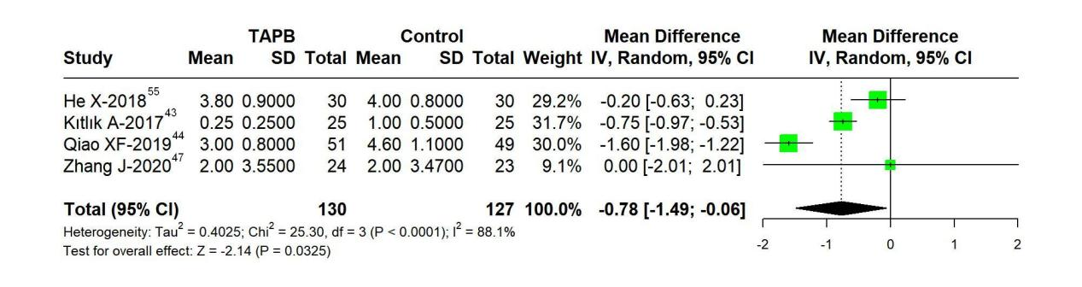
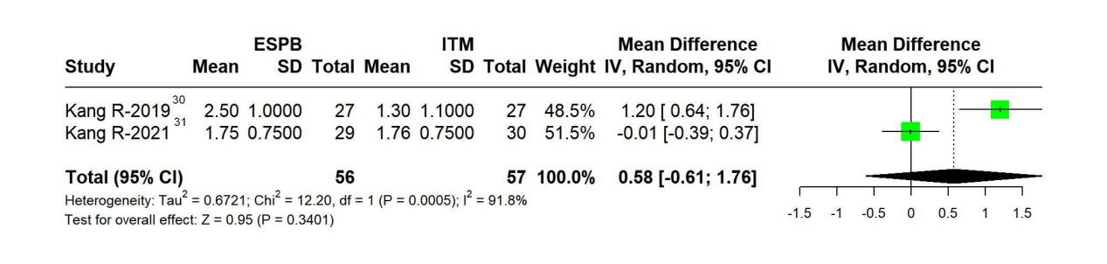
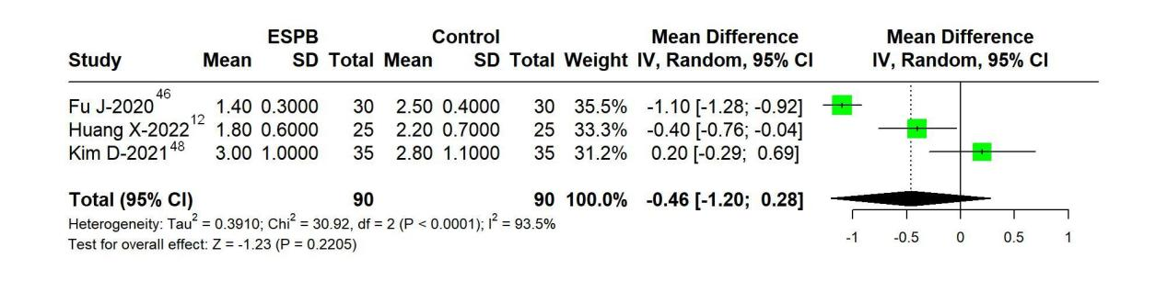

Supplementary Material 3.2 Direct pair-wise meta-analysis of opioid consumption:

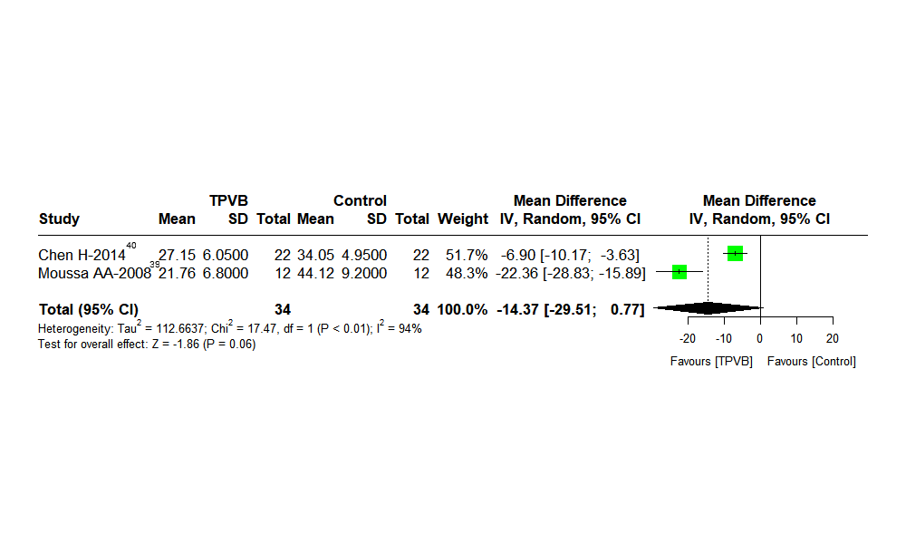
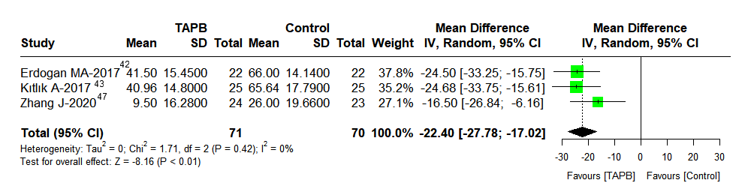
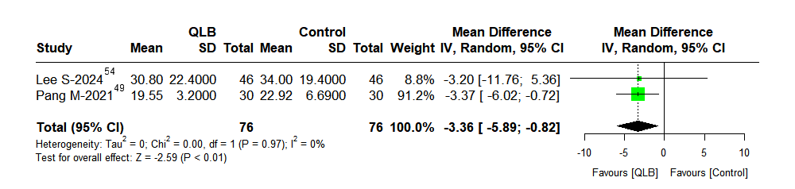
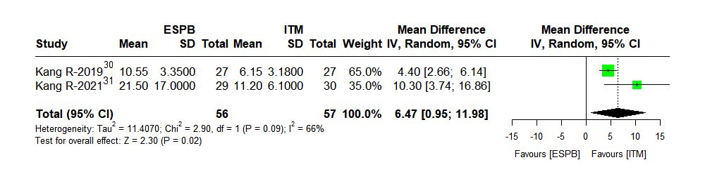
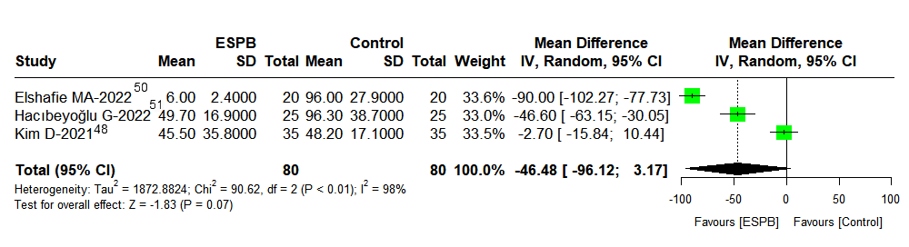

Supplementary Material 3.3 Direct pair-wise meta-analysis of PONV:
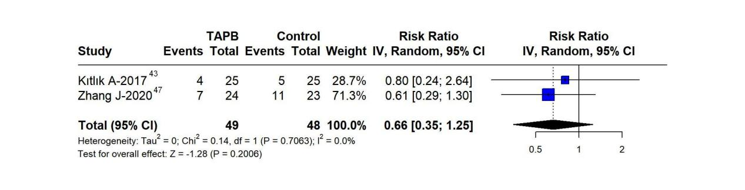
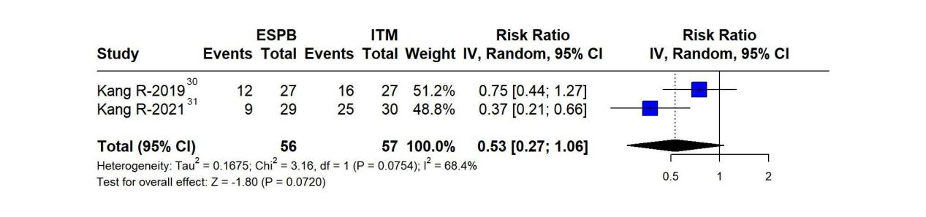
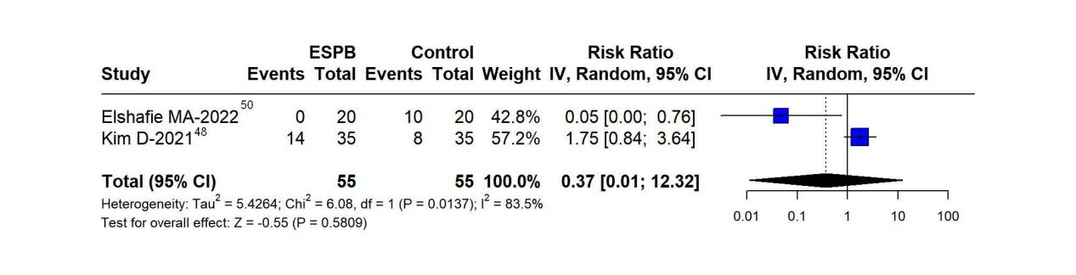
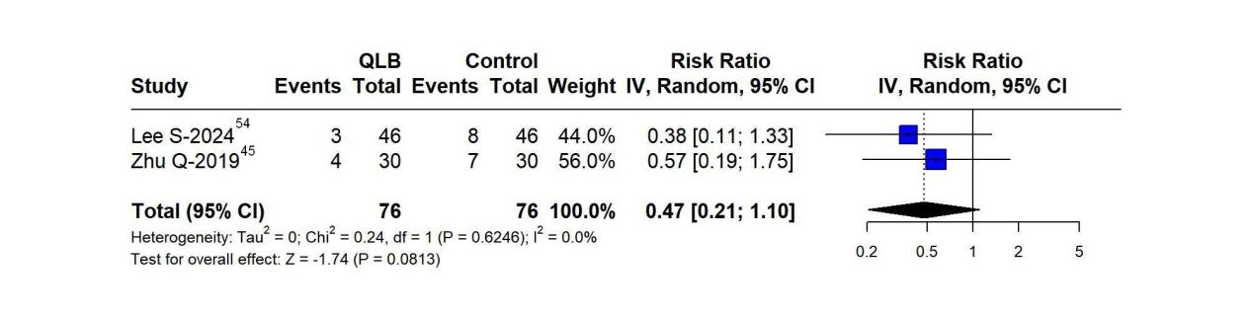

Supplementary Material 4
Absolute effect estimates and certainty of evidence
Supplementary Material 4.1 Pain Scores
COMPARISONS |  | DIRECT ESTIMATE |  |  |  | INDIRECT ESTIMATE |  |  |  | NETWORK ESTIMATE
 |  | ABSOLUTE ESTIMATE |  |  | GRADE | ABSOLUTE ESTIMATE |  |  | GRADE | ABSOLUTE ESTIMATE |  |  | GRADE
TREATMENT 1 | TREATMENT 2 | Point estimate | CI lower limit | CI upper limit | Final rating | Point estimate | CI lower limit | CI upper limit | Final rating | Point estimate | CI lower limit | CI upper limit | Final rating | Reasons for downgrading
ESPB | Control | -0.46 | -1.2 | 0.28 | VERY LOW | -1.14 | -2.73 | 0.48 | VERY LOW | -0.64 | -1.43 | 0.18 | VERY LOW | RoB, Imprecision
QLB | Control | NA | NA | NA | NA | -0.08 | -2.32 | 2.19 | VERY LOW | -0.08 | -2.32 | 2.19 | VERY LOW | RoB, Imprecision
TAPB | Control | -0.75 | -1.51 | 0 | LOW | -0.18 | -2.13 | 1.78 | VERY LOW | -0.65 | -1.41 | 0.18 | VERY LOW | RoB, Imprecision
TEA | Control | NA | NA | NA | NA | -0.84 | -2.3 | 0.56 | VERY LOW | -0.84 | -2.3 | 0.56 | VERY LOW | RoB, Imprecision
TPVB | Control | NA | NA | NA | NA | -0.11 | -2.88 | 2.65 | VERY LOW | -0.46 | -1.81 | 0.92 | VERY LOW | RoB, Imprecision
ITM | Control | NA | NA | NA | NA | -1.2 | -2.6 | 0.22 | VERY LOW | -1.2 | -2.6 | 0.22 | VERY LOW | RoB, Imprecision
ESPB | ITM | 0.58 | -0.61 | 1.76 | VERY LOW | 0.55 | -0.6 | 1.73 | VERY LOW | 0.55 | -0.6 | 1.73 | VERY LOW | RoB, Imprecision
QLB | ITM | NA | NA | NA | NA | 1.12 | -0.64 | 2.88 | NA | 1.12 | -0.64 | 2.88 | LOW | RoB, Imprecision
TAPB | ITM | NA | NA | NA | NA | 0.55 | -0.93 | 2.11 | VERY LOW | 0.55 | -0.93 | 2.11 | VERY LOW | RoB, Imprecision
TEA | ITM | NA | NA | NA | NA | 0.36 | -1.43 | 2.12 | VERY LOW | 0.36 | -1.43 | 2.12 | VERY LOW | RoB, Imprecision
TPVB | ITM | NA | NA | NA | NA | 0.74 | -1.14 | 2.65 | VERY LOW | 0.74 | -1.14 | 2.65 | VERY LOW | RoB, Imprecision
ESPB | QLB | NA | NA | NA | NA | -0.56 | -2.66 | 1.56 | VERY LOW | -0.56 | -2.66 | 1.56 | VERY LOW | RoB, Imprecision
ESPB | TAPB | NA | NA | NA | NA | -0.21 | -1.52 | 1.08 | VERY LOW | 0 | -0.99 | 0.98 | VERY LOW | RoB, Imprecision
ESPB | TEA | NA | NA | NA | NA | 0.8 | -1.93 | 3.45 | VERY LOW | 0.2 | -1.1 | 1.57 | VERY LOW | RoB, Imprecision
ESPB | TPVB | NA | NA | NA | NA | -0.19 | -1.65 | 1.28 | NA | -0.19 | -1.65 | 1.28 | VERY LOW | RoB, Imprecision
QLB | TAPB | NA | NA | NA | NA | 0.56 | -1.79 | 2.86 | NA | 0.56 | -1.79 | 2.86 | LOW | RoB, Imprecision
QLB | TEA | NA | NA | NA  NA | NA | 0.76 | -1.71 | 3.27 | NA | 0.76 | -1.71 | 3.27 | LOW | RoB, Imprecision
QLB | TPVB | NA | NA | NA | NA | 0.38 | -2.19 | 2.95 | NA | 0.38 | -2.19 | 2.95 | LOW | RoB, Imprecision
TAPB | TEA | NA | NA | NA | NA | 0.2 | -1.34 | 1.82 | NA | 0.2 | -1.34 | 1.82 | LOW | RoB, Imprecision
TAPB | TPVB | NA | NA | NA | NA | -0.18 | -1.74 | 1.38 | NA | -0.18 | -1.74 | 1.38 | LOW | RoB, Imprecision
TEA | TPVB | NA | NA | NA | NA | -0.04 | -2.48 | 2.61 | NA | -0.38 | -1.91 | 1.07 | LOW | RoB, Imprecision

Supplementary Material 4.2 Opioid consumption
COMPARISONS |  | DIRECT ESTIMATE |  |  |  | INDIRECT ESTIMATE |  |  |  | NETWORK ESTIMATE
 |  | ABSOLUTE ESTIMATE |  |  | GRADE | ABSOLUTE ESTIMATE |  |  | GRADE | ABSOLUTE ESTIMATE |  |  | GRADE
TREATMENT 1 | TREATMENT 2 | Point estimate | CI lower limit | CI upper limit | Final rating | Point estimate | CI lower limit | CI upper limit | Final rating | Point estimate | CI lower limit | CI upper limit | Final rating | Reasons for downgrading
ESPB | Control | -46.48 | -96.12 | 3.17 | VERY LOW | -23.48 | -55.33 | 9.54 | MODERATE | -36.77 | -57.95 | -15.43 | LOW | RoB, Inconsistency
QLB | Control | -22.4 | -27.78 | -17.02 | HIGH | -36.02 | -69.09 | -3.37 | LOW | -18.73 | -43.15 | 5.27 | MODERATE | RoB, Imprecision
TAPB | Control | -3.36 | -5.89 | -0.82 | MODERATE | -15.27 | -57.11 | 25.42 | VERY LOW | -19.76 | -42.69 | 2.66 | LOW | RoB
TEA | Control | NA | NA | NA | NA | -26.39 | -64.68 | 11.93 | VERY LOW | -26.39 | -64.68 | 11.93 | VERY LOW | RoB, Imprecision
TPVB | Control | -14.37 | -29.51 | 0.77 | VERY LOW | -22.25 | -96.84 | 51.89 | LOW | -16.18 | -46 | 13.94 | VERY LOW | RoB, Imprecision
ITM | Control | NA | NA | NA | NA | -43.82 | -77.49 | -10.92 | MODERATE | -43.82 | -77.49 | -10.92 | MODERATE | RoB
ESPB | ITM | 6.47 | 0.95 | 11.98 | MODERATE | 6.9 | -51.07 | 65.24 | LOW | 7.16 | -21.23 | 35.67 | LOW | RoB
QLB | ITM | NA | NA | NA | NA | 25.28 | -21.02 | 73.44 | LOW | 25.24 | -6.88 | 57.17 | LOW | RoB, Imprecision
TAPB | ITM | NA | NA | NA | NA | 24.15 | -11.9 | 60.64 | LOW | 24.15 | -11.9 | 60.64 | LOW | RoB, Imprecision
TEA | ITM | NA | NA | NA | NA | 17.49 | -27.75 | 64.09 | LOW | 17.49 | -27.75 | 64.09 | LOW | RoB, Imprecision
TPVB | ITM | NA | NA | NA | NA | 27.62 | -13.81 | 71.22 | VERY LOW | 27.62 | -13.81 | 71.22 | VERY LOW | RoB, Imprecision
ESPB | QLB | NA | NA | NA | NA | -23.83 | -54.19 | 7.96 | LOW | -17.9 | -43.46 | 7.67 | LOW | RoB, Imprecision
ESPB | TAPB | NA | NA | NA | NA | -21.61 | -54.95 | 11.32 | VERY LOW | -16.83 | -43.54 | 9.83 | VERY LOW | RoB, Imprecision
ESPB | TEA | NA | NA | NA | NA | -14.25 | -78.84 | 52.03 | VERY LOW | -10.38 | -47.29 | 27 | VERY LOW | RoB, Imprecision
ESPB | TPVB | NA | NA | NA | NA | -20.43 | -54.93 | 12.88 | VERY LOW | -20.43 | -54.93 | 12.88 | VERY LOW | RoB, Imprecision
QLB | TAPB | NA | NA | NA | NA | 10.06 | -24.64 | 45.14 | LOW | 1.05 | -27.24 | 29.11 | LOW | RoB, Imprecision
QLB | TEA | NA | NA | NA  NA | NA | 7.53 | -35.1 | 50.15 | LOW | 7.53 | -35.1 | 50.15 | LOW | RoB, Imprecision
QLB | TPVB | NA | NA | NA | NA | -2.6 | -40.54 | 34.21 | VERY LOW | -2.6 | -40.54 | 34.21 | VERY LOW | RoB, Imprecision
TAPB | TEA | NA | NA | NA | NA | 6.54 | -36.3 | 49.15 | LOW | 6.54 | -36.3 | 49.15 | LOW | RoB, Imprecision
TAPB | TPVB | NA | NA | NA | NA | -3.58 | -40.57 | 32.78 | LOW | -3.58 | -40.57 | 32.78 | LOW | RoB, Imprecision
TEA | TPVB | NA | NA | NA | NA | -14.61 | -80.47 | 51.13 | LOW | -10.15 | -48.06 | 26.97 | LOW | RoB, Imprecision

Supplementary Material 4.3 PONV

COMPARISONS |  | DIRECT ESTIMATE |  |  |  | INDIRECT ESTIMATE |  |  |  | NETWORK ESTIMATE
 |  | RELATIVE ESTIMATE |  |  | GRADE | RELATIVE ESTIMATE |  |  | GRADE | RELATIVE ESTIMATE |  |  | GRADE
TREATMENT 1 | TREATMENT 2 | Point estimate | CI lower limit | CI upper limit | Final rating | Point estimate | CI lower limit | CI upper limit | Final rating | Point estimate | CI lower limit | CI upper limit | Final rating | Reasons for downgrading
ESPB | Control | 0.72 | 0.11 | 4.8 | LOW | 0.47 | 0.08 | 1.84 | NA | 0.47 | 0.08 | 1.84 | LOW | RoB, Imprecision
QLB | Control | NA | NA | NA | NA | 0.53 | 0.07 | 2.79 | LOW | 0.53 | 0.07 | 2.79 | LOW | RoB, Imprecision
TAPB | Control | 0.66 | 0.41 | 1.08 | LOW | 0.73 | 0.17 | 3.02 | NA | 0.73 | 0.17 | 3.02 | LOW | RoB, Imprecision
TEA | Control | NA | NA | NA | NA | 1.24 | 0.02 | 93.34 | NA | 1.24 | 0.02 | 93.34 | VERY LOW | RoB, Imprecision
TPVB | Control | NA | NA | NA | NA | 1 | 0.03 | 27.68 | NA | 1 | 0.03 | 27.68 | VERY LOW | RoB, Imprecision
ITM | Control | NA | NA | NA | NA | 0.9 | 0.06 | 8.6 | LOW | 0.9 | 0.06 | 8.6 | LOW | RoB, Imprecision
ESPB | ITM | 0.53 | 0.27 | 1.06 | LOW | 0.53 | 0.08 | 3.42 | NA | 0.53 | 0.08 | 3.42 | LOW | RoB, Imprecision
QLB | ITM | NA | NA | NA | NA | 0.6 | 0.04 | 8.76 | LOW | 0.6 | 0.04 | 8.76 | LOW | RoB, Imprecision
TAPB | ITM | NA | NA | NA | NA | 0.81 | 0.06 | 15.49 | LOW | 0.81 | 0.06 | 15.49 | LOW | RoB, Imprecision
TEA | ITM | NA | NA | NA | NA | 1.44 | 0.01 | 247.5 | NA | 1.44 | 0.01 | 247.5 | VERY LOW | RoB, Imprecision
TPVB | ITM | NA | NA | NA | NA | 1.16 | 0.02 | 81.32 | NA | 1.16 | 0.02 | 81.32 | VERY LOW | RoB, Imprecision
ESPB | QLB | NA | NA | NA | NA | 0.87 | 0.12 | 6.28 | NA | 0.87 | 0.12 | 6.28 | VERY LOW | RoB, Imprecision
ESPB | TAPB | NA | NA | NA | NA | 0.65 | 0.07 | 4.15 | NA | 0.65 | 0.07 | 4.15 | VERY LOW | RoB, Imprecision
ESPB | TEA | NA | NA | NA | NA | 0.36 | 0 | 34.4 | NA | 0.36 | 0 | 34.4 | VERY LOW | RoB, Imprecision
ESPB | TPVB | NA | NA | NA | NA | 0.45 | 0.01 | 16.71 | NA | 0.45 | 0.01 | 16.71 | VERY LOW | RoB, Imprecision
QLB | TAPB | NA | NA | NA | NA | 0.73 | 0.08 | 4.92 | LOW | 0.73 | 0.08 | 4.92 | LOW | RoB, Imprecision
QLB | TEA | NA | NA | NA  NA | NA | 0.42 | 0 | 42.02 | NA | 0.42 | 0 | 42.02 | VERY LOW | RoB, Imprecision
QLB | TPVB | NA | NA | NA | NA | 0.51 | 0.01 | 21.86 | NA | 0.51 | 0.01 | 21.86 | VERY LOW | RoB, Imprecision
TAPB | TEA | NA | NA | NA | NA | 0.58 | 0.01 | 56.09 | NA | 0.58 | 0.01 | 56.09 | VERY LOW | RoB, Imprecision
TAPB | TPVB | NA | NA | NA | NA | 0.71 | 0.02 | 26.43 | NA | 0.71 | 0.02 | 26.43 | VERY LOW | RoB, Imprecision
TEA | TPVB | NA | NA | NA | NA | 1.23 | 0.08 | 19.14 | NA | 1.23 | 0.08 | 19.14 | VERY LOW | RoB, Imprecision

Supplementary Material 5

Cumulative ranking probability (SCURA)

Supplementary Material 5.1 Cumulative Probability Distribution Diagram of Pain Scores:
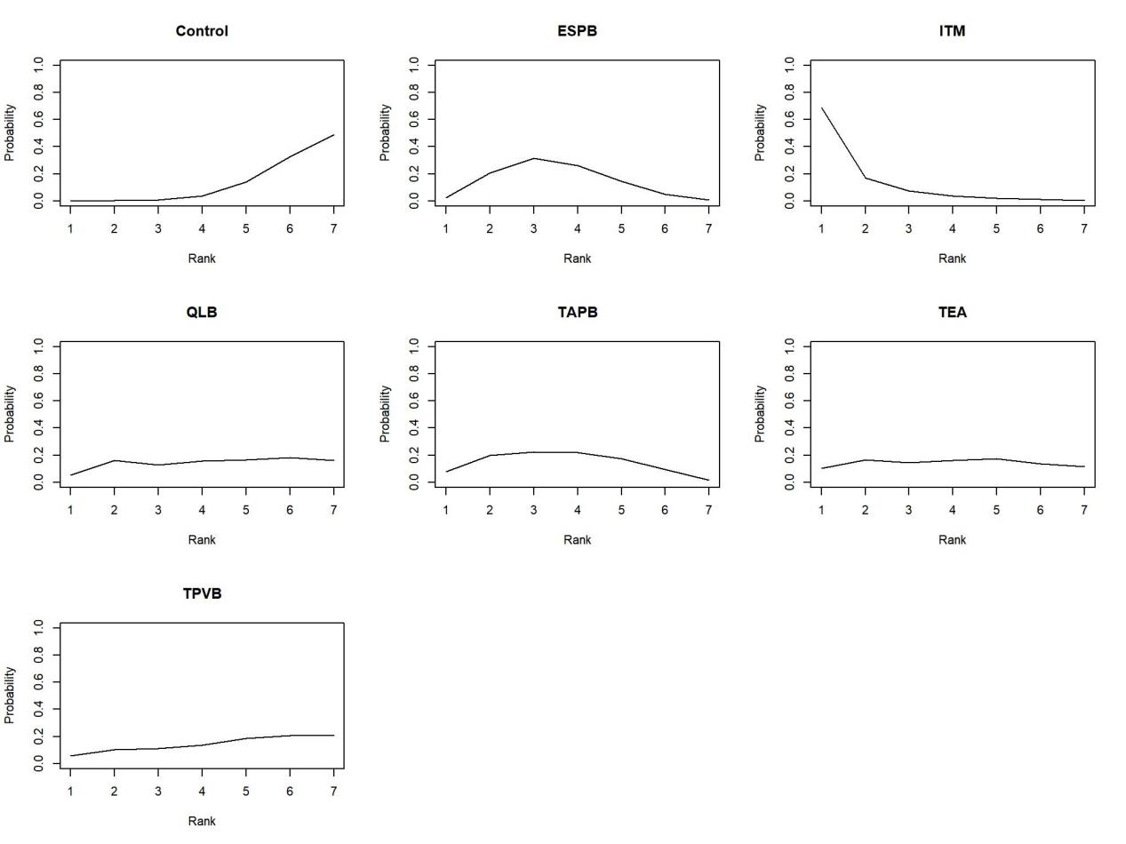

Supplementary Material 5.2 Cumulative Probability Distribution Diagram of Opioid consumption:
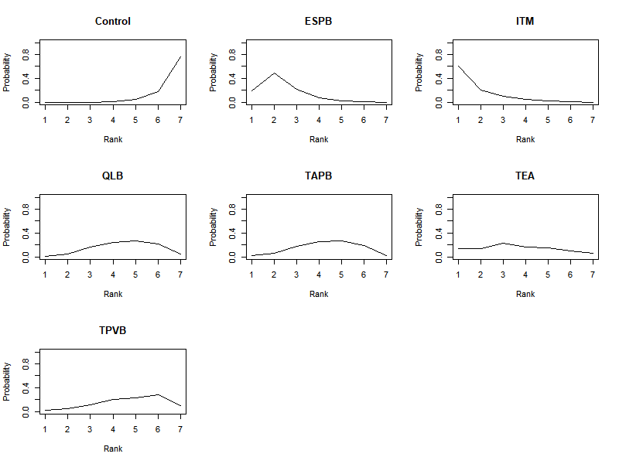

Supplementary Material 5.3 Cumulative Probability Distribution Diagram of PONV:
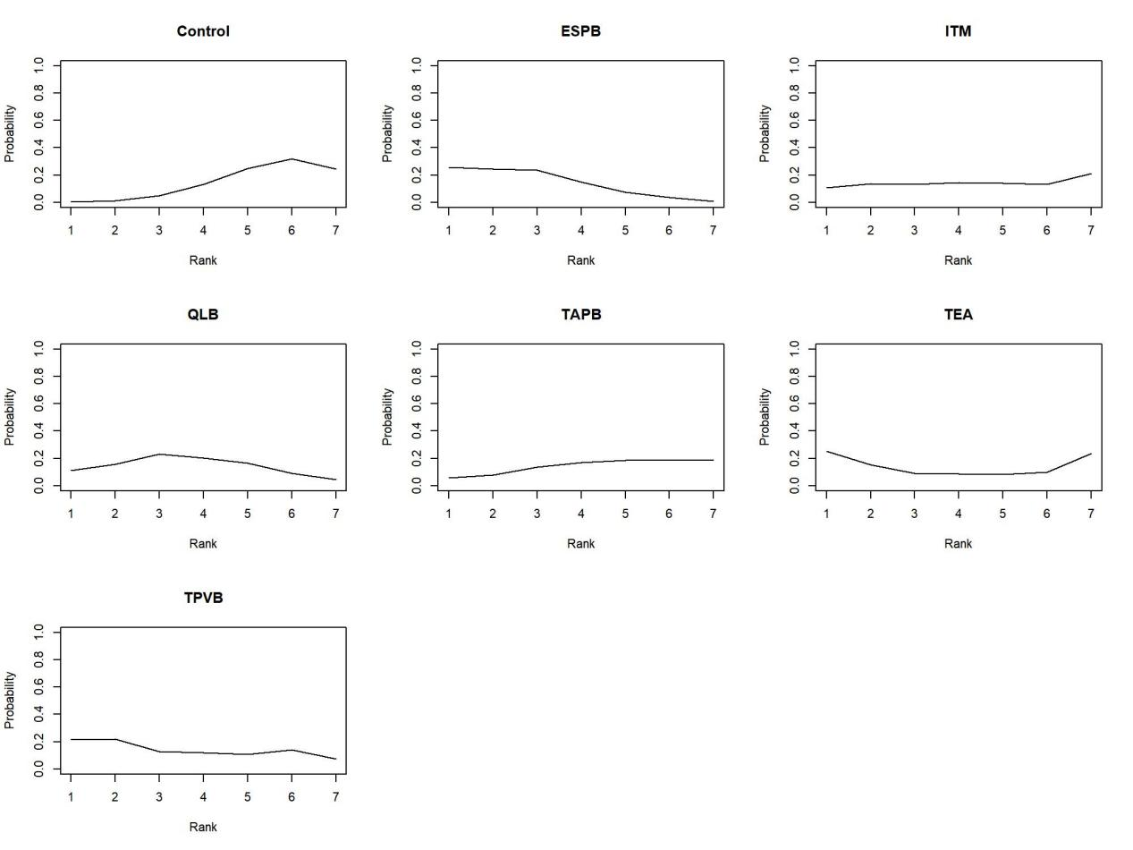

Supplementary Material 6
Network meta-analysis of different nerve blocks by subgroup
Supplementary Material 6.1 Subgroup Analysis of Network Meta-Analysis on Different Nerve Blocks for Pain Scores:
Laparoscopic hepatectomy:
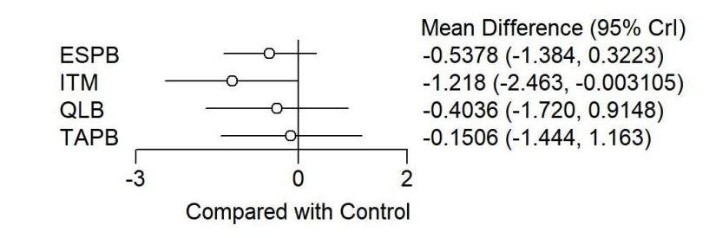
Open hepatectomy:
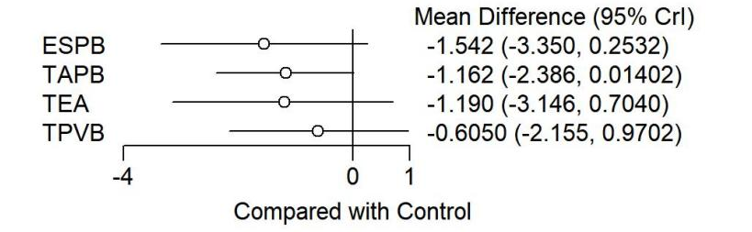

Supplementary Material 6.2 Subgroup Analysis of Network Meta-Analysis on Different Nerve Blocks for Opioid consumption:
Laparoscopic hepatectomy:
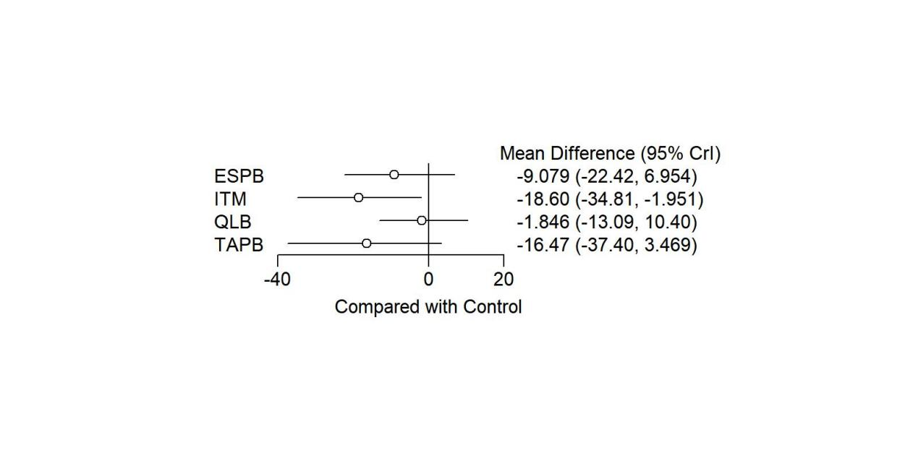
Open hepatectomy:
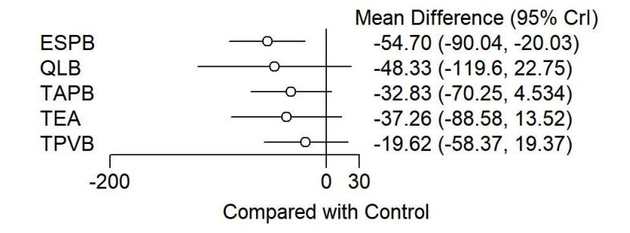
Supplementary Material 6.3 Subgroup Analysis of Network Meta-Analysis on Different Nerve Blocks for PONV:
Laparoscopic hepatectomy:
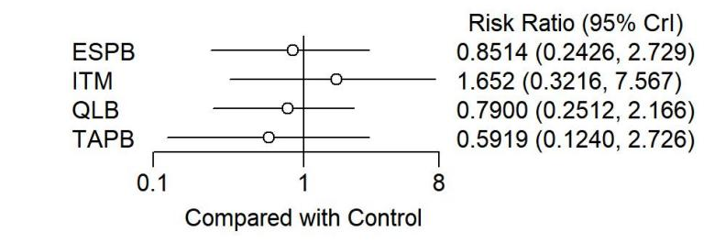
Open hepatectomy:
