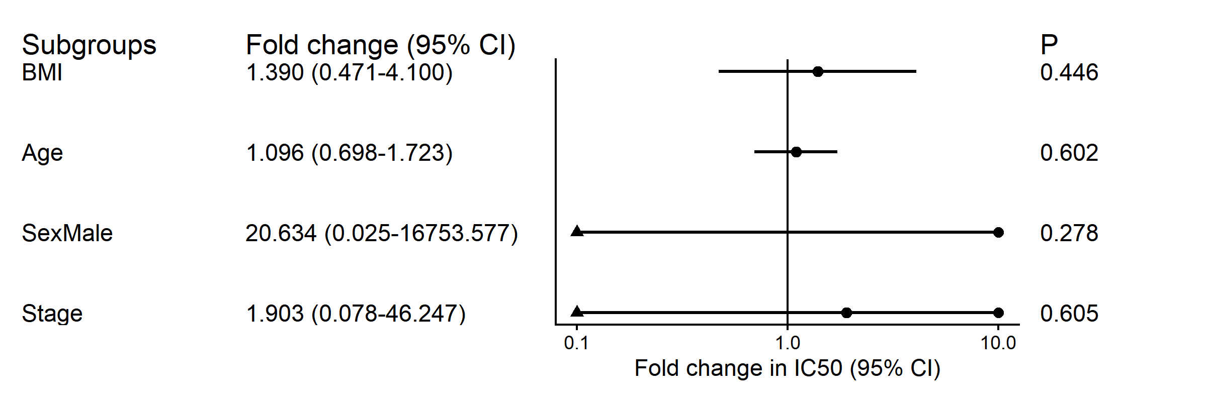
Figure S1. Subgroup analysis of paclitaxel IC50 according to clinical characteristics.

Table S1. Stability of the linoleic acid-log10(IC50) association after adjustment for individual clinical covariates
Model | β (LA) | Pvalue | 95% CI_low | 95% CI_high
Unadjusted | 35.21 | 0.039 | 2.55 | 67.86
+Age | 36.24 | 0.052 | -0.55 | 73.02
+Sex | 35.32 | 0.017 | 9.56 | 61.07
+BMI | 38.36 | 0.007 | 15.63 | 61.10
+Stage | 34.44 | 0.060 | -2.10 | 70.98

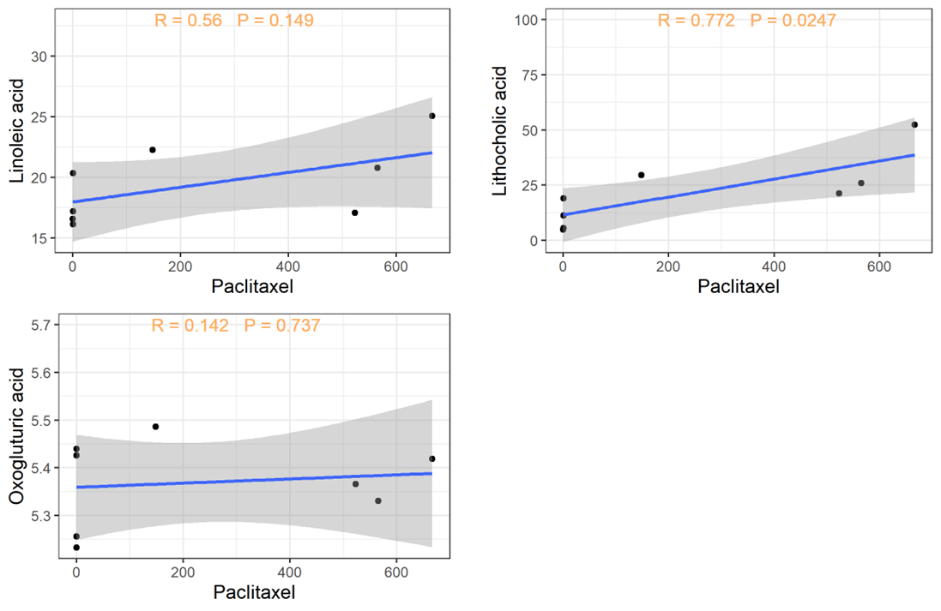
Figure S2. Correlation analysis of the area under the paclitaxel dose curve and its metabolites.

 |  | Table S2. List of candidate metabolites (n=10)
No | Metabolite |  | Spearman |  |  |  | Lower_quartile |  |  |  |  |  | Median |  |  |  |  |  | Higher_quartile
No | Metabolite |  | r | Pvalue | Qvalue |  | Pvalue | FDR | hedges_g | 95% CI_low | 95% CI_high |  | Pvalue | FDR | hedges_g | 95% CI_low | 95% CI_high |  | Pvalue | FDR | hedges_g | 95% CI_low | 95% CI_high
1 | Azelaic acid |  | -0.9048 | 0.0020 | 0.7670 |  | 0.8686 | 0.0612 | 0.9846 | 0.1769 | 0.0964 |  | 0.6776 | 0.1690 | 0.9970 | 0.4593 | -0.2474 |  | 0.3788 | 0.4216 | 0.9029 | 0.9622 | -0.5672
2 | Oxoglutaric acid |  | -0.8571 | 0.0070 | 0.9610 |  | 0.0462 | 1.3355 | 0.1796 | 1.3763 | 1.8897 |  | 0.0395 | 1.4030 | 0.1528 | 1.1466 | 1.5267 |  | 0.0305 | 1.5150 | 0.1476 | 1.1362 | 1.3399
3 | Lithocholic acid |  | -0.8333 | 0.0100 | 0.9610 |  | 0.0203 | 1.6915 | 0.1130 | 1.2462 | 1.5926 |  | 0.0175 | 1.7570 | 0.1528 | 1.2112 | 1.6529 |  | 0.0099 | 2.0045 | 0.1476 | 1.4470 | 2.0622
4 | Phenylacetylglutamine |  | -0.7857 | 0.0210 | 0.9610 |  | 0.2112 | 0.6752 | 0.9242 | 1.4350 | 0.8927 |  | 0.3168 | 0.4992 | 0.9937 | 1.0880 | 0.6131 |  | 0.4290 | 0.3676 | 0.9054 | 0.7960 | 0.4626
5 | 9,12,13-TriHOME |  | -0.7857 | 0.0210 | 0.9610 |  | 0.1489 | 0.8272 | 0.2863 | 1.0522 | 1.2131 |  | 0.1485 | 0.8281 | 0.1549 | 0.8348 | 0.9624 |  | 0.1703 | 0.7688 | 0.2629 | 0.7566 | 0.7647
6 | Terephthalate |  | -0.7381 | 0.0370 | 0.9610 |  | 0.1166 | 0.9334 | 0.9242 | 1.7442 | 1.1512 |  | 0.1818 | 0.7405 | 0.9937 | 1.4230 | 0.8362 |  | 0.3240 | 0.4894 | 0.8889 | 0.9830 | 0.5806
7 | Guanosine |  | -0.6905 | 0.0580 | 0.9610 |  | 0.1459 | 0.8360 | 0.9242 | 1.6378 | 1.0416 |  | 0.3055 | 0.5149 | 0.9937 | 1.1261 | 0.6287 |  | 0.4031 | 0.3946 | 0.9054 | 0.8412 | 0.4895
8 | N-Acetyl-L-phenylalanine |  | 0.7381 | 0.0370 | 0.9610 |  | 0.5868 | 0.2315 | 0.9300 | 0.5158 | -0.2853 |  | 0.8761 | 0.0575 | 0.9970 | 0.1810 | -0.0939 |  | 0.7145 | 0.1460 | 0.9614 | 0.4559 | 0.2595
9 | Pipecolic acid |  | 0.6905 | 0.0580 | 0.9610 |  | 0.0826 | 1.0831 | 0.9242 | 1.6029 | -1.0276 |  | 0.2149 | 0.6678 | 0.9937 | 1.3400 | -0.7783 |  | 0.7497 | 0.1251 | 0.9614 | 0.3606 | 0.1643
10 | Cerulenin |  | -0.6667 | 0.0710 | 0.9610 |  | 0.3760 | 0.4248 | 0.9242 | 0.9247 | 0.5367 |  | 0.8019 | 0.0959 | 0.9970 | 0.2798 | 0.1488 |  | 0.6957 | 0.1576 | 0.9614 | 0.4292 | -0.2346
11 | 5,6-Dihydro-5-fluorouracil |  | -0.6667 | 0.0710 | 0.9610 |  | 0.4282 | 0.3684 | 0.9242 | 0.8004 | 0.4616 |  | 0.9473 | 0.0235 | 0.9970 | 0.1184 | -0.0391 |  | 0.9949 | 0.0022 | 0.9949 | 0.0790 | 0.0040
12 | N-Alpha-acetyllysine |  | 0.6667 | 0.0710 | 0.9610 |  | 0.4155 | 0.3814 | 0.9242 | 0.8472 | -0.4911 |  | 0.2977 | 0.5262 | 0.9937 | 1.1251 | -0.6364 |  | 0.7136 | 0.1466 | 0.9614 | 0.4212 | -0.2295
13 | Linoleic acid |  | 0.6667 | 0.0710 | 0.9610 |  | 0.0013 | 2.8999 | 0.0630 | 1.5132 | -2.4083 |  | 0.0006 | 3.2407 | 0.0287 | 1.5662 | -3.1989 |  | 0.0159 | 1.7983 | 0.1476 | 1.2883 | -1.6381
14 | Picolinic acid |  | -0.6667 | 0.0710 | 0.9610 |  | 0.4930 | 0.3071 | 0.9277 | 0.7749 | 0.4469 |  | 0.2570 | 0.5900 | 0.9937 | 1.2185 | 0.6962 |  | 0.2083 | 0.6814 | 0.8889 | 1.2797 | 0.7826
15 | (R)-2-O-Sulfolactate |  | 0.6905 | 0.0580 | 0.9610 |  | 0.0282 | 1.5499 | 0.9112 | 2.0555 | -1.4669 |  | 0.4846 | 0.3147 | 0.9948 | 0.7909 | -0.4288 |  | 0.6380 | 0.1952 | 0.9614 | 0.4414 | -0.2507
16 | O-Phosphoethanolamine |  | 0.7143 | 0.0470 | 0.9610 |  | 0.0757 | 1.1208 | 0.9242 | 1.6368 | -1.0528 |  | 0.9363 | 0.0286 | 0.9970 | 0.1373 | -0.0481 |  | 0.7689 | 0.1141 | 0.9614 | 0.2732 | 0.1538
17 | N-Acetylornithine |  | -0.6905 | 0.0580 | 0.9610 |  | 0.6556 | 0.1834 | 0.9559 | 0.5585 | 0.2983 |  | 0.6280 | 0.2020 | 0.9962 | 0.5453 | 0.2893 |  | 0.6724 | 0.1724 | 0.9614 | 0.4423 | 0.2514
18 | Mexiletine |  | 0.7857 | 0.0210 | 0.9610 |  | 0.5191 | 0.2848 | 0.9300 | 0.7625 | -0.4189 |  | 0.9423 | 0.0258 | 0.9970 | 0.1479 | -0.0429 |  | 0.7084 | 0.1497 | 0.9614 | 0.3785 | 0.2147
19 | Adenine |  | 0.8095 | 0.0150 | 0.9610 |  | 0.1750 | 0.7570 | 0.2916 | 0.7923 | -0.8451 |  | 0.1300 | 0.8860 | 0.1549 | 0.8337 | -0.9576 |  | 0.6658 | 0.1767 | 0.6658 | 0.6647 | -0.2457
20 | L-Carnitine |  | 0.8095 | 0.0150 | 0.9610 |  | 0.4197 | 0.3770 | 0.9242 | 0.7359 | -0.4229 |  | 0.9973 | 0.0012 | 0.9973 | 0.0188 | 0.0021 |  | 0.1988 | 0.7016 | 0.8889 | 1.2924 | 0.7899
FDR-adjusted q-values in the Spearman section were calculated using the Benjamini–Hochberg procedure across all tested metabolites in the discovery cohort (n = 382), rather than only the candidate metabolites displayed in this table.

Table S3. Leave-one-out sensitivity analysis of the linoleic acid correlation
left_out | r | Pvalue
1 | 0.73 | 0.063
2 | 0.40 | 0.369
3 | 0.86 | 0.012
4 | 0.75 | 0.052
5 | 0.85 | 0.017
6 | 0.72 | 0.069
7 | 0.78 | 0.037
8 | 0.73 | 0.064

Table S4. The statistical results of cell survival rate
Comparisons Test | 95% CI_low | 95% CI_high | Adjusted P (Dunnett) | Celltype
PTX vs Control | -46.14 | -39.53 | <0.0001 | HCT116
PTX vs PTX_LA(1nM) | -4.222 | 2.384 | 0.9153 | HCT116
PTX vs PTX_LA(10nM) | -2.616 | 3.991 | 0.9726 | HCT116
PTX vs PTX_LA(100nM) | -8.735 | -2.128 | 0.0006 | HCT116
PTX vs PTX_LA(1000nM) | -17.15 | -10.54 | <0.0001 | HCT116
PTX vs Control | -69.72 | -61.87 | <0.0001 | SW480
PTX vs PTX_LA(1nM) | -4.444 | 3.408 | 0.9961 | SW480
PTX vs PTX_LA(10nM) | -8.832 | -0.9806 | 0.0102 | SW480
PTX vs PTX_LA(100nM) | -18.88 | -11.03 | <0.0001 | SW480
PTX vs PTX_LA(1000nM) | -30.11 | -22.26 | <0.0001 | SW480
PTX vs Control | -52.67 | -45.37 | <0.0001 | SW620
PTX vs PTX_LA(1nM) | -1.97 | 5.335 | 0.6218 | SW620
PTX vs PTX_LA(10nM) | -3.305 | 4 | 0.9988 | SW620
PTX vs PTX_LA(100nM) | -12.17 | -4.865 | <0.0001 | SW620
PTX vs PTX_LA(1000nM) | -26.59 | -19.29 | <0.0001 | SW620

Table S5. Bootstrap 95% confidence intervals for tubulin
Microtubulin | Comparisons Test | mean difference | 95% CI_low | 95% CI_high | cell_type
Counts of branch | Control vs PTX | -303.4051 | -409.625 | -199.375 | HCT116
Counts of branch | LA vs PTX | -222.1431 | -306.6667 | -130.7063 | HCT116
Counts of branch | PTX_LA vs PTX | -285.9227 | -381.0556 | -190.4889 | HCT116
Counts of branch | Control vs PTX | -756.6383 | -1005.9095 | -334.6549 | SW480
Counts of branch | LA vs PTX | -623.9482 | -910.1469 | -211.1772 | SW480
Counts of branch | PTX_LA vs PTX | -693.965 | -973.5545 | -278.4956 | SW480
Counts of branch | Control vs PTX | -270.4662 | -384.8849 | -195.1905 | SW620
Counts of branch | LA vs PTX | -168.8029 | -278.4444 | -89.2546 | SW620
Counts of branch | PTX_LA vs PTX | -196.7948 | -302.4497 | -112.4667 | SW620
Length of microtubule | Control vs PTX | -3373.702 | -4682.958 | -2293.083 | HCT116
Length of microtubule | LA vs PTX | -2957.18 | -4307.333 | -1896.222 | HCT116
Length of microtubule | PTX_LA vs PTX | -2944.567 | -4320.367 | -1684.5 | HCT116
Length of microtubule | Control vs PTX | -2140.057 | -2783.629 | -1447.697 | SW480
Length of microtubule | LA vs PTX | -1742.314 | -2397.59 | -1043.179 | SW480
Length of microtubule | PTX_LA vs PTX | -1645.837 | -2461.5344 | -821.0599 | SW480
Length of microtubule | Control vs PTX | -2154.759 | -2361.895 | -1886.913 | SW620
Length of microtubule | LA vs PTX | -2065.628 | -2242.419 | -1818.639 | SW620
Length of microtubule | PTX_LA vs PTX | -747.3628 | -1264.2685 | -384.3148 | SW620
Average Intensity | Control vs PTX | -62.8195 | -87.4017 | -46.581 | HCT116
Average Intensity | LA vs PTX | -63.9961 | -88.7797 | -49.4433 | HCT116
Average Intensity | PTX_LA vs PTX | -57.4472 | -82.4877 | -42.5443 | HCT116
Average Intensity | Control vs PTX | -50.0725 | -65.2927 | -37.1 | SW480
Average Intensity | LA vs PTX | -47.7204 | -61.9784 | -34.8011 | SW480
Average Intensity | PTX_LA vs PTX | -33.5547 | -48.8323 | -18.9523 | SW480
Average Intensity | Control vs PTX | -98.1801 | -130.4626 | -79.5497 | SW620
Average Intensity | LA vs PTX | -106.2985 | -138.5117 | -85.3369 | SW620
Average Intensity | PTX_LA vs PTX | -88.1455 | -120.4304 | -68.2387 | SW620

Table S6. Bootstrap 95% confidence intervals for cell cycle
Cell cycle | Comparisons Test | mean difference | 95% CI_low | 95% CI_high | CellType
G1 | Control vs PTX | 14.245 | 10.5833 | 17.89 | HCT116
G1 | LA vs PTX | 6.5362 | 3.2433 | 9.8433 | HCT116
G1 | PTX_LA vs PTX | 5.6106 | 3.0033 | 7.88 | HCT116
G1 | Control vs PTX | 36.4119 | 35.3067 | 37.5133 | SW480
G1 | LA vs PTX | 33.4851 | 30.7633 | 36.9433 | SW480
G1 | PTX_LA vs PTX | 0.6542 | -2.33 | 3.15 | SW480
G1 | Control vs PTX | 34.5573 | 29.3567 | 40.8367 | SW620
G1 | LA vs PTX | 1.0739 | -0.9933 | 2.9333 | SW620
G1 | PTX_LA vs PTX | 5.2387 | 3.7733 | 6.7 | SW620
S | Control vs PTX | 9.2693 | 5.19 | 13.2433 | HCT116
S | LA vs PTX | 8.7985 | 4.6833 | 12.9233 | HCT116
S | PTX_LA vs PTX | 3.9153 | 1.19 | 6.3017 | HCT116
S | Control vs PTX | -4.2566 | -6.89 | -0.3267 | SW480
S | LA vs PTX | 0.6315 | -3.64 | 4.8533 | SW480
S | PTX_LA vs PTX | 18.3882 | 12.8833 | 24.9467 | SW480
S | Control vs PTX | -24.2916 | -30.1533 | -19.61 | SW620
S | LA vs PTX | -4.4669 | -6.6767 | -2.8833 | SW620
S | PTX_LA vs PTX | -7.2247 | -10.6833 | -4 | SW620
G2 | Control vs PTX | -23.4371 | -25.34 | -21.8933 | HCT116
G2 | LA vs PTX | -15.3731 | -18.3667 | -10.6633 | HCT116
G2 | PTX_LA vs PTX | -9.507 | -10.715 | -8.2667 | HCT116
G2 | Control vs PTX | -32.1708 | -35.4267 | -30.0933 | SW480
G2 | LA vs PTX | -34.0914 | -37.3233 | -32.0333 | SW480
G2 | PTX_LA vs PTX | -19.055 | -22.8567 | -15.4167 | SW480
G2 | Control vs PTX | -10.2172 | -11.6333 | -9.1033 | SW620
G2 | LA vs PTX | 3.3899 | 0.78 | 5.7067 | SW620
G2 | PTX_LA vs PTX | 1.9787 | -0.3 | 4.5567 | SW620

Table S7. Linear mixed-effects model analysis of tumour growth
Effect | NumDF | Fvalue | Pvalue
Days | 1 | 735.46823 | <0.0001
Group | 3 | 1.7057766 | 0.172
Days - Group | 3 | 38.216681 | <0.0001

Table S8. Linear mixed-effects model analysis of tumour growth
Group | Growth rate (mm³/day) | 95% CI_low | 95% CI_high
Control | 66.8 | 58.93 | 74.70
LA | 77.6 | 69.67 | 85.44
Paclitaxel | 20.8 | 12.92 | 28.69
Paclitaxel_LA | 51.4 | 43.49 | 59.26

Table S9. Prespecified comparison of tumour growth rates
Comparisons Test | 95% CI_low | 95% CI_high | Pvalue
Paclitaxel vs Control | -60.6614627 | -31.351328 | <0.0001
Paclitaxel vs LA | -71.4004244 | -42.09029 | <0.0001
Paclitaxel vs Paclitaxel_LA | -45.2223821 | -15.912248 | <0.0001

Table S10. The two-ANOVA cross-statistical results of tumor weight
Source of Variation | Effect size (η²) | P value
Interaction | 3.562 | 0.1955
LA | 17.9 | 0.007
Paclitaxel | 38.83 | 0.0003

Table S11. The two-ANOVA multiple comparison results of tumor weight
Comparisons Test | 95% CI_low | 95% CI_high | Adjusted P (Tukey)
Control vs PTX | 0.1384 | 0.7462 | 0.0031
LA vs PTX | -0.8739 | -0.2661 | 0.0002
PTX_LA vs PTX | -0.6372 | -0.02942 | 0.0284

