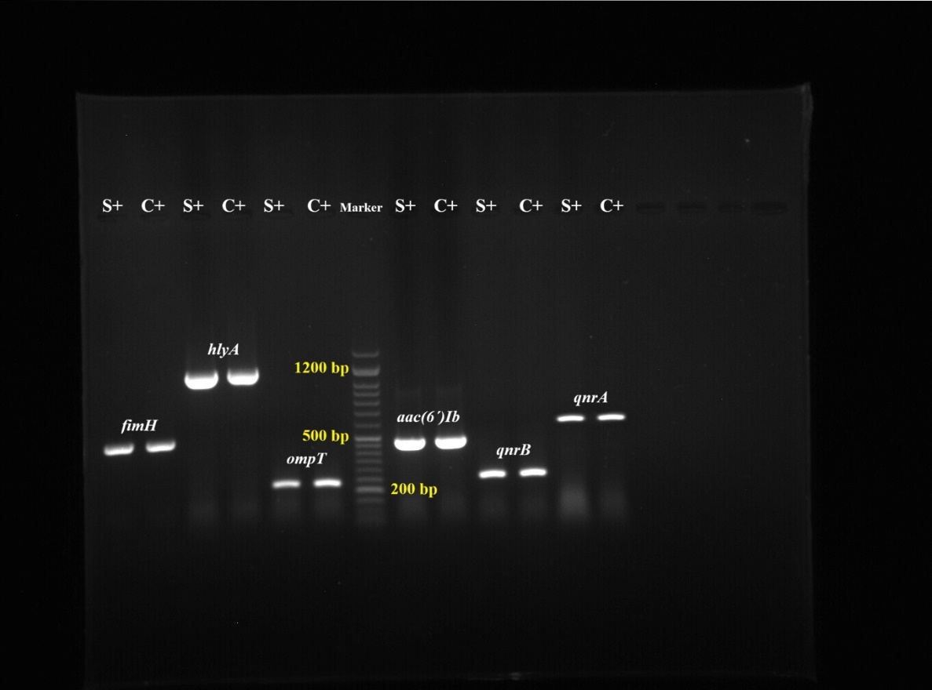
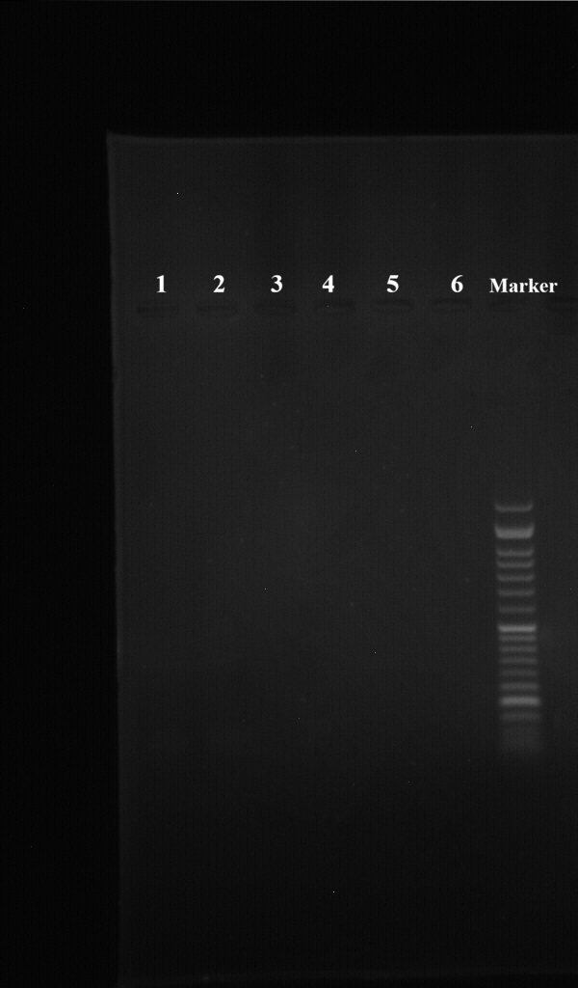
(A)
(B)

Supplementary Figure 1. PCR products of E. coli clinical strains. A) Amplification of fimH, hlyA, ompT, aac(6′)-Ib, qnrA, and qnrB genes along with the Molecular size markers (50‐bp DNA ladder). S+ indicates positive samples, and C+ indicates the positive control. B) Negative controls for the same set of genes (fimH, hlyA, ompT, aac(6′)-Ib, qnrA, and qnrB) are shown in the corresponding lanes along with the Molecular size markers (50‐bp DNA ladder).

