Supplementary Figures and Tables
Table S1 Group classification for multinomial and binary models of BM and PB EVs

Bone Marrow Samples
Name | Type |  | Control | Diseased (1) | Diseased (2)
General asymptomatic / symptomatic MM |  | Multinomial | N | MGUS | ID + REL + REM
Active symptomatic MM |  | Binary | N + MGUS | ID + REL | -
Peripheral Blood Samples
General asymptomatic / symptomatic MM | Multinomial |  | N | MGUS | ID + REL + REM
MGUS | Binary |  | N | MGUS | -
Initial Diagnosis | Binary |  | N + MGUS | ID | -
Relapse | Binary |  | N + REM | REL | -
Table S2 Treatment regimens of MM patients

Patient ID | Disease Status | Diagnosis | Treatment Received
P33 | Initial diagnosis | Multiple Myeloma | CyBorD Chemotheraphy
P39 | Initial diagnosis | IgG lambda Multiple Myeloma (2021) | VTD
P39 | Initial diagnosis | IgG lambda Multiple Myeloma (2021) | Thalidomide + Prednisolone
P40 | Initial diagnosis | MGUS (2012) transformed into Multiple Myeloma (2017) | RVD + Lenalidomide maintenance
P40 | Initial diagnosis | MGUS (2012) transformed into Multiple Myeloma (2017) | DVD
P40 | Initial diagnosis | MGUS (2012) transformed into Multiple Myeloma (2017) | Pomalidomide + Velcade + Dexamethasone + C7D23
P43 | Initial diagnosis | IgA lambda Multiple Myeloma (2016) | Iaxzomib
P43 | Initial diagnosis | IgA lambda Multiple Myeloma (2016) | Prednisolone and a low dose of Thalidomide
P45 | Initial diagnosis | IgA Kappa Multiple Myeloma | Thalidomide
P45 | Initial diagnosis | IgA Kappa Multiple Myeloma | Xgeva
P47 | Initial diagnosis | IgG kappa Mutiple Myeloma (2013) | VTD
P47 | Initial diagnosis | IgG kappa Mutiple Myeloma (2013) | Pomalidomide/Prednisolone
P47 | Initial diagnosis | IgG kappa Mutiple Myeloma (2013) | Zometa
P47 | Initial diagnosis | IgG kappa Mutiple Myeloma (2013) | IVIG
P50 | Initial diagnosis | Multiple Myeloma | Pomalidomide/Dexamethasone
P50 | Initial diagnosis | Multiple Myeloma | Pomalidmide + Dexamethasone
P53 | Initial diagnosis | (1) Light Chain Multiple Myeloma diagnosed in October 2017 | Bortezomib + Dexamethasone
P53 | Initial diagnosis | (1) Light Chain Multiple Myeloma diagnosed in October 2017 | Zometa
P55 | Initial diagnosis | IgG multiple myeloma, progression from smouldering myeloma, ISS stage 2, Baseline plasmacytosis 40% | Lenalidomide + Prednisolone
P55 | Initial diagnosis |  | Velcade + Dexamethasone
P55 | Initial diagnosis |  | Pomalidomide + Prednisolone
P55 | Initial diagnosis |  | DVD
P57 | Initial diagnosis | IgG lamda multiple myeloma stage 3 (2018) | Surgical decompression + radiotheraphy RVD x7
P57 | Initial diagnosis | IgG lamda multiple myeloma stage 3 (2018) | ASCT
P57 | Initial diagnosis | IgG lamda multiple myeloma stage 3 (2018) | Revlimid + Bortezomib
P10 | Initial diagnosis | IgG Kappa Multiple Myeloma (diagnosed 25/2/2015) | RsqVD
P10 | Initial diagnosis | IgG Kappa Multiple Myeloma (diagnosed 25/2/2015) | Revlimid 15mgs PO od (3 weeks on/ 1 week off)
P10 | Initial diagnosis | IgG Kappa Multiple Myeloma (diagnosed 25/2/2015) | IVIG + Zometa
P10 | Initial diagnosis | IgG Kappa Multiple Myeloma (diagnosed 25/2/2015) | Daratumumab + Vel + Dex
P21 | Initial diagnosis | IgA Lambda Multiple Myeloma diagnosed November 2015 | RVD SC
P21 | Initial diagnosis | IgA Lambda Multiple Myeloma diagnosed November 2015 | ASCT
P21 | Initial diagnosis | IgA Lambda Multiple Myeloma diagnosed November 2015 | Velcade/Lenalidomide 15 mg daily 21 days out of 28
P21 | Initial diagnosis | IgA Lambda Multiple Myeloma diagnosed November 2015 | Velcade + Revlimid
P34 | Remission | kappa light chain Multiple Myeloma (2020) | RVD
P34 | Remission | kappa light chain Multiple Myeloma (2020) | stem cell transplant
P34 | Remission | kappa light chain Multiple Myeloma (2020) | Revlimid
P30 | Remission | IgG Lambda Multiple Myeloma Aug 2019 | RVD
P30 | Remission | IgG Lambda Multiple Myeloma Aug 2019 | Velcade (every two weeks) + Revlimid 10mg (day 1-21) + Pomalidomide, Velcade, Dexamethasone (to commenced January 2021 and discontinued April 2022 due to intolerance (insomnia, fatigue))
P30 | Remission | IgG Lambda Multiple Myeloma Aug 2019 | Zometa + Daratumumab + Velcade + Dex
P20 | Remission | IgG Kappa Multiple Myeloma diagnosed February 2011 | VTD chemotherapy
P20 | Remission | IgG Kappa Multiple Myeloma diagnosed February 2011 | ASCT
P20 | Remission | IgG Kappa Multiple Myeloma diagnosed February 2011 | Thalidomide 50mgs
P20 | Remission | IgG Kappa Multiple Myeloma diagnosed February 2011 | Revlimid 10mgs
P20 | Remission | IgG Kappa Multiple Myeloma diagnosed February 2011 | PVD
P20 | Remission | IgG Kappa Multiple Myeloma diagnosed February 2011 | Second ASCT
P20 | Remission | IgG Kappa Multiple Myeloma diagnosed February 2011 | Pomalidomide 4mg 3 weeks on/1 week off
P5 | Remission | IgG Lambda Myeloma diagnosed March 2020 ISS 1 FISH- IGH – CCND1 translocation | Revlimid 25mg
P5 | Remission |  | Velcade
P5 | Remission |  | Dexamethasone 40 mg
P5 | Remission |  | Carfilzomib
P5 | Remission |  | Carfilzomib 27 mg/m2
P5 | Remission |  | Zometa
P5 | Remission |  | stem cell transplant
P5 | Remission |  | Revlimid 15mg - 21 days on one week off
P5 | Remission |  | Xgeva
P41 | Relapse | IgG Kappa multiple myeloma (2014) ISS 3 | RVD
P41 | Relapse | IgG Kappa multiple myeloma (2014) ISS 3 | Stem cell transplant + two additional lines of RVD and DVD
P41 | Relapse | IgG Kappa multiple myeloma (2014) ISS 3 | KRD
P42 | Relapse | IgA lambda Multiple Myeloma (2011) | RVD
P42 | Relapse | IgA lambda Multiple Myeloma (2011) | ASCT
P42 | Relapse | IgA lambda Multiple Myeloma (2011) | Thalidomide
P42 | Relapse | IgA lambda Multiple Myeloma (2011) | PVD
P42 | Relapse | IgA lambda Multiple Myeloma (2011) | Pom/Pred
P42 | Relapse | IgA lambda Multiple Myeloma (2011) | Iaxzomib/Lenalidomide
P42 | Relapse | IgA lambda Multiple Myeloma (2011) | Revlimid
P42 | Relapse | IgA lambda Multiple Myeloma (2011) | Ixazomib + Dexamethasone
P42 | Relapse | IgA lambda Multiple Myeloma (2011) | DVD + Cyclophosphamide (added due to suboptimal response)
P42 | Relapse | IgA lambda Multiple Myeloma (2011) | Len/Dex
P42 | Relapse | IgA lambda Multiple Myeloma (2011) | Bisphosphonate
P46 | Relapse | Kappa light chain Multiple Myeloma (2015) | RSqVD
P46 | Relapse | Kappa light chain Multiple Myeloma (2015) | Bone marrow transplant
P46 | Relapse | Kappa light chain Multiple Myeloma (2015) | Revlimid
P46 | Relapse | Kappa light chain Multiple Myeloma (2015) | Pomalidomide and Dexamethasone
P46 | Relapse | Kappa light chain Multiple Myeloma (2015) | KRD
P46 | Relapse | Kappa light chain Multiple Myeloma (2015) | Daratumunab
P46 | Relapse | Kappa light chain Multiple Myeloma (2015) | Pomalidomide + Velcade + Dexamethasone
P46 | Relapse | Kappa light chain Multiple Myeloma (2015) | Belantamab
P46 | Relapse | Kappa light chain Multiple Myeloma (2015) | DVD, Daratumumab, Velcade, Dexamethsome, along with Thaildomide.
P49 | Relapse | Kappa light chain Mutiple Myeloma (2015) | RSQVD
P49 | Relapse | Kappa light chain Mutiple Myeloma (2015) | Bone marrow transplant + Revlimid
P49 | Relapse | Kappa light chain Mutiple Myeloma (2015) | Pomalidomide and Dexamethasone
P49 | Relapse | Kappa light chain Mutiple Myeloma (2015) | KRD
P49 | Relapse | Kappa light chain Mutiple Myeloma (2015) | Daratumumab
P49 | Relapse | Kappa light chain Mutiple Myeloma (2015) | Pomalisomide, Velcade and Dexamethasone
P49 | Relapse | Kappa light chain Mutiple Myeloma (2015) | Belantamab
P49 | Relapse | Kappa light chain Mutiple Myeloma (2015) | DVD + Thalidomide.
P51 | Relapse | IgG kappa Myeloma in VGRP | Stem cell transplant
P51 | Relapse | IgG kappa Myeloma in VGRP | Lenalidomide + Dexamethosone
P51 | Relapse | IgG kappa Myeloma in VGRP | Pomalidomide, Prednisolone, Pomalidomide 4mg
P51 | Relapse | IgG kappa Myeloma in VGRP | Prednisolone 30mg
P51 | Relapse | IgG kappa Myeloma in VGRP | Zometa + IVIG
P52 | Relapse | relapsed IgG lamda multiple myeloma | Velcade + Dexamethasone, then Lenalidomide/Dexamethasone
P52 | Relapse | relapsed IgG lamda multiple myeloma | Pomalidomide/Dexamethasone
P52 | Relapse | relapsed IgG lamda multiple myeloma | Pomalidomide/Prednisolone
P52 | Relapse | relapsed IgG lamda multiple myeloma | Ixzomib + Lenalidomide + Dexamethasone
P52 | Relapse | relapsed IgG lamda multiple myeloma | Prednisolone.
P54 | Relapse | IgG kappa Multiple Myeloma (2021) | Dexamethasone + Revlimid
P54 | Relapse | IgG kappa Multiple Myeloma (2021) | VTD
P54 | Relapse | IgG kappa Multiple Myeloma (2021) | Immunotherapy Daratumumab
P24 | Relapse | Refractory oligosecretory IgA Kappa Multiple Myeloma (diagnosed 07/2019) | CyBorD C6
P24 | Relapse |  | Daratumumab + Velcade + Dexamethasone
P24 | Relapse |  | #1:1 KrD
P24 | Relapse |  | #4:8 K(R)D

Figure S1 Quantification of EVs using flow cytometry demonstrated similar concentration present in BM and PB from MM, MGUS and normal control EVs

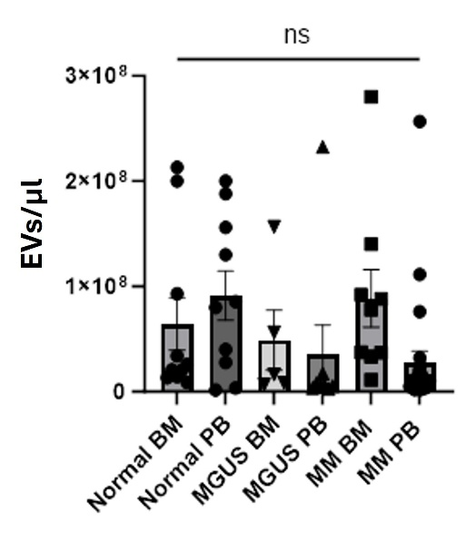
Figure S1 Quantification of EVs using flow cytometry demonstrated similar concentration present in BM and PB samples. Data are presented as mean ± standard error of the mean (SEM). Statistical comparisons were performed using one-way ANOVA; p ≤ 0.05 was considered statistically significant, and “ns” denotes not significant

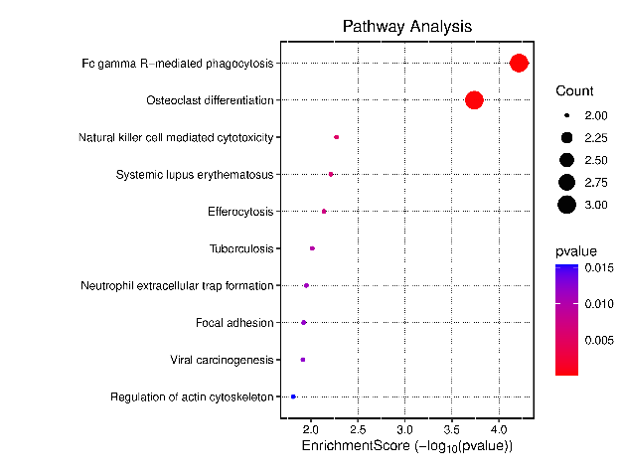
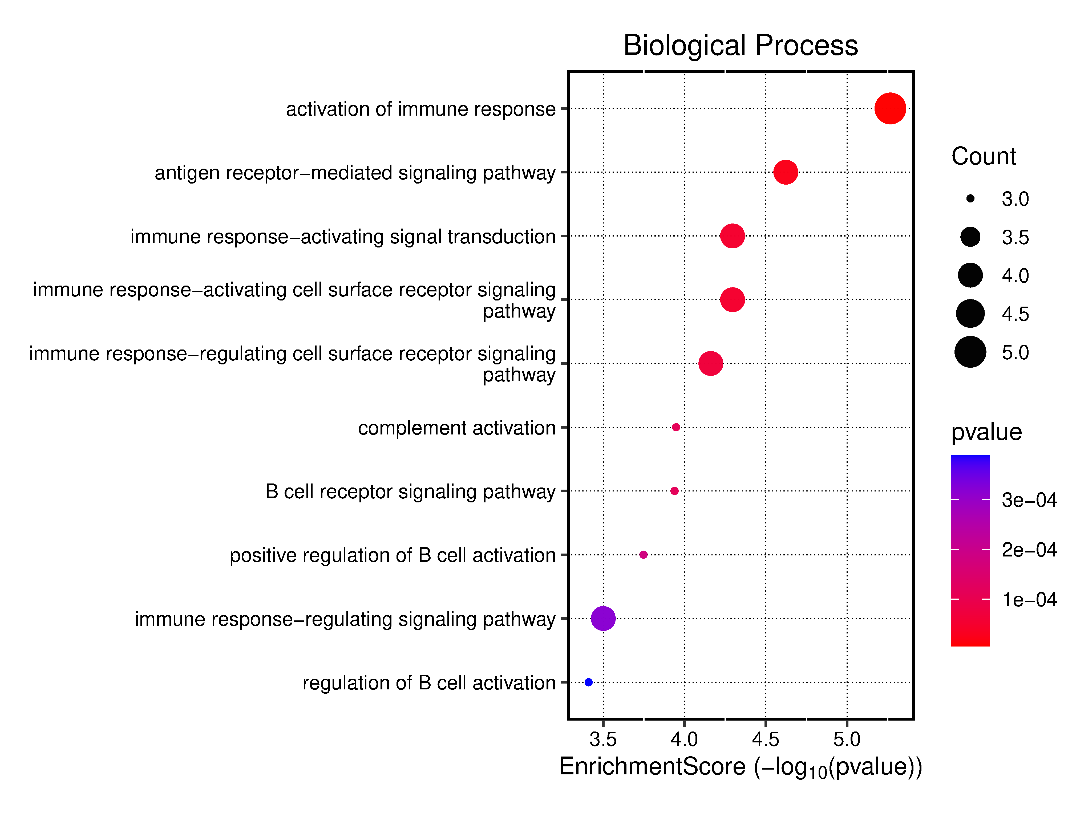
Figure S2 Biological process and pathway enrichment analysis of proteins from MM BM EVs that were significantly altered in abundance (p < 0.05) in active symptomatic MM

 |  |  |  | F1 | Accuracy | Sensitivity | Specificity | PPV | NPV | AUC
General Asymptomatic | C8G, GLIPR2, | Multinomial | Normal | 0.86 | 0.74 | 0.81 | 0.9 | 0.91 | 0.85 | 0.89
/ Symptomatic MM | FGG, ENO1 | Logistic | Asymptomatic | NaN | 0.74 | NaN | 0.88 | NaN | NaN | 0.89
 |  | Regression | Symptomatic | 0.75 | 0.74 | 0.68 | 0.82 | 0.83 | 0.77 | 0.89
Active Symptomatic MM | FGG, ENO1 | Linear SVM |  | 0.84 | 0.88 | 0.93 | 0.85 | 0.76 | 0.96 | 0.98
 |  | Logistic Regression |  | 0.91 | 0.93 | 0.9 | 0.95 | 0.93 | 0.95 | 0.94
 |  | Decision Tree |  | 0.7 | 0.77 | 0.68 | 0.82 | 0.72 | 0.84 | 0.75

Table S3 Performance evaluation of multinomial (logistic regression) and binary (linear SVM, logistic regression, decision tree) MM BM EV classification models.

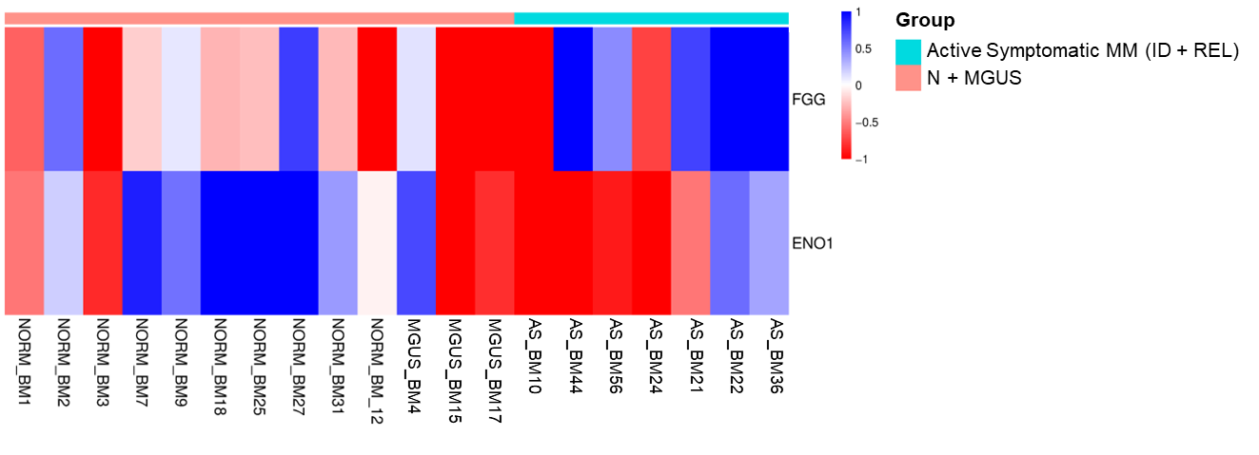
Figure S3 Heatmap of ML–selected protein markers FGG and ENO1 levels in active symptomatic MM samples, compared to their respective controls

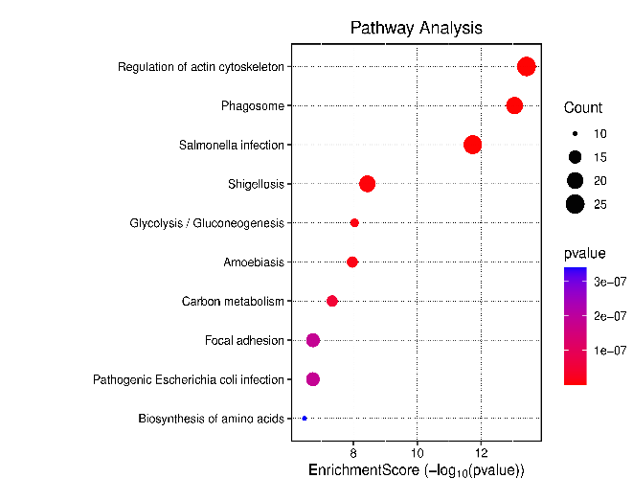
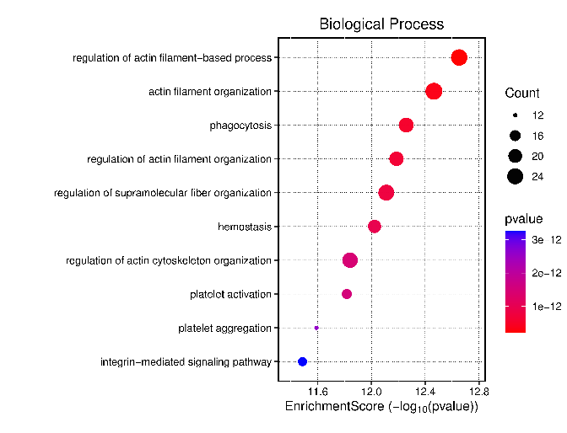
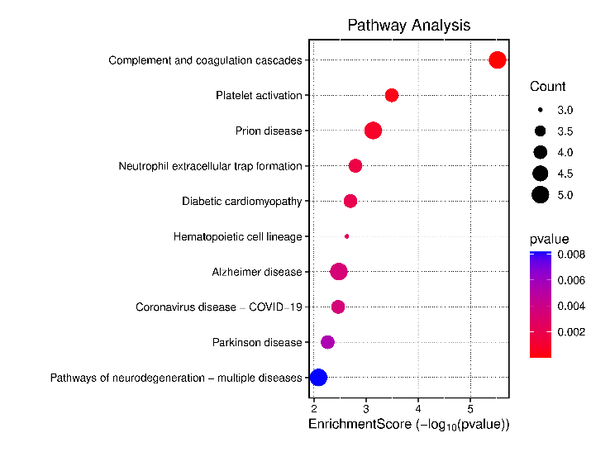
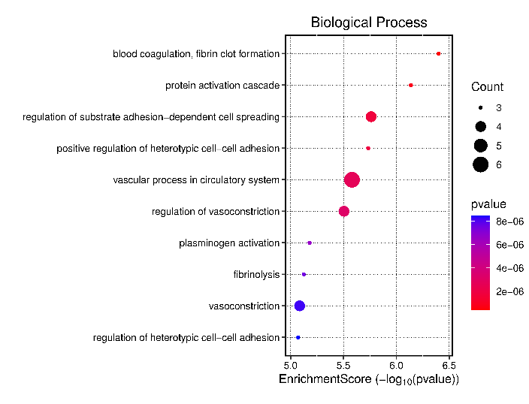
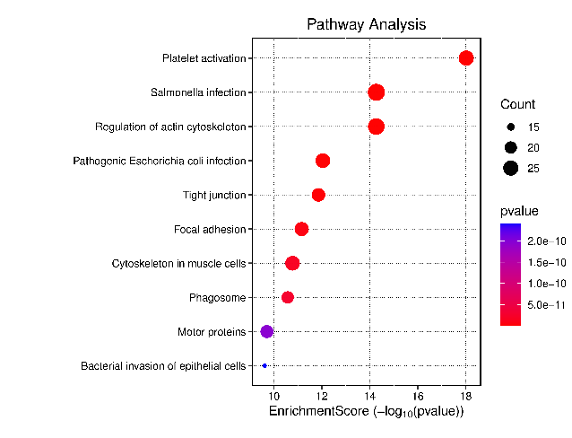
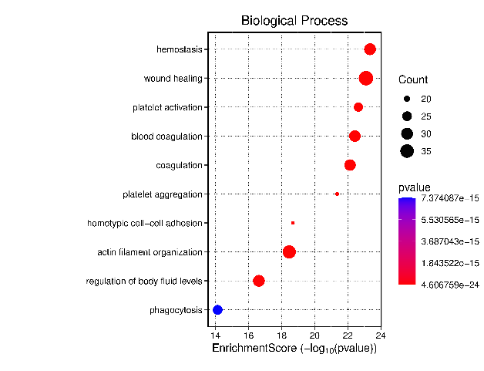
A
B
C
Figure S4 Biological process and pathway enrichment analysis of proteins from MM PB EVs that were significantly altered in abundance (p < 0.05). (A) MGUS, (B) initial diagnosis, and (C) relapse patients.

Table S4 Evaluation of four MM PB EV diagnostic and stratification models. Multinomial (logistic regression) and binary (linear SVM, logistic regression, decision tree) MM PB EV classification models.

 |  |  |  | F1 | Accuracy | Sensitivity | Specificity | PPV | NPV | AUC
General Asymptomatic | ALAD, S100A7, |  | Normal | 0.89 | 0.87 | 0.9 | 0.93 | 0.88 | 0.96 | 0.95
/ Symptomatic MM | APOC1,LGALS1, | Multinomial Logistic Regression | Asymptomatic | 0.84 | 0.87 | 0.84 | 0.96 | 0.84 | 0.98 | 0.95
 | CD226 |  | Symptomatic | 0.9 | 0.87 | 0.86 | 0.9 | 0.94 | 0.86 | 0.95
MGUS | KRT78, APOC1 | Linear SVM |  | 0.91 | 0.93 | 1 | 0.9 | 0.83 | 1 | 0.9
 |  | Logistic Regression |  | 0.96 | 0.96 | 1 | 0.94 | 0.93 | 1 | 0.99
 |  | Decision Tree |  | 0.69 | 0.8 | 0.69 | 0.83 | 0.69 | 0.92 | 0.76
Initial Diagnosis | ALAD, LGALS1 | Linear SVM |  | 0.77 | 0.78 | 0.83 | 0.73 | 0.71 | 0.85 | 0.89
 |  | Logistic Regression |  | 0.85 | 0.85 | 0.81 | 0.89 | 0.89 | 0.88 | 0.91
 |  | Decision Tree |  | 0.71 | 0.73 | 0.72 | 0.75 | 0.71 | 0.81 | 0.73
Relapse | CD226 | Linear SVM |  | 0.92 | 0.9 | 0.92 | 0.88 | 0.92 | 0.88 | 0.93
 |  | Logistic Regression |  | 0.88 | 0.89 | 0.87 | 0.91 | 0.89 | 0.93 | 0.95
 |  | Decision Tree |  | 0.88 | 0.89 | 0.86 | 0.91 | 0.9 | 0.92 | 0.87

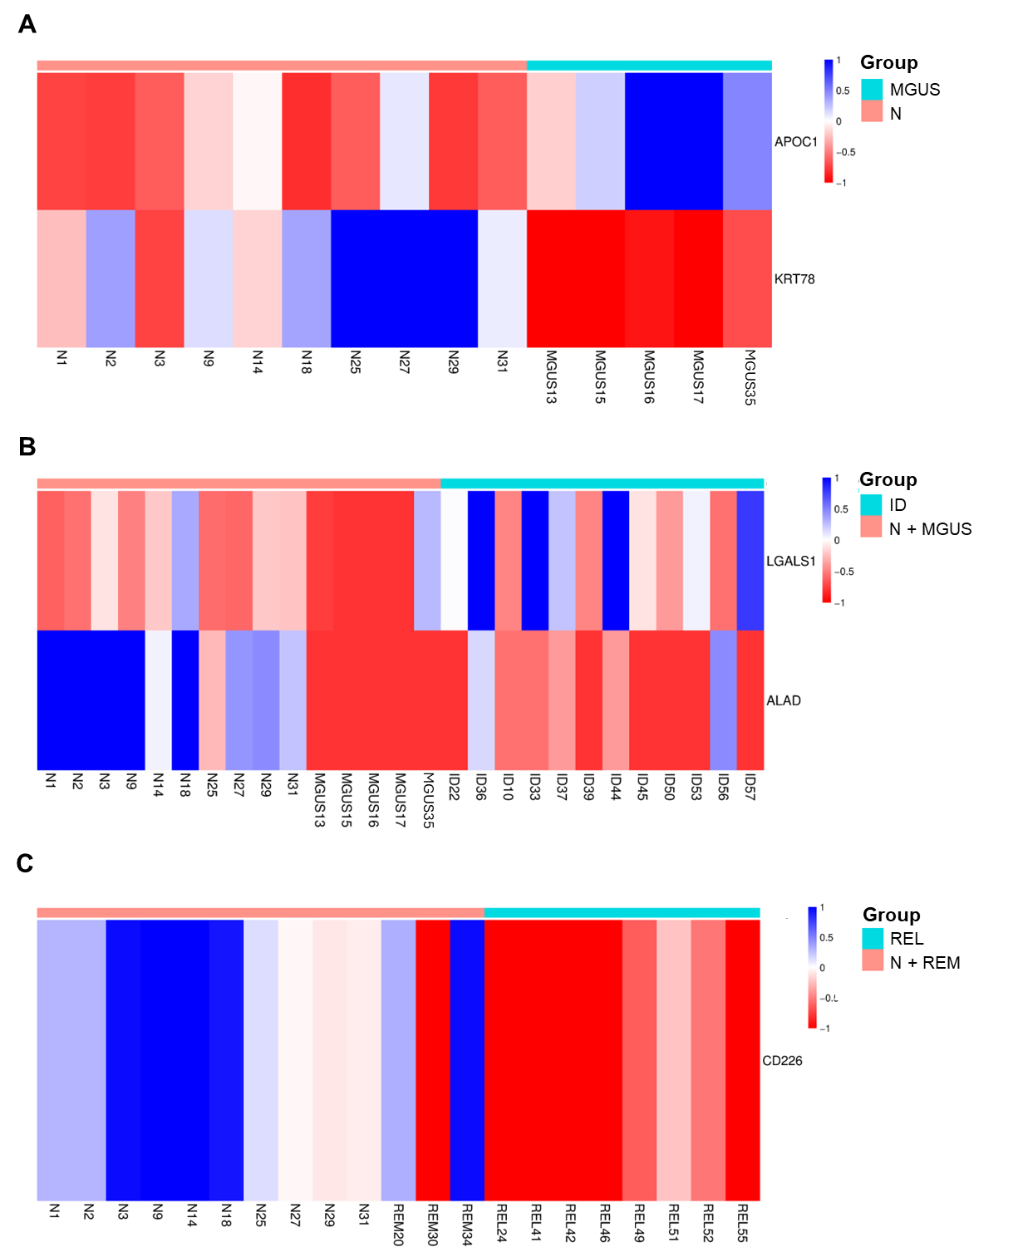
Figure S5 Heatmaps of ML–selected protein markers in MM PB EVs. (A) APOC and KRT78 levels in MGUS samples, (B) ALAD and LGALS1 levels in initial diagnosis, and (C) CD226 levels in relapse, compared to their respective controls.

