Table S1: Baseline characteristics and clinical outcomes of critically ill COPD patients with and without the ROX index
Characteristic | Without ROX index  N = 2,312 | With ROX index  N = 2,176 | P-value
Gender |  |  | <0.001
Male | 1,089 (47.10%) | 1,250 (57.44%)
Female | 1223 (52.90%) | 926 (42.56%)
Age | 72.65 (64.37, 81.54) | 71.55 (63.58, 78.91) | <0.001
BMI | 27.44 (23.14, 33.00) | 28.77 (24.19, 34.40) | 0.002
Race |  |  | <0.001
White | 1,745 (75.48%) | 1,511 (69.44%)
Black | 225 (9.73%) | 178 (8.18%)
Other | 342 (14.79%) | 487 (22.38%)
Admission type |  |  | <0.001
Emergency | 1,574 (68.08%) | 1,602 (73.62%)
Elective | 738 (31.92%) | 574 (26.38%)
SOFA | 3.00 (1.00, 5.00) | 7.00 (4.00, 10.00) | <0.001
SAPSII | 33.00 (27.00, 40.00) | 40.00 (32.00, 49.00) | <0.001
APSIII | 40.00 (30.00, 50.00) | 49.00 (36.00, 67.00) | <0.001
Charlson comorbidity index | 7.00 (6.00, 10.00) | 7.00 (6.00, 9.00) | 0.216
Severe liver disease | 110.00 (4.76%) | 95.00 (4.37%) | 0.524
Malignant cancer | 389.00 (16.83%) | 301.00 (13.83%) | 0.006
Renal disease | 702.00 (30.36%) | 678.00 (31.16%) | 0.611
Myocardial infarct | 536.00 (23.18%) | 587.00 (26.98%) | 0.004
Congestive heart failure | 1,211.00 (52.38%) | 1,078.00 (49.54%) | 0.059
Cerebrovascular disease | 386.00 (16.70%) | 318.00 (14.61%) | 0.057
Diabetes | 865.00 (37.41%) | 829.00 (38.10%) | 0.632
Sepsis | 795.00 (34.39%) | 1,351.00 (62.09%) | <0.001
AECOPD | 513.00 (22.19%) | 558.00 (25.64%) | 0.006
Temperature | 36.80 ± 0.27 | 36.88 ± 0.49 | <0.001
Heart rate | 84.25 (73.56, 95.90) | 83.96 (75.05, 96.20) | 0.415
Respiratory rate | 19.84 ± 3.66 | 20.22 ± 3.73 | <0.001
MBP | 78.38 (71.62, 87.00) | 75.24 (70.39, 81.82) | <0.001
SpO₂ | 95.60 ± 2.05 | 96.13 ± 3.17 | <0.001
PaO₂ | 55.00 (41.00, 84.00) | 99.75 (62.00, 191.00) | <0.001
PaCO₂ | 46.00 (38.50, 56.00) | 47.00 (41.00, 56.00) | 0.003
PH | 7.36 ± 0.07 | 7.34 ± 0.08 | <0.001
PaO₂/FiO₂ | 175.00 (85.25, 268.58) | 190.50 (121.21, 272.00) | 0.326
Glucose | 130.00 (107.50, 166.46) | 135.05 (115.68, 167.90) | <0.001
WBC | 10.15 (7.45, 13.55) | 12.45 (9.20, 16.40) | <0.001
Hemoglobin | 10.15 (8.60, 11.75) | 9.88 (8.55, 11.55) | 0.038
Platelets | 200.50 (149.00, 263.00) | 186.50 (138.00, 251.50) | <0.001
Bicarbonate | 24.39 ± 5.18 | 24.32 ± 5.62 | 0.317
Lactate | 1.60 (1.20, 2.35) | 1.75 (1.30, 2.51) | <0.001
BUN | 21.50 (14.50, 36.50) | 23.00 (15.50, 38.00) | 0.003
Creatinine | 1.00 (0.75, 1.60) | 1.10 (0.75, 1.70) | 0.016
Sodium | 138.50 (135.50, 141.00) | 138.50 (136.00, 141.50) | 0.016
Calcium | 8.60 (8.15, 9.00) | 8.40 (7.95, 8.85) | <0.001
Potassium | 4.25 (3.90, 4.70) | 4.40 (4.00, 4.85) | <0.001
Chloride | 101.00 (97.00, 104.50) | 102.00 (97.50, 105.50) | <0.001
Anion gap | 15.00 (12.50, 17.00) | 14.50 (12.00, 17.00) | <0.001
INR | 1.20 (1.10, 1.50) | 1.30 (1.15, 1.50) | <0.001
PT | 13.25 (11.80, 16.50) | 13.85 (12.30, 16.06) | <0.001
PTT | 30.70 (27.70, 39.09) | 31.30 (27.70, 40.40) | 0.084

Table S2: Results of univariate cox regression analysis for covariates
Variables | HR | 95%CI | P-value
Age | 1.03 | 1.02 - 1.04 | < 0.001
Race (black) | 1.09 | 0.79 - 1.50 | 0.618
Race (other) | 1.47 | 1.21 - 1.79 | < 0.001
Gender (female) | 1.19 | 1.00- 1.42 | 0.047
BMI | 1.00 | 0.99 - 1.01 | 0.384
Admission type (elective) | 0.93 | 0.76 - 1.13 | 0.447
SAPSII | 1.05 | 1.04 - 1.05 | < 0.001
Charlson comorbidity index | 1.17 | 1.13 - 1.20 | < 0.001
Severe liver disease | 2.62 | 1.94 - 3.53 | < 0.001
Renal disease | 1.44 | 1.21 - 1.72 | < 0.001
Congestive heart failure | 1.30 | 1.09 - 1.55 | 0.003
Sepsis | 2.07 | 1.69 - 2.53 | < 0.001
WBC | 1.01 | 1.00 - 1.02 | 0.015
Hemoglobin | 0.90 | 0.87 - 0.95 | < 0.001
Creatinine | 1.21 | 1.15 - 1.26 | < 0.001
Sodium | 1.01 | 0.99 - 1.02 | 0.575
Potassium | 1.29 | 1.14 - 1.46 | < 0.001
PT | 1.03 | 1.02 - 1.04 | < 0.001
Glucose | 1.01 | 1.00 - 1.02 | < 0.001
MBP | 0.98 | 0.97 - 0.99 | < 0.001
Lactate | 1.23 | 1.20 - 1.26 | < 0.001
PH | 0.02 | 0.01 - 0.03 | < 0.001
PaO₂ | 0.98 | 0.97 - 0.99 | < 0.001
PaCO₂ | 1.01 | 1.00 - 1.02 | 0.021
AECOPD | 0.90 | 0.73-1.10 | 0.284

Table S3: VIF values for all variables in the regression equation
Variable | VIF
ROX index | 1.142015
Age | 1.405646
Race | 1.091578
Gender | 1.086889
BMI | 1.061412
Admission type | 1.032034
SAPSII | 1.740859
Charlson comorbidity index | 1.997390
Severe liver disease | 1.181835
Renal disease | 1.955480
Congestive heart failure | 1.243191
Sepsis | 1.145252
WBC | 1.070362
Hemoglobin | 1.234767
Creatinine | 1.777930
Sodium | 1.096901
Potassium | 1.237742
PT | 1.169025
Glucose | 1.093326
MBP | 1.246946
Lactate | 1.490003
PH | 1.726545
PaO₂ | 1.199790
PaCO₂ | 1.521033
AECOPD | 1.158241

Table S4: COX regression results for mortality outcomes among Quartile 2, Quartile 3, and Quartile 4 groups
Outcome | Number (Rate) | Univariate analysis |  | Multivariate analysis*
Outcome | Number (Rate) | HR/OR (95%CI) | P-value | HR/OR (95%CI) | P-value
28-day mortality
Quartile 2 | 119.00 (21.88%) | Reference |  | Reference
Quartile 3 | 103.00 (18.93%) | 0.83 (0.64-1.08) | 0.167 | 0.77 (0.59-1.01) | 0.058
Quartile 4 | 95.00 (17.46%) | 0.76 (0.58-0.99) | 0.049 | 0.74 (0.56-0.98) | 0.035
3-month mortality
Quartile 2 | 158.00 (29.04%) | Reference |  | Reference
Quartile 3 | 156.00 (28.68%) | 0.96 (0.77-1.19) | 0.688 | 0.88 (0.70-1.10) | 0.270
Quartile 4 | 142.00 (26.10%) | 0.86 (0.69-1.08) | 0.202 | 0.80 (0.63-1.01) | 0.056
1-year mortality
Quartile 2 | 222.00 (40.81%) | Reference |  | Reference
Quartile 3 | 233.00 (42.83%) | 1.03 (0.86-1.24) | 0.728 | 0.98 (0.81-1.18) | 0.853
Quartile 4 | 222.00 (40.81%) | 0.97 (0.80-1.17) | 0.735 | 0.91 (0.75-1.10) | 0.313
In-ICU mortality
Quartile 2 | 88.00 (16.18%) | Reference |  | Reference
Quartile 3 | 59.00 (10.85%) | 0.59 (0.42-0.82) | 0.002 | 0.64 (0.46-0.91) | 0.012
Quartile 4 | 48.00 (8.82%) | 0.58 (0.41-0.82) | 0.002 | 0.65 (0.45-0.94) | 0.022
In-hospital mortality
Quartile 2 | 115.00 (21.14%) | Reference |  | Reference
Quartile 3 | 93.00 (17.10%) | 0.74 (0.56-0.98) | 0.032 | 0.67 (0.50-0.88) | 0.005
Quartile 4 | 82.00 (15.07%) | 0.70 (0.52-0.93) | 0.013 | 0.70 (0.52-0.94) | 0.017
Quartile 1: ROX index ≤ 7.79; Quartile 2: 7.79 < ROX index ≤9.72; Quartile 3: 9.72 < ROX index ≤ 12.26; Quartile 4: ROX index > 12.26.
"Number (Rate)" refers to death count and percentage.
∗Adjusted variables included age, race, gender, BMI, admission type, SAPSII, Charlson Comorbidity Index, severe liver disease, renal disease, congestive heart failure, sepsis, WBC, hemoglobin, creatinine, sodium, potassium, PT, glucose, MBP, lactate, PH, PaO2, PaCO2 and AECOPD.

Table S5: COX regression results for mortality outcomes among Quartile 3 and Quartile 4 groups.
Outcome | Number (Rate) | Univariate analysis |  | Multivariate analysis*
Outcome | Number (Rate) | HR/OR/MD (95%CI) | P-value | HR/OR (95%CI) | P-value
28-day mortality
Quartile 3 | 103.00 (18.93%) | Reference |  | Reference
Quartile 4 | 95.00 (17.46%) | 0.92 (0.69-1.21) | 0.547 | 0.96 (0.72-1.28) | 0.766
3-month mortality
Quartile 3 | 156.00 (28.68%) | Reference |  | Reference
Quartile 4 | 142.00 (26.10%) | 0.90 (0.72-1.13) | 0.376 | 0.91 (0.71-1.15) | 0.408
1-year mortality
Quartile 3 | 233.00 (42.83%) | Reference |  | Reference
Quartile 4 | 222.00 (40.81%) | 0.94 (0.78-1.13) | 0.485 | 0.92 (0.76-1.12) | 0.415
In-ICU mortality
Quartile 3 | 59.00 (10.85%) | Reference |  | Reference
Quartile 4 | 48.00 (8.82%) | 0.99 (0.68-1.46) | 0.976 | 1.06 (0.71-1.58) | 0.783
In-hospital mortality
Quartile 3 | 93.00 (17.10%) | Reference |  | Reference
Quartile 4 | 82.00 (15.07%) | 0.94 (0.70-1.26) | 0.671 | 1.07 (0.78-1.45) | 0.683
Quartile 1: ROX index ≤ 7.79; Quartile 2: 7.79 < ROX index ≤9.72; Quartile 3: 9.72 < ROX index ≤ 12.26; Quartile 4: ROX index > 12.26.
"Number (Rate)" refers to death count and percentage.
∗Adjusted variables included age, race, gender, BMI, admission type, SAPSII, Charlson Comorbidity Index, severe liver disease, renal disease, congestive heart failure, sepsis, WBC, hemoglobin, creatinine, sodium, potassium, PT, glucose, MBP, lactate, PH, PaO2, PaCO2 and AECOPD.

Figure S1: Bootstrap analysis of the inflection points for the ROX index.
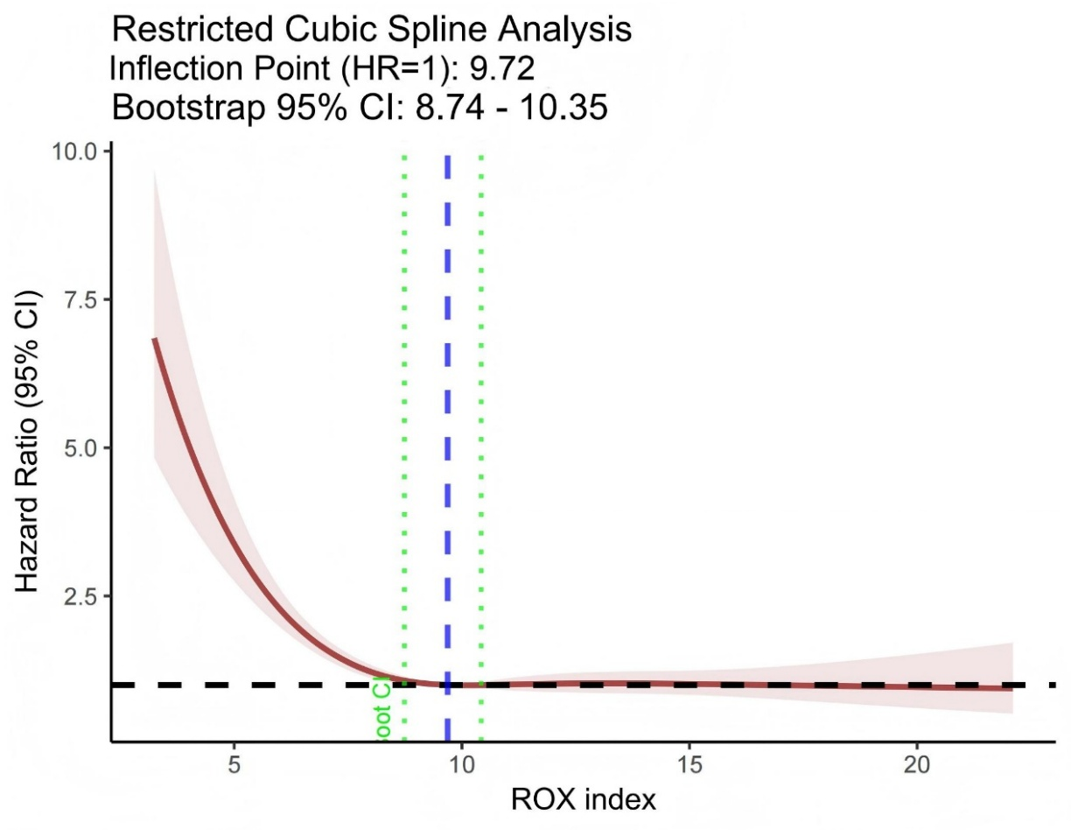
Figure S2: Histogram of the inflection point values for the ROX index derived from bootstrap resamples.
