Supplementary Material
Supplementary Figure 1 Clinical manifestations of jellyfish sting around the mouth
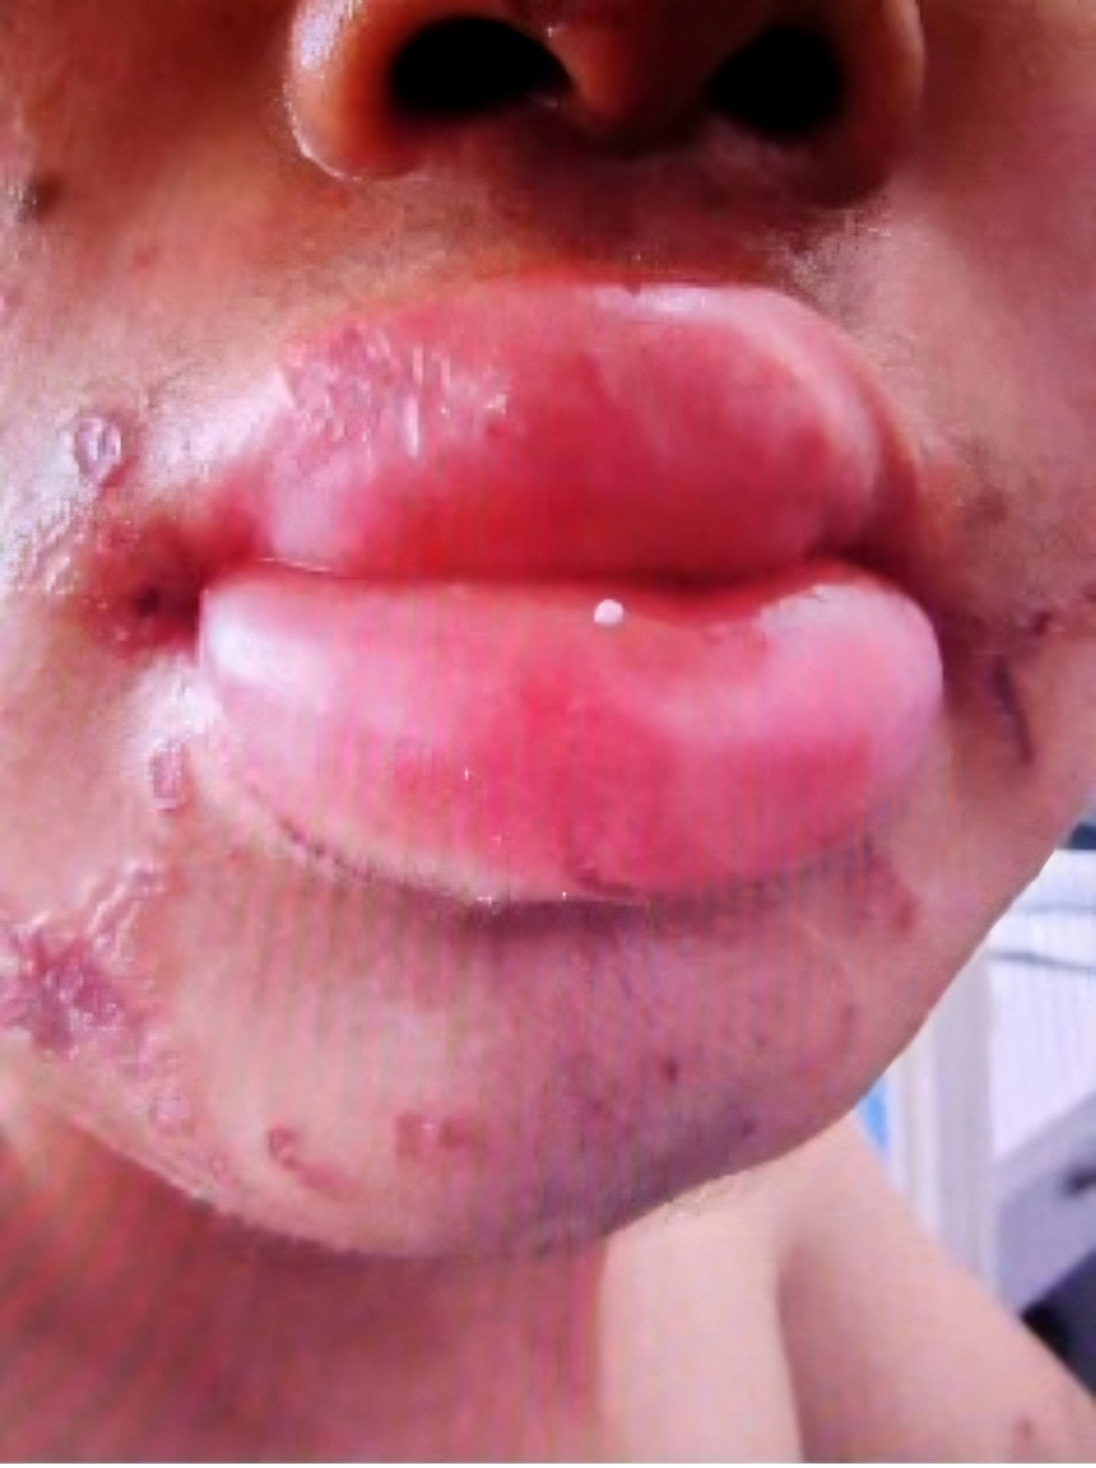

Supplementary Figure 2 Clinical manifestations of jellyfish sting on upper limbs
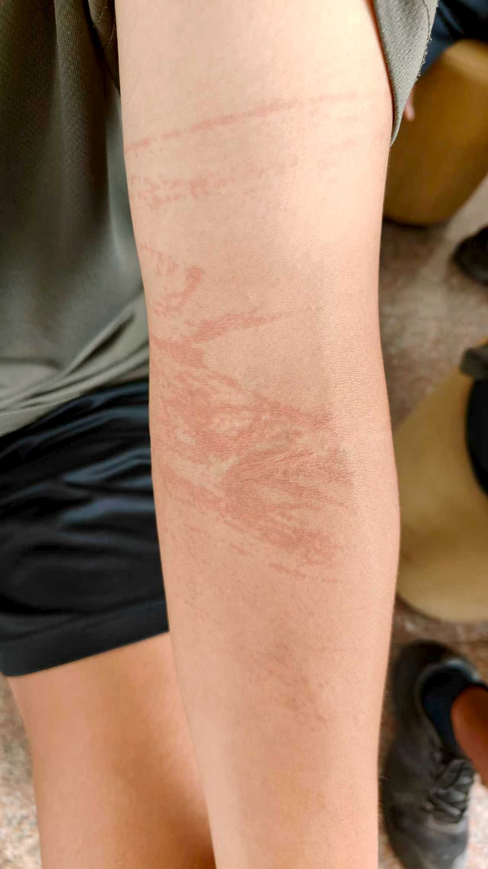

Supplementary Table 1 Time interval from sting occurrence to receiving medical care of patients with and without skin wound infection (min)
 | Patinets without skin wound infection (N=285) | Patinets without skin wound infection (n=285) (N=31) | t | P value
Time interval from sting occurrence to receiving medical care (min) | 39.97±39.77 | 62.90±51.28 | -2.413 | 0.021

