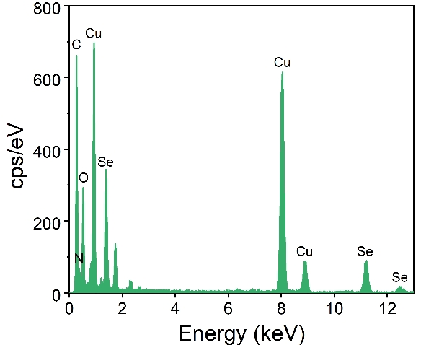
Figure S1 EDX survey spectrum of Cu_{2-x}Se.

A
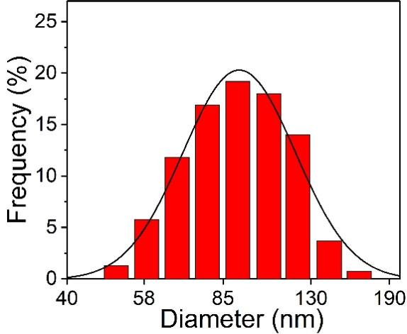
B
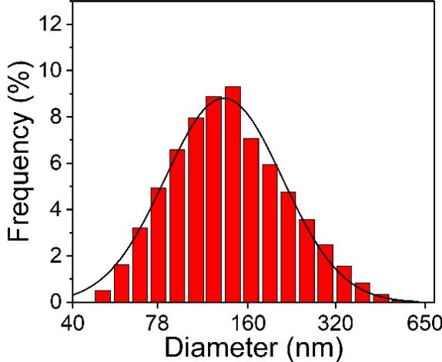
Figure S2 Size distributions of Cu_{2-x}Se nanoparticles (A) and Cu_{2-x}Se/PDA/IR820 nanoparticles (B), with average hydrodynamic diameters of 98.96 ± 0.64 nm and 164.11 ± 1.81 nm, respectively.
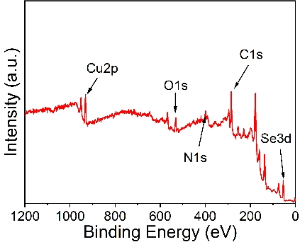
Figure S3 XPS spectrum of Cu_{2-x}Se/PDA/IR820.
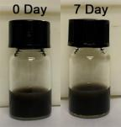
Figure S4 Comparison of the stability images of composite nanoparticles on day 0 and day 7.

A
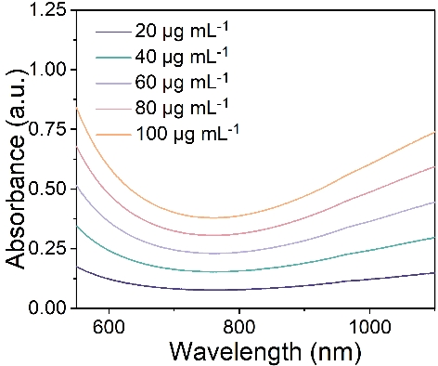
B
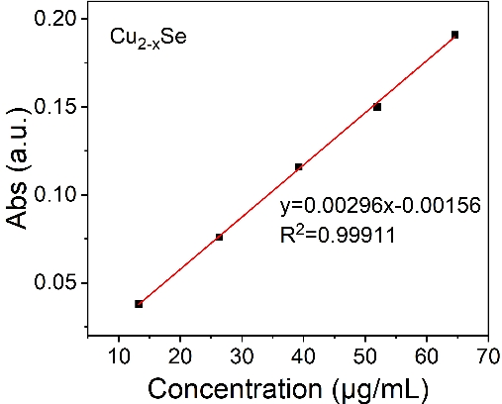

Figure S5 UV absorption curves of different concentrations of Cu_{2-x}Se (A) and absorbance fitting curve at 808 nm (B).

A
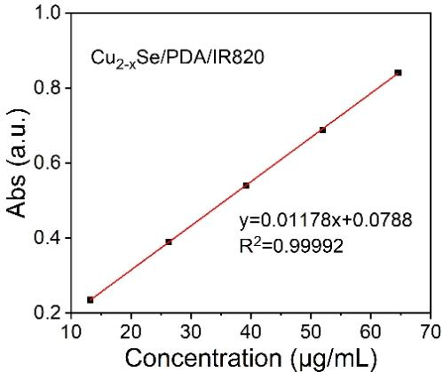
B
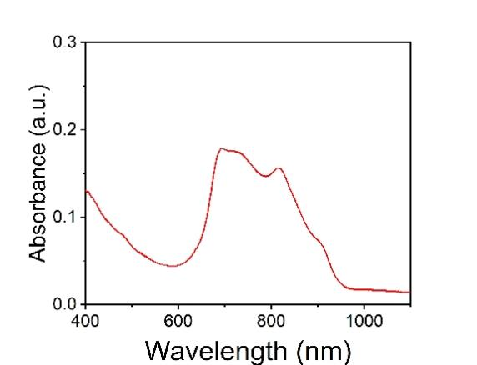
Figure S6 (A) Absorbance fitting curves of Cu_{2-x}Se/PDA/IR820 at different concentrations. (B) UV–vis absorption spectrum of Cu_{2-x}Se/PDA/IR820 composite nanoparticles at 1 mg/mL.

A
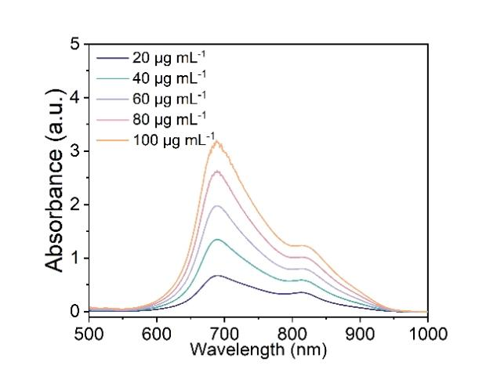
B
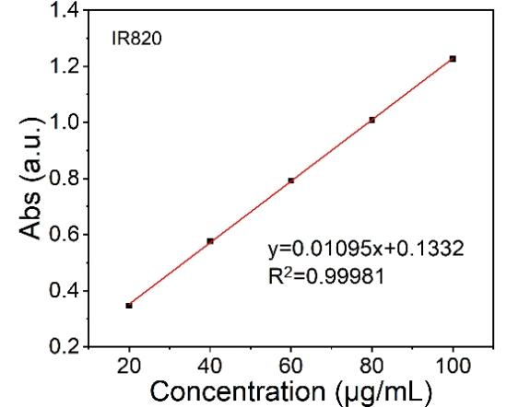
Figure S7 UV–vis absorption spectra of IR820 at different concentrations (A) and the corresponding standard curve (B).

A  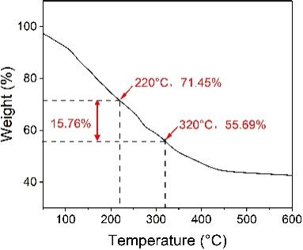 | B 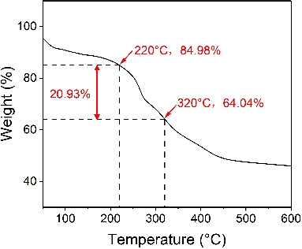 | C 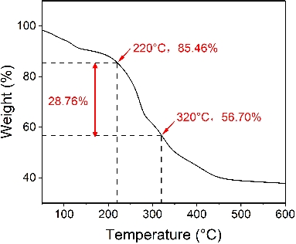
Figure S8 The TGA of Cu_{2-x}Se/PDA/IR820 composite nanoparticles after exposure to simulated tumor microenvironment conditions for 10 min (A), 20 min (B) and 30 min (C).

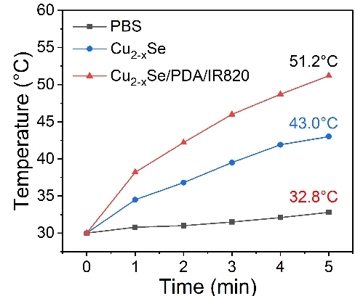
Figure S9 Thermal image-based temperature profiles of PBS, Cu_{2-x}Se, and Cu_{2-x}Se/PDA/IR820 composite nanoparticles.
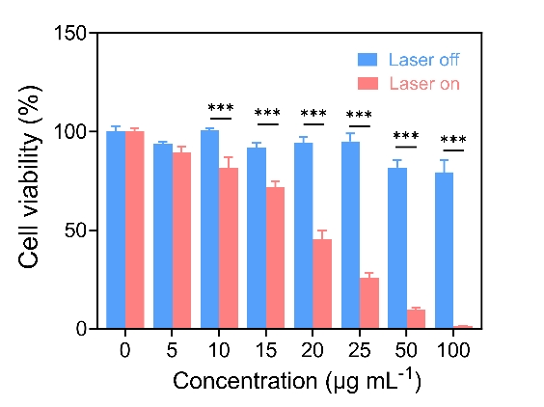
Figure S10 Plot of cell survival after 6 h of co-incubation of KYSE150 with Cu_{2-x}Se/PDA/IR820 in the presence or absence of light. (Data are expressed as mean ± SD, n = 3, ***p < 0.001.)

A  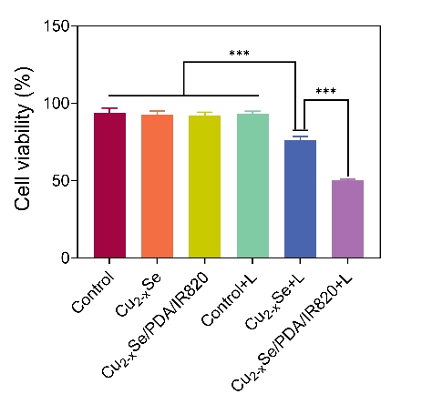 | B  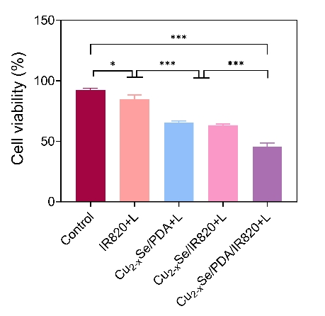
Figure S11 Survival of KYSE150 under different treatment conditions with the same material concentration(A) and additional subgroup control experiments for cytotoxicity assessment (B). (Data are expressed as mean ± SD, n = 3, ***p < 0.001, *p < 0.05.)

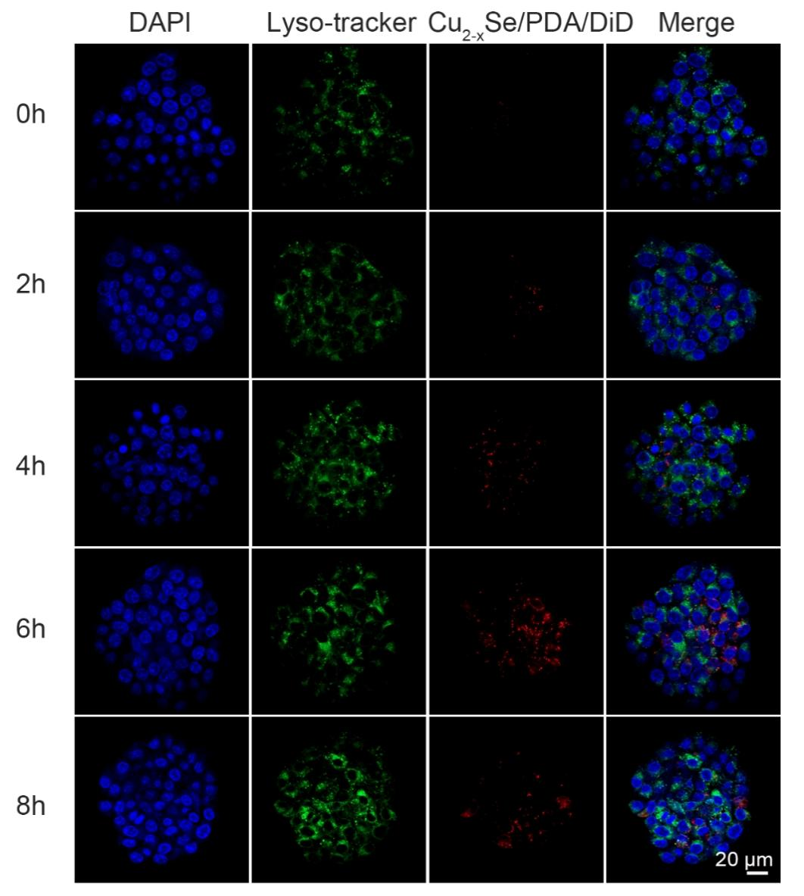
Figure S12 Confocal laser scanning microscopy images showing the time-dependent uptake of the material by HUVEC cells. Scale bar = 20 μm.

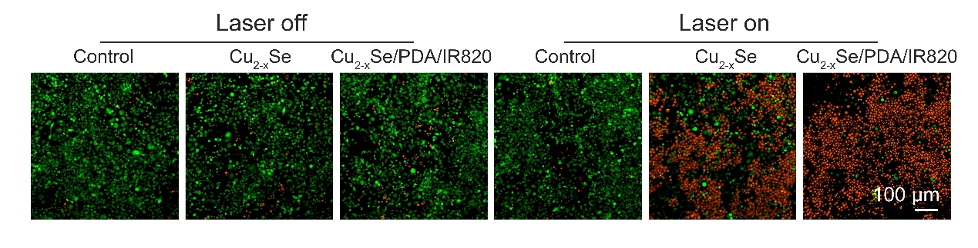
Figure S13 Confocal laser scanning microscopy images of live/dead-stained HUVEC cells. Scale bar = 100 μm.

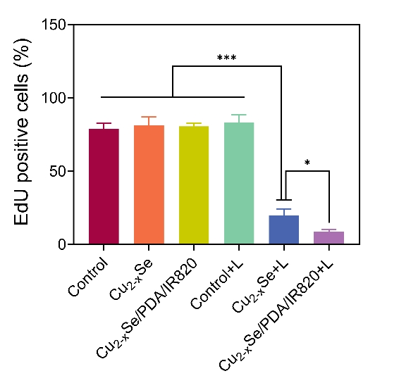
Figure S14 Quantitative graph of EdU proliferation assay of KYSE150 under different treatment conditions. (Data are expressed as mean ± SD, n = 3, ***p < 0.001, *p < 0.05.)

A
B
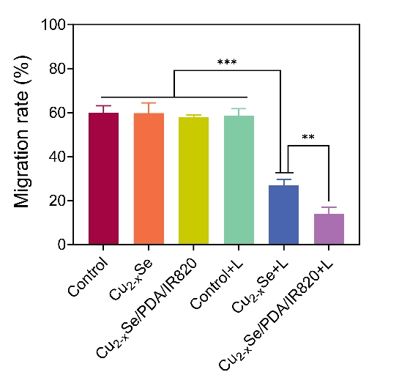
Figure S15 Quantitative analyses of the migration capacity (A) and (B) migration of KYSE150 for 24h after different treatments. The red vertical lines represent the cell boundaries in the wound healing assay. Scale bar = 100 μm. (Data are expressed as mean ± SD, n = 3, ***p < 0.001, **p < 0.01.)
A
B
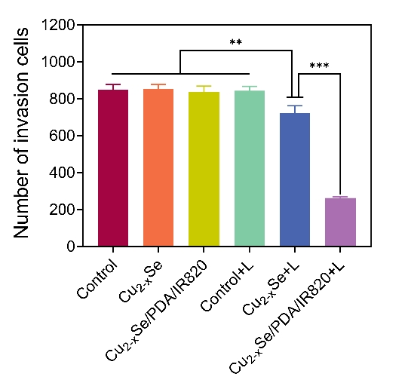
Figure S16 Cell invasion images (A) and (B) quantitative plots of KYSE150 cells under different treatment conditions. Scale bar = 50 μm. (Data are expressed as mean ± SD, n = 3, ***p < 0.001, **p < 0.01.)
A
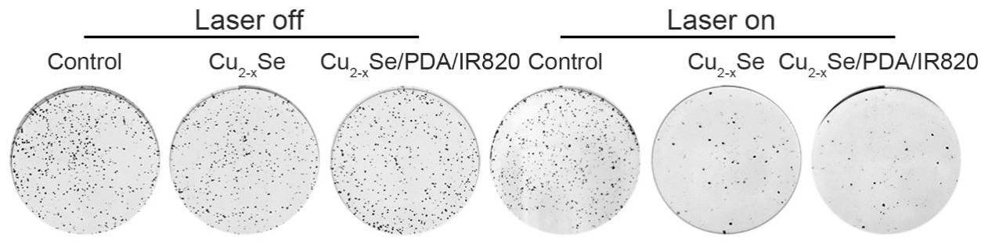
B
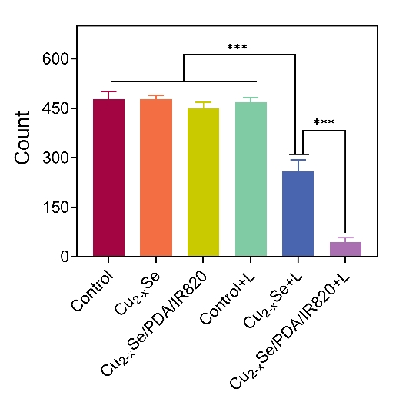
Figure S17 Clone formation of KYSE150 after different treatments (A) and quantitative analysis of the number of clones formed (B). (Data are expressed as mean ± SD, n = 3, ***p < 0.001.)
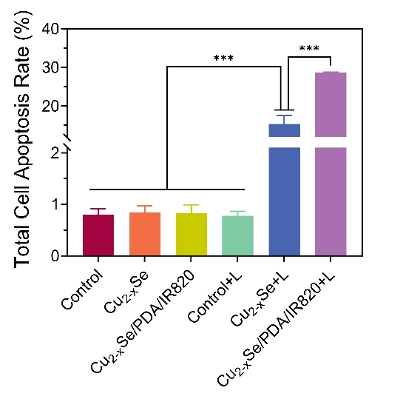
Figure S18 Quantitative flow cytometry analysis of KYSE150 stained with membrane-bound protein V-FITC/PI. (Data are expressed as mean ± SD, n = 3, ***p < 0.001.)

A
B
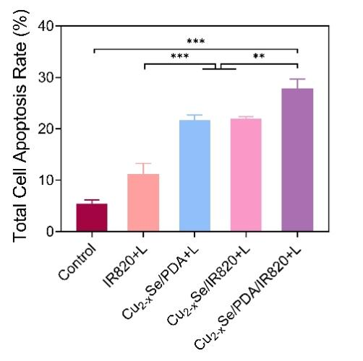
Figure S19 Flow cytometry analysis of cell apoptosis in IR820+L, Cu_{2-x}Se/PDA+L, and Cu_{2-x}Se/IR820+L, Cu_{2-x}Se/PDA/IR820+L treatment groups (A), along with the quantitative analysis of the corresponding results (B). (Data are expressed as mean ± SD, n = 3, ***p < 0.001, **p < 0.01.)

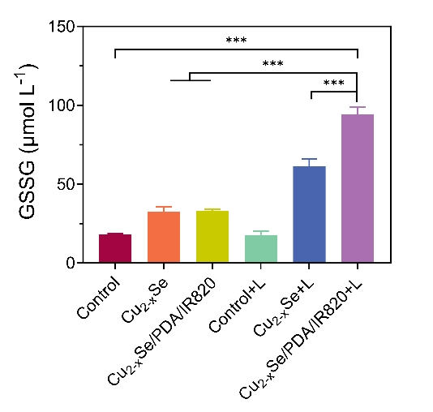
Figure S20 Intracellular GSSG levels in different treatment groups. (Data are expressed as mean ± SD, n = 3, ***p < 0.001.)

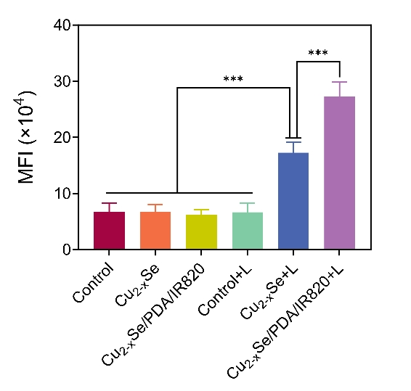
Figure S21 Quantitative analysis results of KYSE150 in ROS flow-through after different treatments. Data are expressed as mean ± SD, n = 3, ***p < 0.001.

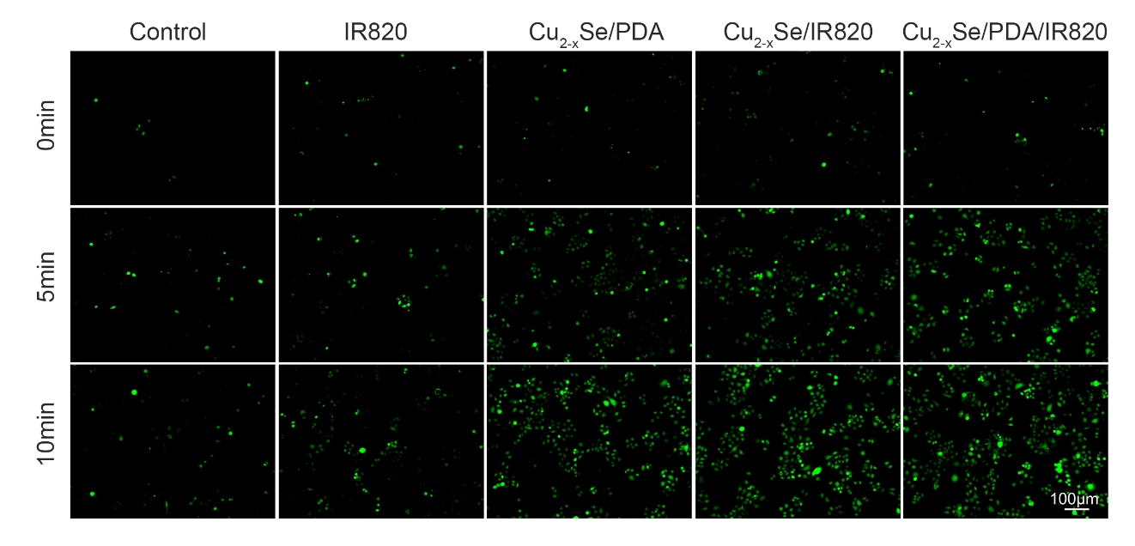
Figure S22 Time-dependent reactive oxygen species (ROS) generation of IR820, Cu_{2-x}Se/PDA, Cu_{2-x}Se/IR820 and Cu_{2-x}Se/PDA/IR820 under 808 nm laser irradiation. Scale bar = 100 μm.

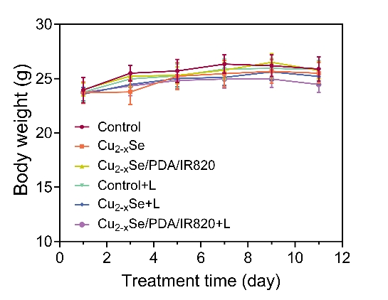
Figure S23 Mean body weights of mice under different treatment conditions. (Data are expressed as mean ± SD, n = 6.)
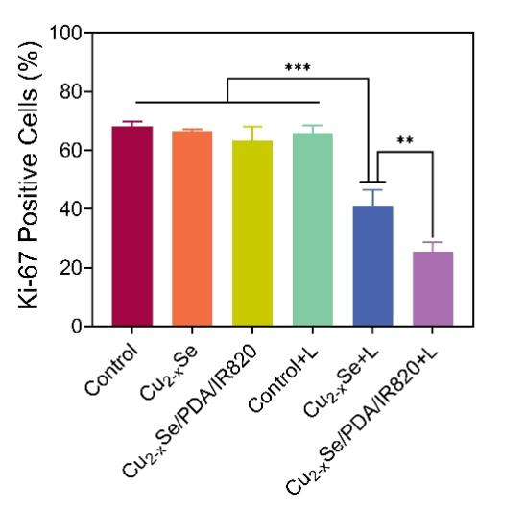
Figure S24 Percentage of Ki-67 positive cells in all cells under different treatment conditions. (Data are expressed as mean ± SD, n = 6, ***p < 0.001, **p < 0.01.)
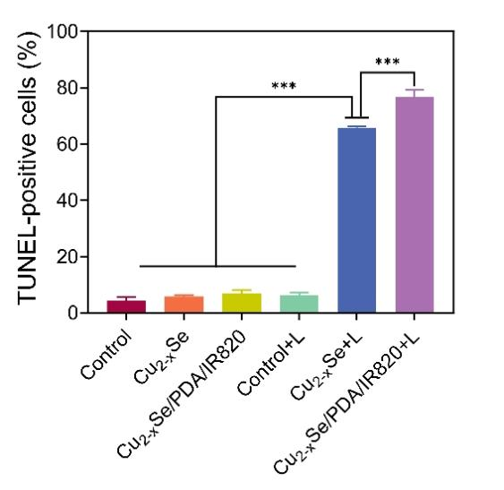
Figure S25 Percentage of TUNEL-positive cells among all cells in different treatment groups. (Data expressed as mean ± SD, n = 6, ***p < 0.001.)

A  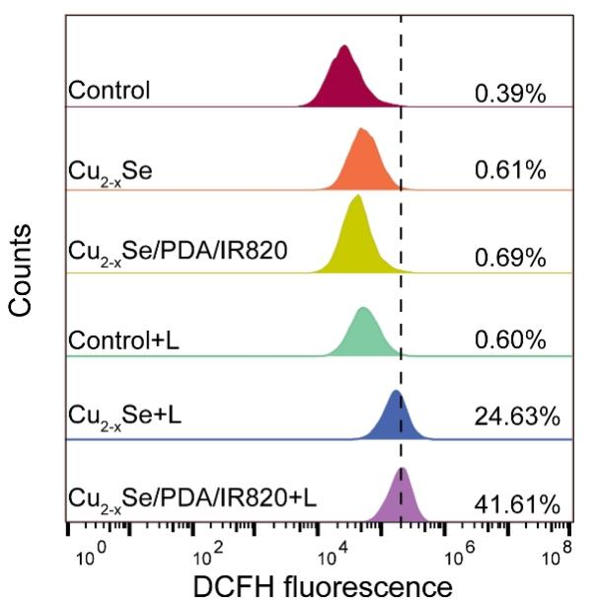 | B  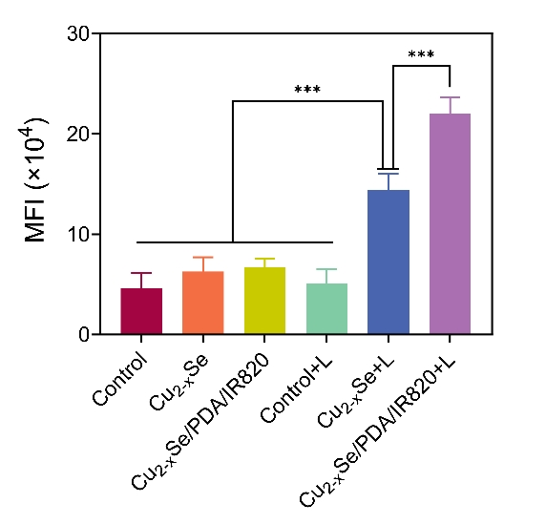
Figure S26 ROS levels in tumor tissues of mice in different treatment groups (A) and the corresponding quantitative analysis (B). (Data are expressed as mean ± SD, n = 6, ***p < 0.001.)

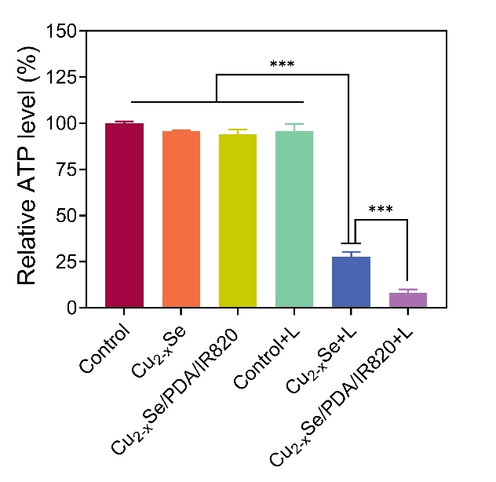
Figure S27 ATP levels in tumor tissues of mice in different treatment groups. (Data are expressed as mean ± SD, n = 6, ***p < 0.001.)

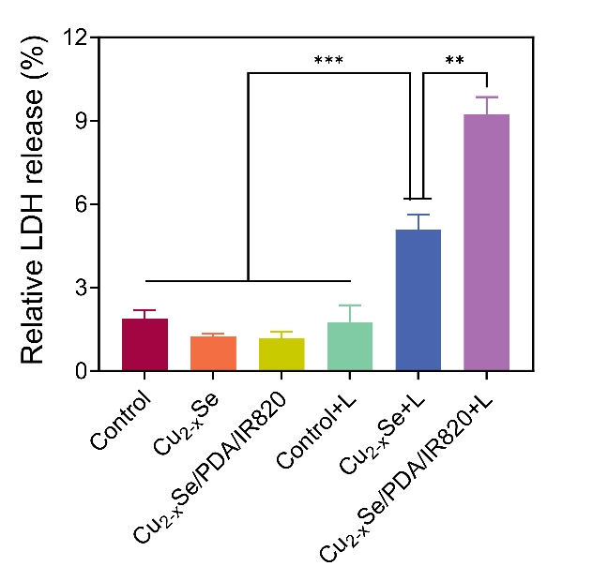
Figure S28 LDH levels in tumor tissues of mice in different treatment groups. (Data are expressed as mean ± SD, n = 6, ***p < 0.001, **p < 0.01.)

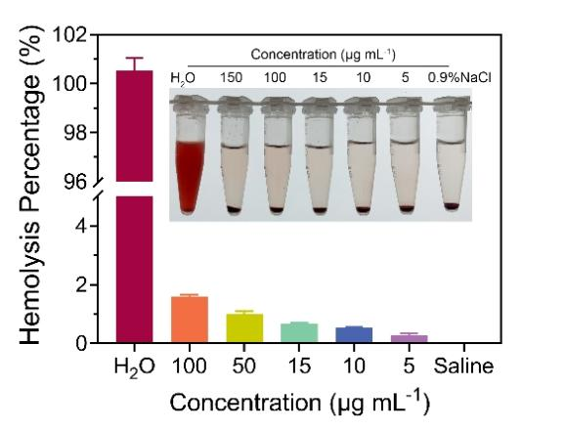
Figure S29 Percentage hemolysis of erythrocytes by different concentrations of Cu_{2-x}Se/PDA/IR820 composite nanoparticles. (Data expressed as mean ± SD, n = 6.)
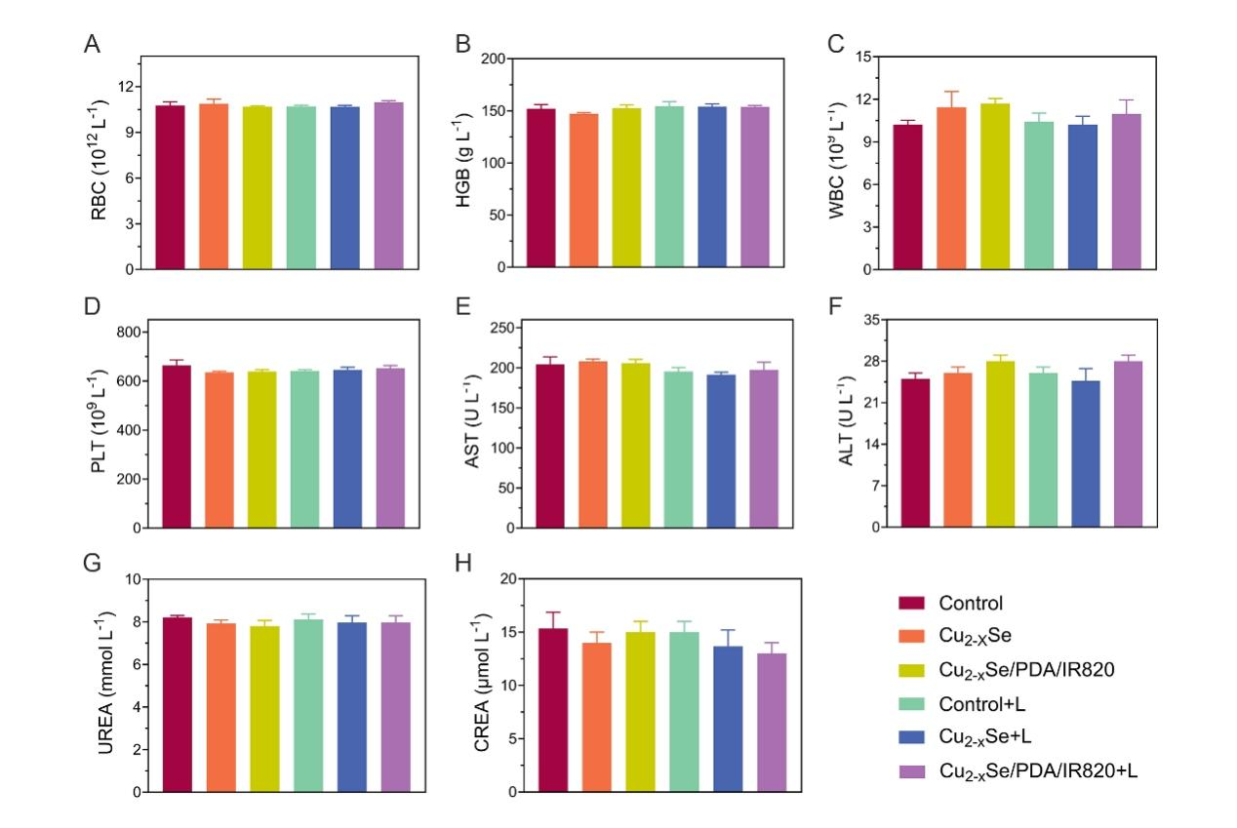
Figure S30 Hematological parameters of male C57 mice after treatment with saline, Cu_{2-x}Se nanoparticles, and Cu_{2-x}Se/PDA/IR820 composite nanoparticles, with or without laser irradiation, including (A) red blood cells (RBC), (B) hemoglobin (HGB), (C) white blood cells (WBCs), and (D) platelets (PLTs). Corresponding blood biochemical indices under different treatment conditions: (E) aspartate aminotransferase (AST), (F) alanine aminotransferase (ALT), (G) urea nitrogen (UREA), and (H) creatinine (CREA). (Data are expressed as mean ± SD, n = 6.)
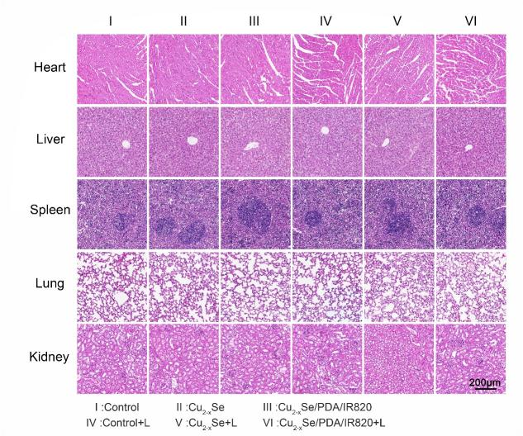
Figure S31 H&E staining results of various organs in male C57 mice under different treatment conditions. Scale bar = 200 μm. (Data are expressed as mean ± SD, n = 6.)

