Supplementary Material
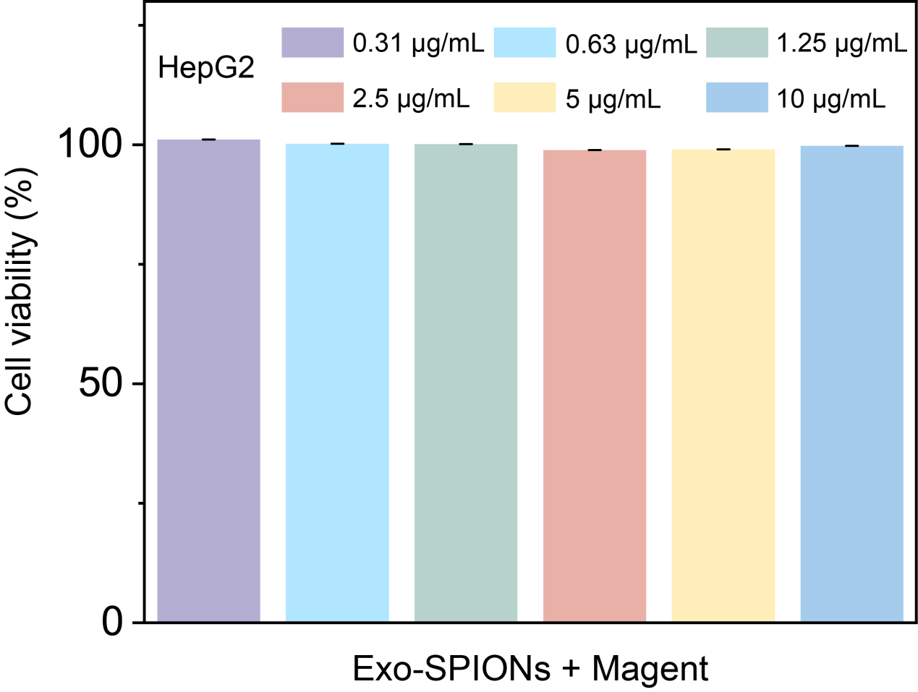
Fig. S1. HepG2 cells were treated with different concentrations of Exo-SPIONs for cell viability detection under magnetic field conditions.
Fig. S2. Biosafety assessment of Exo-SPIONs-SRF/CGA in vivo. Blood biochemical parameters were analyzed in mice after 18-day treatment with PBS, Exo-SPIONs, SRF/CGA, Exo-SPIONs-SRF/CGA, and Exo-SPIONs-SRF/CGA+Magnet.

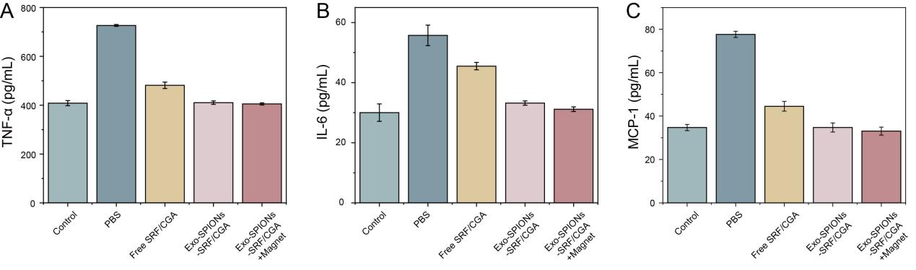
Fig. S3. ELISA measurement of TNF-α, IL-6 and MCP-1 levels in mouse serum. After 18 days of treatment with PBS, Exo-SPIONs, SRF/CGA, Exo-SPIONs-SRF/CGA, and Exo-SPIONs-SRF/CGA + Magnet, TNF-α, IL-6 and MCP-1 levels in mouse serum were analyzed.

