Supplementary Figure 1. Revised forest plot of the relative risk of lung cancer associated with ICS use among individuals with COPD
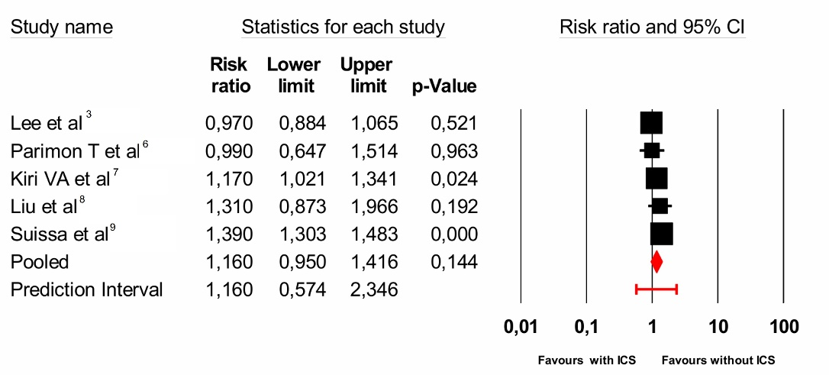
Squares represent individual study relative risk (RR) estimates, with size proportional to study weight.
Horizontal lines indicate 95% confidence intervals.
The red diamond represents the pooled RR estimated using a random-effects model.
The red horizontal bar indicates the 95% prediction interval

Supplementary Figure 2. Forest plot of the risk difference of lung cancer associated with ICS use among individuals with COPD
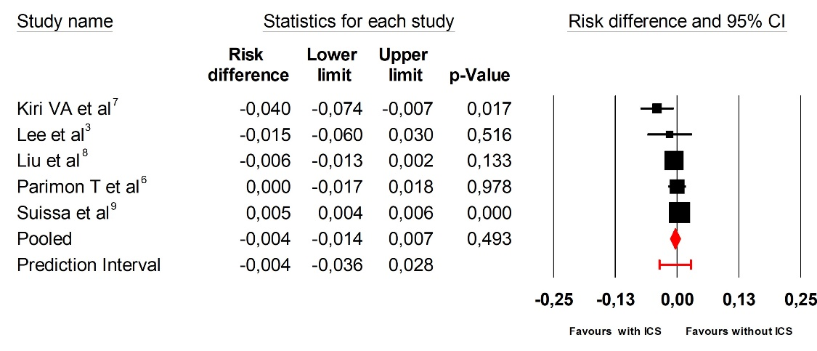
Squares represent individual study risk difference (RD) estimates, with size proportional to study weight.
Horizontal lines indicate 95% confidence intervals.
The red diamond represents the pooled RD estimatedusing a random-effects model.
The red horizontal bar indicates the 95% prediction interval.

All references cited in the supplementary figures are listed and numbered according to the reference list provided in the main manuscript.

