Table S1. 351 genes associated with sialylation retrieved from Genecards database
Gene Symbol | GC Id | Relevance score
FUT7 | GC09M137030 | 17.65198326
SELP | GC01M169558 | 17.0738678
SELE | GC01M169722 | 14.36026192
ST3GAL4 | GC11P126355 | 12.50442886
FUT6 | GC19M005830 | 12.48497391
FUT3 | GC19M104165 | 12.45635414
FUT4 | GC11P104393 | 12.39587593
SELPLG | GC12M108621 | 11.87776089
ST3GAL6 | GC03P098732 | 11.73881912
NEU1 | GC06M031857 | 11.66171169
GNE | GC09M036214 | 10.56637764
SELL | GC01M169690 | 10.36412239
ST6GAL1 | GC03P186930 | 9.002573967
MUC1 | GC01M155185 | 8.42552948
ST6GALNAC1 | GC17M094317 | 8.334094048
ST3GAL1 | GC08M133454 | 7.856826782
SLC35A1 | GC06P087470 | 7.574083805
FUT5 | GC19M005865 | 7.41577816
ST8SIA4 | GC05M100806 | 6.745684624
SLC35A2 | GC0XM048903 | 6.55622673
NEU4 | GC02P242078 | 6.1848979
GCNT1 | GC09P076504 | 6.008908749
TMEM165 | GC04P055395 | 5.859881878
ST6GALNAC6 | GC09M131254 | 5.817185402
ST3GAL3 | GC01P043705 | 5.734291553
ST8SIA3 | GC18P057350 | 5.715121269
NEU2 | GC02P233032 | 5.550958633
POMGNT2 | GC03M043121 | 5.470719337
PLEKHM1 | GC17M093562 | 5.453691483
FUT9 | GC06P096015 | 5.429000378
CHST1 | GC11M045647 | 5.214091301
C1GALT1C1 | GC0XM120625 | 5.18727684
B4GALT1 | GC09M033100 | 5.02628231
B3GALT5 | GC21P039556 | 4.975883007
NEU3 | GC11P103760 | 4.917843819
B4GALNT2 | GC17P144722 | 4.896590233
DPM3 | GC01M155139 | 4.888047218
MAN1B1 | GC09P137086 | 4.881631374
SIGLEC8 | GC19M051450 | 4.785595417
SLC35C1 | GC11P048644 | 4.753277779
SIGLEC1 | GC20M003686 | 4.708815575
ST3GAL2 | GC16M070375 | 4.690661907
ALG1 | GC16P005033 | 4.532412529
ALG6 | GC01P063367 | 4.532412529
DOLK | GC09M128945 | 4.532412529
COG8 | GC16M069320 | 4.521410465
COG1 | GC17P073193 | 4.518251419
MGAT3 | GC22P086945 | 4.468597889
PGM1 | GC01P063593 | 4.430529594
FUT1 | GC19M048748 | 4.377085686
DPM1 | GC20M050934 | 4.362075806
ALG12 | GC22M049859 | 4.362075806
CEACAM5 | GC19P143025 | 4.337996483
COG6 | GC13P039655 | 4.245927334
CHST2 | GC03P143119 | 4.214517593
SPN | GC16P029662 | 4.213160992
ITGB2 | GC21M044885 | 4.207537174
MPI | GC15P074890 | 4.160025597
ALG8 | GC11M136954 | 4.160025597
ALG3 | GC03M184244 | 4.160025597
SRD5A3 | GC04P055346 | 4.160025597
ALG13 | GC0XP111665 | 4.160025597
COG5 | GC07M107201 | 4.052884102
COG7 | GC16M023388 | 4.052884102
CDH1 | GC16P068737 | 3.81491065
ST6GALNAC3 | GC01P076074 | 3.807908297
MUC2 | GC11P001074 | 3.805724859
COG4 | GC16M074198 | 3.800086498
CHST4 | GC16P114188 | 3.719008446
MGAT2 | GC14P049620 | 3.674206257
ST3GAL5 | GC02M085880 | 3.638798714
LGALS8 | GC01P236518 | 3.634653807
EGFR | GC07P055019 | 3.497365952
PMM2 | GC16P008788 | 3.481870174
ITGB1 | GC10M036806 | 3.431519032
B3GNT3 | GC19P017794 | 3.278105736
ITGAM | GC16P113208 | 3.263040781
STT3A | GC11P125592 | 3.261004925
DDOST | GC01M020651 | 3.261004925
MOGS | GC02M074461 | 3.261004925
STT3B | GC03P031532 | 3.261004925
TCN2 | GC22P086685 | 3.261004925
SLC46A1 | GC17M092927 | 3.261004925
DHDDS | GC01P026432 | 3.261004925
MPDU1 | GC17P007583 | 3.261004925
SLC37A4 | GC11M137443 | 3.261004925
SSR4 | GC0XP153793 | 3.261004925
TUSC3 | GC08P015417 | 3.261004925
ALG11 | GC13P052012 | 3.261004925
ALG9 | GC11M137313 | 3.261004925
GMPPA | GC02P219498 | 3.261004925
RFT1 | GC03M054672 | 3.261004925
MAG | GC19P035292 | 3.229329586
TF | GC03P142020 | 3.205416203
MUC5AC | GC11P015759 | 3.191776752
ICAM1 | GC19P142230 | 3.190226078
LGALS1 | GC22P037675 | 3.171303272
ST6GALNAC2 | GC17M076565 | 3.167795897
CHST3 | GC10P071964 | 3.102273703
NME1 | GC17P144771 | 3.091150522
PAEP | GC09P135561 | 3.087498188
ADIPOQ | GC03P186842 | 3.085431337
ST6GALNAC5 | GC01P076867 | 3.064901114
APOE | GC19P143132 | 3.061268091
ITGA4 | GC02P181492 | 3.041239262
PODXL2 | GC03P127629 | 3.013386965
ST8SIA6 | GC10M017315 | 2.99030757
SIGLEC15 | GC18P045825 | 2.942390442
ITGAL | GC16P030472 | 2.901477814
ST8SIA2 | GC15P092393 | 2.900394678
CMAS | GC12P022046 | 2.865514755
GBA3 | GC04P028495 | 2.831070662
CACNA1C | GC12P001970 | 2.76087141
MUC4 | GC03M195746 | 2.699096203
MUC6 | GC11M001012 | 2.699096203
B4GALT4 | GC03M119211 | 2.69833231
EPO | GC07P100720 | 2.689536333
SIGLEC7 | GC19P051142 | 2.668291569
CD59 | GC11M033733 | 2.577344179
ST6GAL2 | GC02M106801 | 2.558844566
VCAM1 | GC01P100719 | 2.533433437
LGALS3 | GC14P055124 | 2.530962467
MAN2A1 | GC05P109689 | 2.512116194
MUC7 | GC04P070430 | 2.434412956
GALNT3 | GC02M165747 | 2.416198492
FUCA1 | GC01M023845 | 2.396097422
ST6GALNAC4 | GC09M127907 | 2.38991785
COLEC12 | GC18M000318 | 2.361622334
C20orf173 | GC20M036703 | 2.356523037
CD22 | GC19P035319 | 2.297525644
B3GNT5 | GC03P183253 | 2.290379763
PTGDS | GC09P150224 | 2.273483992
VWF | GC12M034378 | 2.266891479
HP | GC16P114216 | 2.260865211
SLC26A2 | GC05P157260 | 2.255989075
GMDS | GC06M001624 | 2.225754976
ALG2 | GC09M099216 | 2.222028732
CP | GC03M149162 | 2.211625338
PECAM1 | GC17M064319 | 2.211625338
MGAT5 | GC02P134119 | 2.203922272
CD79A | GC19P041877 | 2.199562788
PIGV | GC01P026787 | 2.193759918
PIGM | GC01M166491 | 2.193759918
TNF | GC06P173080 | 2.156491518
UAP1 | GC01P162561 | 2.134400368
PDPN | GC01P013583 | 2.129942179
CD40LG | GC0XP136649 | 2.111368179
IL1B | GC02M112829 | 2.111368179
MADCAM1 | GC19P141772 | 2.111368179
TLR4 | GC09P117704 | 2.110716105
SLC35D1 | GC01M066999 | 2.086355686
FUT2 | GC19P048695 | 2.07839036
CCR5 | GC03P063059 | 2.054858208
TNR | GC01M175291 | 2.054858208
NANS | GC09P098056 | 2.049573898
LPA | GC06M160531 | 2.039689302
SIGLEC6 | GC19M051517 | 2.038813591
GATA3 | GC10P008045 | 2.035123825
CFH | GC01P196621 | 2.019453764
PMEL | GC12M055954 | 2.005219936
KLRD1 | GC12P010226 | 1.99193573
NCAM1 | GC11P112961 | 1.987823486
PLG | GC06P160702 | 1.979884386
CEACAM1 | GC19M042507 | 1.978917003
SLC2A6 | GC09M133471 | 1.975470185
CGB5 | GC19P049043 | 1.975470185
COG2 | GC01P230642 | 1.946449995
VTN | GC17M092926 | 1.928332686
SLC35A4 | GC05P156977 | 1.922125578
FUT8 | GC14P065356 | 1.905139923
CTSD | GC11M001752 | 1.847663879
SIGLEC5 | GC19M105394 | 1.841590405
DMBT1 | GC10P122560 | 1.827933669
KRT19 | GC17M041523 | 1.820782185
B3GLCT | GC13P031225 | 1.818558097
CD36 | GC07P080369 | 1.807451844
PRG4 | GC01P186296 | 1.788941622
ATP6V0A2 | GC12P123712 | 1.765950203
ACE | GC17P063477 | 1.746813416
B3GNT2 | GC02P062196 | 1.746813416
BDNF-AS | GC11P027466 | 1.731523752
TGFB1 | GC19M041301 | 1.713367105
OSM | GC22M030262 | 1.700127363
ACP3 | GC03P142003 | 1.691639423
GFUS | GC08M147150 | 1.683132887
GAL | GC11P103539 | 1.669476151
TNFRSF1A | GC12M006328 | 1.635125875
CLEC4C | GC12M034472 | 1.61861515
MAN2A2 | GC15P090902 | 1.612933636
CHST6 | GC16M075472 | 1.595225215
IL6 | GC07P022725 | 1.591778398
SERPINA1 | GC14M094376 | 1.591778398
LCAT | GC16M067939 | 1.578451514
TBCK | GC04M106041 | 1.571086526
ST8SIA1 | GC12M022063 | 1.569409847
GYPE | GC04M143870 | 1.56874609
BACE1 | GC11M117285 | 1.544640899
PLCB4 | GC20P009067 | 1.539900303
MLXIPL | GC07M073593 | 1.539900303
PIGY | GC04M088520 | 1.528880954
MGAT1 | GC05M183127 | 1.521448135
SLC35C2 | GC20M046345 | 1.521448135
ERBB2 | GC17P039687 | 1.519297123
CXCL8 | GC04P073740 | 1.519297123
CERNA3 | GC08P056411 | 1.519297123
CD46 | GC01P207752 | 1.509248972
SP1 | GC12P053380 | 1.509248972
PDIA3 | GC15P043746 | 1.509248972
CCR9 | GC03P063047 | 1.509248972
GCNT3 | GC15P059594 | 1.509248972
CD44 | GC11P035139 | 1.505352259
CREBBP | GC16M046544 | 1.475917816
MUC17 | GC07P101020 | 1.475917816
IGHA1 | GC14M123370 | 1.458693027
SCG2 | GC02M223596 | 1.456758142
SLC35B2 | GC06M044254 | 1.456758142
EP300 | GC22P087011 | 1.439049721
HDAC3 | GC05M141620 | 1.439049721
HDAC5 | GC17M044076 | 1.439049721
TBX21 | GC17P047733 | 1.439049721
FCGR1A | GC01P173134 | 1.439049721
B3GNT6 | GC11P077034 | 1.439049721
CD209 | GC19M007739 | 1.423760176
RTN4R | GC22M020241 | 1.397749662
SLC17A5 | GC06M073593 | 1.397749662
MMP2 | GC16P113682 | 1.39720273
CCR7 | GC17M093375 | 1.386934996
TLR2 | GC04P153684 | 1.363121629
SFTPA2 | GC10M084335 | 1.363121629
PTPRC | GC01P198607 | 1.347872019
CD14 | GC05M140631 | 1.34756434
MFAP4 | GC17M019383 | 1.34756434
MUC5B | GC11P015762 | 1.32736218
SERPINA5 | GC14P094850 | 1.307947636
B4GALNT1 | GC12M057623 | 1.306378603
GCNT2 | GC06P010492 | 1.306105733
COL3A1 | GC02P188974 | 1.300582647
ADSL | GC22P040346 | 1.300582647
PDP1 | GC08P093857 | 1.300582647
HMGCL | GC01M023801 | 1.300582647
POMT1 | GC09P131502 | 1.300582647
POFUT1 | GC20P032207 | 1.300582647
KCNC4 | GC01P111557 | 1.300582647
POMT2 | GC14M077274 | 1.300582647
FERMT3 | GC11P103208 | 1.300582647
MLYCD | GC16P083899 | 1.300582647
PGM3 | GC06M103994 | 1.300582647
TACR2 | GC10M069403 | 1.300582647
PDP2 | GC16P113936 | 1.300582647
NMB | GC15M084655 | 1.300582647
APBB1IP | GC10P026448 | 1.300582647
KRT3 | GC12M052789 | 1.300582647
RAPGEF5 | GC07M022128 | 1.300582647
CALCB | GC11P014904 | 1.300582647
POFUT2 | GC21M045263 | 1.300582647
FCSK | GC16P070454 | 1.300582647
PLA2G4E | GC15M041981 | 1.300582647
SLC35B1 | GC17M049700 | 1.300582647
FAHD2A | GC02P098937 | 1.300582647
CCDC85C | GC14M099500 | 1.300582647
SLC35B4 | GC07M134290 | 1.300582647
SLC35D3 | GC06P136922 | 1.300582647
DENND1C | GC19M006467 | 1.300582647
FUOM | GC10M133557 | 1.300582647
SLC35E3 | GC12P068746 | 1.300582647
SLC35D2 | GC09M096313 | 1.300582647
C6orf89 | GC06P173211 | 1.300582647
MIR3187 | GC19P000813 | 1.300582647
MIR4492 | GC11P118910 | 1.300582647
MIR1268B | GC17P080098 | 1.300582647
ITGA3 | GC17P050055 | 1.284014702
LTF | GC03M046435 | 1.284014702
ASGR2 | GC17M007101 | 1.284014702
B4GAT1 | GC11M066345 | 1.284014702
HEG1 | GC03M124965 | 1.284014702
PRNP | GC20P004686 | 1.282874346
ATF2 | GC02M175072 | 1.282874346
CD80 | GC03M119524 | 1.282874346
CCL3 | GC17M036088 | 1.282874346
CSF3 | GC17P040015 | 1.282874346
KLRC1 | GC12M034550 | 1.282874346
PTAFR | GC01M028147 | 1.282874346
SLC2A1 | GC01M042925 | 1.271636248
RAC1 | GC07P017475 | 1.271636248
BDKRB2 | GC14P096205 | 1.271636248
C1GALT1 | GC07P007156 | 1.260982513
F8 | GC0XM154835 | 1.236877203
ITGA2 | GC05P052989 | 1.236877203
UMOD | GC16M047825 | 1.236877203
CAT | GC11P034460 | 1.211533546
CLU | GC08M027596 | 1.211533546
LINC02605 | GC08P078838 | 1.211533546
APP | GC21M025880 | 1.18473804
PTK2 | GC08M140657 | 1.18473804
TSHR | GC14P080954 | 1.18473804
MIR146B | GC10P102436 | 1.156208515
ENO2 | GC12P006913 | 1.133100033
CLEC12A | GC12P009951 | 1.126977205
F2 | GC11P048666 | 1.125557303
MBL2 | GC10M052760 | 1.125557303
SCN4A | GC17M063938 | 1.125557303
AHSG | GC03P186696 | 1.125557303
FUT11 | GC10P073772 | 1.125557303
GAL3ST2 | GC02P242081 | 1.125557303
MIR26B | GC02P218402 | 1.125557303
MIR26A1 | GC03P037969 | 1.125557303
ATP6AP1 | GC0XP154428 | 1.119886398
FN1 | GC02M215360 | 1.116219521
KLRK1 | GC12M034546 | 1.105720758
FAS | GC10P120086 | 1.092226028
CTCF | GC16P114003 | 1.092226028
APOH | GC17M066212 | 1.092226028
CD9 | GC12P068233 | 1.092226028
PI4K2A | GC10P097640 | 1.092226028
CHGA | GC14P094540 | 1.092226028
GYPA | GC04M144109 | 1.092226028
FCAR | GC19P143555 | 1.092226028
GOLPH3 | GC05M032124 | 1.092226028
CLEC4A | GC12P068319 | 1.092226028
SIGLEC9 | GC19P143376 | 1.092226028
FGFR1 | GC08M038400 | 1.055358052
KDR | GC04M055078 | 1.055358052
NRP1 | GC10M033177 | 1.055358052
PROM1 | GC04M015965 | 1.055358052
ICAM2 | GC17M064002 | 1.055358052
PTX3 | GC03P157436 | 1.055358052
RNASE3 | GC14P020891 | 1.055358052
LGALS9 | GC17P027629 | 1.055358052
PILRA | GC07P100367 | 1.055358052
MUC3A | GC07P100949 | 1.055358052
HOTAIR | GC12M053962 | 1.055358052
MIR214 | GC01M172234 | 1.055358052
MIR193B | GC16P112531 | 1.055358052
HNF1A | GC12P120978 | 1.05077076
CFHR1 | GC01P196822 | 1.05077076
NPC2 | GC14M074476 | 1.049352646
F11 | GC04P186424 | 1.045934558
CD248 | GC11M066314 | 1.045934558
AFM | GC04P073481 | 1.045934558
AKT1 | GC14M104769 | 1.013792515
ERBB3 | GC12P069869 | 1.013510942
NOTCH1 | GC09M139117 | 1.013510942
ACE2 | GC0XM015494 | 1.013510942
FCGR2B | GC01P174147 | 1.013510942
LRP1 | GC12P057128 | 1.013510942
VCAN | GC05P083471 | 1.013510942
CADM1 | GC11M115169 | 1.013510942
GYPC | GC02P151295 | 1.013510942
LYVE1 | GC11M014342 | 1.013510942
MEG3 | GC14P120211 | 1.013510942
F2RL1 | GC05P076818 | 1.004087448

Table S2. Oligonucleotide sequences of the siRNAs used in the study.
Name | Sequence (5′-3′)
ST3GAL4-1 | Sense: 5′-GGAGAUUGCAGCUGACAAATT-3′
 | Antisense: 5′-UUUGUCAGCUGCAAUCUCCTT-3′
ST3GAL4-2 | Sense: 5′-GGGAAGACAGGUACAUCGATT-3′
 | Antisense: 5′-UCGAUGUACCUGUCUUCCCTT-3′
siRNA-NC | Sense: 5′-UUCUCCGAACGUGUCACGUTT-3′
 | Antisense: 5′-ACGUGACACGUUCGGAGAATT-3′
siRNA, small interfering RNA; NC, negative control.

Table S3. The primary antibodies used in this study
Antibody name | Vendor | Catalog number, | Dilution ratio
ST3GAL4 | Sabbiotech | #38813 | 1:1000
β-Tubulin | Proteintech | No. 10094-1-AP | 1:3000

Figure S1

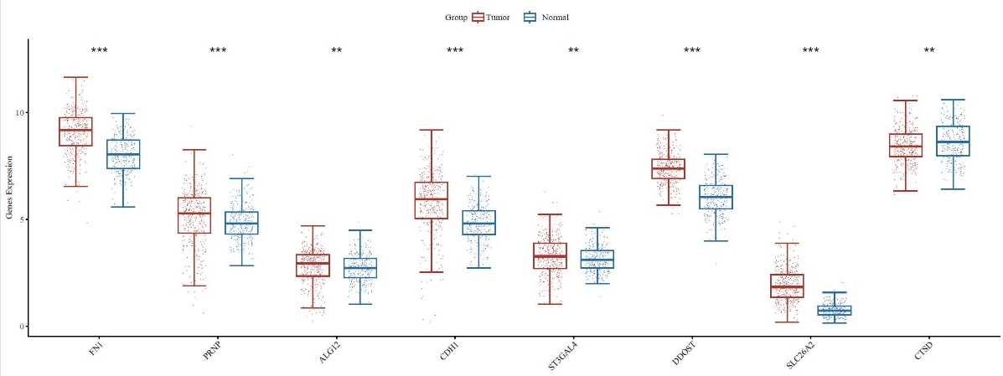
A

B C
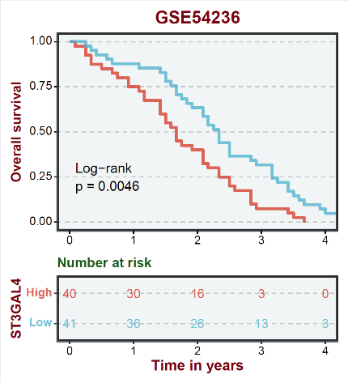
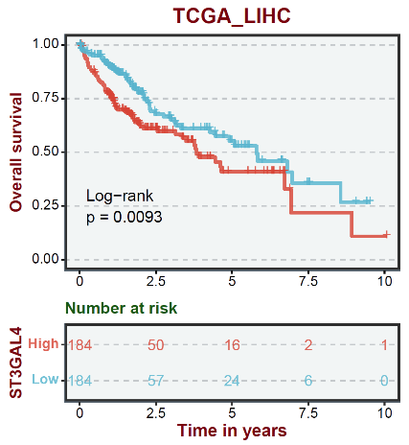

Figure S1 (A) Expression levels of 8 sialylation prognostic model genes in HCC and normal controls. (B) Overall survival was determined on the basis of ST3GAL4 expression in patients with clinically diagnosed HCC using the GSE54236 database. (C）Overall survival was determined on the basis of ST3GAL4 expression in patients with clinically diagnosed HCC using the TCGA_LIHC database. *p < 0.05, **p < 0.01, ***p < 0.001.

