Supplementary Materials
Supplementary Figure 1. The social accountability questionnaire.
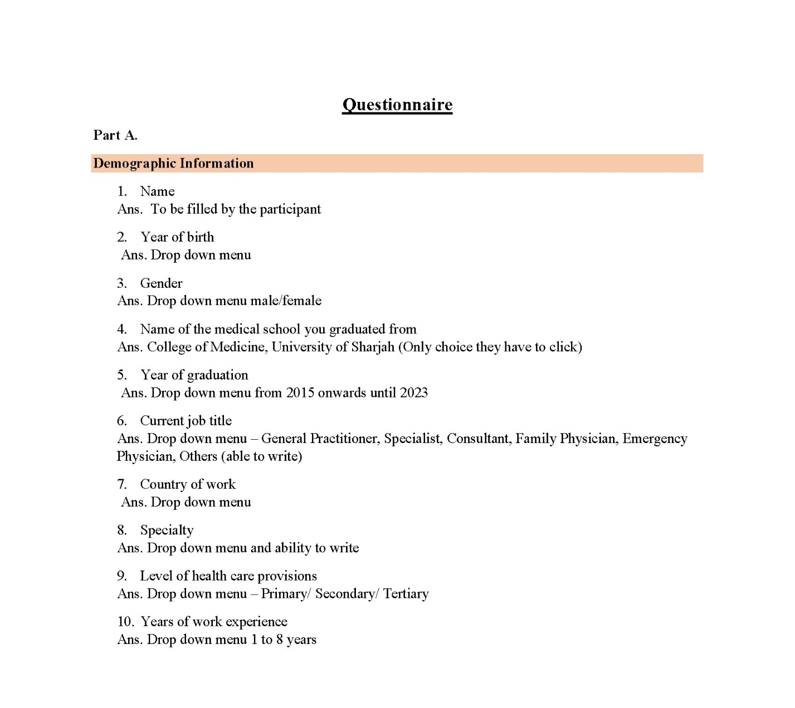

Supplementary Table 1. List of PBL cases used in undergraduate education in the college of medicine at University of Sharjah.
Year 1
Unit Name | PBL Case Title | Topic/Theme
Life Cycle | - A journey in the womb | Pregnancy
Life Cycle | - Road map to health | Infancy and childhood
Life Cycle | - It is all in the genes | Inborn error of metabolism
Life Cycle | - A child with Down syndrome | Chromosomal abnormality
Life Cycle | - Slippery path | Adolescence/drug use and abuse
Life Cycle | - The twilight years | Old age and health issues
Man, and his Environment | - Nadia burns her hand | Acute inflammation and healing
Man, and his Environment | - An unimmunized child | Immunity and immunization
Man, and his Environment | - A viral infection | Virus / Microbes
Man, and his Environment | - Ahmed’s frequent infections | Immunodeficiency and infections
Man, and his Environment | - Pesticide poisoning caused toddler’s death | Acute poisoning/ toxicology
Man, and his Environment | - A smoker with a chronic cough | Introduction to neoplasia/cancer
Musculoskeletal system | - Shoulder pain in an adult | Anatomy of joints
Musculoskeletal system | - Fracture of arm in a 62-year-old woman | Bone fracture
Musculoskeletal system | - 70-year-old woman with skin rash | Peripheral neuropathy
Musculoskeletal system | - Multiple painful swollen joints | Rheumatoid arthritis
Musculoskeletal system | - Taxi driver with back pain | Sciatica
Musculoskeletal system | - A woman with pain in bones and joints | Metabolic bone disorder/osteoporosis
Musculoskeletal system | - Boy with pain and swelling in his right thigh | Bone tumors
Musculoskeletal system | - Chronic pain in her left knee | Osteoarthritis
Musculoskeletal system | - Muscle weakness in a 5-year-old boy | Muscle diseases & Gene therapy
Hematopoietic system | - I always feel tired | Anemia/Hemoglobinopathies
Hematopoietic system | - Palpable spleen | Leukemia/WBC disorders
Hematopoietic system | - Rash in a kindergarten teacher | Platelet disorders
Year 2
Cardiovascular and respiratory system | - Yellow spots below the eyes | Hypertension/hyperlipidemia
Cardiovascular and respiratory system | - Fainting while gardening | Valvular heart diseases
Cardiovascular and respiratory system | - A 70-year-old man collapses while standing | Arrythmias
Cardiovascular and respiratory system | - Heart attack | Myocardial infarction
Cardiovascular and respiratory system | - Swollen fits | Congestive heart failure
Cardiovascular and respiratory system | - Anna’s out of breath | Obstructive lung diseases
Cardiovascular and respiratory system | - A snoring patient | Obstructive Sleep Apnea
Cardiovascular and respiratory system | - Faisal has fever and cough | Respiratory tract infections/pneumonia
Cardiovascular and respiratory system | - Blood in her sputum | Lung cancer
Endocrine system | - Falling behind in growth | Hormonal abnormalities/growth hormone
Endocrine system | - Losing weight | Thyroid diseases
Endocrine system | - No more diets | Cushing’s syndrome
Gastrointestinal system | - Heart burn | Peptic ulcer/GERD
Gastrointestinal system | - A lot of fuss | Celiac disease
Gastrointestinal system | - I always feel tired and fatigued | Colorectal cancer/GI neoplasms
Gastrointestinal system | - Unhealthy eating habits | Obesity/Metabolic syndrome
Gastrointestinal system | - Yellow eyes | Hepatitis/Liver disorders
Gastrointestinal system | - Acute Abdomen | Pancreatitis
Renal and Reproductive | - Diabetic with acute swelling of hands and feet | Diabetic nephropathy/Nephrotic syndrome
Renal and Reproductive | - Ismail with RTA and shock | Acute renal failure/ Hypovolemia
Renal and Reproductive | - Blood in my urine | Bladder cancer
Renal and Reproductive | - Unable to pass urine | Prostate hypertrophy and prostatic diseases
Renal and Reproductive | - Two years & no baby | Infertility
Renal and Reproductive | - Bleeding after menopause | Cervical cancer
Year 3
Neurosciences | - Walking with difficulty | Syringomyelia/ Spinal cord lesions
Neurosciences | - A child with stiff neck | CNS infections/Meningitis
Neurosciences | - Head injury | Head injury
Neurosciences | - Recurrent seizures | Epilepsy
Neurosciences | - Sudden onset of weakness | Stroke/Cardiovascular accidents
Neurosciences | - Ahmed has tremors | Parkinson's disease
Neurosciences | - Salem does not remember | Alzheimer’s disease
Neurosciences | - Headaches | Brain tumors
Special senses and neuropsychiatry | - Blurred vision | Refractive errors of eye
Special senses and neuropsychiatry | - Hard hearing | Hearing impairment/ASOM and CSOM
Special senses and neuropsychiatry | - A Change in Mood | Depression
Special senses and neuropsychiatry | - Nasser has enemies | Schizophrenic disorders
Multisystem unit | - A 27-year-old woman with vaginal discharge | Sexually transmitted infections and reproductive health
Multisystem unit | - A 35-year-old man with fever and cough | Tuberculosis and chronic pulmonary infections
Multisystem unit | - Fever in a returning traveler | Malaria and other blood protozoa
Multisystem unit | - A 20-year-old woman with an ulcer | Skin disorders (benign and malignant)
Multisystem unit | - A 36-year-old lady with a lump in the breast | Breast tumors
Multisystem unit | - Fatima was brought confused | Diabetes
Multisystem unit | - A 63-year-old smoker with leg pain | Peripheral vascular diseases
Multisystem unit | - Salma with facial rash | Systemic lupus erythematous
Multisystem unit | - A 62-year-old man with neck swelling | Lymphoma
Multisystem unit | - A 60-year-old man with painful toe | Gout and other arthropathies

Appendix
Glossary
- Problem-Based Learning (PBL): A student-centered educational strategy in which learners acquire knowledge and skills by working collaboratively to solve complex, real-world problems.
- Social Accountability: The obligation of medical schools to align education, research, and service activities with the priority health needs of the communities they serve.
- Physician training refers to the structured process through which doctors are educated, trained, and assessed to become competent, independent medical practitioners.
- Undergraduate medical education: provide foundational sciences, clinical skills, professionalism to obtain a degree in medicine (MBBS / MD).
- Entrustable Professional Activities (EPAs): Units of professional practice that learners are entrusted to perform independently once sufficient competence is demonstrated through assessment.
- Interprofessional Education (IPE): Learning activities in which students from different health professions learn with, from, and about each other to improve collaboration and patient care.
- Team-Based Learning (TBL): An active learning strategy that emphasizes teamwork, accountability, and application of knowledge through structured group activities.
- Case Method (CM): A learner-centered instructional approach that uses real or simulated clinical cases to promote critical thinking, ethical reasoning, and application of knowledge to practice.
- Scaffolding: An instructional strategy that supports progressive learning by building on prior knowledge and gradually increasing task complexity and learner independence.
- Social Determinants of Health: The social, economic, and environmental conditions that influence individual and population health outcomes.

