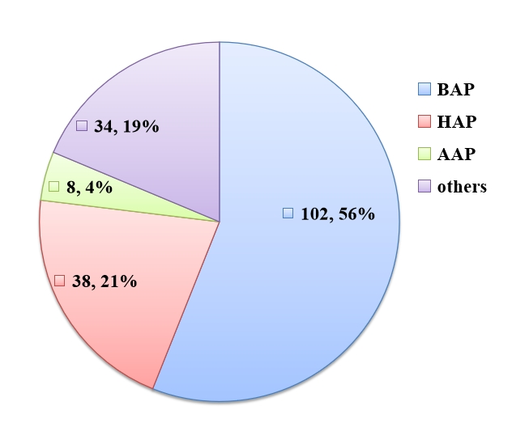
Supplemental Figure 1. Percentage of different etiologies in AP patients.
AP: acute pancreatitis, BAP: biliary origin AP, HAP: hypertriglyceridemia-related AP, AAP: alcohol-related AP.

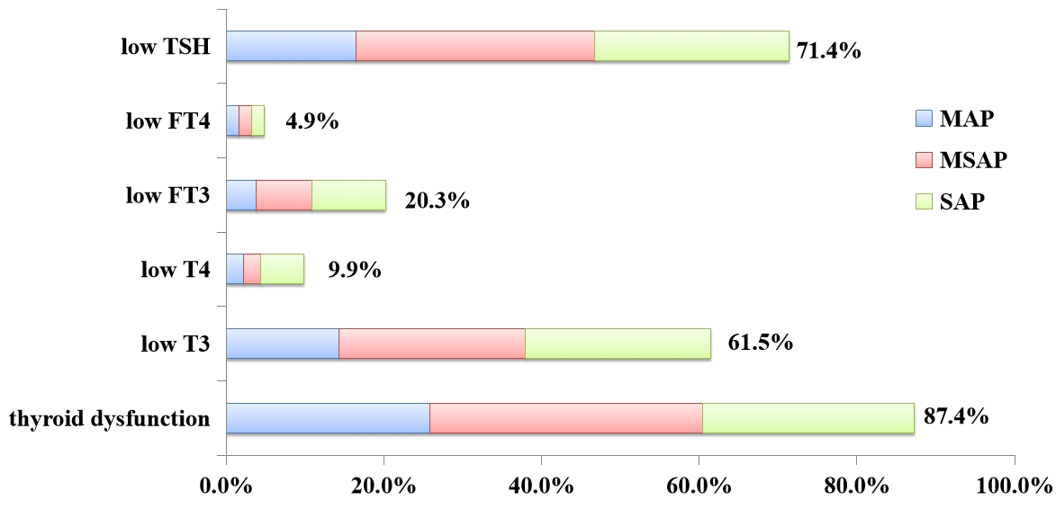
Supplemental Figure 2. Percentage of thyroid dysfunction, low T3, low T4, low FT3, low FT4 and low TSH in AP patients.
T3: triiodothyronine, T4: thyroxine, FT3: free triiodothyronine, FT4: free thyroxine, TSH: thyroid stimulating hormone, AP: acute pancreatitis.

Supplementary Table S1: Detailed Results of Multicollinearity Diagnostics (Variance Inflation Factor) for Multiple Linear Regression Models

Supplementary Table S1a. Coefficients for Model with Dependent Variable ln(TSH)
 | Unstandardized Coefficients |  | Standardized Coefficients |  |  | Collinearity Statistics
Model | B | Std. Error | Beta | t | Sig. | Tolerance | VIF
(Constant) | -2.692 | 1.349 |  | -1.995 | 0.048
Gender(1=M, 2=F) | 0.250 | 0.143 | 0.141 | 1.747 | 0.083 | 0.868 | 1.152
Age | 0.003 | 0.040 | 0.065 | 0.076 | 0.447 | 0.771 | 1.298
HCT | -0.022 | 0.016 | -0.132 | -1.417 | 0.016 | 0.650 | 1.539
hs-CRP | -0.011 | 0.006 | -0.152 | -1.957 | 0.052 | 0.933 | 1.071
Ca | 0.697 | 0.678 | 0.115 | 1.028 | 0.306 | 0.452 | 2.210
Alb | 0.024 | 0.023 | 0.119 | 1.062 | 0.290 | 0.450 | 2.224
LA | -0.096 | 0.104 | -0.081 | -0.927 | 0.356 | 0.744 | 1.345
Dependent Variable: ln(TSH)

Supplementary Table S1b. Coefficients for Model with Dependent Variable T3 (ng/dl)
 | Unstandardized Coefficients |  | Standardized Coefficients |  |  | Collinearity Statistics
Model | B | Std. Error | Beta | t | Sig. | Tolerance | VIF
(Constant) | -16.295 | 25.735 |  | -0.633 | 0.528
Gender(1=M, 2=F) | 0.788 | 2.734 | 0.021 | 0.288 | 0.774 | 0.868 | 1.152
Age | 0.107 | 0.086 | 0.098 | 1.249 | 0.214 | 0.771 | 1.298
HCT | 0.115 | 0.296 | 0.033 | 0.389 | 0.698 | 0.650 | 1.539
hs-CRP | -0.290 | 0.105 | -0.020 | -2.761 | 0.006 | 0.933 | 1.071
Ca | 8.389 | 12.939 | 0.067 | 0.648 | 0.518 | 0.452 | 2.210
Alb | 1.691 | 0.432 | 0.404 | 3.919 | <0.001 | 0.450 | 2.224
LA | -2.682 | 1.981 | -0.109 | -1.354 | 0.178 | 0.744 | 1.345
Dependent Variable:T3 (ng/dl)

Supplementary Table S1c. Coefficients for Model with Dependent Variable T4 (ng/dl)
 | Unstandardized Coefficients |  | Standardized Coefficients |  |  | Collinearity Statistics
Model | B | Std. Error | Beta | t | Sig. | Tolerance | VIF
(Constant) | 54.227 | 31.435 |  | 1.725 | 0.087
Gender(1=M, 2=F) | 7.222 | 3.340 | 0.173 | 2.163 | 0.032 | 0.868 | 1.152
Age | 0.149 | 0.105 | 0.120 | 1.423 | 0.157 | 0.771 | 1.298
HCT | -0.397 | 0.362 | -0.010 | -1.097 | 0.275 | 0.650 | 1.539
hs-CRP | -0.247 | 0.128 | -0.148 | -1.923 | 0.056 | 0.933 | 1.071
Ca | 11.417 | 15.805 | 0.080 | 0.722 | 0.471 | 0.452 | 2.210
Alb | 0.358 | 0.527 | 0.075 | 0.678 | 0.499 | 0.450 | 2.224
LA | -3.631 | 2.420 | -0.129 | -1.500 | 0.136 | 0.744 | 1.345
Dependent Variable: T4 (ng/dl)

Supplementary Table S1d. Coefficients for Model with Dependent Variable FT3 (pg/ml)
 | Unstandardized Coefficients |  | Standardized Coefficients |  |  | Collinearity Statistics
Model | B | Std. Error | Beta | t | Sig. | Tolerance | VIF
(Constant) | 0.881 | 0.617 |  | 1.428 | 0.155
Gender(1=M, 2=F) | -0.068 | 0.066 | -0.076 | -1.044 | 0.298 | 0.868 | 1.152
Age | -0.001 | 0.002 | -0.055 | -0.713 | 0.477 | 0.771 | 1.298
HCT | 0.017 | 0.007 | 0.200 | 2.367 | 0.019 | 0.650 | 1.539
hs-CRP | -0.005 | 0.003 | -0.140 | -1.984 | 0.049 | 0.933 | 1.071
Ca | 0.311 | 0.310 | 0.101 | 1.003 | 0.317 | 0.452 | 2.210
Alb | 0.024 | 0.010 | 0.236 | 2.326 | 0.021 | 0.450 | 2.224
LA | -0.132 | 0.048 | -0.220 | -2.786 | 0.006 | 0.744 | 1.345
Dependent Variable: FT3 (pg/ml)

Supplementary Table S1e. Coefficients for Model with Dependent Variable FT4 (ng/dl)
 | Unstandardized Coefficients |  | Standardized Coefficients |  |  | Collinearity Statistics
Model | B | Std. Error | Beta | t | Sig. | Tolerance | VIF
(Constant) | 1.184 | 0.254 |  | 4.660 | <0.001
Gender(1=M, 2=F) | -0.018 | 0.027 | -0.054 | -0.667 | 0.506 | 0.868 | 1.152
Age | 0.001 | 0.001 | 0.134 | 1.553 | 0.122 | 0.771 | 1.298
HCT | -0.002 | 0.003 | -0.061 | -0.653 | 0.515 | 0.650 | 1.539
hs-CRP | -0.002 | 0.001 | -0.178 | -2.272 | 0.024 | 0.933 | 1.071
Ca | -0.032 | 0.128 | -0.028 | -0.247 | 0.805 | 0.452 | 2.210
Alb | -0.003 | 0.004 | -0.067 | -0.593 | 0.554 | 0.450 | 2.224
LA | -0.036 | 0.020 | -0.160 | -1.823 | 0.070 | 0.744 | 1.345
Dependent Variable: FT4 (ng/dl)

Supplementary Table S1 Footnotes:
Gender was coded as 1 = male, 2 = female.

Abbreviations: HCT, hematocrit; hs-CRP, high-sensitivity C-reactive protein; Ca, serum calcium; Alb, albumin; LA, lactate; VIF, variance inflation factor; T3, triiodothyronine; T4, thyroxine; FT3, free triiodothyronine; FT4, free thyroxine; TSH, thyroid-stimulating hormone.

Note: All VIF values were < 5, indicating no significant multicollinearity among the independent variables in any of the regression models.

