Supplementary Table 1 Primer sequences used for genotyping the ACE
Gene | Primer | Primer sequence (5’3’) | Product size (bp)
ACE | ACE-F | 5’-ACTCTGTAAGCCACTGCTGG-3’ | 206 bp
ACE | ACE-R | 5’-GATGTGGCCATCACATTCGTCAGAT-3’ | 206 bp

Supplementary Table 2 Primer sequences used for genotyping the ACE I/D polymorphisms
Primer | Primer sequence (5’ 3’) | Product size (bp)
ACE-F | 5’-ACTCTGTAAGCCACTGCTGG-3’ | DD variant: 206 bp  II variant: 510 bp  ID variant: 206 and 510 bp
ACE-R | 5’-GATGTGGCCATCACATTCGTCAGAT-3’

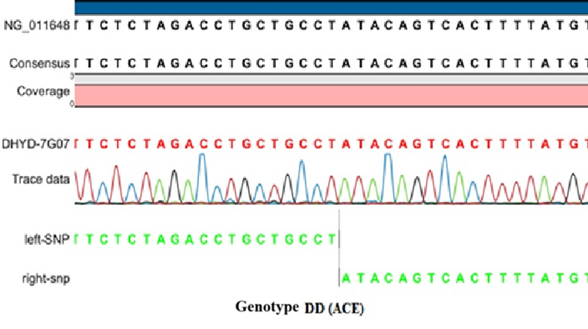
Supplementary Figure 1 Sanger sequencing chromatogram confirming the ACE DD genotype (deletion/deletion)

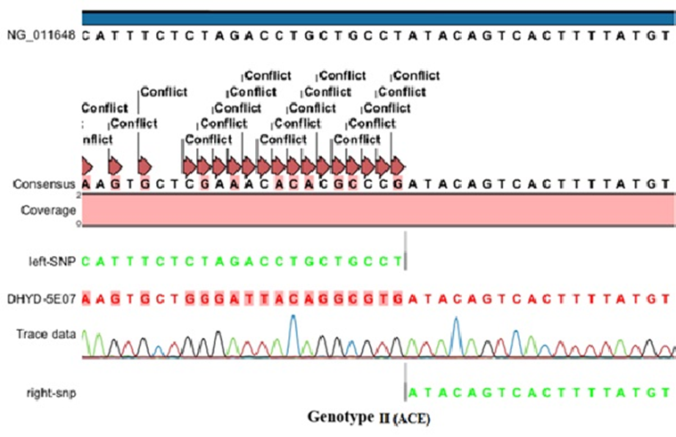
Supplementary Figure 2 Sanger sequencing chromatogram confirming the ACE II genotype (insertion/insertion)

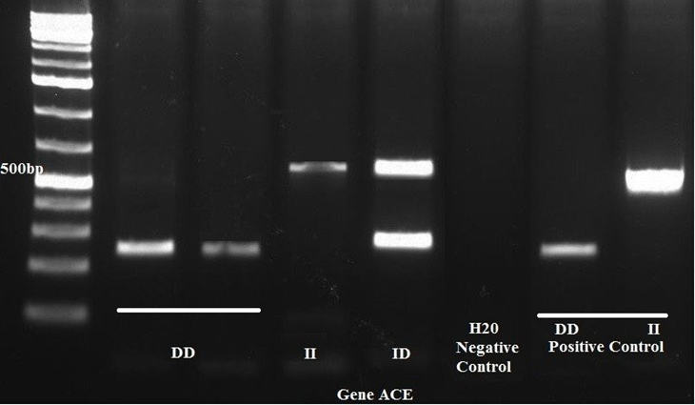
Supplementary Figure 3 Agarose gel electrophoresis of PCR products showing ACE I/D genotypes (DD, ID, and II)

