Supplementary File

Supplementary Figure 1. Kaplan–Meier survival curve showing composite macrovascular complications stratified by the duration of insulin initiation
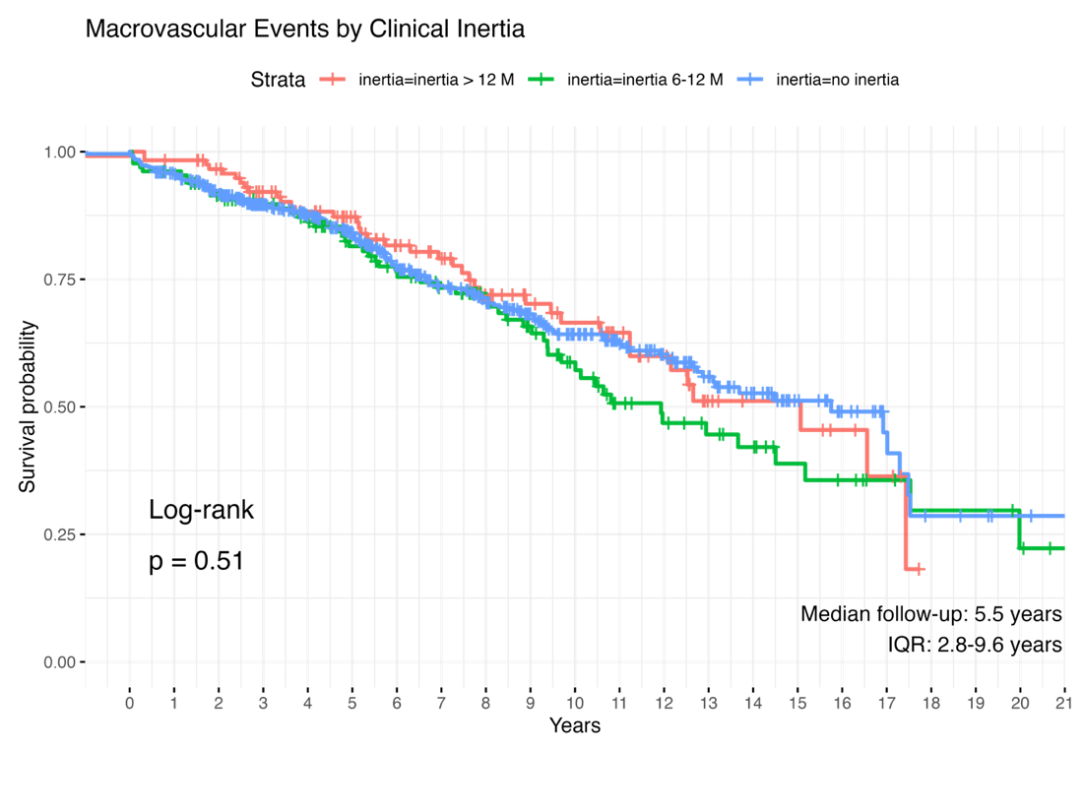

IQR, interquartile range

Supplementary Figure 2. Kaplan–Meier survival curve showing composite microvascular complications stratified by the duration of insulin initiation
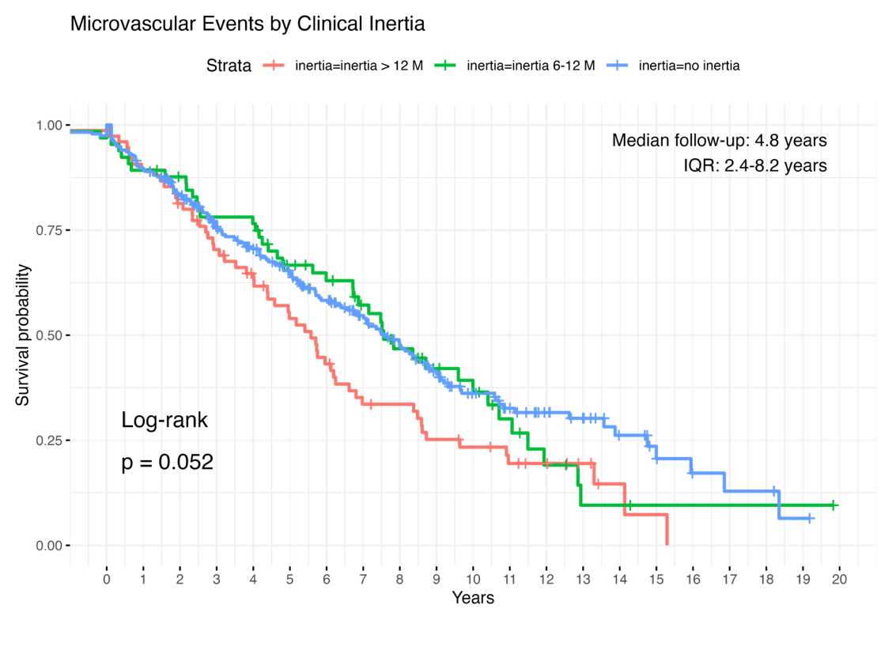
IQR, interquartile range

Supplementary Figure 3. Kaplan–Meier survival curve showing the occurrence of ischemic heart disease stratified by clinical inertia
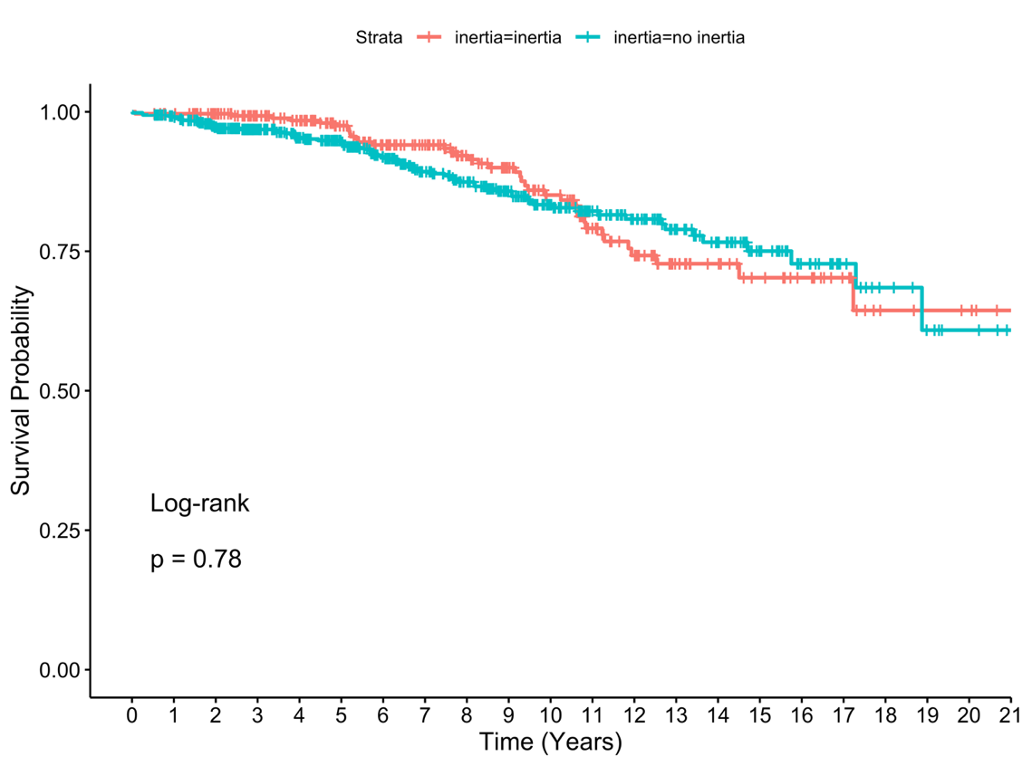

Supplementary Figure 4. Kaplan–Meier survival curve showing the occurrence of heart failure stratified by clinical inertia
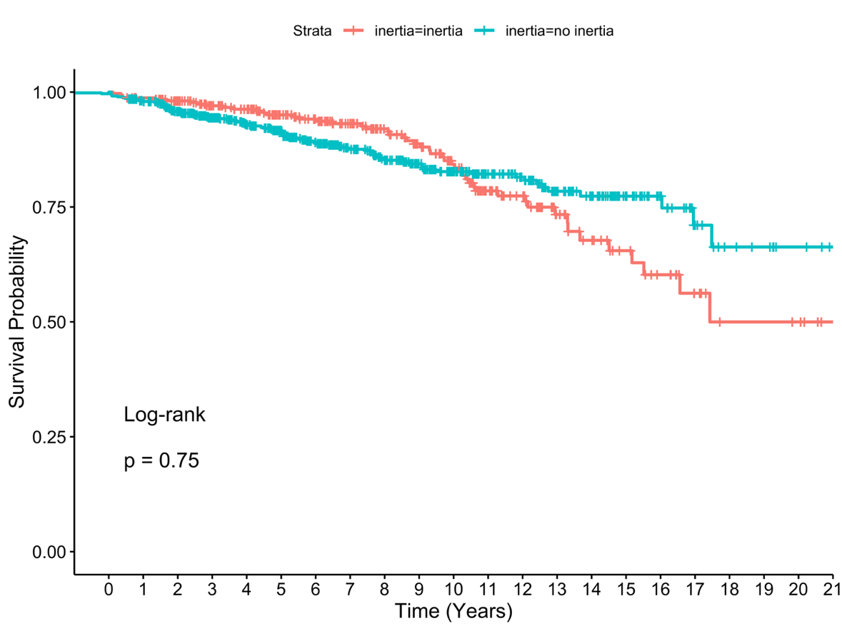

Supplementary Figure 5. Kaplan–Meier survival curve showing the occurrence of ischemic stroke stratified by clinical inertia
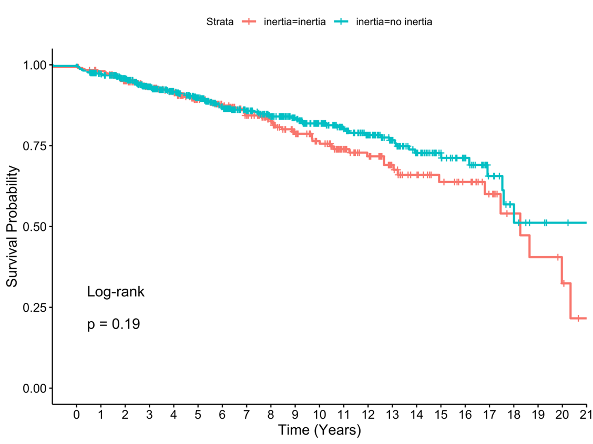

Supplementary Figure 6. Kaplan–Meier survival curve showing the occurrence of peripheral artery disease stratified by clinical inertia
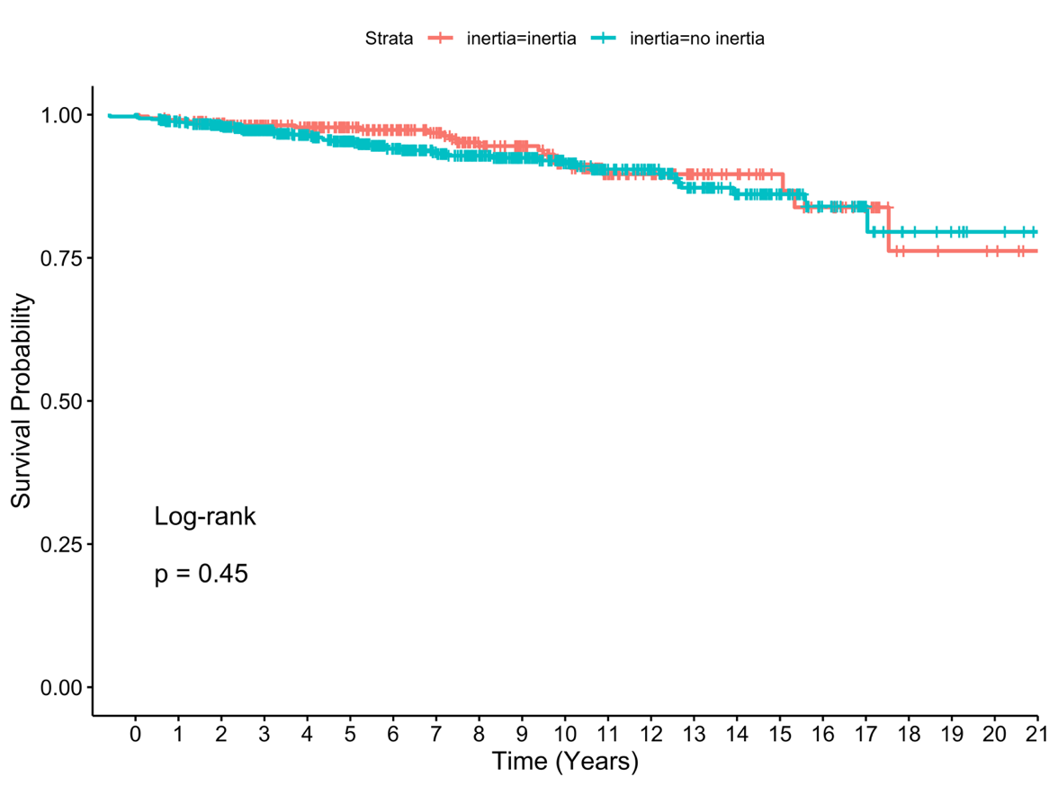

Supplementary Figure 7. Kaplan–Meier survival curve showing the occurrence of diabetic retinopathy stratified by clinical inertia
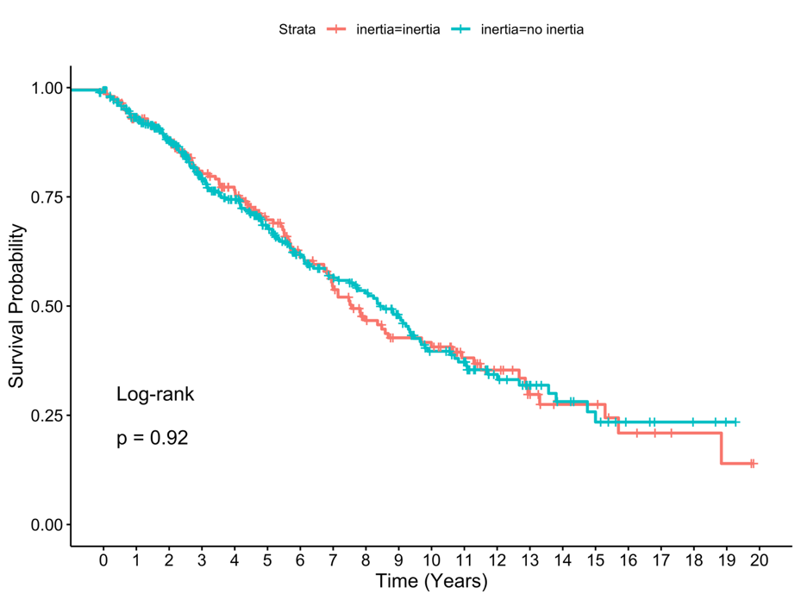

Supplementary Figure 8. Kaplan–Meier survival curve showing the occurrence of diabetic neuropathy stratified by inertia group
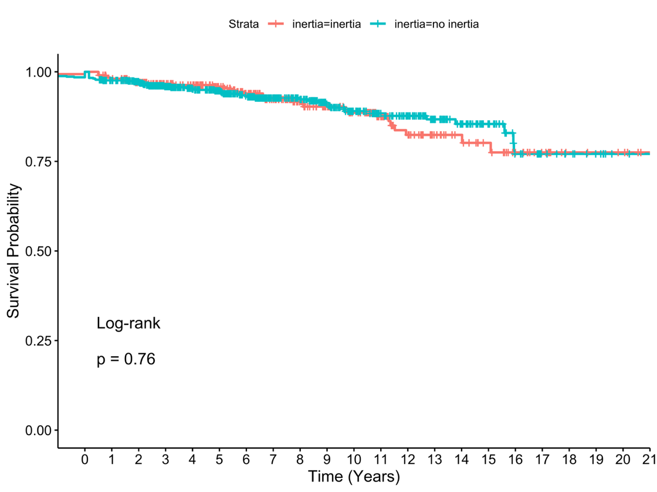

Supplementary Figure 9. Kaplan–Meier survival curve showing the occurrence of diabetic nephropathy stratified by clinical inertia
